Recognizing Kindness & Exploring Interdependence

Purpose:
The focus of this learning experience is to practice recognizing kindness and exploring interdependence. Although students will already have some notions of what kindness looks like, by looking deeper at everyday activities and seeing the various ways kindness is involved, their appreciation for kindness can grow further. Similarly though, students may have some idea of the concept of interdependence; the simple activity of mapping an accomplishment and all the things that accomplishment depends on can help them see interdependence more clearly.
Interdependence refers to the fact every object and event comes into being from a variety of causes, in the sense it depends on other things. Exploring interdependence can be a powerful tool for recognizing how we depend on others and others depend on us;nit can underscore the importance of reciprocity; and it can serve as a foundation for gratitude and feeling of connectedness to others. It also supports systems thinking, since interdependence is a feature of all systems.
In SEE Learning, capacities like our ability to recognize kindness and interdependence are approached as skills that, while innate, can also be strengthened and enhanced through repeated practice. Practicing the skill of recognizing kindness and interdependence can lead to a deeper appreciation for how essential they are to our everyday life, our happiness and even our very survival.
Learning Objectives:  Students will be able to:  - Recognize acts of kindness in their day  - Recognize interdependence as a feature of our shared reality  - Recognize how the objects and events that we need come from the acts of countless others | Primary Core Component  Interpersonal Awareness  
Length  35 Minutes | Materials Required  - Whiteboard or chart paper  - Markers  - SEE learning journals  - Writing utensils

Check In (5 min)
Slide 2 : Check In   | Sample Script  - “Can anyone remember what we said kindness means? We created a way of explaining it to others. Who remembers what we said?  - Lets look at our explanation of what kindness is now. I wrote it up on this piece of paper  - Have any of you felt kindness today? Yes? What was it like? If you can’t think of a moment of kindness from today, you can imagine one if you like.  - Let’s take a moment to sit for a few seconds and remember what kindness feels like. If you are comfortable with it, close your eyes and really try to picture that moment when someone was kind to you or when you felt kindly towards someone else. Or if you are using your imagination, just imagine that moment.  - Thank you. Can some of you share some of the acts of kindness you thought of?”

Insight Activity: Recognizing Kindness (5 min)
Overview

In this activity you will invite students to share moments of kindness that they observed or participated in during the day, guiding them to reflect on how it made them and others feel, and challenging them to recognize as many forms of kindness as they can.

Content to be Explored

We see countless acts of kindness around us every day, but we may recognize very few of them if we do not look deeply

Materials
- Whiteboard or chart paper
- Markers

Instructions
- Ask the students how many acts of kindness they think the class will come up with just from what happened to them today.
- Write the numbers they propose on the board
- At the end of the activity ask the students if their original guesses were correct, too high, or too

Teacher Tips
- Use your discretion in guiding this, as you know your class best.Encourage them to think of any moment - no matter how small. It could be the crossing guard that smiled at them, or how they handed someone a marker when they needed it, or they smiled at someone they don’t usually pay attention to. Let your students know that it’s okay if they can’t think of a time, because they can imagine one. As you practice with this, it will get easier. Encourage curiosity: the feeling that we’re all just exploring and wondering about this together.
- As in every insight activity, students may have other critical insights as you go along - if so, record them or note them on the board so that you can return to them later. Elementary aged kids are developing their abilities to take perspectives and think bigger than just themselves. This is a quick exercise that can be done many times throughout the year that reinforces that kindness is all around.
Slide 3: Reinforcing Kindness  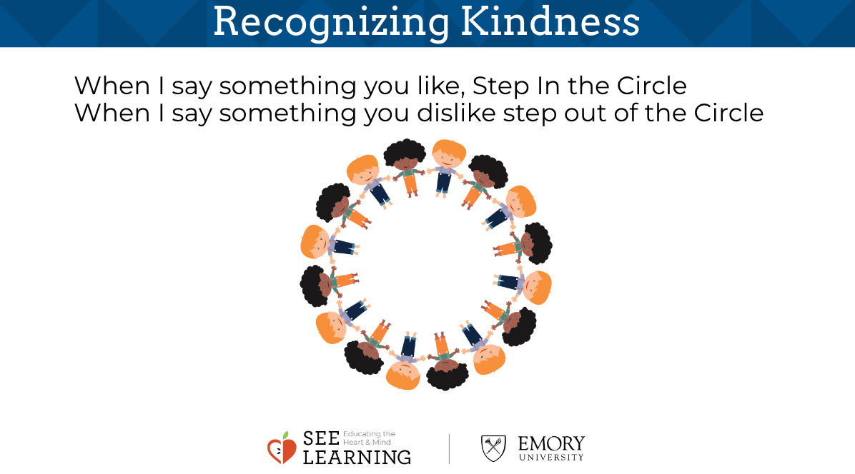 | Sample Script  - We see countless acts of kindness around us every day, but we may recognize very few of them if we do not look deeply.  - Step into the center if you like to build with Legos or blocks.  - Take a look and see who else likes building with Legos or blocks. Now step back please.  - Step in the center if you like playing sports or big active games.  - Take a look and see who else likes those things. And step back please.  - Who noticed they had a similarity with someone? What was it? [These questions are crucial as this way kids start to connect more and are ready for the next step.]  - [You can ask these follow-up questions to other students as well, not just the student who shared, so that they can think about the various ways the action was kind and how it might have made others feel.]  - Now let's try to look more deeply. I wonder if we can find even more acts of kindness?  - Do you think there might have been kindnesses that we didn't even know about or notice?  - We found a lot of acts of kindness when we looked deeply, didn't we? How does it feel to know that we are surrounded by so many acts of kindness?  - Now, let's see. How many did we find? Did we find more than we thought we would? (You can compare with the numbers the students  - suggested earlier and that you wrote on the board.)  - It seems we can find a lot of acts of kindness if we look for them. But if we don't look, we might not see them."

Insight Activity 2: Reflective Practice (20 minutes)
Overview
In this activity students will form groups and draw a web of interdependence starting with a single accomplishment, event, or object.

Content to be Explored
- Objects and events exist in a web of interdependence; they depend on countless other objects and events.
- We are connected to and depend on countless other people in a variety of ways, even if they are strangers to us.

Materials
- A large sheet of paper for each group to draw on
- Markers

Instructions
- If necessary for your group, model the activity to demonstrate what you want them to do in small groups. (The script below includes modeling at two different points in the activity.)
- Divide the class into groups of 4 or 5 students each.
- Ask each group to identify an important accomplishment or event that they share in common or have all participated in in some way. Examples include going on a t rip; learning to ride a bike; learning to play a game; learning to read and write; and so on. Provide 1 or 2 minutes for this.
- If they cannot think of an event or accomplishment that they all have in common, ask them to identify an object made by humans that they all need. What did it look like? What did it feel like? What did you look like? What did you feel like?
- Ask them to draw this accomplishment, event or object in the middle of their sheet of paper. This will be their subject.
- Ask them to create a first circle by adding (drawing or writing) anything their subject depends on or needs to exist. They can draw a line connecting these things to their subject.
- For example, if they chose "learning to ride a bike" as their subject, they might add a teacher, a friend, the bicycle, a flat surface to ride on, the person who invented bicycles, and so on . Or if they choose a pencil as their subject, they could add wood, lead, a factory, paint, and so on. Ask them to see if they can think of at least 10 people or things their subject depends on.
- Ask them to now add and draw what the items in that first circle themselves depend on. Again have them draw lines connecting the new items as they are added.
- Have them continue the process freely, selecting any item on the page and identifying things or people it depends on. Monitor each group to provide guidance as necessary. You can prompt them to think further by asking questions like, "This item here. Does it exist all by itself or does it need other people or things for it to exist?"
- When each group has had sufficient time to fill out most of the paper, stop the groups and ask them to estimate how many people in total are needed for their subj ect. For example, how many people in total are needed for that pencil to be made? Or how many people in total are needed for you to learn to ride a bike? Give them a minute to calculate this and ask them to write it on their sheet of paper.
- Invite each group to share. They should explain their subject; show the various aspects of the interdependence web they created; and then share their estimate of how many people were involved.

Teacher Tips
- As in every insight activity, students may have other critical insights as you go along-if so, record them or note them on the board so that you can return to them later.

Sample Script
- " We have done much investigation about kindness in our lives, and one insight that we might have seen is that kindness rarely involves just you - usually kind acts that occur in our lives involve at least one other person. We call this interdependence: we constantly depend on others. Interdependence is not limited to kind acts, but everyday things that we use or experiences that we've had.
- Today, we are going to investigate this idea of interdependence more deeply. In a small group, you and your peers will come up with an important accomplishment or event that you have in common: Examples for you might include going on a trip; learning to ride a bike; learning to play a game; learning to read and write; and so on. When your group has decided on one, draw or write it in the middle of your piece of paper that you will have. This will be your subject.
- [Divide the class into small groups of 4-5 students. And have them complete the activity up through instructions you have given so far.]
- Now, think about people and things that your subject depends on. Each time you think of something, write it down, circle it, and draw a line connecting it to the subject. First, let me show you how I did this. For my accomplishment, in my imaginary group of a few other adults, we chose "learning to drive a car" as our accomplishment that we all have in common . I'll write /draw that in the center of the paper.
- Next, we discussed who and what that accomplishment depended on for each of us to achieve. I put down "my dad" because he had me drive his car in a parking lot to get some practice. Another person in my group said "the tires" because without the tires, I couldn't have driven the car.
- Try and come up with 10 things that your subject depends on and write or draw them on your group's paper. [Allow enough time for this to happen.]
- Draw a circle around each thing you wrote that your subject depends on. Now, we are going to take this even further. We are going to look at each item we have already written down and think, what does that item depend on? For my example, I will focus on "the tires." The tires on the car would not exist if someone in a factory somewhere did not make them, so I will write "factory worker" out next to "the tires."
- Go ahead and add branches to each circle, writing or drawing what each thing depends on. Create appropriate branches as best you can. See how many connections you can make ." [When this is finished, invite groups to share. If time does not allow this, the sharing part can be at a different time.]
Slide 4: Drawing Kindness  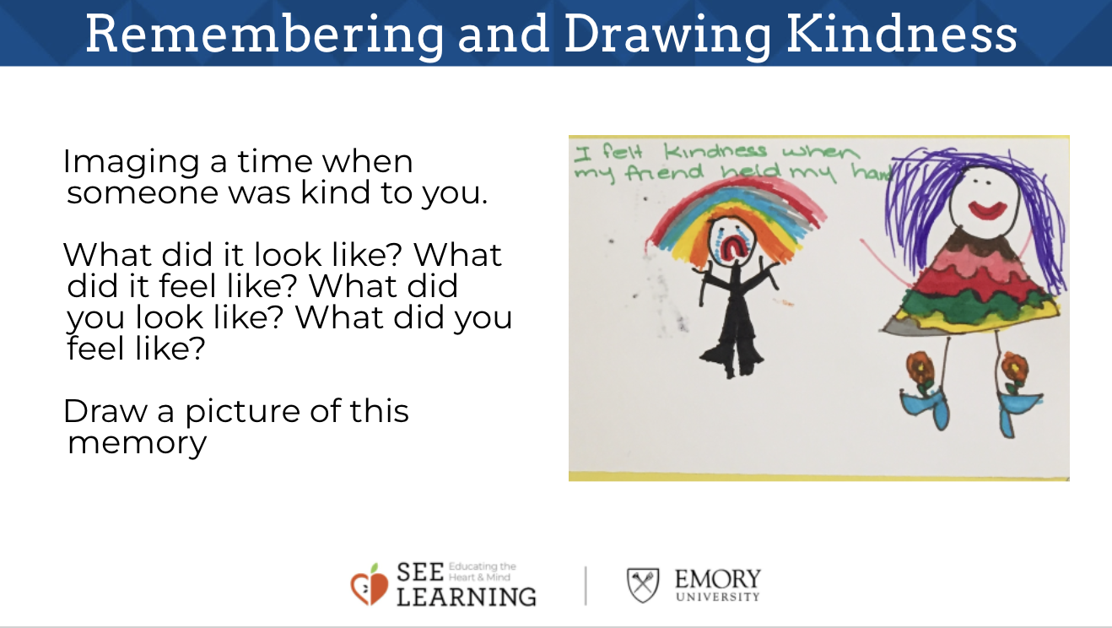 | Sample Script  - “Let’s go back to our desks.  - Remember how we saw that we all like it when people are kind to us?  - Let’s be silent for a moment and think about a moment when someone was kind to us. Sometimes it is easier to bring memories to our mind if we close our eyes or look at the ground. I’ll keep my eyes open.  - It could be something very special, or it could be something very simple.  - It could be someone helping you, or someone saying something nice to you.  - It could be a friend who played with you, or someone giving you a toy or present.  - Raise your hand if you’ve thought of a time when someone was kind to you. [Have a few students share in case others are stuck - this will give some more scaffolding.]  - Now we’re going to draw what happened when someone was kind to us.  - Answer these questions: what did it look like? What did it feel like? What did you look like? What did you feel like? [Give students a few minutes to draw, guiding individual students as necessary. When it seems that most students are ready, invite them to share.]  - Okay, we’ve all done some drawing now of a time when someone was kind to us.  - Who would like to share their drawings and tell us about that time?  - These drawings will be available to you as a resource to come back to if you need a reminder of a kind moment. You are always welcome to look back at what we’ve done and bring positive feelings forward.”

Reflective Practice (5 min)
Materials
- SEE Learning journals
- Writing utensils

Instructions
- Have your students take out their SEE Learning journal for some private journaling in silence. Explain that they do not have to share what they write if they don't want to.
- Ask them to choose something important in their life: an event, accomplishment, person or object. This will serve as their subject. They will journal for 5 minutes about what their subject depends on. They can draw it out as an interdependence web, or they can simple write in sentences.

Debrief (3 min)
Slide 5: Debrief  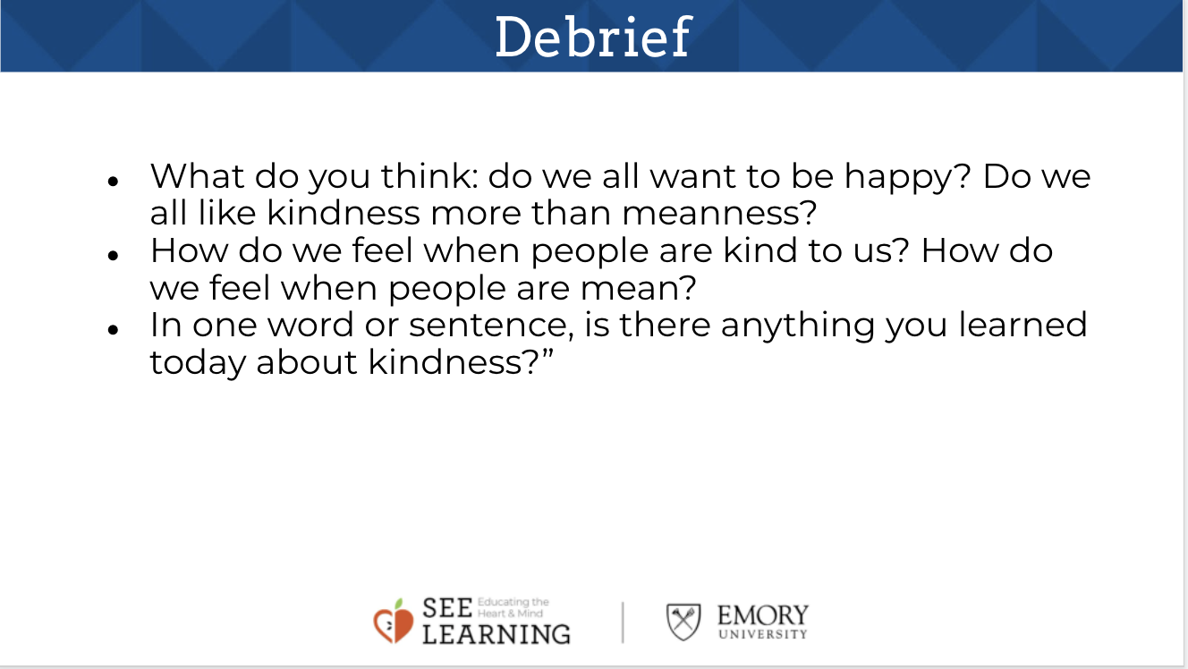  Animated slide | Sample Script  - " Look at your personal web of interdependence or your group's web. What does it feel like to think of yourself as a part of this web? What do you think about this idea?  - How might reflecting on interdependence lead us to feel grateful? How is interdependence related to kindness?””

