Kindness as an Inner Quality
Purpose:
The focus of this fourth learning experience is to go further into the idea of kindness by exploring whether it is just outer actions or also something inside one’s heart and mind. We easily associate kindness with external activities, like giving someone food or money, saying sweet words to someone, or helping someone up when they fall. But if the intention behind those actions and words is to take advantage of the other person, then we do not see that as real or genuine kindness; nor do we see it as genuine help. For students to understand how to cultivate kindness as a disposition, which lies at the heart of SEE Learning, they will be aided by understanding that kindness goes deeper than just external actions but also refers to a state of mind and heart: one’s intention to bring help and happiness to another person.
*The asterisk by a practice denotes that it can be repeated multiple times (with or without modifications).
Learning Objectives:  Students will be able to:  - Explore kindness in the context of outer actions and inner intentions and motivations.  - Recognize the distinction between real (inner, genuine) kindness and apparent kindness.  - Develop their own definitions of kindness.  - Provide examples of actions that might seem unkind, but are really kind, and vice versa. | Primary Core Component  Compassion for Others  
Length  30 Minutes | Materials Required  - Chart paper with “kindness” written in the middle of each, enough for 1 piece per small group; markers  - Students’ SEE Learning journals; writing utensils  - The story provided below  - The kindness drawings made in Learning Experience 2

Check In (3 min)
Slide 2 : Check In   | Sample Script  - “Last time we talked about how we could create a kind, caring classroom and we created some classroom agreements. Does anybody remember some of the things we talked about and put on our list? [Allow time for sharing.]  - Today we are going to think about how we can practice kindness.”

Insight Activity 1: The Two Brothers and the Baby Swan (10 min)
Overview
In this activity, you will read a story to the students that shows how we all naturally prefer kindness, because kindness makes us feel safe and secure. A story is provided for you here that has an element that shows that kindness relates to our intentions also, and is an inner quality. If someone pretends to be kind, but really intends to take advantage of someone, then we do not see that as genuine kindness. If students come to understand that kindness is an inner quality, not just actions, then they will realize that to cultivate kindness, we need to cultivate that inner quality, not just act outwardly in a particular way.

Content to be Explored
- We all prefer kindness and want to move toward kindness and away from meanness.
- Kindness makes us feel safer and more secure
- Kindness is an inner quality.
- Pretending kindness (outward actions without a good intention) is not genuine kindness.

Materials
Story provided below.

Instructions
- Read the story to your students.
- Facilitate a discussion. Sample questions are provided within the script for your use.

Teacher Tips
- The sample discussion questions listed in the script can help you have a discussion and encourage the students to explore the story and its various dimensions. Feel free to add your own questions and respond to the flow of the discussion.
- Allow them to share openly and remember that there are no right or wrong answers, but also keep in mind critical insights (listed above) that you are orienting them towards. These insights have to come naturally, and it’s all right if not all the students reach all the insights at once, since they will be returned to continuously in future learning experiences.
Slide 3: The Two Brothers and the Baby Swan  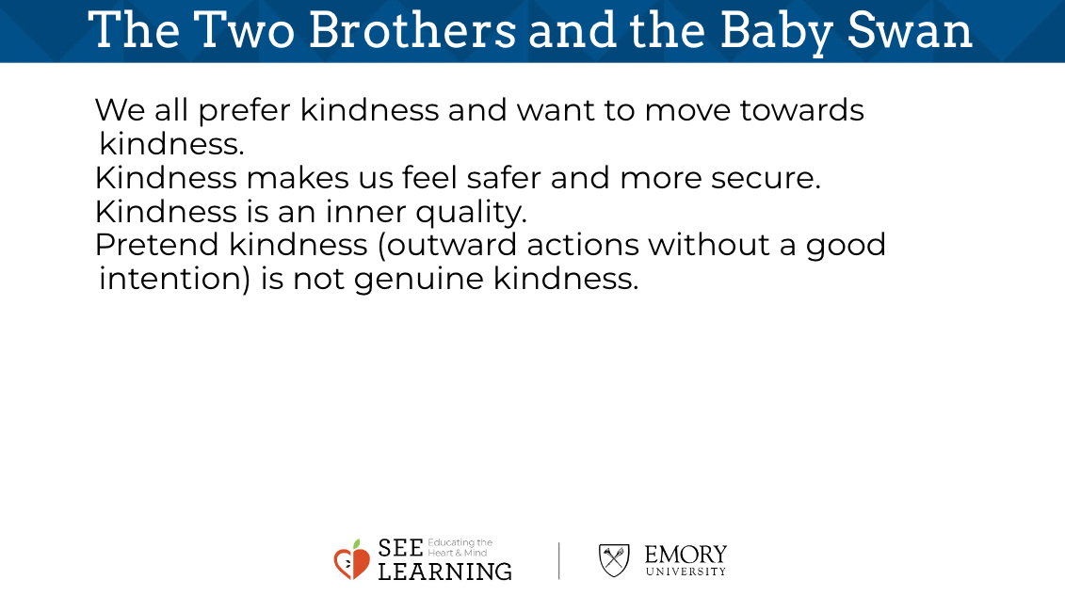 | Sample Script  - “We are going to read a story together that has to do with kindness. Sometimes people do things that look kind, but in their heart, they are not actually kind and compassionate. While I read this story, think about who is truly kind in this story and who is pretending.”  - [Read the story below.]  - “Now we’re going to talk about that story a little bit.  - What happened in the story? What are some of the things you noticed?  - How do you think the different people in the story were feeling?  - If the baby swan could talk to us, what are some things she would say? What else?  - Why do you think the swan went to the younger brother?  - Remember when the older brother was saying sweet things to the swan? What happened after that?  - Was the older brother being kind when he was saying those things? Why or why not?  - How is kindness like helping?  - If someone pretends to be kind, but inside they don’t really want to help the other person, is that really kindness? Explain your thinking.  - Is kindness just the outer action, like sweet words, or is it also something inside us? An inner quality? Explain your thinking.  - Could something that looks unkind at first, really be kind? Like if a parent says “No” to their child, is that always unkind or could it be kind? What if the child was going to do something dangerous and the parent said “No.” What do you think?”

Insight Activity 2: Making and Reflecting on a Definition of Kindness (15 min)
Overview
In this reflective practice, students will make a word map of the word “kindness.” This will be used to develop a simple definition of kindness (one or two sentences) for use in the classroom. The students will take moments for silent reflection during the making of this definition and after making it, to allow this wider understanding of kindness to deepen in them.

Content to be Explored
- We all prefer kindness and want to move toward kindness and away from meanness.
- Kindness makes us feel safer and more secure.
- Kindness is an inner quality.
- Pretending kindness (outward actions without a good intention) is not genuine kindness.

Materials
- Chart paper with “kindness” written in the middle of each (1 piece per small group)
- Markers
- Students’ SEE Learning journals
- Writing utensils;
- The kindness drawings made in Learning Experience 2

Instructions
- Ask students to silently think about the story and the discussion
- Ask them to think about the word kindness and what it means to them. Next, divide them into small groups
- Pass out chart paper with “kindness” written in the middle - one per group. In small groups, students will come up with ideas and words that explain kindness. Tell them to write their ideas around the chart paper.
- After 5-7 minutes, regroup all together. Have a big piece of chart paper with “kindness” written in the middle.
- Ask students to share some of their ideas and add them to the poster. New ideas may come up as they share.
- When you feel like enough has been shared (this can be done on a different day), ask students to move to sit on their own and take out their SEE Learning journal. Ask them to write one sentence that defines kindness.
- Students can share their sentences at the end of this activity or at a later point.

Teacher Tips
- Note: Many of the reflective practices in SEE Learning involved moments of silent reflection for students to think, ponder, and internalize their insights. How long these moments should be will depend on the classroom environment and your students. They can be as short as 15 seconds or can be as long as a few minutes. You will be the best judge of the appropriate amount of time. You may find that with practice, the students will get more comfortable and familiar with these moments, and that you can prolong them for longer periods of time.
- You may consider asking students to do this small group portion of the activity in silence as a challenge - maybe for just a few minutes for half the time allotted.
- You may want to display their definitions of kindness in some way in your room as reference points - for example, students could make sentence strips of their definitions and they could be placed on the walls.
Slide 4: Making and Reflecting on a Definition of Kindness  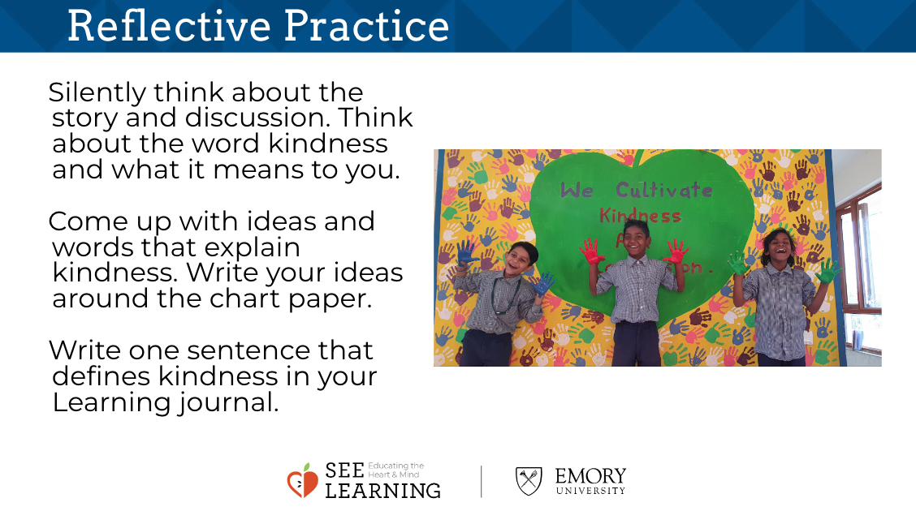 | Sample Script  - “I wonder if we could come up with one sentence to explain what kindness is so that if someone asked us “What does kindness mean?” we can tell them.  - Let’s take a quiet moment to think about the story and our discussion about it.  - I’m going to divide you into small groups. Your group is going to get a piece of paper with the word kindness in the middle. You and your group will come up with words that are like kindness that we can use to explain what kindness is. You may look at your kindness drawings to help you.  - [Allow students to work in small groups for 5-7 minutes.]  - Let’s hear from each group. What shall we add to our classroom kindness chart?  - We have lots of good ideas up here. Now, the last step is to come up with a definition of kindness. You are going to go back to your spot, with your SEE journal and write one sentence that defines kindness. You can even start the sentence with “kindness means … “”  - [Allow students to work in small groups for 3-5 minutes. If time allows, ask students to share their sentences.]

Debrief (2 min)
Slide 5: Debrief  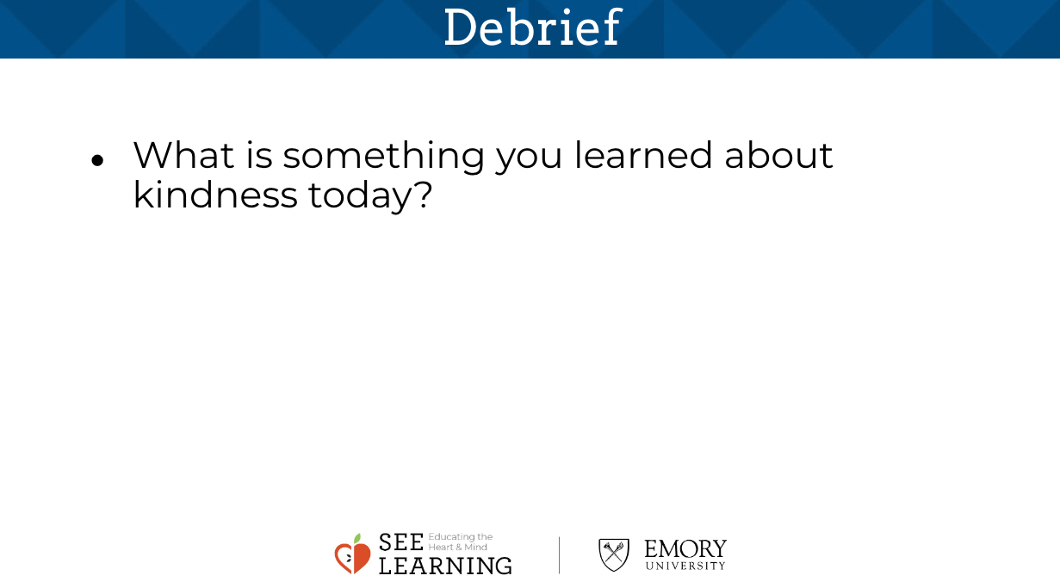 | Sample Script  - “What is something you learned about kindness today?”

