It Takes a Village

Purpose:
By using the example of a child their age, students will explore interdependence, a vital aspect of systems thinking, by identifying the many forms of care and support a child needs from others to arrive at their current age. Recognizing the value and care that one had received and that one still receives on a daily basis can help students realize that they are not alone, that they are valued, and that they can be confident in moving forward knowing that others are supporting them. It also shows that all individuals live within and are shaped by a systems context.
Learning Objectives:  Students will be able to:  - Enumerate the many acts of kindness, care, and support a child receives while growing up.  - Explore systems thinking by examining how an individual depends on and is affected by many members of a community | Primary Core Component  Appreciating Interdependence
Length  35 minutes | Materials Required  - None

Check-In | 3 minutes
Slide 2: Check In  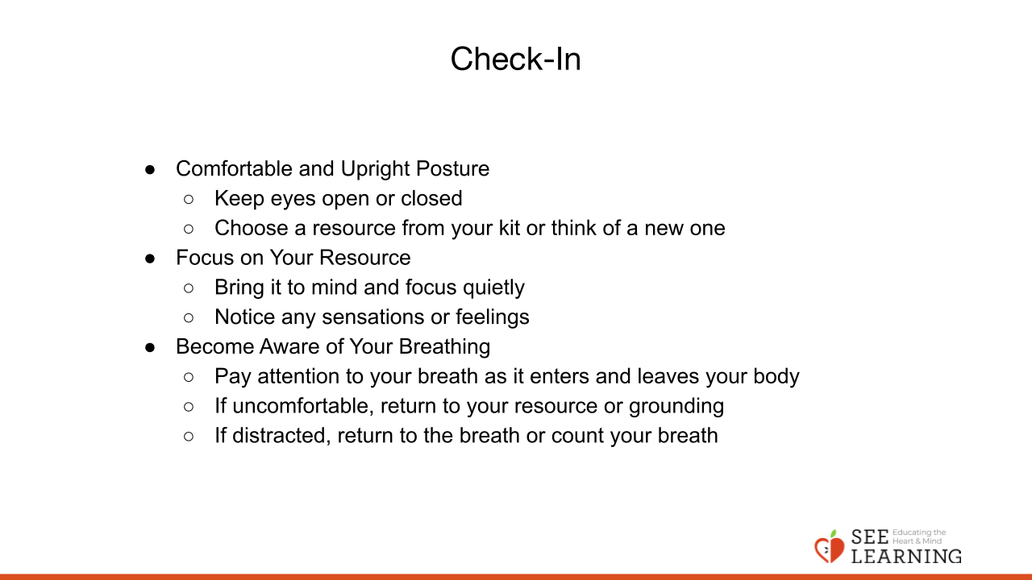 | Sample Script  - “Let’s do a short attention practice. How do we want our body to be?  - First we’ll take a comfortable and upright posture. I’ll be keeping my eyes open, but you can close them or look at the ground.  - Now choose one of your resources from your resource kit, or you can think of a new resource if you like: something that makes you feel better, safer, happier.  - Let’s bring our resource to mind and focus on it for a few moments quietly. You can also do grounding if you prefer. [Pause.]  - What do you notice inside? If you feel pleasant or neutral, you can rest your mind on that. If you feel unpleasant, you can shift to a place in your body that feels better. [Pause.]  - Now let’s become aware of our breathing. Let’s see if we can pay attention to the breath as it enters and leaves our body.  - If you find paying attention to the breath uncomfortable, then feel free to go back to your resource or grounding. [Pause for 15-30 seconds.]  - If you ever get distracted, you can just return your attention to the breath. You can also count your breath. [Pause for a longer time, such as 30-60 seconds or longer.]  - Now let’s end the practice and open our eyes. What did you notice?” [Share aloud]

Discussion: What is Caring and How Have We Experienced It? (7 minutes)
Overview

In this presentation/discussion, students will talk about what “care” means, concrete examples of things they have cared for, and people who have cared for them.

Content to be Explored

- We tend to care for things that we find valuable.
- Everyone has received care from many others throughout their life.

Materials

None

Instructions
- Using a few concrete examples, discuss the meaning of care. The sample script below
- provides discussion questions you may ask.
Teacher Tips
- Allow students to guide this discussion.
Slide 3: “What is caring and how have we experienced it?”  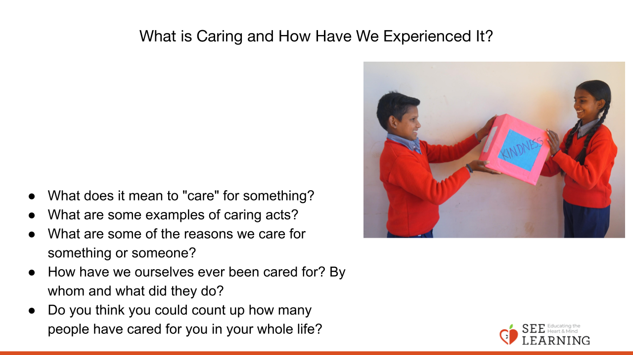 | Sample Script  - “All right. We just did the check-in, in which we showed caring for ourselves by allowing  - ourselves to get settled and grounded.  - What does it mean to “care” for something?  - What are some things or people you have cared for? [pets, plants or a garden, younger siblings, grandparents, etc]  - What are some examples of caring acts [for one of these examples]?  - What are some of the reasons we care for something or someone? [because we value it; it’s important to us; we love it]  - How have we ourselves ever been cared for?  - By whom and what did they do?  - Do you think you could count up how many people have cared for you in your whole life?  - Thank you for participating in this discussion about caring. Next, we’ll do an activity together where we explore the idea of caring further.”

Insight Activity(15 minutes)
Overview

This insight activity offers students the opportunity to explore how many people and how
much love, work, and energy go into raising a single child to age 5, 6, or 7 (choose the age
that most of your students are). This activity is somewhat similar to the interdependence
drawing activity done in Chapter 1.

Content to be Explored

- It takes a great deal of care from many people to raise a single child.
- The caring of others helps us survive, thrive, and be healthy and happy.
- Much of this care is not given in order to receive something back in return.

Materials

- 4 large pieces of paper that or a board that both the teacher and students can draw on.

Instructions
- Tell students you are going to think about all the people that help to raise a single child and all the things needed for the child to be provided for, protected, fed, clothed, and cared for. You will go through four stages: (a) pregnancy, (b) infancy age 0-1, (c) pre-school age (2-4) and (d) current age (5-7).
- First draw a pregnant woman in the center of the chart paper. Ask students who cares for the child and what it needs at this point in its life. Either write what they say or invite them to draw who cares for the child and what it needs at that point in its life.
- Then, ask students to write what kind of care or support next to each person who provides to the child for the child to survive and thrive.
- Draw lines out from each person and write the kind of care or support they provide.
- Repeat the above steps for the remaining 3 stages.
- Ask the whole group to look at all four stages. Ask them what observations they have at this point.
- If it does not come up, ask:
  - “What is expected back in return from the child for all of this care? Nothing, from the child. It is the joy and responsibility of the adults to create a caring environment for the child. True, not every child experiences this in the same ways, or perhaps as fully or easily as every other child. But the adults in every child’s life love and care for them, the best they can.”
  - If you have time, discuss the “It Takes a Village” learning experience title with the group.
Teacher Tips
- Keep in mind that among the caring experiences your students have had growing up, some will be shared (being fed, clothed, and cared for, etc.) and some specifics may not be shared (receiving presents, having both parents around, having a loving extended family, having a stable home or stable housing). Some of your students may have experienced separations from family members or other difficult experiences. It should not be about comparing how some students received more care than others, but on the basic care that anyone would have had to receive to reach their current age. Try to keep the focus on appreciating that which was received. If difficult emotions arise, always remember that you can use the resilience skills of resourcing, grounding, and Help Now! with your students at any time.
- If you have time, you may want to draw the four stages of life posters before you begin class.
- If your students are prepared for it, you may try this activity in small groups, assigning each group an age-level. Then after all groups have time to brainstorm and draw, you can have them share out, either verbally or with a gallery walk.
Slide 4: “Insight Activity”  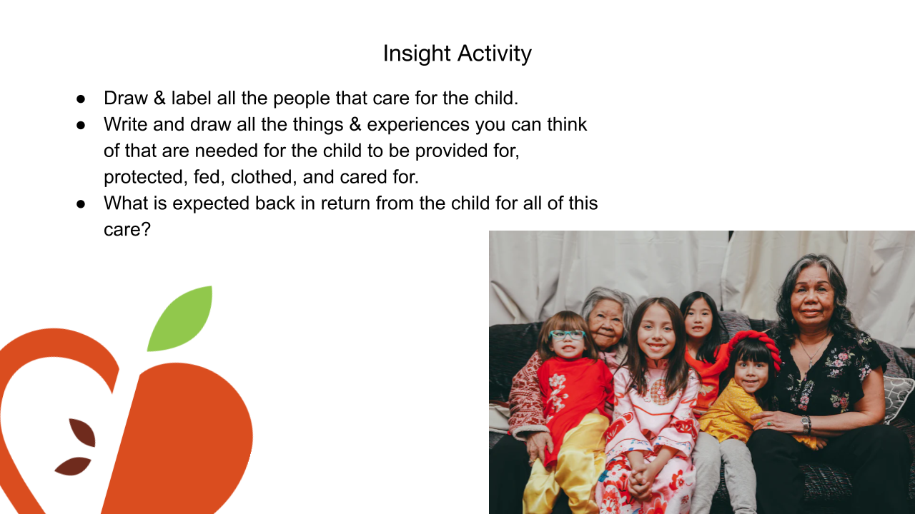 | Sample Script  - “One of the basic parts of being human beings is needing to be cared for, and appreciating being able to care for others. From the time we are babies, we count on others to care for us, to be a part of making our lives safe and comfortable.  - And even as babies, and even more as we grow, we can contribute too, showing care for others and for our surroundings. Let’s think for a moment about the people, our family, caregivers, friends, or neighbors, who do things and act in ways that show they care about us and how we care for others. Let’s start with in the mornings. What are some ways people help to care for one another in the mornings? [Pause.]  - What about in the evenings? What are some ways we can see people doing caring things for one another in the evenings? [Pause.] [Allow time for sharing.]  - Ok, great. Now, we’re going to think about all the people that it takes to raise a single child. Let’s start with a pregnant mother and a baby before it’s born. I’m going to draw them here. [Draw the pregnant woman on the chart paper.]  - At this point in a baby’s life, who cares for it? [Write or draw what students say or invite them to do so.]  - Next, let’s say what each of these people do for the child - what kind of care or support does each person provide to help the child survive and thrive? [Draw lines out from each person and write students’ ideas of the kind of care/support they provide.]  - Ok, these are wonderful ideas. Let’s go to the next stage of life, newborn to 1 year old. I’ll draw the baby here. [Draw the baby on the next piece of chart paper.]  - At this point in the baby’s life, age 0-1 year, who cares for them? [Write or draw what students say or invite them to do so.]  - Next, let’s say what each of these people do for the baby - what kind of care or support does each person provide to help the baby survive and thrive? [Draw lines out from each person and write students’ ideas of the kind of care/support they provide.]  - Ok, these are wonderful ideas. Let’s go to the next stage of life, ages 2-4 years. I’ll draw the young child here. [Draw the child on the next piece of chart paper.]  - At this point in the child’s life, age 2-4 years, who cares for them? [Write or draw what students say or invite them to do so.]  - Next, let’s say what each of these people do for the child - what kind of care or support does each person provide to help the child survive and thrive? [Draw lines out from each person and write students’ ideas of the kind of care/support they provide.]  - Ok, these are wonderful ideas. Let’s go to the next stage of life, ages 5-7 years. I’ll draw the child here. [Draw the child on the next piece of chart paper.]  - At this point in the child’s life, age 5-7 years, who cares for them? [Write or draw what students say or invite them to do so.]  - Next, let’s say what each of these people do for the child - what kind of care or support does each person provide to help the child survive and thrive? [Draw lines out from each person and write students’ ideas of the kind of care/support they provide.]  - Thank you! Now let’s look at all four stages together. What do you notice? [Allow time for observing and sharing.]  - What is expected back in return from the child for all of this care? Nothing, from the child. It is the joy and responsibility of the adults to create a caring environment for the child. True, not every child experiences this in the same ways, or perhaps as fully or easily as every other child. But the adults in every child’s life love and care for them, the best they can.”
Reflective Practice (7 minutes)
Overview

In this reflective practices, students make the previous activity personal by writing or drawing all of the people who have been involved in caring for them during their whole life. They will come up with the ways they have been cared for by these people. They will notice what sensations they have in their bodies while they do this and then will have the opportunity to share, as desired.

Content to be Explored

- It takes a great deal of care from many people to raise a single child.
- Much of this care is not given in order to receive something back in return.
- We tend to care for things that we find valuable.
- The caring of others helps us survive, thrive, and be healthy and happy.
- Everyone has received care from many others throughout their life.

Materials

- Student-made posters about caring for all age-levels displayed
- Paper and writing/drawing utensils for each student Instructions Use the script below to facilitate the reflective practice.
Slide 5: “Reflective Practice”  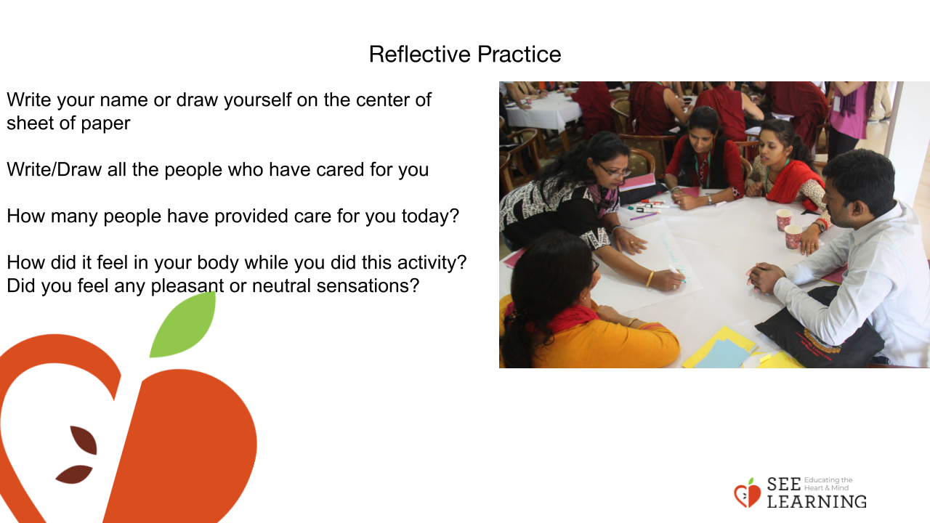 | Sample Script  - “In the center of your sheet of paper, write your name and/or draw a picture that represents you. [Allow for 1 minute.]  - Looking at our charts, or thinking about another example from your own ideas, choose one person, one act of caring, to draw and/ or write now. [Allow for several minutes for drawing.]  - If you want to, you can include more people and more acts of caring to your drawing.  - If students are struggling here, ask them to consider: “Who helped you this morning? Who made your lunch today? Who taught you today? What are some ways people help you in the evenings?”  - Now see if you can count: How many people provided care for you today (or yesterday)? How many people do you think have provided care for you in your whole life? [Provide 1 minute.]  - How did it feel in your body while you did this reflection? Did you feel any pleasant or neutral sensations?  - What would you like to share with the group about your reflection? Do any realizations or ideas pop into your head? [Allow time for sharing.]
Debrief (3 minutes)
Slide 6: Debrief  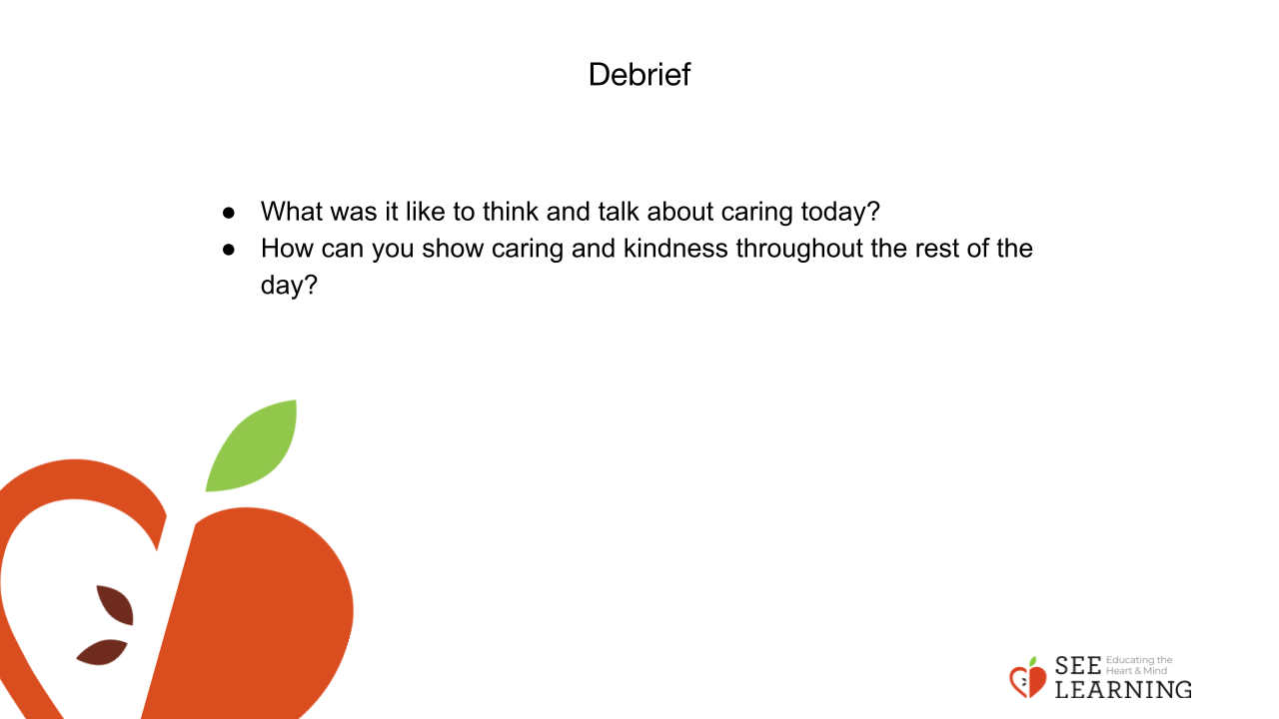 | Sample Script  - “What was it like to think and talk about caring today?  - Today you shared so many wonderful ideas about how people show caring for each other. As we get ready to (insert name of your next activity), think for a moment about a way that you can show caring and kindness during (activity name). [Pause.]  - When you have an idea, give me a thumbs-up. [Pause.] Wonderful!”

