Exploring Active Compassion
Needs to be updated after SD is created

Purpose:
In this learning experience students will explore more deeply the concept of active compassion, which involves taking responsibility for another and acting to help and protect them. Through discussion of a few scenarios, they will explore three main components of active compassion: having affection for someone, understanding their needs and wants, and taking responsibility to help them. They will also explore how active compassion can involve saying no and setting boundaries.
Learning Objectives:  Students will be able to:  - Explore three components of active compassion: affection for someone, understanding their needs and wants, and taking responsibility to help them.  - Explore how compassion sometimes requires saying no or standing up to someone  - Recognize the difference between being assertive and being mean or unkind | Primary Core Component  Compassion for Others
Length  30 minutes | Materials Required  - Paper  - Drawing utensils for each student

Check-In | 3 minutes
Slide 2: Check In   | Sample Script  - “Let’s do a short attention practice. How do we want our body to be?  - First we’ll take a comfortable and upright posture. I’ll be keeping my eyes open, but you can close them or look at the ground.  - Now choose one of your resources from  - your resource kit, or you can think of a new resource if you like: something that makes you feel better, safer, happier.  - Let’s bring our resource to mind and focus on it for a few moments quietly. You can also do grounding if you prefer. [Pause.]  - What do you notice inside? If you feel pleasant or neutral, you can rest your mind on that. If you feel unpleasant, you can shift to a place in your body that feels better. [Pause.]  - Now let’s become aware of our breathing. Let’s see if we can pay attention to the breath as it enters and leaves our body.  - If you find paying attention to the breath uncomfortable, then feel free to go back to your resource or grounding. [Pause for 15-30 seconds.]  - If you ever get distracted, you can just return your attention to the breath. You can also count your breath. [Pause for a longer time, such as 30-60 seconds or longer.]  - Now let’s end the practice and open our eyes. What did you notice?” [Share aloud]

Discussion: Active Compassion is a Strength (8 minutes)
Overview

By using a story and then other scenarios, students explore how compassion is about protecting others and doing what is best for them, not just saying yes or giving people what they want without thinking about whether it is good for them.

Content to be Explored

Explore how active compassion means we have to think about what is best for another person and take responsibility for them.

Materials
None

Instructions
- Explain that you will read a story and ask students to pay attention to moments of kindness and compassion.
- Ask them to raise their hand if they notice any moment of kindness or compassion. When they do, have them share why they raised their hands.
- After reading the story, ask a few debriefing questions.

Story: Alice Climbs a Tree

“One day Theresa was playing outside on the playground at school with Nelson and Albert. She saw Alice, a younger girl, climbing a tree by herself.

Later when they went back inside, their teacher Ms. Kelly asked the students what they had done outside.

“We played ball and I saw a girl in another class climb a tree,” said Theresa. “So next time I’m going to climb a tree too!”

Ms. Kelly looked concerned. “That’s dangerous. Last year a student fell from a tree and hurt her arm. So we made a rule that students cannot climb the trees.”

Albert looked unhappy. He thought to himself, “That’s mean! Climbing trees is fun.”

Ms. Kelly asked Theresa, “How old was the girl who was climbing?”

Theresa said, “It was Alice. She’s small. She’s in a lower grade than we are.”

Ms. Kelly said, “Then you can help her. Next time you’re on the playground, please tell her she can’t climb the trees because it’s a school rule. I’ll do the same if I see her.”

Theresa said, “She might not like it. She might get angry at me and think I’m being mean.”

Ms. Kelly said, “That is possible. But if we don’t say anything to her, she won’t know. Then the next time she climbs a tree, she might fall, and hurt herself.”

“I don’t want that to happen,” said Theresa. “I’ll definitely tell her tomorrow.””

Questions

- “What did you find interesting in this story?
- Why was Albert unhappy when he heard they
- couldn’t climb trees?
- Why did the school make a rule to stop students from climbing trees?
- Why didn’t Theresa want to tell Alice she couldn’t climb trees?
- Why did Theresa change her mind and decide to tell Alice the school rule?
- Do you think Theresa cares about Alice? Why or why not?”

Slide 4: “title”  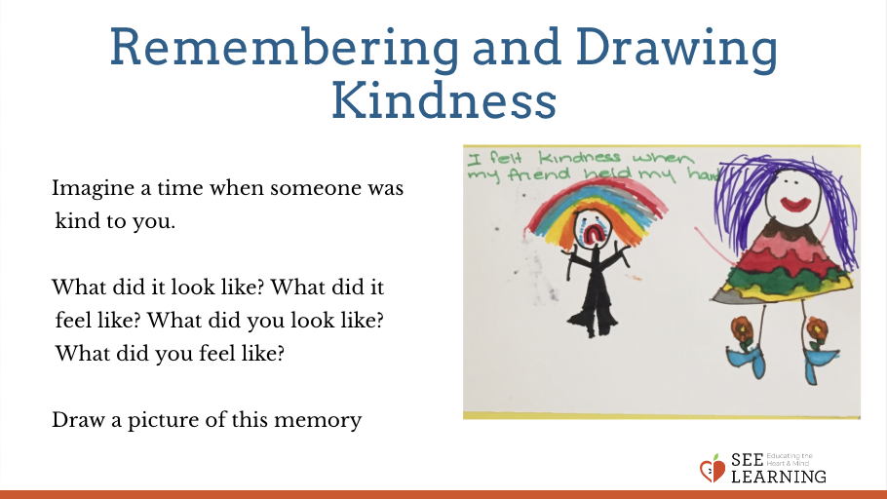 | Sample Script  - “We’ve been talking about kindness, and we’ve also talked about how kindness can be an inner quality.  - Remember we talked about how saying some sweet words to someone might not be kindness if the wish is to trick them.  - I’m going to read you a story and I’d like you to watch to see if you can find any moments of kindness. Some of them might be hidden.”  - [Read the story. If students raise their hands, ask them to explain the moment of kindness they observed. After the story, use the questions above.]

Insight Activity: Practicing Active Compassion Through Role Play
Overview

In this activity, students will role-play the continuation of the above story in order to practice what it feels like to say no to someone with compassion and kindness, and what it feels like to hear that from someone else.

Content to be Explored

- Explore how compassion sometimes requires saying no or standing up to someone.
- Recognize the difference between being assertive and being mean or unkind.

Materials

None

Instructions
- For each round of the role-play, ask for student volunteers to do a role-play. Students can choose one of three roles: Alice, Theresa, Ms. Kelly, or Albert. You can run the role-play with Alice and any number of other characters (two, three, or four), but it will generally work best when one student is playing the role of Alice.
- Explain that it is the next day, and Alice is on the playground about to climb a tree.
- Make sure each student understands their role. To the student playing Alice, explain “You are Alice. You really want to climb the tree!” To the student playing Ms. Kelly or Theresa, explain, “You are concerned about Alice because you don’t want her to get hurt.” To the student playing Albert, explain, “You think it’s mean and unfair that students can’t climb trees.” Explain that they will take turns in speaking.
- Say “Start!” to begin the role play. Ask each character in turn what they would like to say or do.
- After they have each had a chance to speak, end the role-play. Ask the debriefing questions.
- Ask for new volunteers and begin the round again.
Teacher Tips
- As aids to your students, you can use the dialogue cards provided at the end of this learning experience. You can have the students playing Alice or Albert choose from among the first set of cards, and those playing Ms. Kelly or Theresa choose from among the second set of cards. Allow them to choose what they would like to say, then allow the other side to reply. Then allow the first side to choose a new card and continue until they have finished the role-play. (They do not need to use all the cards.) After they have done this once or twice, they may feel confident to come up with their own dialogue.
- Alternatively, use the dialogue cards as suggestions for when a student has volunteered to role play but can’t think of anything to say. In this case, you can have them choose a card or you can suggest things for them to say from the dialogue cards.
- A script is not provided, but the dialogue cards and discussion questions are included.

Questions for Role-Play

(Note that each question can be used for any character)

- “What can Theresa say to Alice?
- What might Alice say in return?
- How do you think Theresa feels right now?
- How do you think Alice feels right now?
- What do you think Theresa needs right now?
- What do you think Alice needs right now?
- Is Theresa being kind to Alice?”
Slide 4: “title” | Sample Script

Reflective Practice (6 minutes)
Overview

Students will take a moment to think of an example from their own life, where kindness and compassion involves recognizing needs and taking responsibility for another person or animal to protect them.

Content to be Explored

Explore how active compassion involves recognizing the needs of another and taking responsibility to help and protect them.

Materials

- Paper
- Drawing utensils for each student
Slide 4: “title” | Sample Script  - “We just read a story in which Theresa had to tell Alice that she couldn’t climb the tree.  - She didn’t do it to be mean, but to be kind. She took responsibility because she wanted to protect Alice.  - Let’s take a moment to think if anything has happened in our life that is like that.  - What does it mean to protect someone? If you saw a smaller child playing near the fire and you tell them to stop, or take them away from the fire, you are protecting them from getting hurt. You’re not doing it to be mean, but to  - be kind.  - Can anyone think of other examples? Can you think of a time when you protected someone or someone protected you?  - Maybe you cared for an animal or pet, and you had to keep them safe by keeping them indoors or in a special place. Maybe you have cared for a family member like a brother or sister, or a friend. [Ask for examples.]  - Let’s now take a moment to sit quietly and think of a time when we protected someone else, or someone else protected us. You can close your eyes while we think of something.  - Now let’s draw what we remembered or thought of. If you couldn’t think of a time from your own life, you can imagine something. Or you can draw the Theresa and Alice story we just heard. Our drawing is going to show a person helping and protecting another person.  - [Allow time for drawing. Share out after drawing.]  - What does it feel like inside when we think of being protected? Does anyone notice any sensations?"

Debrief (3 minutes)
Slide 5: Debrief  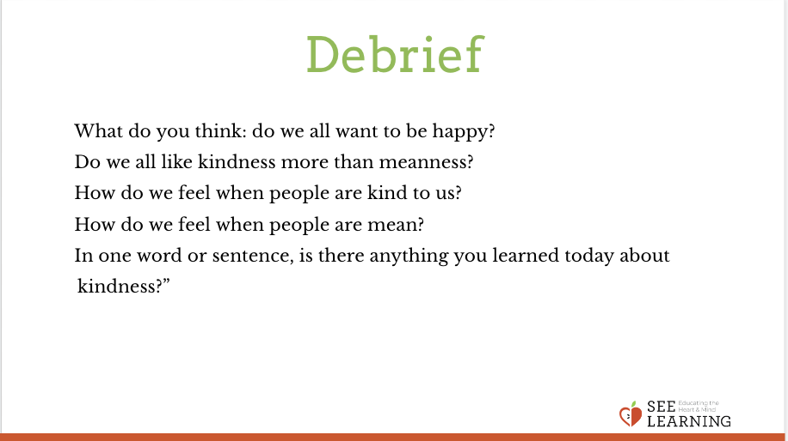 | Sample Script  - “Why might it be important for us to protect each other?  - Can you think of a time when you were upset because someone said no to you, but alter you realized they were being kind?  - What have you learned or thought about today that you’d like to remember?”

