Exploring Kindness to Oneself Part 1

Purpose:
In this learning experience, students explore the concepts of positive and negative talk, especially as it manifests in self-judgment and self-criticism when facing an obstacle
or challenge.
Learning Objectives:  Students will be able to:  - Explore the concept of positive (helpful) and negative (unhelpful) talk to oneself and others.  - Explore the idea that one can be kind and encouraging to oneself, just as to a friend. | Primary Core Component  Self-Compassion
Length  25 minutes | Materials Required  - Chart paper or whiteboard  - Markers  - The “Nelson the Photographer” story (included here)  - Cards that say “Positive” and “Negative” (included here)  - Three puppets for Nelson, Theresa, and Teddy (or printouts of the three pictures included here).

Check-In | 5 minutes
Slide 2: Check In   | Sample Script  - “Let’s do a short attention practice. How do we want our body to be?  - First we’ll take a comfortable and upright posture. I’ll be keeping my eyes open, but you can close them or look at the ground.  - Now choose one of your resources from your resource kit, or you can think of a new resource if you like: something that makes you feel better, safer, happier.  - Let’s bring our resource to mind and focus on it for a few moments quietly. You can also do grounding if you prefer. [Pause.]  - What do you notice inside? If you feel pleasant or neutral, you can rest your mind on that. If you feel unpleasant, you can shift to a place in your body that feels better. [Pause.]  - Now let’s become aware of our breathing. Let’s see if we can pay attention to the breath as it enters and leaves our body.  - If you find paying attention to the breath uncomfortable, then feel free to go back to your resource or grounding. [Pause for 15-30 seconds.]  - If you ever get distracted, you can just return your attention to the breath. You can also count your breath. [Pause for a longer time, such as 30-60 seconds or longer.]  - Now let’s end the practice and open our eyes. What did you notice?” [Share aloud]

Discussion (10 minutes)
Overview

In this presentation and discussion, students will hear and talk about a story that presents the character Nelson dealing with failure and how one can show kindness to oneself and others during such situations.

Content to be Explored

- We can encourage others when they meet with challenges, and we can also encourage ourselves through kind self-talk.

Materials

- Nelson The Photographer story, included. Instructions
- Read the story to your group.
- At the points marked with an asterisk (*),
- you can pause to ask your students questions such as:
- What emotions do you think Nelson might be feeling right now?
- What is Nelson thinking to himself? Are these kind or unkind words?
- Conclude with a discussion about negative and positive self-talk.

Instructions

None

Teacher Tips

None
Slide 4: Nelson the Photographer  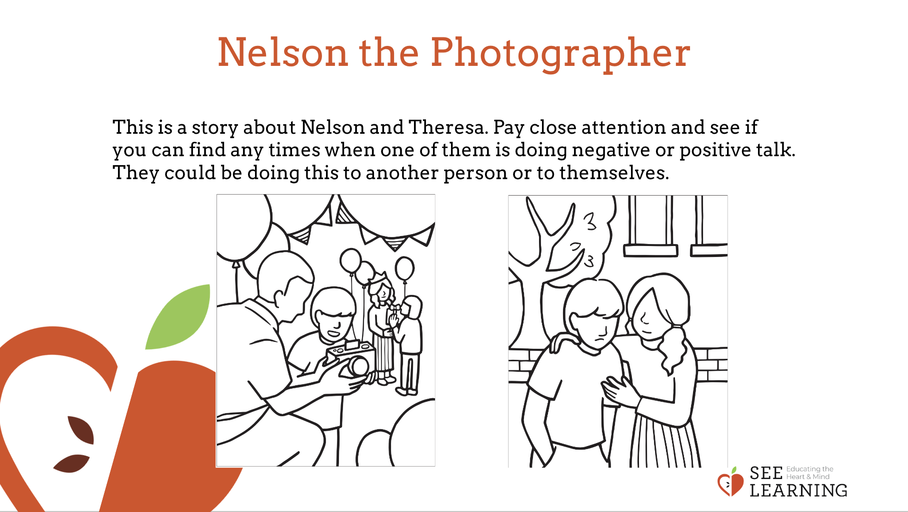 | Sample Script  - “I’m going to read a story called Nelson the Photographer.  - We’ve heard about Nelson several times before. What do we know about him so far? (Take responses.)  - As I read the story I’m going to pause at certain points and ask you what you think Nelson and his friend Theresa, might be feeling or thinking.  - [Read the script.]  - We’ve been learning a lot why it’s important to show kindness to others instead of being mean. And we’ve learned different ways of being kind to each other.  - Was Theresa kind or unkind to Nelson in the story? What makes you say that?  - Was Nelson kind or unkind to himself in this story? What makes you say that?  - Nelson was discouraging himself, instead of encouraging himself. He was using negative self-talk. Negative self-talk is unhelpful because it just makes things feel harder.  - What might a good friend say to Nelson to encourage him? [ Take responses.]  - Yes, these are kind and unhelpful thoughts. Nelson can also say these things to himself. This is called positive self-talk.”

Discussion: Positive Talk (7 minutes)
Overview

This discussion explores the idea of whether one can be kind to oneself and what that might look like. One can learn to recognize negative self-talk and its unhelpful effects. One can also learn to offer oneself the kindness one would offer a friend.

Content to be Explored

- We can talk positively to a friend experiencing difficulties.
- We can talk positively to ourselves when we face difficulties.

Materials

- Chart paper or whiteboard
- Markers

Instructions
- Use puppets or the two pictures provided.
- Nelson says: “I tried to ride my bike without training wheels and I couldn’t do it. I’ll never be able to do it.” Theresa is the other puppet. Is there anything she can say to help Nelson feel better? What could she say? Show Nelson being happier/moving in a happy way. When we say something that is helpful, we call that positive talk (write on board). Then Teddy comes along. “It’s true, you’ll never learn how to ride a bike without training wheels.” Now Nelson looks sads. Stop. Now what happened just now? Let kids share. So this is an example of negative talk (write negative talk on board).
- Then go through it again. Nelson comes along and doubts himself. What could Nelson say to himself? This is self-talk. Self-talk can be positive or negative.
- Lead a discussion with your students about the difference between positive (helpful, true, kind, encouraging) talk and negative (unhelpful, untrue, unkind, discouraging) talk.
- Ask them whether we might be able to have positive talk with ourselves when we face difficulties (self-talk).
Teacher Tips
- At this age, not all students may experience negative self-talk, and not all may feel like not succeeding in something makes them feel like a failure or makes them feel severely discouraged. Even so, they may still be able to recognize negative self-talk in others (seeing someone struggle at something and then hearing that person say they feel discouraged because of it), and this is valuable both for empathizing with others and for themselves in future when they may feel this way.
Slide 4: Positive Talk  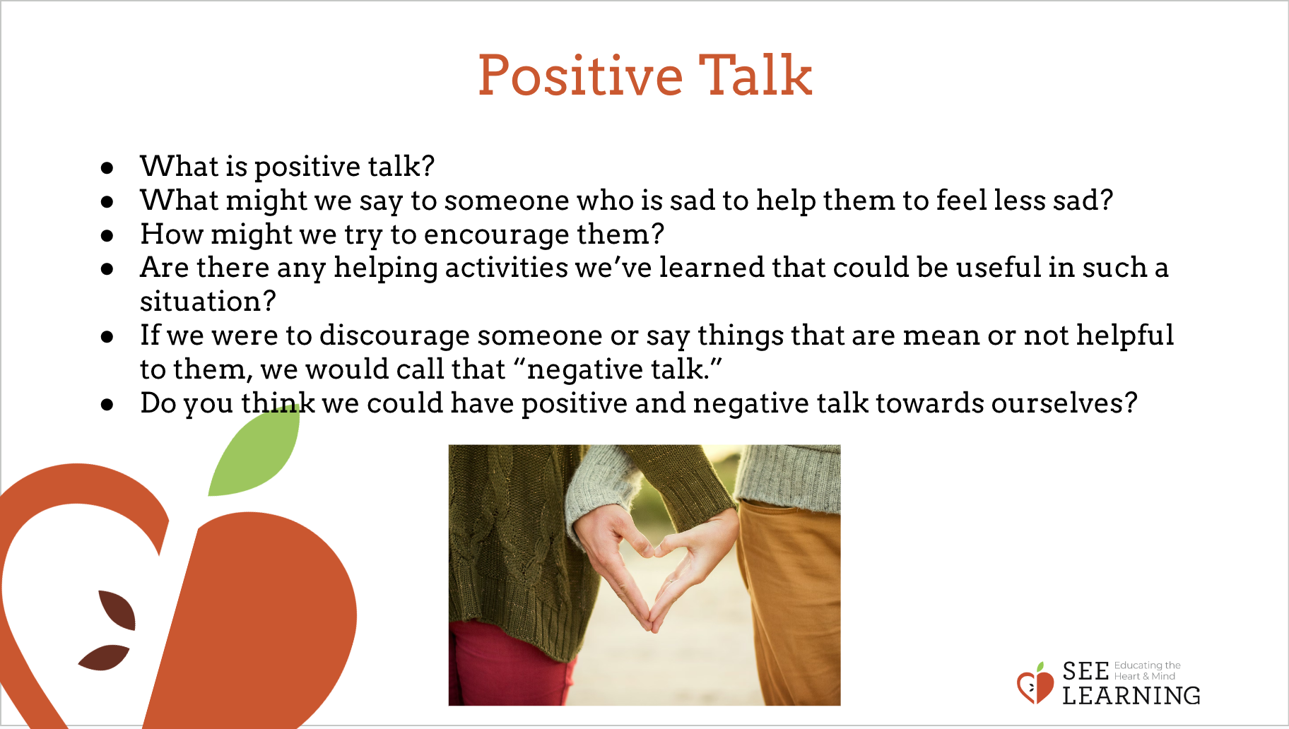 | Sample Script  - “We’ve been learning a lot why it’s important to show kindness. And we’ve learned different ways of being kind to each other.  - Let’s say we have a close friend or family member and they try to do something but it doesn’t work. Like maybe it was their job to take pictures at a party, but none of the pictures came out right, and they feel really bad about it.  - What might we say to them to be kind and help them to feel less sad? How might we try to encourage them?  - We can call saying things that are helpful and kind “positive talk.” [Write the words “positive” and “kind” on the board.] When we say the word “positive” here, we mean things that are helpful, kind, nice, useful.  - Are there any helping activities we’ve learned that could be useful in such a situation?  - If we were to discourage someone or say things that are mean or not helpful to them, we would call that “negative talk.” Negative is the opposite of positive. [Write the word “negative” on the board.]  - Do you think we could have positive and negative talk towards ourselves?  - What if it was us ourselves who had not succeeded and we were the ones feeling sad? Like if it was me, I might say or think things to myself, like “I’m no good. I’ll never be able to do this!” And then it might get even worse. I might start to think, “I’m no good at anything!”  - Then, instead of trying harder or practicing more so that I can succeed, I might just give up. I might even feel like a failure for a while. Do you think that could happen sometimes?  - These aren’t very kind things for me to say to myself. They’re not things I would say to a friend. They’re not even true.  - If I said things like that, would that be positive or negative talk?  - But if I were kind to myself, the way I’m kind to a friend who is having problems, then that would be positive.  - We’re going to read a story about Nelson and Theresa, and I’d like you to pay attention and see if you can find any times when one of them is doing negative or positive talk.”

Insight Activity: Nelson the Photographer (12 minutes)
Overview

This insight activity invites students to think about and discuss failure and how one can show kindness to oneself and others during such situations.

Content to be Explored

- Sometimes if we don’t succeed to our expectations, we may feel discouraged.
- Having difficulty with new tasks is normal and can often be accomplished with practice and help from others.

Materials

- Printouts of the “Positive” and “Negative” cards at the end of this learning experience (or you can make your own).

Instructions
- Read Part 1 of the story below. Ask students to raise their hands if they hear a character doing negative or positive talk to another person or to themselves.
- When students raise their hands, ask them to explain where they saw negative or positive talk.
- At the points marked with an asterisk (*), you can pause to ask your students questions such as:
- What do you think Nelson might be thinking now?
  - What emotions do you think Nelson might be feeling?
  - What do you think the other characters in the story are thinking or feeling now?
  - Is anyone doing positive or negative talk right now?
- After finishing Part 1, ask the students to describe what has happened in the story thus far and what they think might happen next.
- Have a few children volunteer to choose one of the cards that say “positive” or “negative” and give actual examples of things they could say at that moment.
- Read Part 2 of the story, using the same method noted above.
- Conclude with the questions below, which encourage the students to think about what it means to be kind and encouraging to oneself with positive talk when facing difficulties.
Teacher Tips
- You can use the puppets to act out the story as well.
- You may want to record students’ words of kindness for Nelson on a poster so they can be displayed in your classroom as a resource. You may consider writing these out generically (i.e. “You’re not good at that yet.”) so they can be used in a more universal way.
Slide 4: | Sample Script  - “This is a story about Nelson and Theresa. I’d like you to pay attention and see if you can find any times when one of them is doing negative or positive talk. They could be doing this to another person or to themselves. Raise your hand when you think one of them is doing negative or positive talk to someone else or to themselves. I’m going to pause at certain points and ask you what you think they are feeling or thinking at that moment.”
Story: Nelson the Photographer

Part 1

“Nelson arrived at Theresa’s birthday party and he was very excited. There were lots of kids there, and even though he didn’t know all of them, he did know Theresa. He had attended Theresa’s birthday party the year before, so he knew that there would be lots of good food and cake and fun games to play. He was especially looking forward to playing with Theresa and his other friends.*

As Nelson was eating some cake, he noticed Theresa’s father was taking photographs of the party using a camera. Nelson had always wanted to use a camera, but he had never had the chance before.

“Can I use the camera to take pictures?” Nelson asked.

“Do you know how to use a camera, Nelson?” Theresa’s father asked.

“Yes,” Nelson said, even though he didn’t really know how to use it. He saw people using cameras all the time, so he didn’t think it could be very hard.

Theresa’s father gave Nelson the camera and showed him how to hold it. “Just press this button to take the photos, but make sure the camera is pointed at what you want to shoot and make sure it’s in focus. Otherwise all the photos will be blurry. Also, remember to take a photo of Theresa when she blows out the candles on her cake.”

“No problem!” said Nelson confidently. For the rest of the party, Nelson ran around taking photos of his friends.*

The time came for Theresa to make a wish and blow out the candles on her cake as was the tradition in her family. Theresa’s father looked for Nelson, because he wanted Nelson to take a picture. But nobody could find Nelson because he was playing soccer outside.*”

Nelson with Theresa’s dad and camera

Part 2

“Later on the party was ending and people started going home. Nelson gave the camera back to Theresa’s father.

“Shall we look at the pictures?” Theresa’s father asked. They looked at them together, but Nelson saw that they were all blurry. None of them had come out well. Then he remembered he had forgotten to take a picture of Theresa with her cake.*

“Oh no,” Nelson thought to himself. “I did a terrible job. Theresa’s never going to be my friend again after this.”

Later when he went home he was still feeling bad. He thought to himself, “How come I can never get anything right?”*

The next day Nelson tried to avoid Theresa at school. He knew she would be upset at him.*
But at the end of the school day, Theresa found him. “Hi Nelson! Thanks for coming to my party!” she said.

“I’m sorry about the photos,” Nelson said. “I messed up again. I always mess up.”*

“That’s okay. Other people were taking photos too,” said Theresa. “I thought your pictures were funny! Maybe you’ll be a photographer when you grow up.”

“But I’m terrible,” said Nelson. “I can’t do it. I saw the photos and they were awful!”

“Don’t feel bad. Taking good pictures is hard at first,” Theresa said. “My father taught me how to do it, and it takes a while to learn. Do you want to come over to my house another time and we can practice together?”

“Do you really think I could learn to do it?” Nelson asked.

“If you practice, then of course you can!” Theresa said.*

Nelson thought for a while and then said, “I guess I just didn’t know what I was doing. I thought it would be easier than it was. But, Theresa, if you learned how to do it over time, then I suppose I could learn to do it too. Okay, I’ll give it a try!””

Discussion Questions

- “Why did Nelson think he could never become good at photography?
- Why did Theresa think Nelson could become good at photography?
- What did Nelson think to himself when he realized that the pictures he had taken came out blurry?
- How did Theresa react to the blurry pictures? What kinds of things did she say to Nelson?

Theresa comforting Nelson

- What would the kindest person in the world say to Nelson? [Examples below.]
- You made a mistake.
- You will do better next time.
- You can learn how to take good pictures with practice.
- You’re not terrible, you’re just not a very good photographer yet.
- If Theresa or the kindest person in the world weren’t there to encourage him, how do you think Nelson could encourage himself? What could he say to himself? [Examples below.]
- I made a mistake.
- I will do better next time.
- I can learn how to take good pictures with practice.
- I’m not terrible, I’m just not a very good photographer yet.”

Debrief (3 minutes)
Slide 5: Debrief  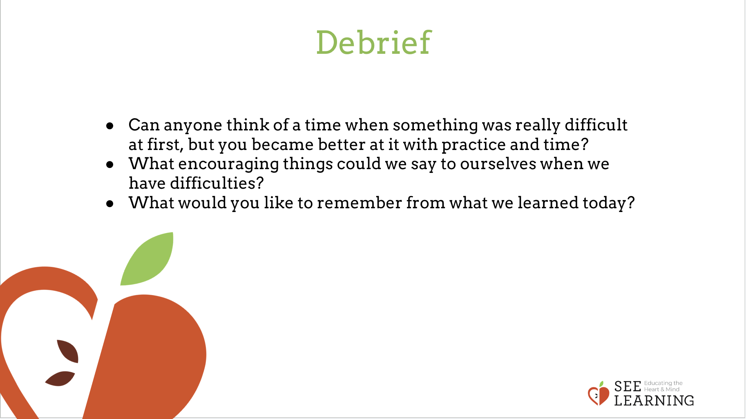 | Sample Script  - “Can anyone think of a time when something was really difficult at first, but you became better at it with practice and time?  - What encouraging things could we say to ourselves when we have difficulties?  - What would you like to remember from what we learned today?”

