Appreciating Diversity and Shared Commonalities

Purpose:
This learning experience explored the ways in which we are similar and different. Difference is explored with curiosity, rather than judgement, to convey the understanding that diversity is something to be appreciated, rather than feared or seen as negative. Despite our differences, we are also the same in many important and fundamental ways. Some of these commonalities include having bodies that experience sensations, living together in communities, having basic needs, desiring to be happy, appreciating and wanting kindness from others, and experiencing emotions. This approach to diversity and difference, contextualized in our common experiences as human beings, can lead to an understanding of why appreciating difference is so important.
Learning Objectives:  Students will be able to:  - Explore ways in which all human beings are the same and ways in which we are different  - Recognize that despite our differences, we have shared needs and wishes.  - Recognize some things we think might be true for all people might not actually be. | Primary Core Component  Recognizing Common Humanity  
Length  30 minutes | Materials Required  - Mindful listening behaviors chart  - Chart paper and/or whiteboard with the columns:  - “Ways Most People are the Same”  - “Ways People Are Different”  - room for one more column  - Markers

Check-In | 3 minutes
Slide 2: Check In  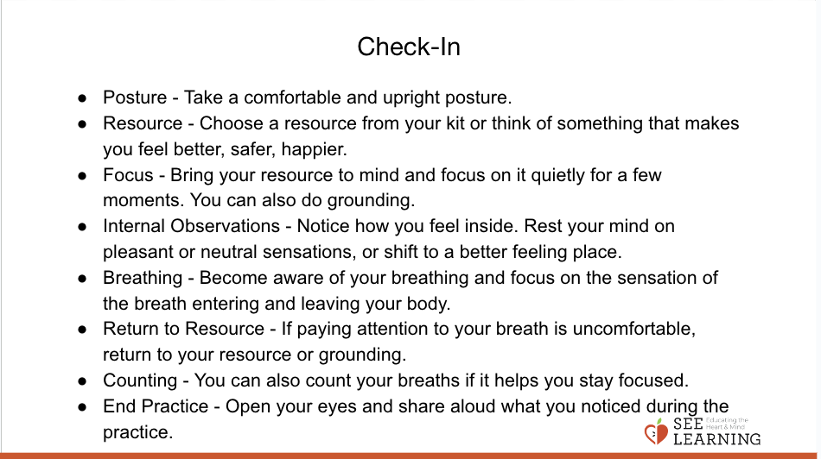 | Sample Script  - “Let’s do a short attention practice. How do  - we want our body to be?  - First we’ll take a comfortable and upright posture. I’ll be keeping my eyes open, but you can close them or look at the ground.  - Now choose one of your resources from  - your resource kit, or you can think of a new resource if you like: something that makes you feel better, safer, happier.  - Let’s bring our resource to mind and focus on it for a few moments quietly. You can also do grounding if you prefer. [Pause.]  - What do you notice inside? If you feel pleasant or neutral, you can rest your mind on that. If you feel unpleasant, you can shift to a place in your body that feels better. [Pause.]  - Now let’s become aware of our breathing. Let’s see if we can pay attention to the breath as it enters and leaves our body.  - If you find paying attention to the breath uncomfortable, then feel free to go back to your resource or grounding. [Pause for 15-30 seconds.]  - If you ever get distracted, you can just return your attention to the breath. You can also count your breath. [Pause for a longer time, such as 30-60 seconds or longer.]  - Now let’s end the practice and open our eyes. What did you notice? [Share aloud]

Insight Activity: Step In, Step Out Activity (12 minutes)
Overview

Using the Step In, Step Out activity, students will explore things that are the same among them and things that are different.

Content to be Explored

- As human beings, we all have differences, as well as things we share in common based on our common humanity.
- In addition to our shared humanity, each person has things that make them unique.

Materials

None

Instructions

- Have students form a circle.
- Read statements in the script one at a time.
- Students will take one step into the circle
- if the statement applies to them. If the statement doesn’t apply to them, they should remain standing in their spot.
- Students should remain silent (no discussion), but you will be asking them to notice how the circle looks and who is on the inside and who is on the outside. Then say “Thank you, step back out” and have students step back out to their original place.
- Once you have read all the statements, have students sit down in place or return to their desks and debrief with the following questions:
  - "In what ways are we different?
  - In what ways are we the same?"

Teacher Tips
- This activity will be much more meaningful if you are able to take a moment to think about the ways in which the students in your class are diverse, be it religion, ethnicity, where they live, what they eat, their family structure, socio-economic background, and so on. Then you can replace some of the prompts at the beginning of the activity with concrete questions that bring out these differences and commonalities specific to the context of your students. Be sure to avoid questions that would force students to share things that would make them uncomfortable. Begin with things that the students do not all have in common, such as preferences or aspects of their identity, then move towards what we all have in common that we have explored in the SEE Learning Curriculum this far: the experience of emotions, sensations, needs, attention, kindness, etc.
- You will want to have a large enough area for students to gather in a large circle to step in and out of. You may need to move desks/ tables or use a larger space like a gymnasium or an outdoor space.
- Alternatives: Instead of having students step in and step out of a circle, you can have students form a circle of chairs and have them stand up or remain seated. Or you could have them raise their hands instead of stepping in. Whichever method you choose, make sure that students can see each other, so they can see how their classmates answer each question.
- You can point out who has what in common with whom as you go through the activity to help students start to notice these things themselves.
- Avoid questioning why students are or are not stepping into the circle. If some students don’t step in during the last few questions, they may not have heard or understood the questions. Repeat the question if you believe this is the case, but allow for students’ responses to stand on their own without judgment.
Slide 3: Step In, Step Out  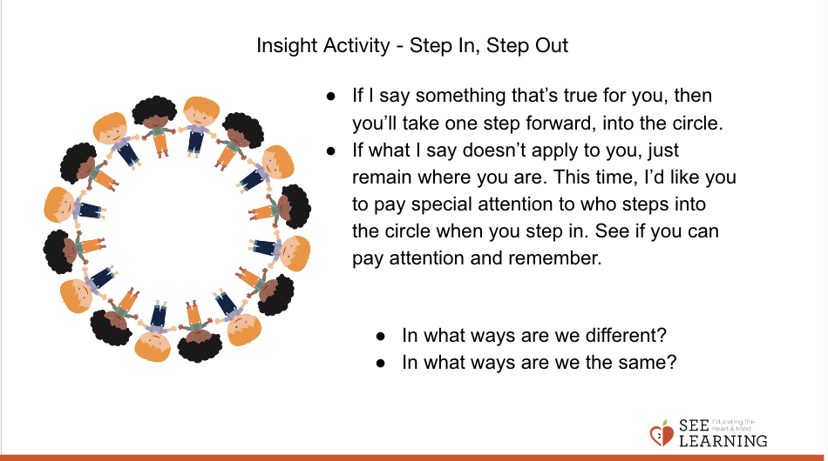 | Sample Script  - “Let’s all form a circle.  - If I say something that’s true for you, then you’ll take one step forward, into the circle.  - If what I say doesn’t apply to you, just remain where you are. This time, I’d like you to pay special attention to who steps into the circle when you step in. See if you can pay attention and remember, because this will help in our next activity.  - Let’s start.  - Step into the circle if you like to make art or draw. Take a look at the circle and see who else likes to make art. Step back out.  - Step into the circle if you have a pet. Now take a look and see who else has a pet and who doesn’t. Try to remember who is stepping in. Step back out.  - Step into the circle if any member of your family or household is a vegetarian. Thank you, step back out.  - Step into the circle if people in your family or household speak more than one language. Thank you, step back out.  - Step into the circle if someone in your family or household was born in another country. Thank you, step back out.  - I'm noticing that only some of you are stepping in each time. Let's see what happens if I ask this: Step into the circle if you experience sensations in your body. Now, take a look around. What do you notice about this?  - Step into the circle if you have the ability to focus your attention on something you like to do. Thank you, step back out.  - Step into the circle if you have a resource you can use or think of to calm your mind or body. Thank you, step back out.  - Step into the circle if you need food to live. Take a look at who is in the circle now. No matter who we are, we have some needs in common. Thank you, please step back out.  - Step into the circle if you need other people to live, like to provide food and clothing.  - Step into the circle if you'd rather feel happy than sad. Ah, look! All of us (or most of us) are in center! It seems that we all like to be happy rather than sad. Now let's step back.  - This is the final one! Step into the circle if you like it when people are kind to you, rather than mean. Let's look around. Are we all here? It seems we feel happier when people are kind to us.  - Thank you, let's have a seat.  - In what ways are we different? [You may want to remind students of the statements you made]  - In what ways are we the same? [You may re-read the statements to students to remind them of the statements where everyone, or almost everyone stepped in.]

Insight Activity: How Are We the Same? How Are We Different? (12 minutes)
Overview

In this activity, students explore what they have in common with each other.

Content to be Explored

- As human beings, we all have things in common that we share.
- Some things we think might be common or true for all people might not actually be.

Materials

- Mindful listening behaviors chart
- Chart paper and/or whiteboard with the columns: “Ways Most People are the Same,” “Ways People Are Different,” and room for one more column
- Markers

Instructions
- Before you begin this activity, review your class’s mindful listening behaviors.
- Brainstorm together as a group:
  - Let’s name some ways in which most people are the same. (We all have bodies. We all wear clothing. We need water and food.) Now let’s name ways in which people are different. (We have different names. We wear different types of clothing.) Write these on a piece of chart paper or the whiteboard. Encourage them to try to go beyond things they can’t see just by looking at each other.
- Repeat and ask them to think of two more ways in which people can be different. Add their ideas to the chart.
- Take a look at the chart together. Ask students:
  - “Does everyone agree that most people share these things in common? Are they the same for most people? If you agree, raise your hand. If one or more students does not agree, ask them to explain why.
  - Is this something that everyone in the world has in common? If you agree, raise your hand. If one or more students does not agree, ask them to explain why.
  - Are there other ways we can be different that we could add to this second list?”
- Read this first list aloud once every group has shared. Note which of these are part of our shared “common humanity” and write the words “common humanity” on the chart paper.
- Create a new column called “Something Unique to Me.” Explain that this means something about them that is not the same for anyone else, like their name. Invite students to share one thing that is unique about them. Write this on the chart in a new column labeled “Something Unique to Me.”

Teacher Tips
- Be sensitive to issues that come up when students are deciding whether or not everyone in the class has something in common. For example, someone might suggest that “We all have a father.” Don’t challenge or single out students, but leave it up to the students if they want to speak up and share about what applies or doesn’t apply to them.
- After asking students to think of a few things most people have in common, ask students to get into pairs or trios to think of two more ways in which most people are the same. Then ask them to share out and add their ideas to the written chart.
Slide 4: “How Are We the Same? How Are We Different?”  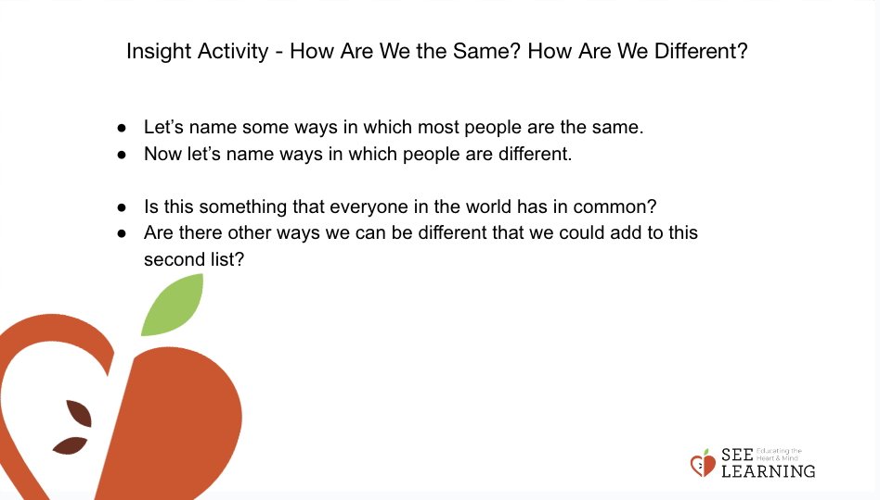 | Sample Script  - “Let’s look over our mindful listening behaviors chart. Which ones might we focus on in our work today? [Allow time for sharing.]  - Ok, let’s brainstorm together. What are some ways that most people are the same? [Allow time to share ideas; write them on whiteboard/chart paper.]  - Let's see if we can think of a few more ideas, maybe thinking of things we can't see just by looking at each other.  - Ok, these are great ideas. Now, what are some ways that people can be different? [Allow time to share ideas; write them on whiteboard/chart paper.]  - [At this point, if you want to, you can have students get into pairs or trios to think of more ideas.]  - Let's see if we can think of two more ways people can be different. [Allow time to share ideas; write them on whiteboard/chart paper.]  - Ok, great. Now, let's look at all of our ideas on the chart.  - Does everyone agree that most people share these things in common? Are they the same for most people? If you agree, raise your hand. [If one or more students does not agree, ask them to explain why.]  - Is this something that everyone in the world has in common? If you agree, raise your hand. [If one or more students does not agree, ask them to explain why.]  - Are there other ways we can be different that we could add to this list? [Add ideas to list.]  - Now I'll read the "Same" list aloud for us. These are things that we share in common as humans. We can call this list "common humanity." [Write these words on the chart paper.]  - Now we'll make a new column: "Something Unique to Me." [Write this heading on the chart paper.]  - This means something about you that is not the same for anyone else, like your name.  - Who would like to share one thing that is unique to them?" [Write shared items in the column.]
Debrief (3 minutes)
Slide 5: Debrief  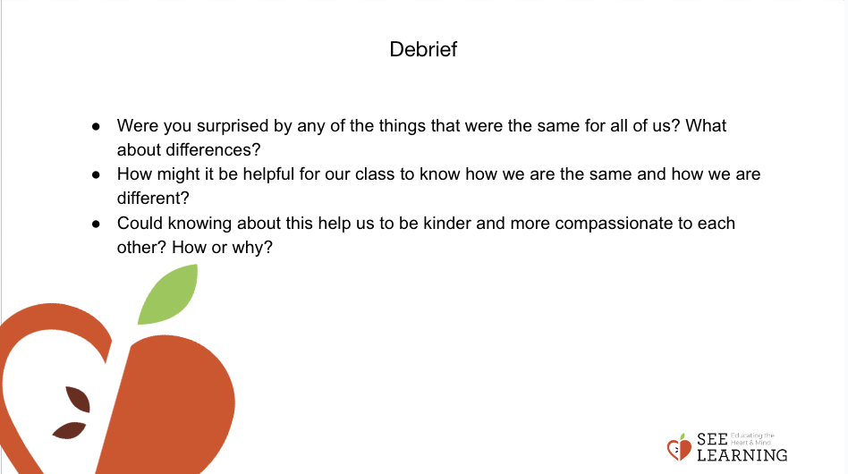 | Sample Script  - "Were you surprised by any of the things that were the same for all of us? What about differences?  - How might it be helpful for our class to know how we are the same and how we are different?  - Could knowing about this help us to be kinder and more compassionate to each other? How or why?"

Extension Activity Ideas

Have students create and decorate two posters:

- One that includes a list of the things all your students share in common with each other and other people in the world
- Another that includes a list of the things that make each of them unique.

Hang these posters in the classroom. When you have a class visitor, ask them to read the posters, and then share one thing that they have in common with your students, and one thing that that makes them unique.

