Mindful Listening
Purpose:
This learning experience introduces “mindful listening.” Mindful listening means to listen respectfully and empathically with full attention without interrupting the other person, without being distracted, and without focusing on oneself or one’s judgments. This kind of listening takes well-honed attentional skills because it requires that we focus solely on what the other person is saying, rather than on what one wants to say in response. Mindful listening provides an opportunity for students to learn from and about each other without judgment.
Learning Objectives:  Students will be able to:  - Identify mindful listening behaviors.  - Practice the skill of listening mindfully without interrupting or shifting the focus to oneself.  - Consider the ways in which mindful listening can be used at school or in life. | Primary Core Component  Interpersonal Awareness  
Length  30 minutes | Materials Required  - Chart paper with three headings: “Not Being Listened to Feels Like...,” “Being Listen To Feels Like...,” and “Mindful Listening Behaviors”  - Markers

Check-In | 4 minutes
Slide 2: Check In  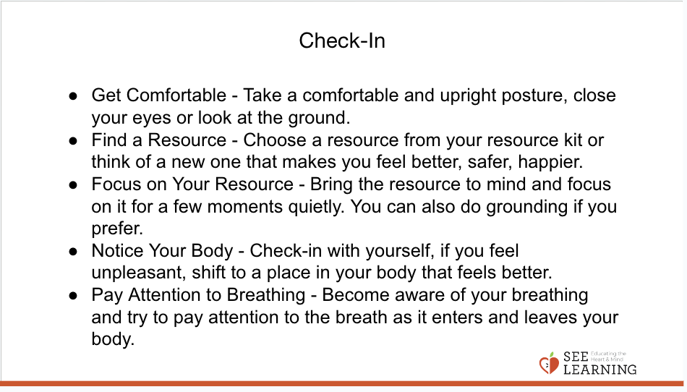 | Sample Script  - “Let’s do a short attention practice. How do we want our body to be?  - First we’ll take a comfortable and upright posture. I’ll be keeping my eyes open, but you can close them or look at the ground.  - Now choose one of your resources from your resource kit, or you can think of a new resource if you like: something that makes you feel better, safer, happier.  - Let’s bring our resource to mind and focus on it for a few moments quietly. You can also do grounding if you prefer. [Pause.]  - What do you notice inside? If you feel pleasant or neutral, you can rest your mind on that. If you feel unpleasant, you can shift to a place in your body that feels better. [Pause.]  - Now let’s become aware of our breathing. Let’s see if we can pay attention to the breath as it enters and leaves our body.  - If you find paying attention to the breath uncomfortable, then feel free to go back to your resource or grounding. [Pause for 15-30 seconds.]  - If you ever get distracted, you can just return your attention to the breath. You can also count your breath. [Pause for a longer time, such as 30-60 seconds or longer.]  - Now let’s end the practice and open our eyes. What did you notice?” [Share aloud]

Discussion: Mindful Listening Role Play (8 minutes)
Overview

In this reflective practice students observe you and another student perform a listening role play. They reflect on what they saw and discuss the impact of mindful listening.

Content to be Explored

- We can get better at listening to each other in a more mindful way.
- When we engage mindful listening with each other, we are gaining an opportunity to really communicate with one another and to provide the gift of mindful listening.

Materials

- A timer or watch

Instructions

- When you introduce this activity to the rest of the students, do not tell them that you are demonstrating poor listening. Instead, just let the students know you will be doing a skit and to try to figure out what is happening.
- The speaker in the role play will be invited to speak to you about something they like to do during the weekend. (You can use another topic if you feel there is one in particular that would particularly engage your students.) They should already be prepared by knowing the purpose of the skit and how you will behave with poor listening skills, so that they will not be upset by this.
- Start the timer for 45 seconds (or use a watch or clock to keep track of the time) and ask the speaker to begin. While they are speaking, you will clearly engage in poor listening skills such as: interrupting, rolling your eyes, turning away, looking at your watch or phone, etc. The speaker's job will be to try to continue speaking during the 45 second role play, as you engage in exaggerated poor listening skills. (See the note about preparing for this activity under Teaching Tips below.)
- When 45 seconds has elapsed, thank the speaker, and invite the class to give your student or colleague a warm round of applause for their performance.
- Ask students to reflect on what they observed, using the debrief questions provided in the script.

Teacher Tips
- It is advised that you practice the role-play in advance with the student or colleague you will be doing it with. Be sure that they understand that this is a role-play and be sure they feel comfortable in their role. If it is a student, they should know what they are going to say so in advance, so that they are ready to speak about the topic from the beginning of the role play.
- Students might laugh during this activity. They might find some of the behaviors you do to be funny, or they may find that watching bad listening makes them nervous. You can ask them non-judgmental questions about their reactions to help them understand why they might have laughed at the skit. (They will likely understand that poor listening might seem funny when it's just pretend, but not when it's actually happening to you.)
Slide 3: “Mindful Listening Role Play”  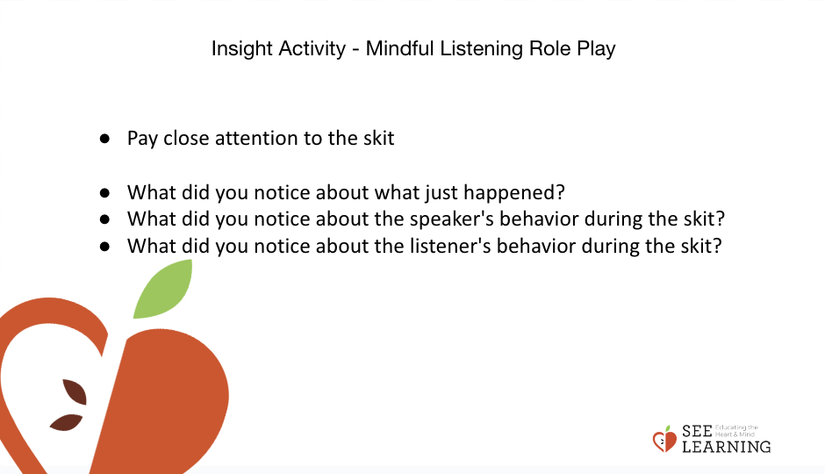 | Sample Script  - "Please direct your attention to (skit partner) and me. We'll be doing a little skit for you and when we're done, I will ask you what you noticed. [Set the timer for 45 seconds. Start the role play by greeting your partner and asking them to tell you about something they did over the weekend. End when the timer ends.]  - Thank you. Let's all give (skit partner) a round of applause for doing a great job.  - Now what did you notice about what just happened?  - Did you notice anything about my behavior? What kinds of things was I doing? [Take responses and encourage students to describe the actual behavior they observed. If a student says "You were being rude" ask what specific behavior made them think that, such as: "You interrupted the speaker."]  - What did you notice about the speaker? How did they react? If you were in their position, how might you feel?  - Let's ask the speaker: How did it feel to be on the receiving end of my poor listening skills? Did you notice any sensations in your body? Did you notice any feelings or emotions?  - What kinds of things do you think the speaker would have liked me to do instead?  - When might it be important to listen to others mindfully and with attention?

Reflective Practice: Mindful Listening (15 minutes)
Overview

In this activity students will contrast how it feels to be listened to in a mindful way, versus not being listened to mindfully. Students will generate a description of mindful listening behaviors. Then, they briefly practice using mindful listening behaviors in pairs.

Content to be Explored

- There is a difference between just listening without much attention and mindful listening.
- Mindful listening can affect us as speakers, listeners, and as a whole classroom and community at large.

Materials

- Markers
- A timer, watch or clock
- Chart paper with three headings: “Not Being Listened to Feels Like...,” “Being Listen To Feels Like...,” and “Mindful Listening Behaviors.”

Instructions
- Explain that today you will talk about what it means to really listen to someone with full attention.
- Ask for examples of what it feels like when someone isn’t really listening to you. Write student suggestions on a piece of chart paper under the heading “Not Being Listened
- To Feels Like...” You can refer to the poor listening skills skit you just completed.
- Ask for student ideas of what it is like when you are really listened to with full attention and without judgment. Write their ideas on a piece of chart paper under the heading “Being Listened To Feels Like...”
- Take a moment to note with them the differences between the two lists.
- Ask what it would look like for us to listen to someone else with full attention. Explain that you will call that “Mindful listening” in class. Write their ideas down under the heading “Mindful Listening Behaviors.” (Note: You will save this chart.)
- Recruit two students to do a practice with your coaching in front of the class. (If there are no student volunteers, you can demonstrate mindful listening yourself with a student speaker.) The student who is a speaker will talk about an activity they enjoy. Before the demonstration begins, help the listener to sit prepare their body and mind to be a mindful listener. Ask them to explain what behaviors they will use, encouraging them to refer to the behaviors on the chart. Ask other students to pay attention to the mindful listening behaviors they see during short demonstration.
- Have them begin the demonstration and start the timer for 60 seconds.
- When time is up, ask the two students to stop. Then ask the rest of the class to share what good mindful listening behaviors the noticed. If they noticed anything new that wasn't yet on the Mindful Listening Behaviors chart, add it to the chart. If students point out poor listening behaviors, remind them that you are only looking for examples of good mindful listening for now.
- Congratulate and thank the students for doing the demonstration and allow them to return to their seats.
- Place students in pairs so they can practice mindful listening. Pairs will decide who will speak first, and who will listen. The speaker will have 90 seconds to talk about an activity they enjoy doing while their partner listens mindfully. They can explain the activity and talk about when they do it, why they like it, when they first started doing it, etc.
- After 90 seconds has elapsed, let them know to switch roles, so that the one who was listening will now speak, and the one who was speaking will practice mindful listening.
- Debrief the activity, asking questions such as:
  - "What mindful listening behaviors did you notice?
  - How did it feel to be listened to? To be a mindful listener?
  - What was challenging about mindful listening?"
Teacher Tips
- Save your mindful listening behaviors chart for later use.
- In SEE Learning, mindful listening means to listen attentively without interrupting, without being distracted, without giving advice, and without turning the conversation towards oneself. Often when listening to others, we are only partially paying attention to the other person and what they are saying; part of our attention is on our own reactions, our thoughts, and what we are going to say once the other person finishes or gives us a chance to speak. Mindful listening involves just listening with full attention and without judgment. Just like compassion itself, mindful listening is other-focused, rather than self-focused.
- Remember to only focus on the positive mindful listening behaviors of the students who volunteer to demonstrate in front of the class. If no mindful listening behaviors are present, ask for further volunteers or demonstrate yourself. But avoid criticizing the student's listening behaviors in front of the whole class, reserving this for a one-on-one discussion if necessary.
Slide 4: “Mindful Listening”  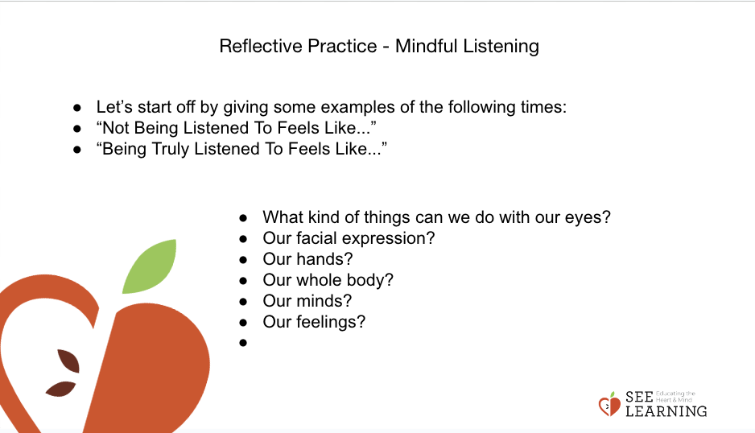  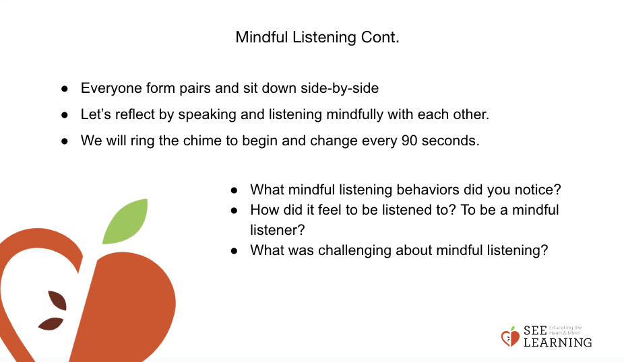 | Sample Script  - “Now that we’ve seen an example of poor listening, we’re going to learn how we can avoid that, and be a mindful listener instead.  - Let’s review your ideas about what it feels like to be NOT listened to. What does it feel like? [Ask for student ideas and write them on a piece of chart paper under the heading “Not Being Listened To Feels Like...”]  - What does it feel like when listens to you fully [Ask for student ideas and write them on a piece of chart paper under the heading “Being Listened To Feels Like...”]  - Let’s look at these two lists we made. What are the main differences we notice?  - What kinds of things can we do to be a great listener, to listen mindfully when someone else is speaking. Let’s identify mindful listening behaviors. [You can refer back to the discussion you had about the poor listening skit to think of opposite behavior than were shown  - What kinds of things can we do with our eyes? Our facial expression? Our hands? Our whole body? Our minds? Our feelings? [Take responses and help students be specific about the behaviors of a mindful listener. Write student ideas on a piece of chart paper under the heading “Mindful Listening Behaviors.”]  - Just like we can strengthen our attention like a muscle, we can also strengthen our ability to listen mindfully by practicing these behaviors.  - We’re going to try it right now. Our sharing topic will be an activity you enjoy. Think of an activity you enjoy. I’ll be asking you to talk about that activity with a partner. [Wait a moment.] Does everyone have something in mind?  - [Then, recruit two students to do a practice with your coaching in front of the class. The student who is a speaker will talk about an activity they enjoy. Before the demonstration begins, help the listener to prepare their body and mind to be a mindful listener.] Let’s review the mindful listening behaviors. What do you want to remember to do with your body? Your mind?  - [To the rest of the class] Let’s pay attention to this demonstration, and see what mindful listening behaviors we notice. [Set timer for 60 seconds and ask students to begin.]  - Thank you! What mindful behaviors did you observe? [Take responses. If students begin to offer a criticism, refer them back to the question, which is about which good mindful listening behaviors they observed.]  - Did you notice our listener do anything helpful that isn’t included on our mindful behaviors list? [Add additional points to the chart.]  - Now, we’ll all practice in pairs. [Place students in pairs.] You will each have 90 seconds to practice mindful listening to your partner. Remember, the speaking topic is “an activity you enjoy doing.” Now decide who will be the speaker first, and who will be the listener. [Pause.]  - When I say begin, the first speaker will talk about an activity they enjoy and the listener will practice mindful listening, by using the behaviors of a mindful listener we just discussed. I will let you know when 90 seconds have passed, and then the person who was speaking will become the listener.  - Ready? [Facilitate the activity. Circulate around the classroom to observe students' behavior.]  - What mindful listening behaviors did you notice?  - How did it feel to be listened to? To be a mindful listener?  - What was challenging about mindful listening?
Debrief (3 minutes)
Slide 5: Debrief  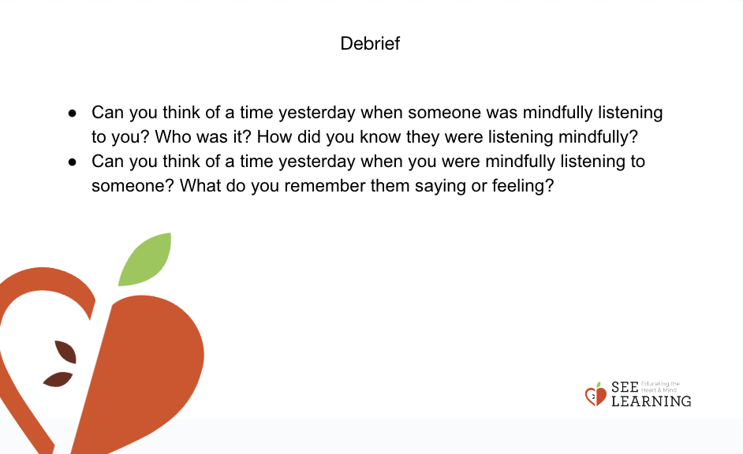 | Sample Script  - "Can you think of a time yesterday when someone was mindfully listening to you? Who was it? How did you know they were listening mindfully?  - Can you think of a time yesterday when you were mindfully listening to someone? What do you remember them saying or feeling?  - We'll be practicing mindful listening more together in the classroom now that we know how to do it."

