Understanding Others Emotions in Context
Needs to be updated after SD is created

Purpose:
Compassion and kindness flow more easily when we recognize that others’ behaviors and emotions arise within the specific context of their lives and past experiences. Students will be provided with scenarios in which characters react differently to similar situations, giving them the opportunity to explore why people might have different emotions to the same events.
Learning Objectives:  Students will be able to:  - Explore the ways in which different situations might impact someone’s feelings.  - Consider the ways in which people can have different emotional responses to the same situation | Primary Core Component  Interpersonal Awareness
Length  25 minutes | Materials Required  - Alice and Albert story (provided)  - Paper and drawing utensils for each student

Check-In | 3 minutes
Slide 2: Check In   | Sample Script  - “Let’s do a short attention practice. How do we want our body to be?  - First we’ll take a comfortable and upright posture. I’ll be keeping my eyes open, but you can close them or look at the ground.  - Now choose one of your resources from your resource kit, or you can think of a new resource if you like: something that makes you feel better, safer, happier.  - Let’s bring our resource to mind and focus on it for a few moments quietly. You can also do grounding if you prefer. [Pause.]  - What do you notice inside? If you feel pleasant or neutral, you can rest your mind on that. If you feel unpleasant, you can shift to a place in your body that feels better. [Pause.]  - Now let’s become aware of our breathing. Let’s see if we can pay attention to the breath as it enters and leaves our body.  - If you find paying attention to the breath uncomfortable, then feel free to go back to your resource or grounding. [Pause for 15-30 seconds.]  - If you ever get distracted, you can just return your attention to the breath. You can also count your breath. [Pause for a longer time, such as 30-60 seconds or longer.]  - Now let’s end the practice and open our eyes. What did you notice?” [Share aloud]

Insight Activity: Albert and Alice See a Dog (12 minutes)
Overview

In this story reading and discussion, students will explore how and why different people react with different emotions to the same situation.

Content to be Explored

- We can have different reactions to the same situation and different feelings about it.
- By paying close attention, we can see if another person’s reaction is different to ours, and we can ask them, too.

Materials

None

Instructions

- Tell students you are going to read a story together and pay attention to how the characters might be feeling. Tell them that sometimes the characters may be feeling different things to each other.
- Read the story aloud.
- Discuss the story and the characters’ feelings using questions such as:
- What was Alice feeling in the story? Why do we think she was feeling that way?
- Raise your hand if you would have felt the same as Alice?
- What about Albert, how was he feeling? Why do we think he was feeling that way?
- Raise your hand if you would have felt like Albert?
- Why do you think Alice and Albert had different feelings to the same dog?
- If time permits, re-read the story and ask students to raise their hands when they think a character is feeling something and know what that character might be feeling. Ask them to explain what the character might be feeling and why.

Teacher Tips
- Note that this story also appears in Chapter 4 and an illustration can be found there that may be useful to use again.
- You may alter the story to make it more applicable to your own students and a situation they can relate to.

Story: Albert & Alice See a Dog

"Albert and Alice go to the same elementary school. One sunny, warm day when they are outside in the school yard, they hear a dog barking. It sounds like it's getting closer to the field they are in. Alice smiles and her brown eyes widen. She looks around excitedly for the dog. She thinks of her own dog, Pupper, who often sleeps curled up by her feet at home, and she feels warmth in her chest. She starts calling out for the dog. On the other hand, Albert heard the dog barking, too. Albert's body gets a bit stiffer, and his eyes widen. He frantically looks around the open field. He feels his palms start to sweat and his heart starts beating faster. A jolt of energy runs through his arms and legs. He can't see the dog anywhere, but he begins to walk quickly to the large, painted school door. From inside the school, Martin sees Alice playing with the dog who is wagging its tail, and he sees Albert walking hurriedly through the school door and down the hallway."

Slide 3: “Albert and Alice See a Dog”  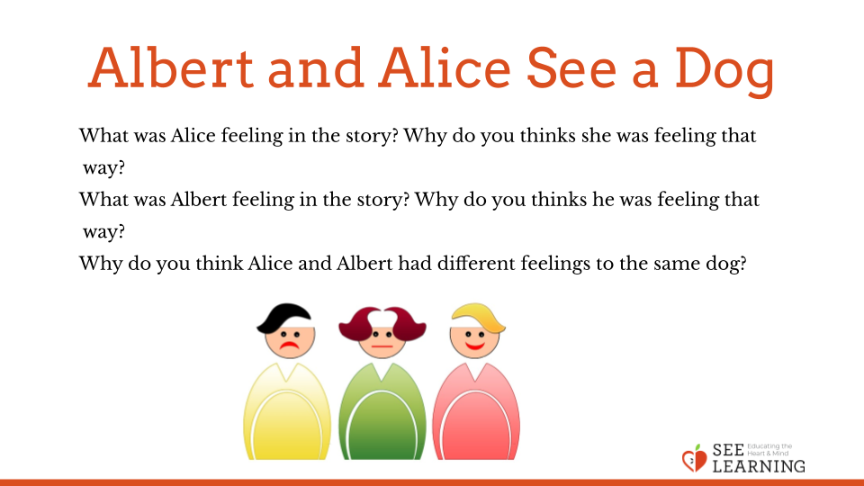 | Sample Script  - "What was Alice feeling in the story? Why do we think she was feeling that way?  - Raise your hand if you would have felt the same as Alice?  - What about Albert, how was he feeling? Why do we think he was feeling that way?  - Raise your hand if you would have felt like Albert?  - Why do you think Alice and Albert had different feelings to the same dog?  - I'm going to read the story again, and I want you to raise your hand when you hear something that tells you how a character might be feeling. You'll then explain what that character is feeling and why you think they are feeling that way.  - [Read the story aloud again, stopping to discuss when students notice clues about feelings.]  - [Discuss the following questions.]  - How might we be able to notice how others in our class are feeling?  - Can you think of a time when you felt one way about something but your parent (or guardian or friend) felt another way? How did you know they were feeling differently? How did you find out what they were thinking?  - Can you think of things that you like a lot, but other people don’t like very much? (Examples can include games, types of food, sports or other activities.)

Reflective Practice: We Can Experience Things Differently (7 minutes)
Overview

Students will think of a time when they were really excited about something, then imagine other people they know who might not react the same way.

Content to be Explored

- Even when we feel strongly about something, others can have different feelings and reactions to the same thing.

Materials

- Paper and drawing utensils for each student.

Instructions
- Distribute the paper and drawing utensils to each student.
- Ask them to think of a time when they were really excited about something. Ask them to raise their hands when they have thought of something like this. Ask for a few students to share their moments of excitement so that it can prompt ideas for others in class or give examples yourself.
- Ask each student to do a drawing illustrating themself and their moment of excitement, including what they were excited about.
- Then ask them to include a few family members or friends in the drawing. Ask them to consider the following questions: Would they also be excited about the same thing? Why or why not? Would some of them feel differently?
- Ask them to include at least one person who might not be excited about the same thing.
- Ask students to share out to the whole group what they draw, and why the characters might share the same feelings or why some of them might not.
Teacher Tips
None
Slide 4: “We can Experience Things Differently”  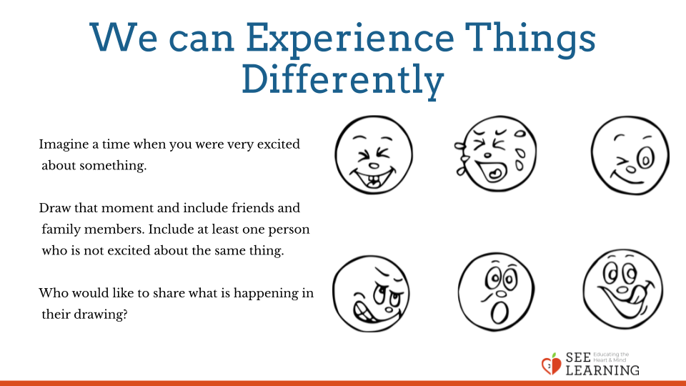 | Sample Script  - "Here is a piece of paper for each of you and something to draw with. Please wait for the instructions before you begin this reflective practice.  - Imagine a time when you were really excited about something. Raise your hand when you have thought of something.  - Let's hear from a few of you. [Invite a few students to share; give your own example.]  - Ok, next I'd like to invite you to close your eyes or lower your gaze to the floor. Imagine this time of excitement again, and this time, include a few family members or friends. Are they excited too? Why or why not? Would some of them feel differently? [Pause for 30 seconds.]  - Open your eyes. Now we're going to draw. Draw yourself being excited about something and a few family members or friends with you. make at least one of them NOT excited about the same thing you are excited about. You'll do this quietly and on your own, and we'll have time to share at the end. You may begin drawing. [Provide time for drawing.]  - Who would like to share?  - Tell us what is happening in your drawing.  - Who is excited and who is not? Explain why."
Debrief (3 minutes)
Slide 5: Debrief  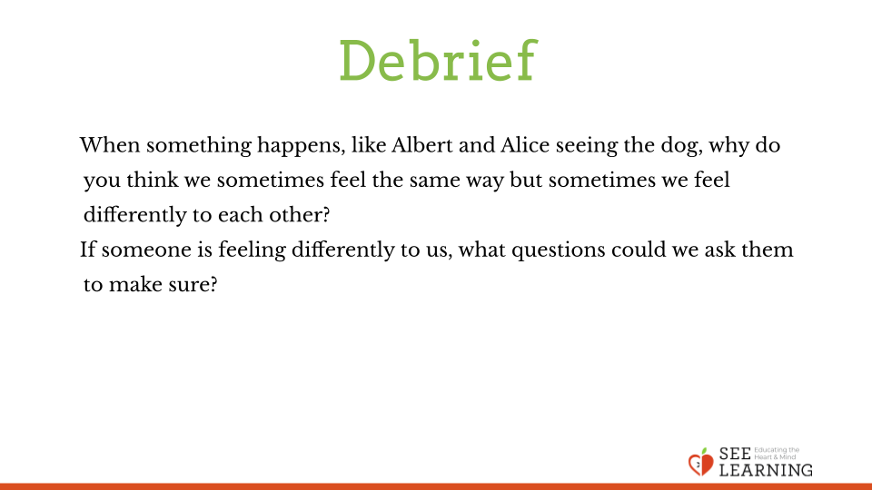 | Sample Script  - "When something happens, like Albert and Alice seeing the dog, why do you think we sometimes feel the same way but sometimes we feel differently to each other?  - If someone is feeling differently to us, what questions could we ask them to make sure?"

