Exploring Needs

Purpose: The purpose of this learning experience is to begin exploring needs that we have to live, learn, and be happy. Recognizing that all people have needs and that we share needs can be an important precursor to developing greater empathy and compassion both for oneself and others.
Learning Objectives:  Students will be able to:  - Explore the basic human needs for happiness, life, and learning. | Primary Core Component  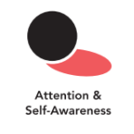
Length  20 minutes | Materials Required  - Whiteboard or chart  - Markers  - An index card or small piece of paper  - Writing utensils for each student

Check-In (4 min)
Slide 2: Check-In   | Sample Script  - “We’re going to practice using a resource to calm our minds and relax our bodies.  - Take out your resource kit. Choose one resource and place it on your desk. Remember, we’ve created these resources to help us feel safer and calmer whenever we need to.  - Now let’s pay attention to your bodies for a moment. Sit up straight and get comfortable in your chair.  - Now focus on the resource in front of you. Pay close attention to the details of it. [Pause]  - What do you notice on the inside as you look at your resource? Does it make you feel pleasant, calmer, or neutral? If it does, focus your attention on that pleasant or neutral feeling inside.  - But if you feel unpleasant, you can change your focus to something else. You might want to close your eyes and imagine a favorite person or thing. [Pause]  - What did you notice on the inside?”

Insight Activity: Shared Needs (12 min)
Overview
In this insight activity, students will create a list of “needs”: what people need for happiness, life, and learning. They will identify those needs that are basic to most people.

Content to be Explored
- We all have needs.
- Although some of our needs may be specific to ourselves, many are shared among ourselves and others.

Materials
A whiteboard or large piece of chart paper for the list of needs.

Instructions
- Write the word “NEEDS” on the whiteboard or a large piece of chart paper.
- Ask students to name some things that we need to be happy, to live, and to learn.
- Write their suggestions as a list on the board. Explain that the class is making a list of our “needs,” meaning things we need to be happy, live, and learn.
- Once you have a list of ten or more needs, ask students which of the needs they think everyone has: Do all people have this need? Put a star next to those. Identify these as “Shared Needs.”
Teacher Tips
- Students may suggest things that do not seem to be needs, but rather wants or other things. Return to the question, “Is that something we need to be happy, to live, or to learn?” If the student says yes, then to acknowledge and encourage student participation, write their suggestion on the board also, but put it to one side. You can say something like, "I'm going to put it here on the side and we can see if it fits later." As you go along, and especially when you make the list of shared needs, it will become clearer to students what is meant by a "need."
- A sample list of shared needs is provided at the end of this learning experience for your reference.
- If students have trouble coming up with ideas, offer suggestions, such as, "What about friends? Do we need friends to be happy? Or what about time to play?"
- It could be helpful to ask students to think about the things they do every day, since many of the things we do daily (eating, sleeping, going to school, playing with friends, and so on) have to do with our needs.
- Students this age are likely to list concrete things (like shoes, teachers, cars, pencils) rather than more abstract categories that those items might fall under (clothing, fun, freedom, etc.) You can either write that concrete item on the list as a need, or you can probe further by asking, "Why do we need a pencil? So that we can write and do our homework? So, we need to be able to study and learn things? Or we need to be able to do work?" In this way you can lead them to more general needs.
Slide 3: Shared Needs  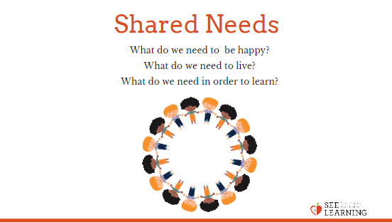 | Sample Script  - "Today we're going to talk about needs. These are things that we need as human beings to be happy, to live, and to learn.  - What are some things that we need? Let's talk first about what we need to be happy.  - What do we need to live?  - What do we need in order to learn?  - [If students have trouble coming up with ideas, offer suggestions, such as, "What about friends? Do we need friends to be happy? Or what about time to play?" Also, it could be helpful to ask students to think about the things they do every day and what they need for that.]  - Let's look at our list so far. What do you notice?  - Which of these needs do you think your friends, teachers, and family members all have as well? I'll put a star next to the ones you think others might also have.  - These needs with the stars next to them are called "shared needs.""

Debrief (4 min)
Slide 4: Debrief  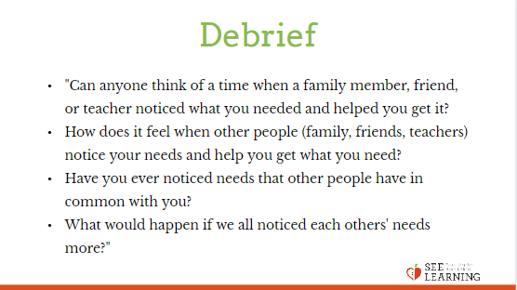 | Sample Script  - "Can anyone think of a time when a family member, friend, or teacher noticed what you needed and helped you get it?  - How does it feel when other people (family, friends, teachers) notice your needs and help you get what you need?  - Have you ever noticed needs that other people have in common with you?  - What would happen if we all noticed each others' needs more?"

