Emotional Hygiene

Purpose:
The purpose of this learning experience is to introduce the concept of “emotional hygiene” as a way of dealing with or preventing risky emotions before they cause difficulties for oneself and others. Students imagine scenarios and run through a checklist for each risky emotion, seeing what can be done by oneself and what one can do for others experiencing that emotional state.
Learning Objectives:  Students will be able to:  - Explore the concept of “emotional hygiene” as practices of self-care and restraint.  - Identify strategies for dealing with risky emotions in oneself and others. | Primary Core Component  Self-Awareness  
Length  30 minutes | Materials Required  - The emotion families chart (created) earlier on a board or piece of chart paper that students can see  - a piece of blank chart paper, or board

Check-In | 4 minutes
Slide 2: Check In   | Sample Script  - “We’ve been talking about emotions and risky emotions.  - In order to notice an emotion, especially a risky one, we need strong attention.  - So we’re going to start by strengthening our attention.  - Take out your resource kit and choose one resource. Place it in your desk. It’s there if you need it.  - Let’s pay attention to our bodies for a moment. If your body feels like it needs a stretch, take one.  - Let’s get back in our chairs, sit up straight, and get comfortable.  - This time we’re going to focus our attention on our breathing. But if it makes you feel uncomfortable or you don’t want to do breathing, you can think about your resource instead and notice how that makes you feel inside.  - See if you can notice the feeling in your nose and face when you breath in [pause] and also when you breath out. Or you can notice the breath in your belly. [Pause.]  - Let’s try to sit for a few minutes while we practice paying attention to our breathing. [Have students practice focusing on their breath for about one to two minutes, depending on their ability.]  - What did you notice?” [Share aloud]

Discussion: What is Emotional Hygiene (10 minutes)
Overview

In this discussion, students will be introduced to and explore the concept of emotional hygiene.

Content to be Explored

- Just as we take care of our bodies (physical hygiene), we can take care of our minds (emotional hygiene).
- Emotional hygiene allows us to “think twice” when we experience a risky emotion, protecting ourselves and others.

Materials

None

Instructions

- Remind the class of the “Creating Emotion Families” activity and which emotions were identified as risky. Hang up the chart that you made or make a list of the risky emotions the students identified so that everyone can see it.
- Refer back to Nelson, from the “Nelson’s Difficult Day” or “Nelson’s Day at Grandma’s House” (found in learning experience 2 of this chapter) stories. Since it may have been a while since they heard the story, you can remind them of the story or re-read the beginning of it.
- As you go through the story, ask students when Nelson may have felt one of the risky emotions.
- When they identify a risky emotion Nelson might be experiencing, use the strategies checklist (provided at the end of this learning experience) to generate ideas about what Nelson could do to help himself handle that particular risky emotion.
- Continue through the story finding other risky emotions and exploring strategies of how Nelson might deal with each one.

Teacher Tips
- If the opportunity arises, you can point out that sometimes a strategy might work well for a risky emotion in one situation but not in another situation. This is one reason why it's good to have several strategies for handling risky emotions and not just one.
Slide 3: “What is Emotional Hygiene?”  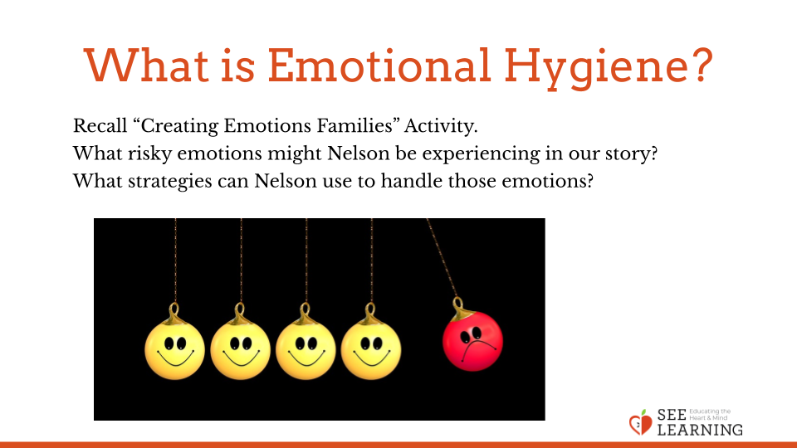 | Sample Script  - "Who remembers when we did the activity about emotion families? Can you share with the group so we can all remember?  - Yes, we came up with related words for the emotions.  - Can anyone remember an emotion that we decided was a risky emotion? [Review this with your class, reminding them of which emotions they decided were more risky. Hang up a chart of the risky emotions identified in the previous learning experience.]  - Does everyone experience this emotion at some point?  - Let's go back to the story we read about Nelson visiting his grandmother's house. Do you remember that story?  - Nelson was visiting his grandmother's house. When he woke up he didn't remember where he was. Then later he learned that his friend couldn't come play with him. A little later he went to play in the park but the other children wouldn't let him play with them.  - Do you think it's possible Nelson might feel some risky emotions during this? Which risky emotions could he be feeling?  - If he were feeling that risky emotion, what sensations might he be feeling in his body?  - What could he do to help himself if he were feeling that particular risky emotion? Have we learned any strategies he could use? (Write these on the board under the heading "Things We Can Do For Ourselves")  - What if we were there with him? What could we do to help him if we saw him feeling that emotion? (These are strategies for others. Write these on the board under the heading "Things We Can Do For Others")  - That's wonderful. We've come up with some ways we can help ourselves and ways we can help others. What if Nelson felt one of the other risky emotions? Like if he felt afraid, or angry, or frustrated, or lonely? [Repeat the above questions of how this would feel in his body, what he could do for himself, and what a friend could do for him, again writing down the students' suggestions.]  - Imagine if Nelson came to us for help because he kept feeling risky emotions. He heard we are learning about emotional hygiene. What could we teach him that he could do every day to help him feel prepared and confident to keep a spark from turning into a fire?”

Reflective Practice: What Can I Do When I Feel A Strong Emotion? (9 minutes)
Overview

In this reflective practice, students will choose a strong emotion from the emotion families chart that could cause problems for oneself and others. They will then draw what a student of their same age (Nelson) could do if such an emotion were to arise.

Content to be Explored

- We can use strategies for dealing with risky emotions when we or others experience them.

Materials

- A piece of drawing paper
- drawing utensils for each student

Instructions
- Explain that Nelson has learned from our class what he can do to practice emotional hygiene. Because of that, when he starts to experience a risky emotion, he knows some things he can do.
- Explain that each student can choose another risky emotion from the ones identified in the emotion families chart. Then ask them to draw Nelson using the strategies they’ve learned to deal with that particular risky emotion so that it doesn’t cause bigger problems for themselves and others.
- Allow time for sharing of the drawings.

Teacher Tips
- Talking about risky emotions and the potentially harmful behaviors they can lead to can itself be risky if the students immediately talk from their own lives and experience from the start. This is why they are first introduced to it through a third-person fictional character (Nelson). They will naturally apply this learning to themselves. In many cases, it is advisable to start with this indirect method first before having students talk about their own emotional lives in the classroom.
Slide 5: “What Can I Do When I Feel A Strong Emotion?”  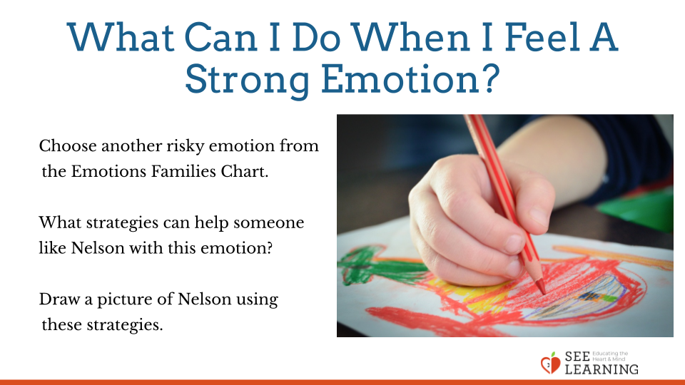 | Sample Script  - “Let’s pretend that Nelson has been in our class with us and has learned the same things as we have. He can practice emotional hygiene. Because of that, when Nelson starts to experience risky emotions, he knows some things he can do to handle them.  - Each of you will choose a risky emotion from the ones we talked about in the families chart.  - Next think about what Nelson could do to handle that risky emotion so that it doesn’t turn into a bigger problem, so the spark doesn’t become a forest fire.  - Then draw a picture of Nelson using a strategy he has learned to deal with that one particular risky emotion.  - After some time for drawing, those who want to can share what they drew with the class.”  - [Allow 5 minutes or so for drawing. Then allow students to share out.]
Debrief (3 minutes)
Slide 5: Debrief  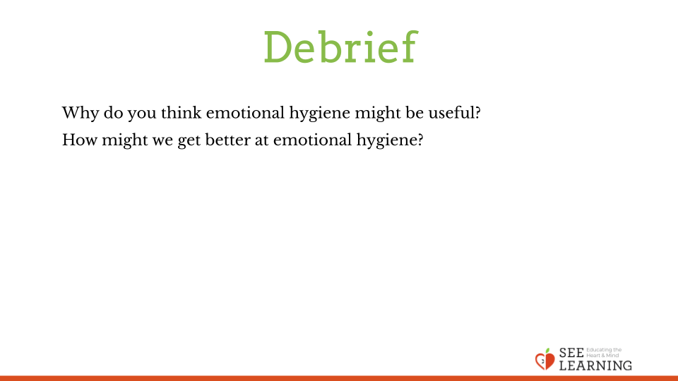 | Sample Script  - “Why do you think emotional hygiene might be useful?  - How might we get better at emotional hygiene?”

