Emotion Families

Purpose: The purpose of this learning experience is to help students build up their vocabulary of emotion words by creating “emotion families” or collections of related emotions. They will also notice how different families of emotions tend to make us feel different ways, are connected to different sets of sensations, and prompt different types of behaviors.
Learning Objectives:  Students will be able to:  - Develop a wider vocabulary of emotion terms.  - Explore the ways different emotion terms are related to each other. | Primary Core Component  Attention and Self Awareness 
Length  20-25 minutes | Materials Required  - Print-outs of the cards at the end of this learning experience

Check-In (5 minutes)
Slide 2: Check In   | Sample Script  - “We’ve been talking about emotions and needs.  - In order to notice our own emotions and needs, or the emotions and needs of others, we need to be able to pay attention.  - So we’re going to start by strengthening our attention.  - Take out your resource kit and choose one resource. Place it in your desk. It’s there if you need it.  - Let’s pay attention to our bodies for a moment. If your body feels like it needs a stretch, take one.  - Let’s get back in our chairs, sit up straight, and get comfortable.  - This time we’re going to focus our attention on our breathing. But if it makes you feel uncomfortable or you don’t want to do breathing, you can think about your resource instead and notice how that makes you feel inside.  - See if you can notice the feeling in your nose and face when you breath in [pause] and also when you breath out. Or you can notice the breath in your belly. [Pause.]  - Let’s try to sit for a few minutes while we practice paying attention to our breathing. [Have students practice focusing on their breath for about one to two minutes, depending on their ability.]  - What did you notice?” [Share aloud]

Insight Activity (15 minutes)
Overview
In this insight activity students will make “emotion families” to expand their vocabulary of emotions and see how emotions relate to each other.

Content to be Explored
- Emotions can vary in intensity.
- Some emotions are related to each other.

Materials
- 5 sets of the print-outs of the emotion cards at the end of this learning experience.
Instructions
- Divide the students into groups of 3-5 or you can choose to do this activity as a whole class. (The script below is written for instruction for small groups.) Each group should be stationed around a table or gather together on the floor.
- Hand out the main emotion cards (happy, kind, sad, angry, afraid) to each group. These can be found at the end of this learning experience. Explain that this emotion is the “parent” of each group.
- Then give each group one set of the rest of the emotion cards. These are for the additional “family members.”
- Read all the words with students to be sure they know how to read each card.
- Instruct students that their job will be to create "emotion families" by grouping together the words that go together.
- Do the happy emotion family all together as a class. Ask students to find another word that is similar to "happy." When they find it, they can place it next to the happy card. And so on.
- Have students do the rest of the activity in their small groups, placing all emotions in family groups.

Teacher Tips
- Here is the list of completed emotion families:
  - Happy: joyful, excited, content, pleased
  - Kind: caring, loving, friendly, empathetic
  - Sad: lonely, gloomy, miserable
  - Angry: frustrated, impatient, annoyed
  - Afraid: worried, scared, nervous
- Each group will need enough room (flat surface like table or floor) to place the emotions cards under each family group card.
- It can be helpful to draw faces or use "emojis" on the emotion cards as well, especially for students who cannot yet read well.

Slide 3: Creating Emotion Families  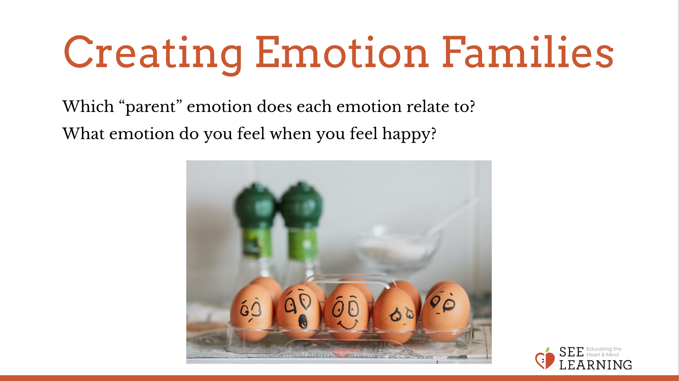 | Sample Script  - "Here we have 5 main emotions.I'm going to give one to each of your groups. This is the main "parent" of your emotion family. Let's read them aloud together.  - We also have a lot of other emotion cards too. They are like relatives. Each one will go to one of the main groups where it will join its parent. (Teacher holds up and reads each card with the help of students.)  - Now let's see where they should go. Let's start with the emotion family of "happy" and do that together.  - If I feel happy, what other emotion might I feel? What's an emotion related to feeling happy? Find the card in your deck that has a word that is similar to happy. [joyful, excited] Great, I will place joyful right under happy.  - What other emotions do we have here that would fit with happy? [Ask for suggestions.]  - Now let's do the rest in groups. Find what cards you have that fit with your main emotion parent, and place them around the parent. [Give enough time for them to work in groups, checking in on each group.]  - Now let's share. Which group would like to go first? Tell us your emotion parent, and then tell us which other emotions you decided were related. [Allow each group to share.]  - Were there any emotion words you didn't understand?"

Debrief (3 minutes)
Slide 5: Debrief  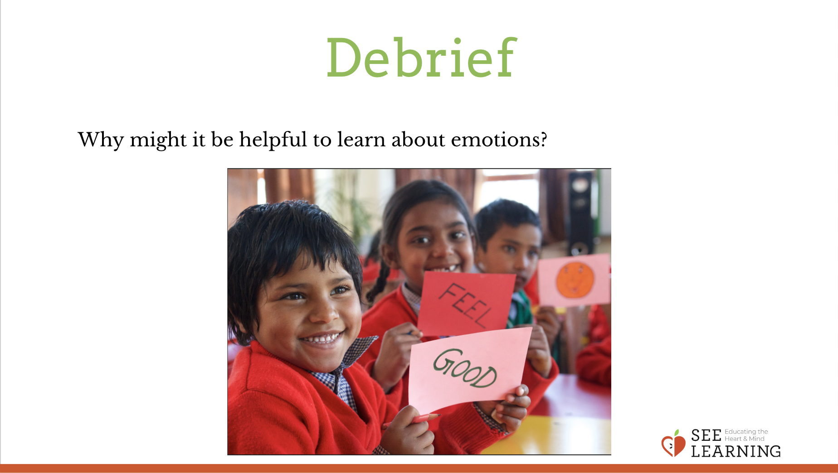 | Sample Script  - “Why might it be helpful to learn about emotions?”

