Exploring Needs and Feelings
Needs to be updated after SD is created

Purpose:
The purpose of this learning experience is to begin exploring the relationship between needs and feelings. By listening to a story and identifying the needs of the character and what they are feeling, students will practice recognizing another’s needs and noticing the connection between needs and feelings.
Learning Objectives:  Students will be able to:  - Explore the basic human needs for happiness, life, and learning.  - Explore the relationship between needs and feelings. | Primary Core Component  Self-Awareness  
Length  25 minutes | Materials Required  - Whiteboard or chart paper  - Markers  - Nelson’s Day at Grandma’s House story  - List of shared needs  - A green marker and a blue marker

Check-In | 3 minutes
Slide 2: Check In   | Sample Script  - “We’re going to practice using a resource to calm our minds and relax our bodies.  - Take out your resource kit. Choose one resource and place it on your desk. Remember, we’ve created these resources to help us feel safer and calmer whenever we need to.  - Now let’s pay attention to your bodies for a moment. Sit up straight and get comfortable in your chair.  - Now focus on the resource in front of you. Pay close attention to the details of it. [Pause]  - What do you notice on the inside as you look at your resource? Does it make you feel pleasant, calmer, or neutral? If it does, focus your attention on that pleasant or neutral feeling inside.  - But if you feel unpleasant, you can change your focus to something else. You might want to close your eyes and imagine a favorite person or thing. [Pause]  - What did you notice on the inside?“

Insight Activity: Recognizing Needs (17 minutes)
Slide 3: Recognizing Needs  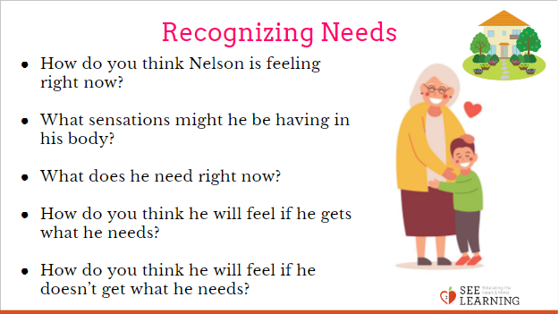 | Sample Script  - “Who remembers the story of Nelson we read before? What was the activity we did with that story last time? Yes, we looked for sparks and discussed how he moved through the zones.  - We’re going to read another story about Nelson. This time, we are going to focus on Nelson’s feelings and how they relate to what Nelson might need.  - What does it mean for a need to be met or unmet? Well if Nelson needed friendship, his need would be met if he had friends around him. But if he needed friendship and he doesn’t have any friends, then his need would be unmet.  - I’m going to read the story and pause at moments when we come to a feeling or need. [Begin reading the story, provided below. When you come to a blank, ask some or all of the following questions:]  - How do you think Nelson is feeling right now? What sensations might he be feeling in his body? (Like his heart beating fast, feeling sweaty, feeling hot, feeling cold, feeling tired.) [Write these sensation words in green on the board.]  - What emotions might he be feeling about  - this situation? Is he feeling mad, sad, happy, surprised, or afraid? Or something else? [Write these emotion words in blue on the board.]  - What would make him feel better? (Point to the shared needs list if necessary.)  - Why might he need that?  - How might he feel if that need was met—if he got what he needed?  - How might he feel if that need was not met--if he didn’t get what he needed?  - Is there something he could do now to help him get what he needs?  - Good. Let’s continue the story. [Continue with this format, pausing at each blank.]  - [When done, point out the two types of feelings: sensations and emotions.]  - Did you notice that I wrote two lists of things Nelson was feeling? What’s the difference between these lists?  - Yes, this is a list of sensations. Those are things we feel in the body. This other one is a list of emotions. These are things we feel about a situation. They’re usually not just in one part of the body. We’re going to learn more about emotions later.”“

Overview

In this insight activity, your class will read the story “Nelson’s Day at Grandma’s House,” and discuss how Nelson is feeling. The group will consider Nelson’s needs and the feelings associated with met and unmet needs.

Content to be Explored

- We have many needs as we go throughout our day.
- Our needs can be met or can go unmet.
- We generally feel one way if our need is met,
- but a different way if our need is not met.
- Considering a person’s needs can help us understand what they are going through and why they are feeling certain emotions.

Materials

- The list of shared needs created in the previous lesson
- chart paper
- 1 green marker and 1 blue marker,
- the story: Nelson’s Day at Grandma’s House

Instructions

- Tell students that you will read the story “Nelson’s Day at Grandma’s House.” Last time we heard about Nelson, it was about his difficult day. This story follows our friend Nelson at his Grandma’s house.
- As you read the story, pause where there are fill-in-the-blanks for Nelson’s feelings, and ask students to share how the blanks should be filled in. You will write the feeling words they suggest on a piece of chart paper using the blue marker. Then ask students about Nelson’s sensations, and write those words on the chart paper using the green marker.
- At the fill-in-the-blank points in the story, ask students one or more of the following questions:
- How do you think Nelson is feeling right now?
- What sensations might he be having in his
- body?
- What does he need right now? [Refer to the shared needs list if necessary. Add the student’s suggested need to your list by writing it on the board.]
- How do you think he will feel if he gets what he needs?
- How do you think he will feel if he doesn’t get what he needs?
- After you finish reading the story, go over your shared needs list. Did Nelson also have any of those needs?
Debrief (5 minutes)
Slide 4: Debrief  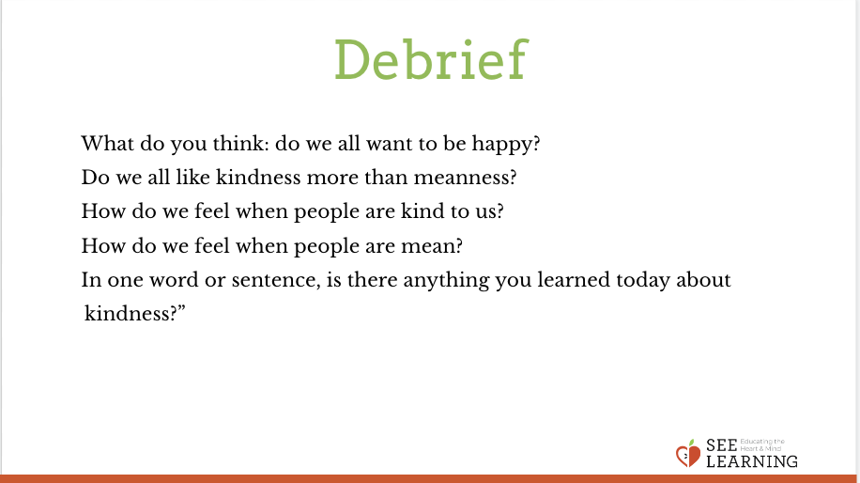 | Sample Script  - “How did Nelson generally feel when he had an unmet need?  - How did he feel when his need was met?  - Who helped Nelson meet his needs?  - How would we find out what someone needs, like in our classroom?”  Story: “Nelson’s Day at Grandma’s House”  “Nelson woke up suddenly. He heard car horns in the street making loud noises. Beep! Beep! Beep! It was very unusual to hear car horns loudly honking on the country street where Nelson lived. He rubbed his eyes and then noticed that the furniture in the bedroom didn’t look like his own. For a moment, Nelson felt ________.  Then Nelson felt something soft in his hand. He realized it was the very soft scarf that his grandma made for him. Whenever he traveled he took it with him. Then he remembered,  “Of course! I’m at grandma’s house!” Nelson remembered that his father brought him from his home in the country to his Grandma’s house in the city, the night before. Now, Nelson felt _______. Nelson got out of bed and felt his stomach grumble. He was feeling _____. What he needed now was ______.  Then he heard his grandma’s warm voice call to him, “Nelson, are you awake? I’ve made your favorite breakfast! Come to the kitchen to eat!” Nelson felt_______ that his grandma made him his very favorite breakfast. It was a special meal that Grandma made only for him!  Nelson enjoyed a delicious breakfast of fried eggs, spicy beans, and slices of banana with honey spread on them. Nelson loved it! Now, he was feeling _____.  Nelson and his grandma were washing the dishes when the phone rang. Grandma answered it. Nelson couldn’t hear everything over the running water in the sink, but could hear his grandma say, “Oh, that’s really too bad. I hope feels better soon.” “Nelson” said grandma, “that was Mrs. Montoyo. She called to say that Juan is sick and won’t be able to come over today to play.” Nelson’s heart sank. Nelson only gets to see Juan when he is at Grandma’s house, because Juan lives in the city, while Nelson’s lives in the country. Nelson felt ________. He liked seeing Juan and playing soccer with him outside. He liked his grandma’s house but there weren’t his usual games and toys there. Now, Nelson started wondering what he would do to pass the time.  Nelson’s grandmother noticed the nervous look on Nelson’s face. “Nelson,” said Grandma, “Why don’t we take a walk to the park? Maybe you will meet some new friends there.” Nelson felt _______.  When Nelson and his grandma got to the park, Nelson saw several groups of children playing. There were children on the swings, a few playing with a basketball, and some others playing a tag game. Nelson walked over to the children playing with the basketball. “Hi,” he said, “Can I join your game?” A tall girl with curly brown hair said, “No, we have even teams right now.” Nelson felt _______.  Just then, Nelson felt a tap on his arm. He spun around to hear a boy with glasses say, “tag, you’re it!” Nelson barely had time to think. He had to find another child to tag. He noticed a group of children running in all directions, and he thought if he ran really hard, he could tag one of them. Now, Nelson felt ______. It would be a fun time after all.

