Cultivating Attention in Activities: Part 2

Purpose: The purpose of this learning experience is to show what the cultivation of attention looks like when applied to simple activities like listening, eating or walking, which are mildly but not overly stimulating, before transitioning to even more neutral things like the breath and writing. It also introduces the idea of “the spark and the forest fire” as an analogy for how our feelings and impulses can get out of control and cause problems for us if we do not pay attention to them with heedfulness and address them in time. There are many activities included here, so feel free to split the learning experience into multiple sessions.
Learning Objectives:  Students will be able to:  - Notice that the training of attention can be involved in any activity we do.  - Practice mindful eating.  - Practice mindful walking, including how to lead the activity. | Primary Core Component  
Length  25 minutes | Materials Required  - Provided scenario  - A picture of a spark and a forest fire (provided at the end of this chapter)  - A chime or bell  - Optional: small food or snack items such as grapes, raisins, grape tomatoes, crackers with enough for two items per student; napkins; a clear open space where your students can walk in a circle together
Check-In (4 min)
Slide 2: Check-In   | Sample Script  - “We’ve been learning how to pay attention.  - What are some things you have learned about attention?  - Have you been noticing people paying attention or not paying attention? Would anyone like to share an example?  - Have you thought of any other things that attention helps us to do? Since yesterday, can you share one time you used your attention?  - Let’s take a moment to calm our bodies and minds so that we can pay attention for the activities we’re about to do. Take a comfortable posture, one that is relaxed but that will help you keep your attention here. Let’s lower or close our eyes.  - Let’s do grounding or resourcing. First, take a moment to think of one of your resources that you would like to use to help you today. Raise your left hand when you have thought of your resource. Let’s begin. If you’re doing grounding, notice the contact of your body with the floor or chair or some other contact.  - If you’re doing resourcing, bring your resource to mind.  - If you ever feel uncomfortable, you can shift to a pleasant or neutral sensation in your body and focus on that instead. [Pause 15-30 seconds or longer as your students are able.]  - What did you notice on the inside?”

Insight Activity: The Spark and the Forest Fire (8 min)
Overview
In this insight activity, students review the metaphor of the spark and the forest fire
as representations of feelings and impulses through reading a scenario. Then they discuss some times when they practiced heedfulness themselves.

Content to be Explored
- Feelings and impulses can be like sparks that quickly grow to a forest fire if we don’t catch them in time.
- It is important to notice our sparks and address them before they become fires, and that can be helped through strengthening our attention and awareness muscles.
- When it’s still a spark, a fire is easy to put out and even a child can do it. Once it’s a forest fire, it lasts until it burns itself out.
Materials
- Scenario, provided below
- Pictures of spark and forest fire (provided at end of learning experience)
Instructions
- Ask students to help remind each other of the spark/forest fire metaphor. Show students a picture or video of a forest fire. (Script below if needed.)
- Share the story provided below.
- Give students a few moments to reflect and think about the story. Then ask the group:
  - What happened in the story?
  - What was the spark for the main character?
  - What could happen next if he doesn't catch the spark?
  - What might he do to catch his spark?
  - How can we benefit from catching our sparks?
  - How can we help others by catching our sparks?
Teacher Tips
- You can write the main character's thoughts on the board with arrows connecting them to show how one leads to another.
- You can also share with your students the graphic novel Sparks! provided in the supplementary materials to SEE Learning or a similar story that illustrates the concept of the spark of a feeling becoming a forest fire or someone catching it before that happens.
Slide 3: The Spark and the Forest Fire  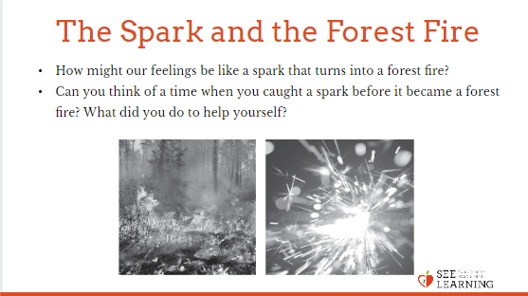 | Sample Script  - "Who knows what is happening here? (Show picture of forest fire.)  - Does anyone know how a forest fire gets started? How big is the fire when it first starts?  - How would you put out the spark or small flame when it's just getting started? Who could do that?  - What about when it's really big like this? How would you put it out? Is it harder to put out when it's a big forest fire like that?  - We've been talking about things on the inside, like our thoughts and feelings. How might our feelings be like a spark that turns into a forest fire?  - What happens when someone has a feeling and then it starts to get bigger and bigger, and suddenly they're feeling really angry or really unhappy?  - What could they have done if they caught that feeling when it was just a spark?  - How could we be careful or heedful of those sparks before they become forest fires?  - Let's read a short scenario together and talk a little more about this metaphor.  - [After reading the scenario, ask:]  - What happened in the story?  - What was the spark for the main character?  - What could happen next if he doesn't catch the spark?  - What might he do to catch his spark?  - Can you think of a time when you caught a spark before it became a forest fire? What did you do to help yourself?  - How can we benefit from catching our sparks?  - How can we help others by catching our sparks?"  - Sample scenario  - “Louis got his math test back. He saw that he missed 3 problems and failed the test. He thought “I did terribly on this test, I’m terrible at math.” Then he thought,”I am never going to be good at math, which means I’m not a good student and then I’m not going to get into college and get a good job and have a successful and happy life...” ”

Reflective Practice: Mindful Listening (10 min)
Overview
In this practice students try mindful listening. This also serves as a grounding practice after discussing heedfulness and students’ own examples, which could be activating for some.
Content to be Explored
- We can pay attention to any activity.
- We notice more when we pay close attention.
- Attention can make things more vivid and interesting.
- Despite looking the same at first, each thing is unique and different in some way.
- Paying close attention can calm our body and mind.
Slide 4: Mindful Listening  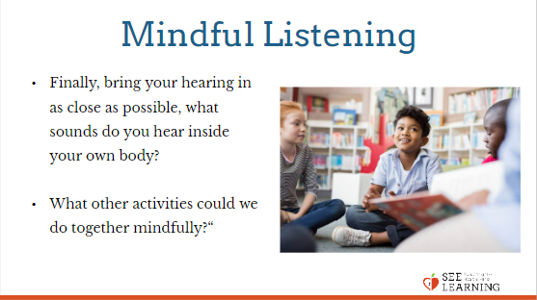 | Sample Script  - “Find a comfortable place in the room. It may be more comfortable for you to close your eyes, but if not, you are also welcome to focus your eyes on the floor. Now, let’s take two breaths to settle in.  - We are first going to focus on things that are far away from us. Open up your ears as big as you can, can you find the farthest away sound. It is not important to identify the sound, just notice it.  - Now we are going to find the sounds happening inside the building.  - Let’s bring it in even closer - notice the sounds happening inside the room.  - Finally, bring your hearing in as close as possible, what sounds do you hear inside your own body?  - Open your eyes, and come back: How do you feel? What zone do you feel in right now?  - What sensations do you notice in your body? Has your breathing changed?  - What other activities could we do together mindfully?“

Debrief (3 min)
Slide 5: Debrief  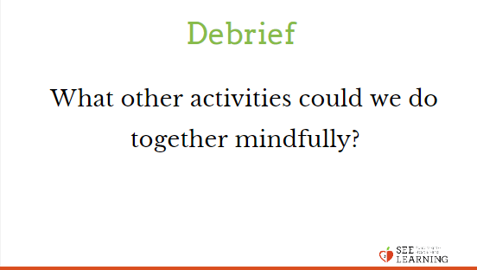 | Sample Script  - There is no debrief listed here because each Reflective Practice contains discussion questions specific to each practice.

