Exploring the Mind

Purpose:
This learning experience uses a story and a “mind jar” to explore what goes on in our minds. In SEE Learning, “mind” is a broad category that involves our first-person experience of the world, including feelings, emotions, thoughts, memories, hopes and fears, our imagination, and so on. The mind is also what we use to pay attention to - or to be mindful of - things. Students also create two illustrated mind jars of their own in groups to show what might be in their minds when they are feeling stirred up and anxious, as opposed to when they are feeling calmer and more relaxed.
Learning Objectives:  Students will be able to:  - Explore what we mean by “mind” and the ways we can categorize mental experience.  - Learn that our mind can be relatively clear or cloudy, making it easier or harder to discern what is happening in our minds.  - Learn that we can calm and stabilize the mind by allowing it to relax and settle.  - Explore the similarities we share with regard to our minds and mental experiences. | Primary Core Component  *Replace this line with image and name*  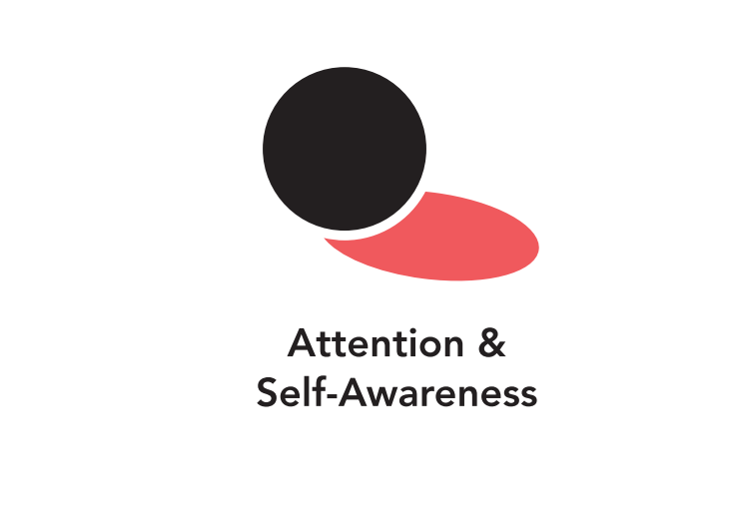
Length  30 Minutes | Materials Required  - Water in a large, clear glass (pint) jar with lid  - Small containers with sand, pebbles, small glass stones or glitter if available (or other materials with some that sink and some that float)  - Spoon to stir with  - A small stool or table to put the jar on at eye level so the class can watch it

Check In (3 min)
Slide #: Title  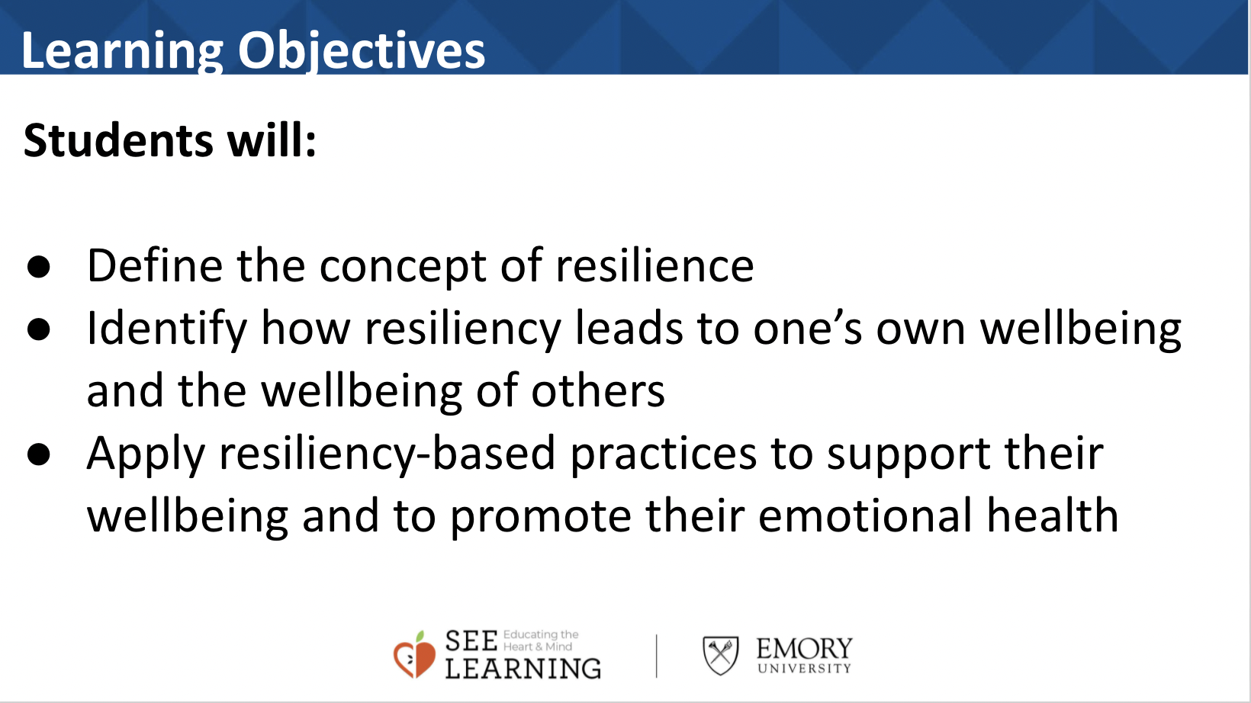 | Sample Script  - “Let’s start with some resourcing. If you like you can take out a resource from your treasure chest or you can just imagine your resource.  - If someone did something kind for you recently, or if you were kind to someone else, you can feel free to use that as your resource.  - If you’d rather do grounding, you can find a comfortable way to sit or something comfortable to hold or touch.  - Let’s now take a few moments to think about our resources or pay attention to our grounding. [Pause.]  - Now let’s do tracking and pay attention to the sensations inside our bodies.  - If you find a pleasant or neutral sensation just pay attention to that and watch it. See if it changes or stays the same. [Pause.]  - If you haven’t found a pleasant or neutral sensation, see if you can shift to another part of your body to find a place that feels better. [Pause.]

Insight Activity - The Mind Jar (14 min)
Overview
In this insight activity, your class will explore what we mean by “mind” through a story and the use of a “mind jar.” A mind jar is a large transparent jar of water to which you can add sand, pebbles, and other things that can float in the water and make it cloudy, but eventually settle down if left undisturbed, leaving the water clear. The mind jar serves as a visual metaphor for how our minds become clearer when we let them settle.

Content to be Explored
- There are many things that go on in our minds, including thoughts, emotions, memories, feelings, hopes, fears, and more.
- When agitated, our minds can become cloudy, making it hard for us to see what is going on inside us or around us. Even pleasant sensations/thoughts/emotions can cause our minds to become cloudy instead of calm.
- We can cultivate greater clarity of mind by not agitating it and instead developing focus and attention.
- When our mind is calm, things in our mind become more clear.
- We feel calmer.
- We learn more easily.
- We make better decisions.
- Our body feels more settled.
- We can stir our mind up (agitation, confusion, rumination) or let it settle.

Materials
- Water in a large, clear glass (pint) jar with lid
- Small containers with sand, pebbles, small glass stones or glitter if available (or other materials with some that sink and some that float)
- A spoon to stir with
- A small stool or table to put the jar on at eye level so the class can watch it
Instructions
- Review the Zones that were introduced in Chapter 2 : the resilient zone, the high zone and the low zone.
- Place a large plastic or glass jar with water on a table or in a place where it is clearly visible. Invite your student to join you sitting in a circle or in a way that everyone can see the jar.
- Show the students how clear the water is and how easy it is to see through.
- What do you notice about the water now?
- I’m going to tell you a story about a boy called Desmond. For this story, we will be using this jar to show what is happening in Desmond’s mind. Can you see clearly through it? We’re going to use sand, pebbles and glitter. Sand will be for neutral things, pebbles for challenging things, and glitter for nice things.
- Tell a “Clear-Muddy Mind” story (a sample story is provided below), Add the materials into the jar yourself, or invite your students. To add them, at appropriate times (here marked by letters in the story.)
  - S = Sand
  - P = Pebbles
  - G = Glitter
- Or substitute other appropriate substances for neutral, challenging and nice things, As the story goes on and your students start to understand the process, you can ask them what substance to add after each sentence.
Teacher Tips
- This activity uses the mind jar in conjunction with a story (you can make one up or use the story provided below.)
- It is highly recommended that you test out your mind jar before doing this activity with your class.
- You can vary the substances you put inside.
- When left on its own, ideally the substances in the mind jar will sink within a minute or two, resulting in the cloudy liquid becoming clear.
- You can use a snow globe, but you lose the opportunity for class participation and the chance to show different mental activities (thoughts, feelings).
- After you finish, keep the mind jar set up, as you will use it again in upcoming learning experiences.
Slide 3: The Mind Jar  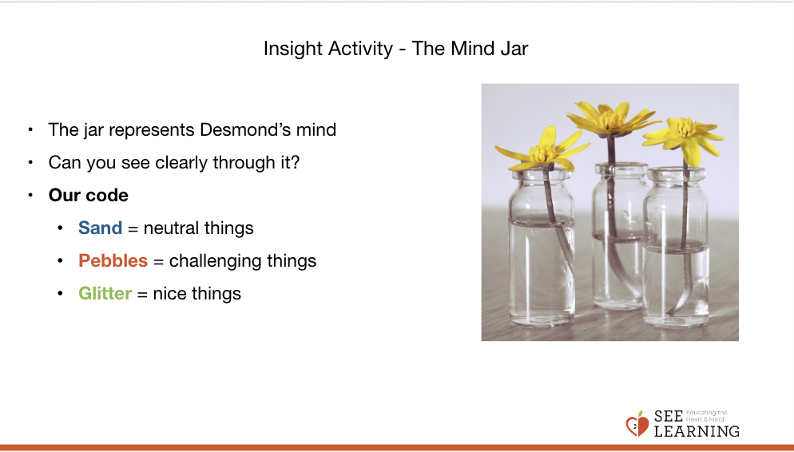 | Sample Clear-Muddy Mind Story  - “It’s snack time, which Desomnd loves, because he is always hungry and he looks forward to morning snack (G).  - He looks in his lunch box and realizes that he has pretzels and carrots, not his favorite, but not too bad (S).  - He really enjoys the crunch that the pretzels and carrots make and gets lost in thought while eating them (G).  - Before he is halfway through he hears his teacher say, “It’s time to clean up to go outside.” Desmond is not finished with his snack and he wanted to eat all of it (P).  - “Oh well,” he thinks, at least I get to go outside and play with friends (S).  - He’s looking forward to playing four square (or other popular game) with his friends like they always do at morning recess (G).  - But when he gets outside, he realizes that other kids are already playing there and it’s crowded (P).  - “We can just play soccer or catch,” suggests his friends, but Desmond really wanted to play four square.  - “Recess is ruined,” he cries, “I’d rather just sit by myself” (P).  - Desmond watches as his friends play soccer (P).  - Finally, his best friend Lincoln comes over and says, “I know you wanted to play four square, maybe we could play it at afternoon recess instead. Come play with us, we really miss you out there.” (G)  Debrief  - “What happened in the story?  - How did Desmond feel at the beginning, middle, and end?  - What was challenging for him?  - What was neutral for him?  - What was pleasant for him?  - Note that things Desmond felt might not have felt that way for you. Your mind is different than Desmond’s and that’s ok. We all react to things differently because we have different minds, and that is ok.  - What else did you notice or what else do you want to talk about in the story?”

Reflective Practice - Settling the Mind (4 min)
Overview
In this practice, students will practice keeping their attention on the mind jar for a short while as it settles. However, they also have the option of shifting their attention to their bodies – particularly to neutral or pleasant sensations – and keeping their attention on those sensations. Either way, the students will be cultivating attention.

Teacher Tips
- It's recommended that you start with very brief attention training exercises like this–even as short as a minute or two–and gradually build to longer sessions over weeks and months. Where the script says “Pause,” you can pause for as short as 8-12 seconds, or as long as you feel is comfortable for your students. It is also recommended that you allow students to shift to resourcing, grounding, or a Help Now! Strategy as needed. This is because if students feel dysregulation in their bodies, asking them to still their bodies and focus their concentration on a particular thing can sometimes increase discomfort.
Slide 5: Settling the Mind  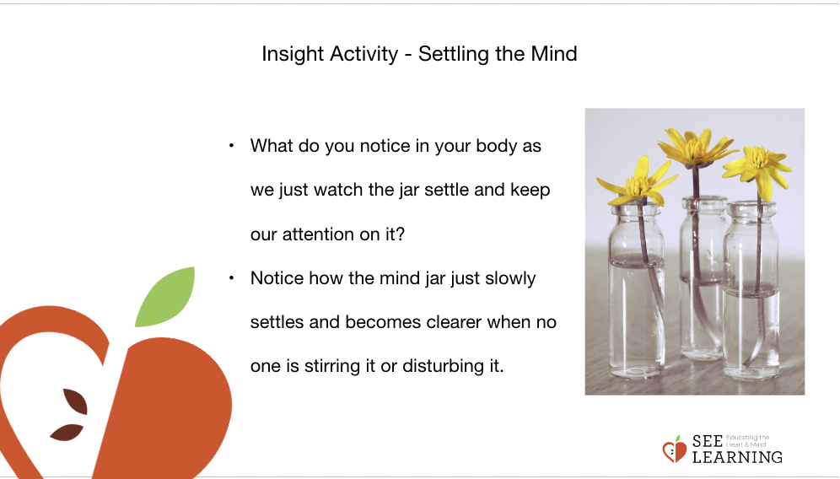 | Sample Script  - “I’m going to talk you through this reflective practice and then we can share out at the end. Remember that you can always adjust your position to a better one, and you can always think about a resource or do grounding if you ever feel uncomfortable.  - The mind jar settles if we leave it alone and allow it to return to its natural state.  - I’m going to shake this jar and then we’ll just watch as it settles.  - When we watch (or listen) to something closely we call that “paying attention”. If we keep watching for a longer time, that’s called “keeping our attention” on whatever it is we’re watching. See if you can keep your attention on the jar as it settles.  - Let’s watch the jar quietly now. [Pause.]  - What do you notice in your body as we just watch it and keep our attention on it?  - If you find a neutral or pleasant sensation in your body, then you can shift your attention to that if you like.  - If you feel unpleasant, you can do resourcing or grounding as we watch the mind jar. You can think of a resource from your kit. Maybe you’ll find a resource that helps your mind settle a bit, just like the mind jar is settling. [Pause.]  - No9tce how the mind jar just slowly settles and becomes clearer when no one is stirring it or disturbing it. [Pause.]  - Remember that you can always adjust your position to a better one, and you can always think about a resource or do grounding if you ever feel uncomfortable. Otherwise, let’s just keep watching the mind jar. Let’s see what we notice in the mind jar and in our body.”

Debrief (2 min)
Slide 6: Debrief  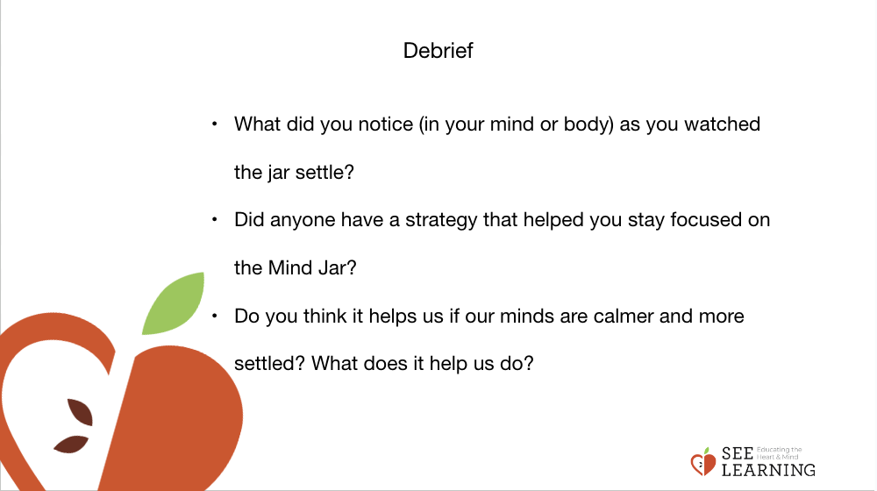 | Sample Script  - “What did you notice – in your mind or in your body - as you watched the jar settle?  - Who had a strategy or a way that helped you stay focused on the Mind Jar? Could you share it with the group?  - Do you think it helps us if our minds are calmer and more settled? What does it help us do?”

