Lesson Title

Purpose:
The purpose of this learning experience is to introduce students to the concept of the resilient zone, which you can also call the “OK zone” or “zone of well-being,” by using a puppet and charts to facilitate understanding. The resilient zone refers to when our mind and body are in a state of well-being. When we are in our resilient zone we can handle the stresses that happen during the day and react with the best part of ourselves. Stress can bump us out of our resilient zone into our high or low zone.

When we are stuck in the high zone we may feel anxious, agitated, nervous, angry, stressed out, and so on. Our body is dysregulated, making it hard for us to concentrate, learn new information, or make good decisions. When we are stuck in the low zone, we may feel tired, lacking in energy, unexcited about things we normally like, unmotivated and deflated and it’s just as difficult for us to learn new things, solve problems, or make our best choices.
Learning Objectives:  Students will be able to:  - Understand our three zones.  - Develop the skill of recognizing which zone they are in at any given moment through tracking.  - Develop the skill of returning to the resilient zone using resourcing and grounding. | Primary Core Component  
Length  30 minutes | Materials Required  - A board or chart paper for drawing the three zones  - A hand puppet (or you can substitute a stuffed animal or soft toy)

Check In (4 min)

Slide 2: Check In  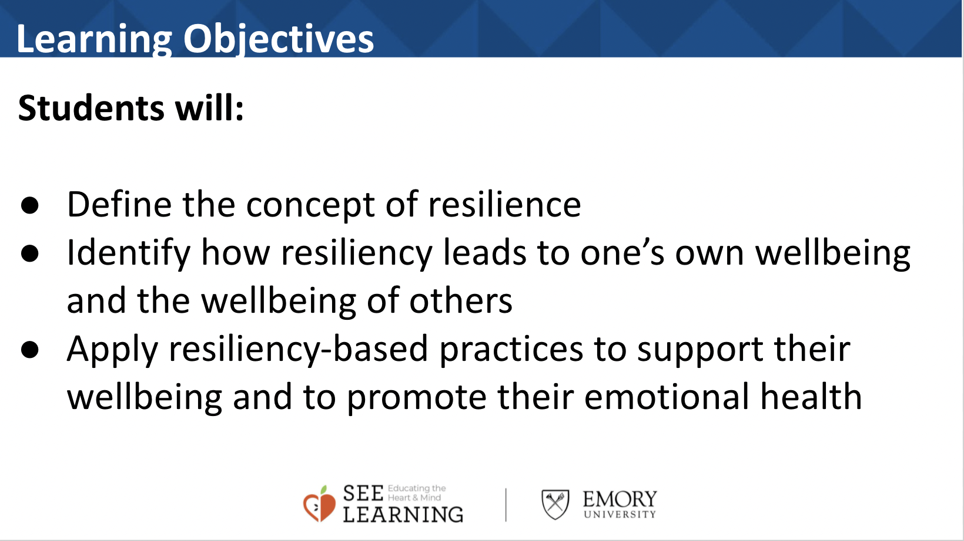 | Sample Script  - “Take a moment to give your attention to the sensations inside your body. You might want to check how much energy you have, whether you are feeling heavier or lighter, warmer or cooler, relaxed and soft or tight and jumpy. I invite you to notice what’s going on.  - Last time we talked about grounding - using our body and senses to help us calm down and feel better. Can you remember something you tried that felt pleasant or neutral to you? (Take enough responses to feel that most strategies have been represented.) Is anyone having trouble remembering these? (If so, you might want to make a list to post in the classroom.)  - Is there one form of grounding you would like to try right now? (Allow some time for individual choice and exploration, or you may want to choose one experience for the whole group to try.)  - How do you feel now? Can you tell whether that exercise was helpful to you? Do you notice any differences in your body?”

Check In (4 min)
Overview
Text

Content to be Explored
Text

Materials
text
Instructions

Teacher Tips

(note, delete these row if not needed)
Slide #: Title | Sample Script  Corresponding script for teachers here.

Activity title (# min)
Overview
Text

Content to be Explored
Text

Materials
text
Instructions

Teacher Tips

(note, delete these row if not needed)
Slide #: Title | Sample Script  Corresponding script for teachers here.

Activity title (# min)
Overview
Text

Content to be Explored
Text

Materials
text
Instructions

Teacher Tips

(note, delete these row if not needed)
Slide #: Title | Sample Script  Corresponding script for teachers here.

Activity title (# min)
Overview
Text

Content to be Explored
Text

Materials
text
Instructions

Teacher Tips

(note, delete these row if not needed)
Slide #: Title | Sample Script  Corresponding script for teachers here.

