Exploring Sensations

Purpose:
This first learning experience explores sensations and helps students build a vocabulary to describe them, since sensations tell us most directly about the state of our nervous system. Students will also learn Help Now! strategies, most of which involve sensing things around the room. Help Now! Strategies (developed by Elaine Miller-Karas and the Trauma Resource Institute) are immediate tools to help students return to a regulated body state if they are stuck in a dysregulated state, such as being overly agitated. They also are a great way to introduce the concept of sensations and practice attending to them.
Learning Objectives:  Students will be able to:  - Develop and list vocabulary of words that describe various sensations.  - Practice attending to external sensations while learning Help Now! strategies for regulating the body. | Primary Core Component  Self-Awareness
Length  30 minutes | Materials Required  - A piece of chart paper or a board for creating a list of words that describe sensations  - Print outs of the Help Now Strategies (optional)  - Markers

Check-In | 4 minutes

Slide 2: Check In   | Sample Script  - “Welcome. As you think about this whole day until now - from when you first woke up to being in class right now, raise your hand if you can think of something kind that you experienced or did for someone. Would anyone like to share?  - Have any of you been practicing kindness by using the class agreements? Which ones? What did that feel like?  - Have you seen anyone else practice one of the agreements? Describe it. What did it feel like to see that?  - What do you think might happen if we keep practicing kindness with each other?”

Insight Activity: What Are Sensations? (10 minutes)
Overview

In this presentation you will help your students understand what a sensation is and then
have them come up with a list of words that describe sensations, thereby building a shared vocabulary of sensation words.

Content to be Explored

- Just as we can sense things on the outside with our five sense, we can pay attention to sensations inside our bodies also.
- Sensations can be pleasant, unpleasant or neutral.
- There are simple strategies we can use to help our bodies become calmer and feel safer

Materials

- Chart paper or whiteboard
- Markers

Instructions

- Review the five senses and talk about what we use them for. Discuss the nervous system and how senses are related to it. Discuss the concept of sensations.
- Make a list of sensation words with the students.
  - If they say things like “I feel good!” which is a feeling but not a specific sensation, then encourage them to put that into sensation words by asking, “And what does good feel like in the body?” or “Where in the body do you sense that?” It is all right if some of the words they come up with are not precisely sensation words, as the activities that follow will help them further develop their understanding of what a sensation is.

Teacher Tips
- A sensation is a physical feeling that arises in the body, such as warm, cold, tingling, loosening, tightening, heaviness, lightness, openness, and so on. Physical sensation words are to be differentiated from general feeling words like good, bad, stressed, relieved, and so on, and they are also different from emotion words like happy, sad, afraid, excited, and so on. Helping your students come up with a list of sensation words will help them recognize sensations in the body, which in turn will help them monitor the state of their bodies.
- If you feel comfortable doing so, it is also recommended that you introduce your students to the role of the nervous system: the part of our body that allows us to feel sensations on the inside as well as sense things on the outside (through our five senses, for example) and that keeps us alive by regulating our breathing, our heart rate, blood flow, digestion and other important functions. This whole chapter involves coming to understand the nervous system (specifically the autonomic nervous system). You can teach the content and skills without naming the nervous system specifically and instead using the general term “the body,” but if you are able to bring in additional information about the autonomic nervous system gradually, this will likely enrich your students’ overall understanding.
Slide 3: “What are sensations?”  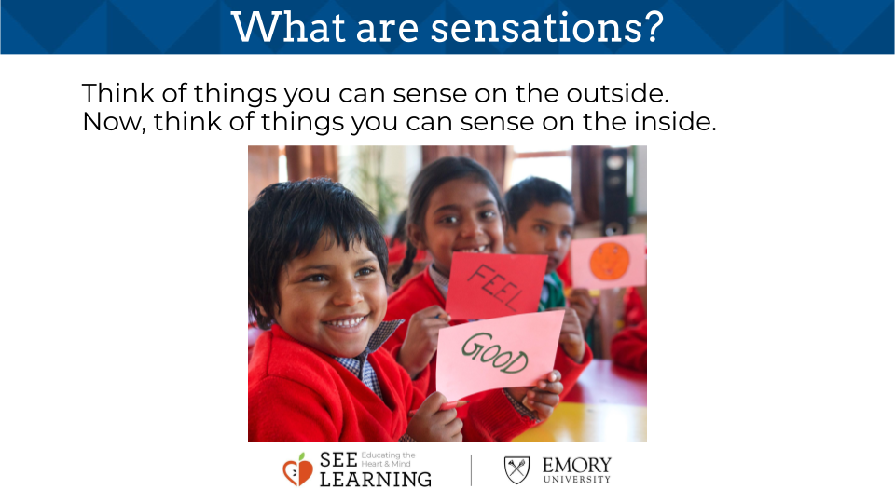 | Sample Script  - “We’ve been exploring kindness and happiness. Today we’re going to learn about how about how our senses can help us know what our bodies are feeling.  - Let’s see if we can name the five senses? Those are for feeling things on the outside: we can see, hear, smell, touch and taste things.  - What are things we can sense on the outside through our five senses? Let’s think about one of our senses --hearing -- let’s take a moment of silence and notice what sounds we can hear during a minute of silence. What did you hear? Can anyone share what you are sensing right now using one of the other senses? What about seeing? Touch? Smell?  - There is a part of our bodies that help us sense these things on the outside of our bodies and also inside our bodies. We call it the nervous system.  - It is called the nervous system because our body is full of nerves that send information from different parts of our bodies to and from our brain. We’re going to be learning some interesting things about our nervous system that can help us be happier and healthier together.  - So, our senses help us feel things on the outside of our bodies like a sound or smell. Let’s notice if we can feel anything inside our bodies. Let’s put one hand on our heart and the other hand on our belly and let’s close our eyes for a moment and notice if we can feel anything inside our body.  - Sometimes we can feel something in our bodies like whether we are feeling hot or cold. We call things like that sensations. That’s because we sense them.  - Sensing something is feeling something with our body. Sensations are just things we can feel or sense with our body. Our body tells us what we are sensing.  - Let’s think of things we can sense on the outside. We will make a list of sensations together.  - When you touch your desk, is it hard? Is it soft? Is the temperature warm or cool?  - If you touch your clothing, is it soft? Scratchy? Smooth? Something else?  - Take out your pencil/crayon/pen, as you touch it, is it round? Flat? Warm? Cool? Sharp? Something else?  - Is there something else on your desk/near you that you want to describe with sensation words?  - Now let’s think about what we sense on the inside. An example would be if we are standing in the sun, our senses may let us know it is too hot, and we take action to move into the shade to cool down. In the beginning, we sense the warmth or the heat on the inside and when we move to the shade, we sense a cooling down on the inside. Let’s think together about other sensations we experience on the inside.  - Let’s see how many we can come up with. If you say something but we’re maybe not sure if it’s a sensation, I’m going to write it separately over here.”  - (Some children may need further prompting to understand sensations. Hence asking questions like the following may help:)  - “What do you feel on the inside when you’re sleepy? What part of your body tells you that you are sleepy? How about when you’re hungry? What do you feel like when you are having fun? What do you feel on the inside when you’re happy? If you play a sport, what do you feel like on the inside? What do you feel on the inside when you’re excited? Where in your body do you feel that? (It may be helpful if you give a personal example, such as when I’m thinking about having fun, I sense warmth in my shoulders and cheeks.)”

Insight Activity: Sensing on the Outside and Inside (12 minutes)
Overview

- This activity is to help students continue to recognize that we can sense things on the outside (using our five senses) and on the inside (turning our awareness inside, noticing and naming what sensations we find inside the body).
- The Community Resiliency Model, designed by the Trauma Resource Institute, provides several activities called “Help Now!” strategies. These all involve doing an easy cognitive task or directing our attention to sensations. It has been found that when the nervous system is agitated, directing attention to sensations by doing activities like these can have an immediate calming effect on the body. This insight activity works through the individual Help Now! strategies and also lays the foundation for cultivating attention as a skill (which is further developed later in SEE Learning), since all the Help Now! strategies involve paying attention.

Content to be Explored

- Just as we can sense things on the outside with our five senses, we can pay attention to sensations inside our bodies also.
- Sensations can be pleasant, unpleasant or neutral.
- There are simple strategies we can use to help our bodies become calmer and feel safer.

Materials

- Optional: copies of the stations handout if you are doing stations
- Help Now strategies posters (both items are included at the end of this learning experience)

Instructions
- Select a Help Now strategy to lead your class through. Follow the script below in order to get comfortable asking questions about sensations. Show the poster of the Help Now strategy to your class.
- Use this format to explore the various Help Now! strategies as you have time, and repeat this activity as necessary.
- Note: You can also have students explore the Help Now! strategies as stations around the room. Use the handouts provided in the following section or make your own and post them around the room. Have your students pair up and then walk around the room until they find a Help Now! station that they want to try. Then they can do the Help Now! skill together as a pair and share what they experience. After everyone has had a chance to try two or more stations, bring them back together as a class and ask them to share which stations they did and what they experienced.
Teacher Tips
- As students explore the effects of these strategies on their bodies, it is important that they also learn to notice whether the sensations they experience are pleasant, unpleasant or neutral. As this vocabulary (pleasant, unpleasant and neutral) and the ability to connect these terms to sensations in the body will be important for all learning experiences in this chapter, it is worth checking in occasionally with your students to deepen their understanding of noticing sensations in this three-fold way. Note that sensations are not inherently pleasant, unpleasant or neutral for everyone or at all times: warmth, for example, can be experienced as pleasant, unpleasant, or neutral at different times.
- Note that not every Help Now! strategy will work for every student. Some may prefer to push against a wall, some may prefer to lean against a wall. Some may like touching pieces of furniture around them, some may not. An important part of the process here is for each student to learn what works for himself or herself, while you as the teacher also learn what works for each individual student. This is the building of body literacy--a knowledge of one’s own body and how it experiences well- being and distress. Even something that works one time may not be effective another time, so learning a variety of strategies is best.
- Once your students have had some familiarity practicing Help Now! strategies, you can also have them illustrate their own Help Now! stations and place them around the room.
- Here is a list of the Help Now! strategies and below is a sample script of how you can lead the activity to explore a few of them at a time.
  - Notice sounds in the room, and then outside of the room.
  - Name the colors in the room.
  - Touch a piece of furniture near you. Notice its temperature and texture (is it hot, cold or warm; is it smooth, rough, or something else?).
  - Push against a wall with your hands or your back and notice how your muscles feel.
  - Count backwards from 10.
Slide 4: “Sensing on the Outside and Inside”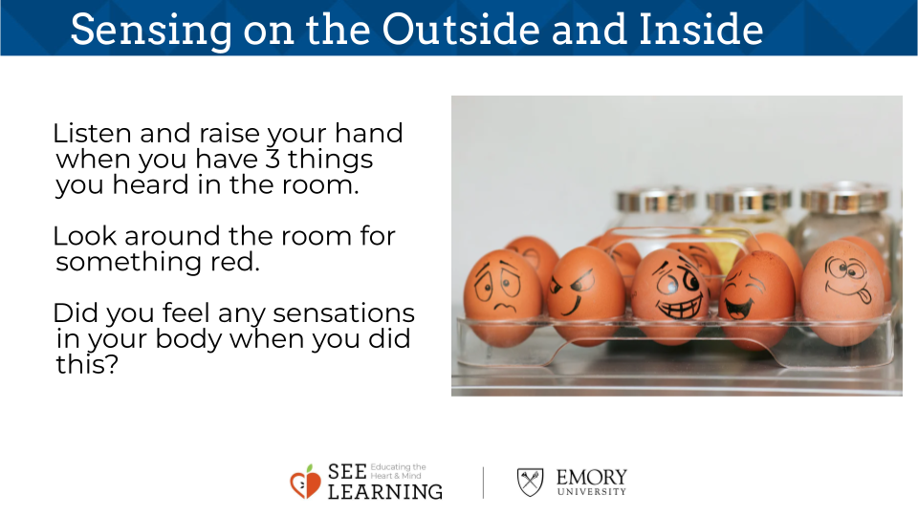 | Sample Script  - “Remember we said we want to feel happy and we want to experience kindness.  - Our bodies can feel happy or unhappy too. If we pay attention to that, we can do things that feel kind to our bodies.  - We’re going to try a few sensing activities and see if we notice anything happening to our bodies.  - We’ll start with sensing things on the outside.  - Let’s all listen and see if we can hear three things inside this room. Listen and then raise your hand when you have three things that you heard inside this room. (Wait until all or most of the students have raised their hand.)  - Let’s share now. What three things did you notice? (Call on individual students to share).  - Now let’s see if we can hear three things outside of this room. Raise your hand when you’ve got three things that you heard outside this room.” (Note: This exercise can also be accomplished with music. You can play music and ask the students what happens on the inside as they listen to music.)  - (When most or all students have raised their hands, allow them to share.)  - “What happened to our bodies when we all listened for sounds inside and outside the room? What did you notice?” (Allow for sharing. You may notice that when you are all listening for sounds, you become quieter and more still.)  - “Now we’re going to notice what happens inside our bodies when we do this.  - Our sensations can be pleasant, unpleasant or neutral. There are no right or wrong sensations. Sensations exist to give us information like I am too hot in the sun, I need to walk to that shade to cool down. Neutral means in-between. It means that the sensation isn’t pleasant, but it isn’t unpleasant either.  - Let’s listen for things inside or outside this classroom that we didn’t notice before. [Pause.]  - When we’re doing this, what do you notice on the inside of your body as you’re listening? Do you notice any sensations inside your body right now? Raise your hand if you notice a sensation inside your body.  - What do you notice? Where is it? Is it pleasant, unpleasant or neutral? [Allow other students to share.]  - Now let’s see if we can find things of a certain color in the room. Let’s start with red.  - Look around the room and see if you can find three red things in this room  - Notice what you’re feeling on the inside as you find the color red. Does anyone notice any sensations in their bodies? Raise your hand if you noticed one.  - What is it? Is it pleasant, unpleasant, or neutral?”
Use this format to explore the various Help Now! Strategies as you have time, and repeat this activity as necessary.

Strategy

Name six colors you notice in the room.

Count backwards from 10.

Notice different 3 sounds in the room and 3 outside of the room.

Slowly drink a glass of water. Feel it in your mouth and throat.

Spend a minute walking around the room. Notice the feeling of your feet on the ground.

Press your palms together firmly or rub your palms together until they get warm.

Touch a piece of furniture or a surface near you. Notice its temperature and texture.

Slowly push against a wall with your hands or your back and notice any feelings in your muscles.

Look around the room and notice what catches your attention

What Sensation Do You Notice in Your Body?

Are the Sensations Pleasant, Unpleasant, or Neutral?
Debrief (4 minutes)
Slide 5: Debrief  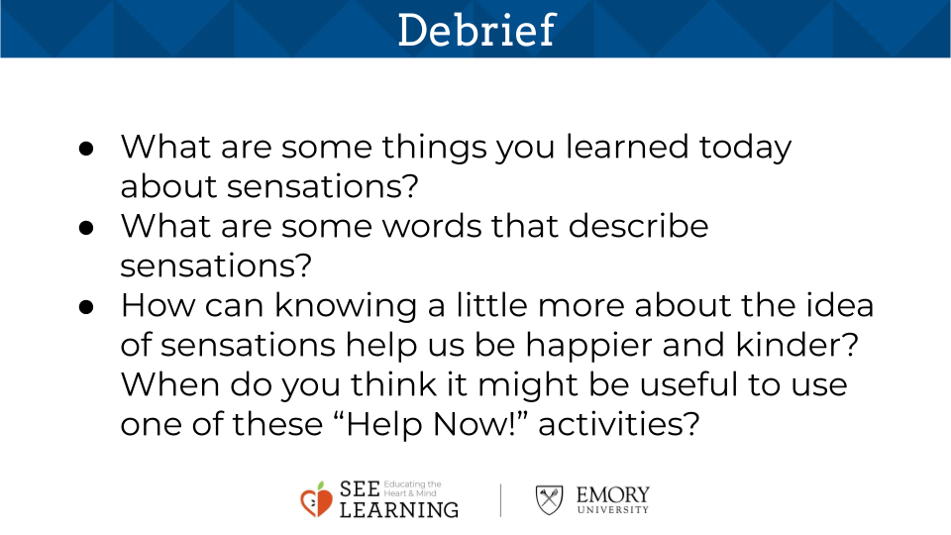 | Sample Script  - “What are some things you learned today about sensations?  - What are some words that describe sensations?  - How can knowing a little more about the idea of sensations help us be happier and kinder? When do you think it might be useful to use one of these Help Now! activities?  - Let’s remember what we’ve learned and see if we can use it together next time.”

