Exploring Kindness

Purpose:
The focus of this first learning experience is to introduce students to SEE Learning through an exploration of kindness and why we need it. The foundation of SEE Learning is compassion and kindness. From the start, it is important for students to learn what kindness is, and why we want it for ourselves and need it. We all want kindness shown to us, because we all want happiness and well-being, and none of us wants sadness, troubles, and difficulties. If we recognize this, we can understand why we should show kindness to others, because they too, like us, want to be happy and don’t want to be sad. (Note: The next learning experience will use this understanding of our shared need for kindness to create a mutually agreed-on list of class agreements that will support a safe, productive learning environment.)
Learning Objectives:  Students will be able to:  - Recognize that we all want happiness and kindness  - Create a personal drawing of kindness that they can use as a resource. | Primary Core Component  Interpersonal Awareness
Length  30 minutes | Materials Required  - The prompts provided below  - Markers or pens for drawing

Check-In | 3 minutes
Slide 2: Check In   | Sample Script  - “This year we will be spending some time each week to learn about ourselves and each other.  - We will be doing some activities to learn what happiness is and what kindness is.  - We will learn about how we can make our classroom a happy place to learn where we can all feel safe.”  - Ask students to notice who is on the inside and who is on the outside. Discuss.  - At the end of the prompts tell them:  - “Let’s look around. It seems we all feel happier when people are kind to us. Just like we can connect over things that we like or things that we have, like the same number of brothers and sisters, we can connect over something that brings our whole class together: our desire to be happy and for people to be kind to us.”

Insight Activity: Step In, Step Out Activity (12 minutes)
Overview

Students will step in and out of a circle depending on whether the prompts the teacher reads apply to them. Then students will take a moment to notice who is on the inside and who is on the outside. This shows who shares that same trait or experience, and who doesn’t.

Content to be Explored

We have many differences, but wanting happiness and kindness is something we all share in common.

Materials

Script of prompts, provided below

Instructions

- Students form a circle.
- Using the prompts in the sample script below, ask students to step in if the prompt applies to them.

Teacher Tips
- You will want to have a large enough area for students to gather in a large circle to step in and out of. You may need to move desks/ tables. An option would be to do this activity outside, or in the gymnasium.
- Instead of having students step in and step out of a circle, you can have students form a circle of chairs and have them stand up or remain seated. Or you could have them raise their hands instead of stepping in. Whichever method you choose, make sure that students can see each other, so they can see how their classmates answer each question.
- In addition to the questions given below in the sample script, add additional questions as you see fit and as time allows. You can also adapt the questions as necessary to your particular students. The point is to begin with things that the students do not all have in common, such as preferences or aspects of their identity, but then move towards what we all have in common: that we want happiness and prefer kindness.
- Pay attention if some students don’t step in when asked the final few questions: they may not have understood the questions. But do not feel the need to make students step in or to accept your conclusions: subsequent learning experiences will continue to explore the ideas of happiness and kindness in greater depth, so their views and feelings may change as their understanding progresses.
Slide 3: Step In, Step Out  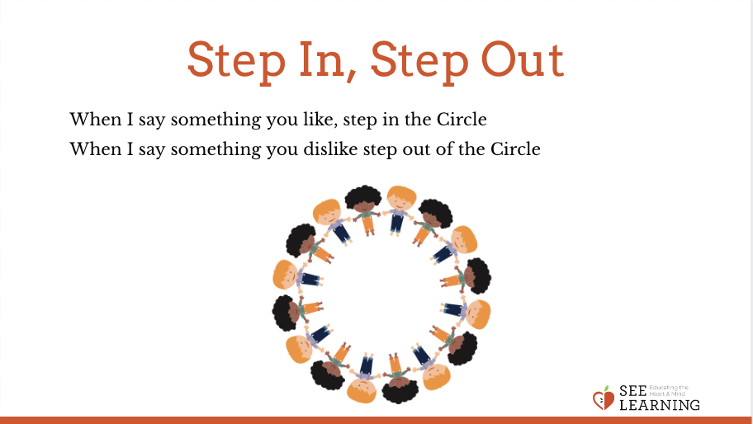 | Sample Script  - “Let’s all form a circle. This circle is a safe circle. People are free to think and feel independently without comment or judgment from others.  - If I say something that’s true for you, then you’ll step into the middle. We are going to try and do this without talking, but instead just noticing what is going on around you.  - Let’s start.  - Step in the center if you have a brother or sister.  - Now, stop and take a look and see who else has a brother or sister, or who else doesn’t. Now step back please.  - Now, we’re going to think about some things that you like.  - Step in if you like pizza.  - Now, take a look and see who else likes pizza. Step back please.  - Step into the center if you like to build with Legos or blocks.  - Take a look and see who else likes building with Legos or blocks. Now step back please. • Step in the center if you like playing sports or big active games.  - Take a look and see who else likes those things. And step back please.  - Who noticed they had a similarity with someone? What was it? [These questions are crucial as this way kids start to connect more and are ready for the next step.]  - I notice that only some people step in each time. Let’s see what happens if I ask this: Step in if you like to be happy rather than sad.  - Now, take a look around. What do you notice about this?  - Ah, look! All of us (or most of us) are in the center! It seems that we all like to be happy rather than sad. Now let’s step back.  - Step in if you feel better when you’re happy than when you’re sad.  - Let’s look around. How many of us are here?  - Step in if you like it when people are kind to you, rather than mean.  - Let’s look around. Are we all here?  - It seems we like it when people are kind to us. Now let’s step back.  - Step in if you feel happier when people are kind to you, rather than when they are mean.  - Let’s look around. It seems we all feel happier when people are kind to us.  - Just like we can connect over things that we like or things that we have, like the same number of brothers and sisters, we can connect over something that brings our whole class together: our desire to be happy and for people to be kind to us.

Insight Activity: Remembering and Drawing Kindness (12 minutes)
Overview

Students will produce a drawing of when someone was kind to them with some sentences underneath explaining the scene and how they felt.

Content to be Explored

- We can recall memories or imagined acts of kindness
- Kindness adds to our happiness
- We all want to be happy

Materials

- Paper for each student
- Pencils, markers or pens for drawing

Instructions
- Ask students to silently imagine a time when someone was kind to them.
- Ask students to draw an image of that time. Then ask them to write a few sentences to answer these questions about the memory/ image:
- What did it look like? What did it feel like? What did you look like? What did you feel like?
- Give students a few minutes to draw, guiding individual students as necessary. When it seems that most students are ready, invite them to share.
- When they are sharing, ask them what it felt like when they were shown kindness.
- If students share moments that were not kind, or that made them feel bad, remind them that kindness is something that makes us feel happier when we receive it from others, and ask them to think of another time when they were shown kindness and felt happy receiving that kindness.
- Allow as many children to share as time allows, drawing their attention to the simple fact that we all want kindness, because it adds to our happiness, and we all want to be happy.
Teacher Tips
- You can do this activity sitting at tables or desks or together as a whole group, sitting in a circle. The script below is written for students sitting at tables or desks.
- Have a few students share their moment of kindness in case others are stuck as this will give some more scaffolding.
- You may want to model with a drawing you have made.
- Depending on the size of your class and reluctance of some students to talk in a large group, you might ask them to pair up to talk first.
- You can also ask other students what they feel when they see another student sharing their kindness moment, as it may also make them feel happy, or it may remind them of a time when they received a similar kindness.
- This drawing activity can be done more than once in different class sessions, but make sure to save at least one copy of the drawings as they will be used again in later learning experiences. The students can save their own drawing, you can hang them up on the wall, or you can collect them and distribute them again later when they are needed. This activity can be repeated at least once a month.
Slide 4: Remembering and Drawing Kindness  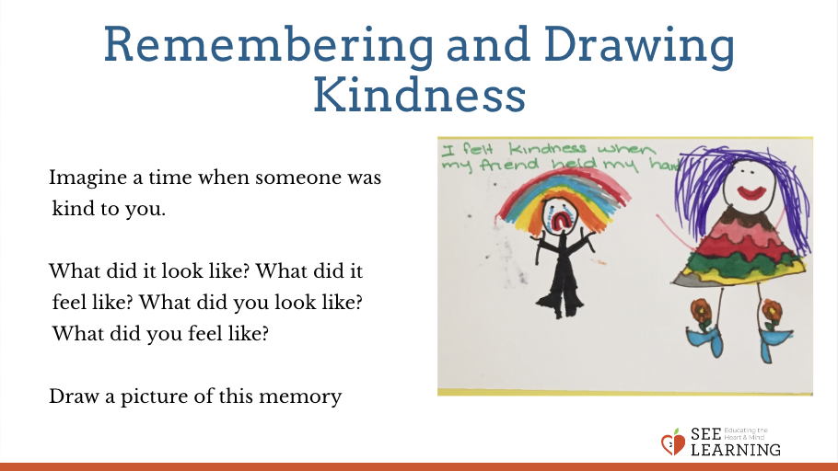 | Sample Script  - “Let’s go back to our desks.  - Remember how we saw that we all like it when people are kind to us?  - Let’s be silent for a moment and think about a moment when someone was kind to us. Sometimes it is easier to bring memories to our mind if we close our eyes or look at the ground. I’ll keep my eyes open.  - It could be something very special, or it could be something very simple.  - It could be someone helping you, or someone saying something nice to you.  - It could be a friend who played with you, or someone giving you a toy or present.  - Raise your hand if you’ve thought of a time when someone was kind to you. [Have a few students share in case others are stuck - this will give some more scaffolding.]  - Now we’re going to draw what happened when someone was kind to us.  - Answer these questions: what did it look like? What did it feel like? What did you look like? What did you feel like? [Give students a few minutes to draw, guiding individual students as necessary. When it seems that most students are ready, invite them to share.]  - Okay, we’ve all done some drawing now of a time when someone was kind to us.  - Who would like to share their drawing and tell us about that time?  - These drawings will be available to you as a resource to come back to if you need a reminder of a kind moment. You are always welcome to look back at what we’ve done and bring positive feelings forward.”
Debrief (3 minutes)
Slide 5: Debrief  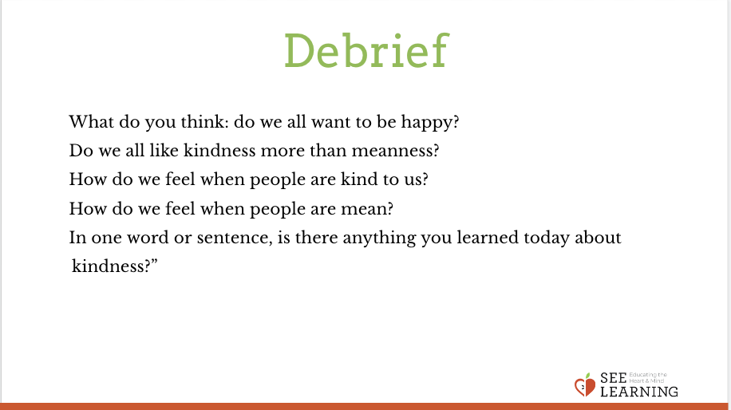 | Sample Script  - “What do you think: do we all want to be happy? Do we all like kindness more than meanness?  - How do we feel when people are kind to us? How do we feel when people are mean?  - This year we’re going to be helping each other create a caring classroom. If we all want to be happy, and we all like kindness, then we should learn to be kind to each other. So that’s what we’re going to do.  - In one word or sentence, is there anything you learned today about kindness?” (Invite individual students to share out.)

