Recognizing Kindness and Exploring Interdependence

Purpose:
The focus of this learning experience is to practice recognizing kindness and exploring interdependence. Although students will already have some notions of what kindness looks like, by looking deeper at everyday activities and seeing the various ways kindness is involved, their appreciation for kindness can grow further. Similarly, though students may have some idea of the concept of interdependence, the simple activity of mapping an accomplishment and all the things that that accomplishment depended on can help them see interdependence more clearly. Interdependence refers to the fact that every object and event comes into being from a variety of causes, in the sense that it depends on other things. Exploring interdependence can be a powerful tool for recognizing how we depend on others and others depend on us; it can underscore the importance of reciprocity; and it can serve as a foundation for gratitude and a feeling of connectedness to others. It also supports systems thinking, since interdependence is a feature of all systems.
Learning Objectives:  Students will be able to:  - Recognize acts of kindness in their day.  - Recognize interdependence as a feature of our shared reality.  - Recognize how the objects and events that we need come from the acts of countless others. | Primary Core Component  Interpersonal Awareness  
Length  35 minutes | Materials Required  - Whiteboard or chart paper  - Markers

Check-In | 5 minutes
Slide 2: Check In   | Sample Script  - "Can anyone remember what we said kindness means? We created a way of explaining it to others. Who remembers what we said?  - Let's look at our explanation of what kindness is now. I wrote it up on this piece of paper.  - Have any of you felt kindness today? Yes? What was it like? If you can't think of a moment of kindness from today, you can imagine one if you like.  - Let's take a moment to sit for a few seconds and remember what kindness feels like. If you are comfortable with it, close your eyes and really try to picture that moment when someone was kind to you or when you felt kindly towards someone else. Or if you are using your imagination, just imagine that moment. (Pause)  - Thank you. Can some of you give or share some of the acts of kindness that you thought of?"
Teaching Tips

- Use your discretion in guiding this, as you know your own class. Encourage them to think of any moment – no matter how small. It could be the crossing guard who smiled at them, or they handed someone a marker when they needed it, or they smiled at someone they don’t usually pay attention to. Let your students know that it’s ok if they can’t think of a time, because they can imagine one. As you practice with this, it will get easier. Encourage curiosity: the feeling that we’re all just exploring and wondering about this together.
- It’s possible you may wish to do the check-in. during a morning meeting time, and then save the other parts of the learning experience for later in the day. That way, children will already be oriented towards thinking about kindness when you come to the activities.

Insight Activity: Recognizing Kindness (5 minutes)

Overview

In this activity you will invite students to share moments of kindness that they observed or participated in during the day, guiding them to reflect on how it made them and others feel, and challenging them to recognize as many forms of kindness as they can.

Content to be Explored

- We see countless acts of kindness around us every day, but we may recognize very dew of them if we do not look deeply

Materials

- Whiteboard or chart paper; markers

Instructions
- You can begin by asking them how many acts of kindness you think the class will come up with from just things that happened to them today and write the numbers they propose on the board. Then, at the end of the activity, ask them if they think their original guesses were correct, too low, or too high.
Teacher Tips
- As in every insight activity, students may have other critical insights as you go along--if so, record them or note them on the board so that you can return to them later. Elementary aged kids are developing their abilities to take perspectives and think bigger than just themselves. This is a quick exercise that can be done many times throughout the year that reinforces kindness is all around.

Slide 3: “Insight Activity-Recognizing Kindness”  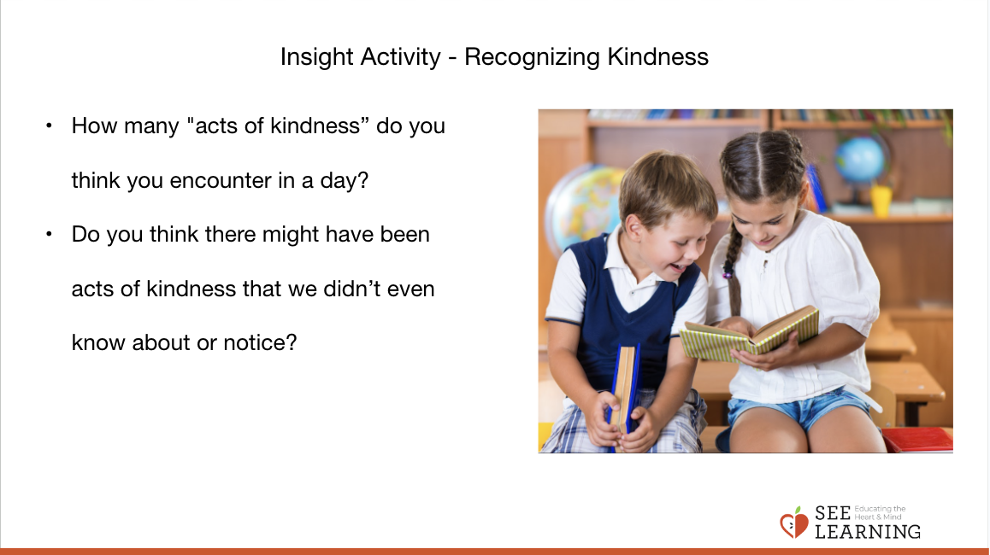 | Sample Script  - "So, I have a question for you. If you think about our day together in school, how many "kindnesses" do you think you could count? 10? 20? [Let them make guesses and write the numbers on the board or chart paper.]  - Ok I'm going to write those numbers down on the board here so we can check them again later.  - Now, let's see how many acts of kindness we can come up with. Who can think of something that happened today that was an example of kindness? Did anyone show you kindness today? Or did you do anything that was kind for someone else?  - [Allow for student sharing. If you like you can write a single word or phrase that captures what was shared on the board so that a list begins to grow. After the student has shared, you can ask follow up questions, such as: Why was that kind? How did it make you feel? How do you think it made the other person feel?]  - [You can ask these follow-up questions to other students as well, not just the student who shared, so that they can think about the various ways the action was kind and how it might have made others feel.]  - Now let's try to look more deeply. I wonder if we can find even more acts of kindness?  - Do you think there might have been kindnesses that we didn't even know about or notice?  - We found a lot of acts of kindness when we looked deeply, didn't we? How does it feel to know that we are surrounded by so many acts of kindness?  - Now, let's see. How many did we find? Did we find more than we thought we would? (You can compare with the numbers the students suggested earlier and that you wrote on the board.)  - It seems we can find a lot of acts of kindness if we look for them. But if we don't look, we might not see them."
Reflective Practice: Recognizing Interdependence (20 minutes)

Overview

In this activity students will draw a web of interdependence starting with a single accomplishment, event, or object.

Content to be Explored

- Objects and events exist in a web of interdependence; they depend on countless other objects and events.
- We are connected to and depend on countless other people in a variety of ways, even if they are strangers to us.

Materials

- A large sheet of paper for each group to draw on
- Markers

Instructions
- Point out to the class that you have been thinking a lot about acts of kindness together.
- Tell them that today you will explore an idea called interdependence.
- Ask the group for suggestions of an important accomplishment or event in their lives. Examples include going on a trip; learning to ride a bike; learning to play a game; learning to read and write; and so on. Take suggestions for about 1 or 2 minutes for this.
- Write down their suggestions and then select one that many of the students may share or is most relatable among the group.
  - If your group cannot think of an example that many or most have in common, ask them to identify an object made by humans that they all need
- Draw this accomplishment, event or object in the middle of the board or a sheet of paper. This will be the "subject" for the activity.
- Model the following and then ask them to do it:
  - Create a first circle by adding (drawing or writing) anything the subject depends on or needs to exist. Ask "What else do we need to have X (subject)"?
  - Draw a line connecting this thing to the subject.
    - For example, if you chose "learning to ride a bike" as their subject, you might add a teacher, a friend, the bicycle, a flat surface to ride on, the person who invented bicycles, and so on. Or if you choose a pencil as their subject, they could add wood, lead, a factory, paint, and so on.
  - Ask them to see if they can think of at least 10 people or things the subject depends on.
  - Ask them to now add and draw what the items in that first circles themselves depend on. Again, have them draw lines connecting the new items as they are added.
- Have them continue the process freely, selecting any item on the page and identifying things or people it depends on.
  - You can prompt them to think further by asking questions like, "This item here. Does it exist all by itself or does it need other people or things for it to exist?"
- When enough time has passed, stop the class and ask them to estimate how many people in total are needed for their subject.
  - For example, how many people in total are needed for that pencil to be made? Or how many people in total are needed for you to learn to ride a bike? Give them a little time to calculate it and discuss this.
- Debrief.
Teacher Tips
- This activity works great with students standing around the whiteboard or with a piece of chart paper on the floor in the center of a circle of students, each with a marker to participate.
- Examples for accomplishments/events might include going on a trip; learning to ride a bike; learning to play a game; learning to read and write; and so on.
- As in every insight activity, students may have other critical insights as you go along--if so, record them or note them on the board so that you can return to them later.

Slide 4: Recognizing Interdependence  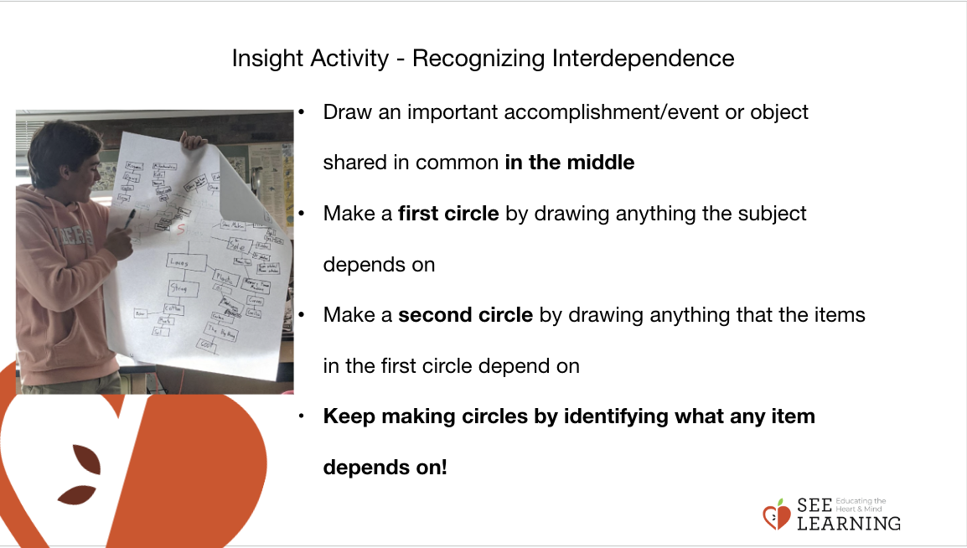 | Sample Script  - “We have talked a lot about kindness in our lives, and one thing that we might have seen is that kindness rarely involves just you - usually kindness that occurs in our lives involves and depends on at least one other person.  - We call this interdependence: we constantly depend on others.  - Today, we are going to investigate this idea of interdependence more deeply. Who can think of an important accomplishment or event they have achieved or experienced? [Write down a few suggestions and select one that is relevant and relatable to use with the whole group. If your group cannot think of an example that many or most have in common, ask them to identify an object made by humans that they all need.]  - Now, let’s think about people and things that ____________ (riding a bike) depends on. Each time you think of something, draw or write it, circle it, and draw a line connecting it to the subject. First, let me show you how. So, we are focusing on (riding a bike). That depends on having a bike, a road, and someone to teach you.  - Let’s try and come up with at least 10 things that (riding a bike) depends on and write or draw them together. [Invite students to do the writing/drawing. Allow enough time for this to happen.]  - What do you notice?  - Now, we are going to take this even further. We are going to look at each circled item we have already written down and think, what does that item depend on?  - Let me show you. I’ll go back to “the bike.” The bike exists because a person in a factory somewhere made it, so I will write “factory worker” out next to “bike.”  - Go ahead and add branches to each circle, writing/drawing what each thing depends on. Create connected branches as best you can.  - We can help each other. Let’s see how many connections we can make.”
Debrief (5 minutes)
Slide 6: Debrief  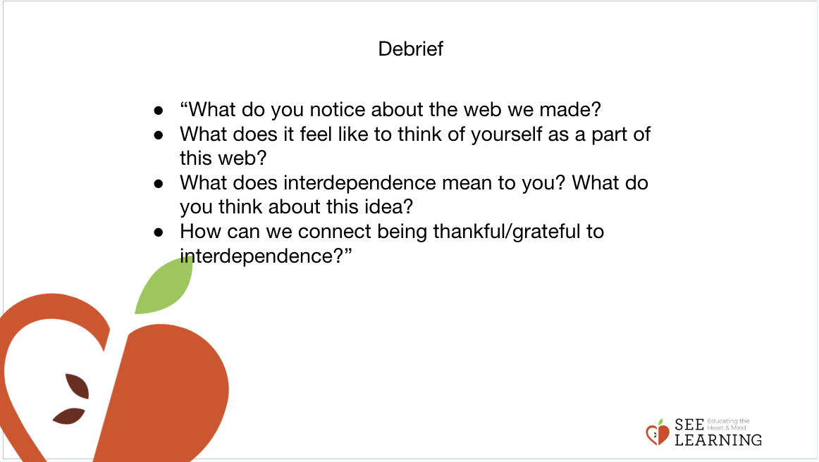 | Sample Script  - “What do you notice about the web we made?  - What does it feel like to think of yourself as a part of this web?  - What does interdependence mean to you? What do you think about this idea?  - How can we connect being thankful/grateful to interdependence?”

