Kindness as an Inner Quality

Purpose:
The focus of this fourth learning experience is to go further into the idea of kindness by exploring whether it is just outer actions or also something inside one’s heart and mind. We easily associate kindness with external activities, like giving someone food or money, saying sweet words to someone, or helping someone up when they fall. But if the intention behind those actions and words is to take advantage of the other person, then we do not see that as real or genuine kindness; nor do we see it as genuine help. For students to understand how to cultivate kindness as a disposition, which lies at the heart of SEE Learning, they will be aided by understanding that kindness goes deeper than just external actions but also refers to a state of mind and heart: one’s intention to bring help and happiness to another person.
Learning Objectives:  Students will be able to:  - Explore kindness in the context of outer actions and inner intentions and motivations.  - Recognize the distinction between real (inner, genuine) kindness and apparent kindness.  - Develop their own definition of kindness.  - Provide examples of actions that might seem unkind, but are really kind, and vice versa. | Primary Core Component  Compassion for Others  
Length  30 minutes | Materials Required  - Chart paper with “kindness” written in the middle of each  - The story provided below
Check-In | 3 minutes
Slide 2: Check In  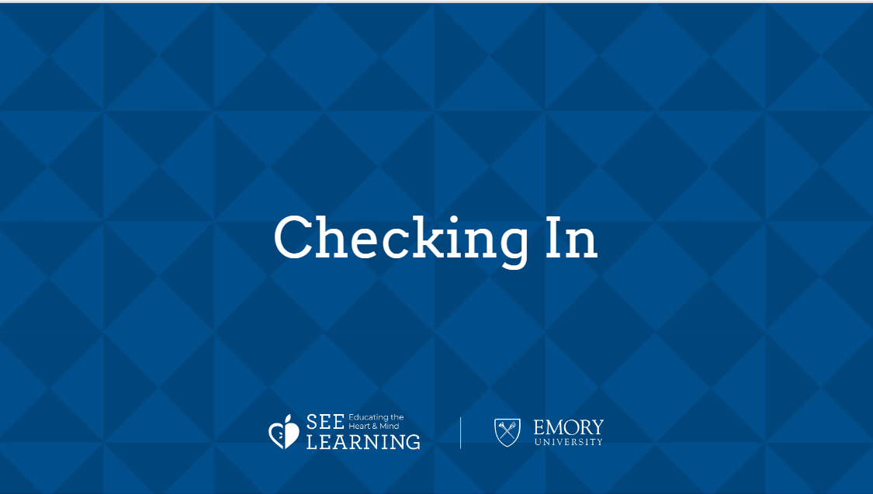 | Sample Script  - “Last time we talked about how we could create a kind, caring classroom and we created some classroom agreements. Does anybody remember some of the things we talked about and put on our list? [Allow time for sharing.]  - Today we are going to think about how can we practice kindness.”

Insight Activity: The Two Brothers and the Baby Swan (10 minutes)
Overview

In this activity, you will read a story to the students that shows how we all naturally prefer kindness, because kindness makes us feel safe and secure. A story is provided for you here that has an element that shows that kindness relates to our intentions also, and is an inner quality. If someone pretends to be kind, but really intends to take advantage of someone, then we do not see that as genuine kindness. If students come to understand that kindness is an inner quality, not just actions, then they will realize that to cultivate kindness, we need to cultivate that inner quality, not just act outwardly in a particular way.

Content to be Explored

- We all prefer kindness and want to move towards kindness and away from meanness.
- Kindness makes us feel safer and more secure.
- Kindness is an inner quality.
- Pretend kindness (outward actions without a good intention) is not genuine kindness.

Materials

- Story provided below

Instructions
- Read the story of your students.
- Facilitate a discussion. Sample questions are provided within the script for your use.
Teacher Tips
- The sample discussion questions listed in the script can help you have a discussion and encourage the students to explore the story and its various dimensions. Feel free to add your own questions and respond to the flow of the discussion.
- Allow them to share openly and remember that there are no right or wrong answers, but also keep in mind the critical insights (listed above) that you are orienting them towards. These insights have to come naturally, and it’s all right if not all the students reach all the insights at once, since they will be returned to continuously in future learning experiences.
Slide 3: The Two Brothers and the Babe Swan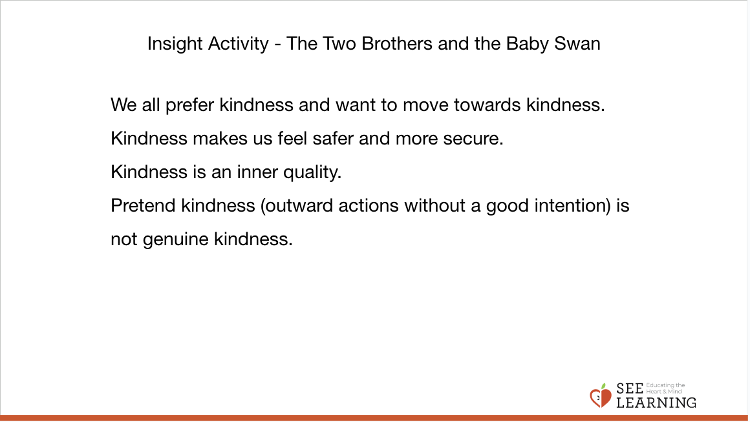 | Sample Script  - “We are going to read a story together that has to do with kindness. Sometimes people do things that look kind, but in their heart, they are not actually kind and compassionate. While I read this story, think about who is truly kind in this story and who is pretending.”  - [Read the story below.]  - “Now we’re going to talk about that story a little bit.  - What happened in the story? What are some of the things you noticed?  - How do you think the different people in the story were feeling?  - If the baby swan could talk to us, what are some things she would say? What else?  - Why do you think the swan went to the younger brother?  - Remember when the older brother was saying sweet things to the swan? What happened after that?  - Was the older brother being kind when he was saying those things? Why or why not?  - How is kindness like helping?  - If someone pretends to be kind, but inside they don’t really want to help the other person, is that really kindness? Explain your thinking.  - Is kindness just the outer action, like sweet words, or is it also something inside us? An inner quality? Explain your thinking.  - Could something that looks unkind at first, really be kind? Like if a parent says “No” to their child, is that always unkind or could it be kind? What if the child was going to do something dangerous and the parent said “No.” What do you think?”
Story | The Two Brothers and the Baby Swan
“Two brothers were playing in a park one day and when they saw a beautiful little baby swan. The older brother thought, “Oh, what a pretty bird!” and he wanted to capture the bird for himself, so he threw a stick at it. The baby swan got scared and tried to run away, but since it couldn’t fly very well yet, it had to move on its legs. The younger brother said, “Stop! Don’t hurt the bird! It’s only a baby!” and he went to go and help the swan and protect it. When he reached the swan, he petted it and offered it some food. But the older brother got angry and kept trying to chase the swan and catch it.

Then their mother came by and said, “What’s going on?”

“That bird is mine,” said the older brother, who wanted to capture the bird. “Make him give it to me!”

“No, don’t give her to him,” said the younger brother. “He tried to hurt her.”

“I don’t know what happened because I wasn’t here to see it,” said the mother. “Maybe we should let the bird decide.”

She placed the baby swan between the two boys and said to her, “Who would you like to be with?”

The older brother who had tried to hurt and capture the swan tried to call to her sweetly. “Please come to me little bird! I will take good care of you!”

But the baby swan didn’t go to him. She went over to the younger brother, who had tried to protect her.

“Look, the bird prefers you,” said their mother. “You should be the one to keep her.”

So she gave the baby swan to the younger brother, who fed it and took care of it and kept it safe.”

[The End.]

Reflective Practice: Making and Reflecting on a Definition of Kindness (10 minutes)
Overview

In this reflective practice, students will make a word map of the word “kindness.” This will
be used to develop a simple definition of kindness (one or two sentences) for use in the classroom. The students will take moments for silent reflection during the making of this definition and after making it, to allow this wider understanding of kindness to deepen in them.

Content to be Explored

- We all prefer kindness and want to move towards kindness and away from meanness.
- Kindness makes us feel safer and more secure.
- Kindness is an inner quality.
- Pretend kindness (outward actions without a good intention) is not genuine kindness.

Materials

- Chart paper or a board to write on

Instructions
- Write the word “Kindness” in the middle of a piece of chart paper or on the board.
- Then take suggestions and write the other words around the word kindness that help define what kindness is. You can use lines to connect them to the word kindness. This will create a kind of word map on the paper.
- If the students mentioned words in the discussion related to the insights listed above, but do not mention them now, you can prompt them by saying, “Remember someone said something about how kindness is an inner quality, not just words and actions. Should we add something about that?”
- Allow the students to come up with their own words and ways of expressing what kindness means.
- Come up with a once sentence definition of kindness. Since it may be difficult for the students to come up with a one sentence definition on their own, you can propose different wordings that incorporate some of the words they have provided. If necessary, you can group those words together to make it easier first.
- When you have come up with your short definition, however tentative, write it on a new piece of chart paper and allow the students a minute of silence to reflect on it.
Teacher Tips
- Don’t worry if you can’t come up with a perfect short definition right away. If you cannot come up with one in class, you can come up with one later on your own that uses the input they provided and that is now recorded on the chart paper.
- Note: Many of the reflective practices in SEE Learning involve moments of silent reflection for students to think, ponder, and internalize their insights. How long these moments should be will depend on the classroom environment and your students. They can be as short as 15 seconds or can be as long as a few minutes. You will be the best judge of the appropriate amount of time. You may find that with practice, the students will get more comfortable and familiar with these moments, and that you can prolong them for longer periods of time.

Slide 4: Reflective Practice  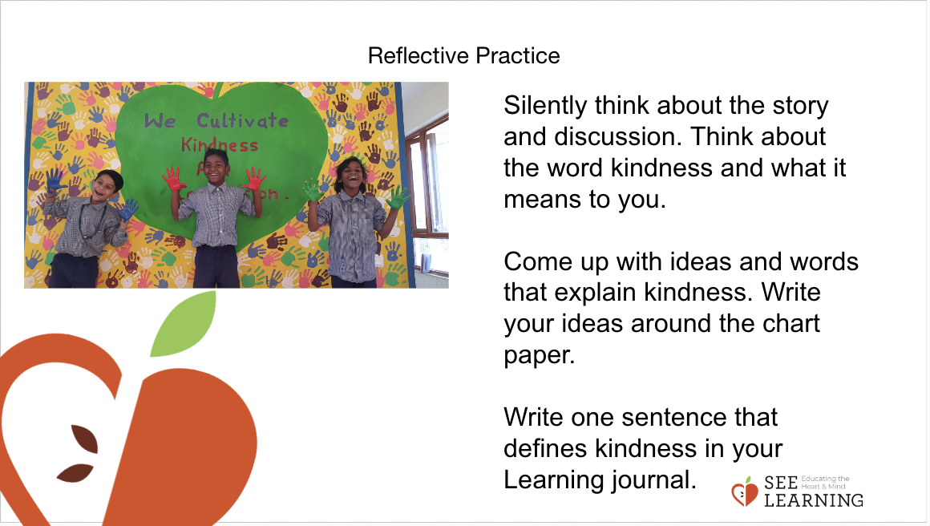 | Sample Script  - “I wonder if we could come up with one sentence to explain what kindness is. So that if someone asked us “What does kindness mean?” we could tell them.  - Let’s take a quiet moment to think about the story and our discussion about it.  - I’m going to write the word kindness in the middle of the board, and you can suggest words that are like kindness that we can use to explain what kindness is.  - What words should be put here along with kindness? What words are like kindness or help to explain kindness?  - Now we have several words up here. We’ve made a word map around the idea of kindness.  - Let’s take a moment to be silent and think about these words. Is there anything missing? Is there anything we would like to add? Don’t tell me right away. Let’s wait and think for a minute. (Allow a moment of silence for reflection. This could be as short as 15 seconds or could be longer.)  - Now that we’ve waited a little bit, why don’t you raise your hand quietly if you have something to add. If not, you can continue quietly reflecting while others are making suggestions.  - (Add suggestions as students make them.)  - Now let’s take out our kindness drawings.  - Let’s take a moment to silently look at them and think. Is there anything we notice from the drawings that we are missing in our word map? Don’t tell me right away. Let’s wait and look at our drawings and think quietly for a little bit. (Allow a moment of silence for reflection. This could be as short as 15 seconds or could be longer.)  - Now that we’ve waited a little bit, why don’t you raise your hand quietly if you have something to add. If not, you can continue quietly reflecting while others are making suggestions.  - (Add suggestions as students make them.)  - Now let’s see if we can make that one sentence explanation of kindness we talked about. How would we explain in one sentence what kindness is, using these words and ideas here? Let me try to make a sentence and you can help me.  - So now here is our explanation of what kindness is. It may not be perfect, but we can always make it better as we go along and learn more about kindness.  - Let’s take a moment to quietly read this and think about what kindness means and how important it is for us. Let’s do this silently so that we can really get a feel for kindness and what it means inside ourselves.” (Allow time for silent reflection.)

Debrief (2 minutes)
Slide 5: Debrief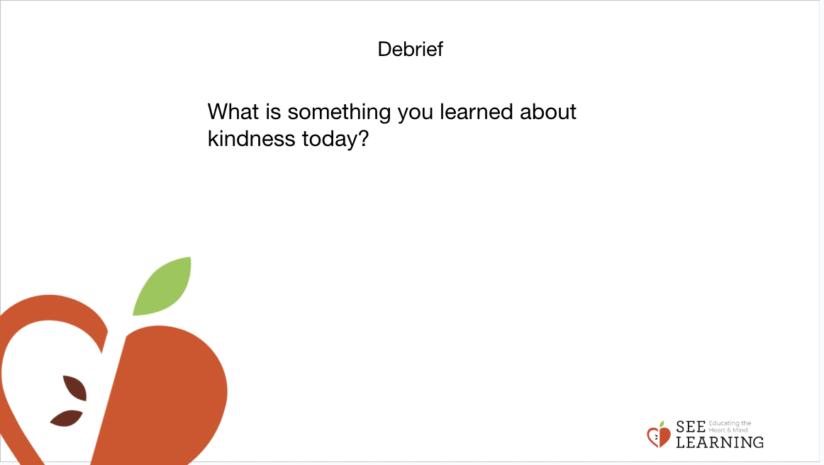 | Sample Script  - “What is something you learned about kindness today?  - Students have the choice to debrief on their own, with a partner of their choice, or in a sharing circle with the right to pass.”

