Practicing Kindness

Purpose:
The focus of this third learning experience is to build on prior learning and engage in the actual modeling and practice of kindness for experiential and embodied understanding. This involves two steps: an insight activity whereby the students translate the class agreements into practical examples that can be acted out; and then a practice activity where they act out those examples in front of each other and reflect on what they experienced. By acting out the very same items they said they wanted in the classroom, they will come to a better understanding of kindness, of their class agreements, and of how they look in practice. This process of embodied understanding should continue as the school year goes on and will make it easier to refer to the class agreements concretely throughout the year.
Learning Objectives:  Students will be able to:  - Develop specific ways of exhibiting kindness based on the class agreements  - Apply their understanding of kindness in concrete individual and collective actions | Primary Core Component  Relationship Skills  
Length  30 minutes | Materials Required  - Your class agreements listed on a piece of chart paper or on the board  - Another piece of chart paper or a board to write ideas for practicing the class agreements

Check-In (3 min)
Slide 2: Check In   | Sample Script  - “Let’s take a moment to sit quietly and rest our minds and bodies so that we can think a bit. (Pause) Maybe you are tired or full of energy, maybe it’s been a challenging morning (day) or an exciting one. Either way, it’s okay.  - Now let’s all see if we can think of any moments of kindness in the day so far. Maybe something happened at home or on your way to school or as recently as just a minute ago. See what comes up for you. Don’t worry if you can’t think of something, you can always imagine a moment of kindness too. (Pause)  - Let’s sit with your moment of kindness for a little bit.  - Would anyone like to share what they thought of?  - How did that make you feel?  - Anyone else?”

Insight Activity: Turning Class Agreements into Helping Actions (12 min)
Overview

In this insight activity, students discuss translating the class agreements concrete actions and behaviors that they can practice doing with each other, thereby making the class agreements “visible” in a direct way.

Content to be Explored

- We all want kindness and happiness
- There are specific actions we can take to support each others’ happiness.

Materials

- Your class agreements listed on a piece of chart paper or on the board
- Extra chart paper or board space

Instructions

- Ask students what each agreement look like, sounds like, and feels like when it is enacted effectively and kindly.
- As the students give examples, document what they are saying by writing or drawing the examples on a piece of chart paper and link them to the class agreements that they reflect.

Teacher Tips

- Depending on the class agreements, sometimes the actions will be obvious. In this case, ask students to give examples so that their understanding grows of how they might practice it. For example, if one of the class agreements is “Listen to each other,” you can ask them to be very specific about the actions that this would involve by asking questions like, “What does it look like when we listen to each other?” or “What do we do with our eyes when we listen? Do we look at the other person?” or “Do we talk while we’re listening to the other person or are we quiet?”
- You may not have enough time to complete all the agreements in one session, in which case you can move on to the reflective practice for now and return to this activity again later.
Slide 3: Turning Class Agreements into Helping Actions  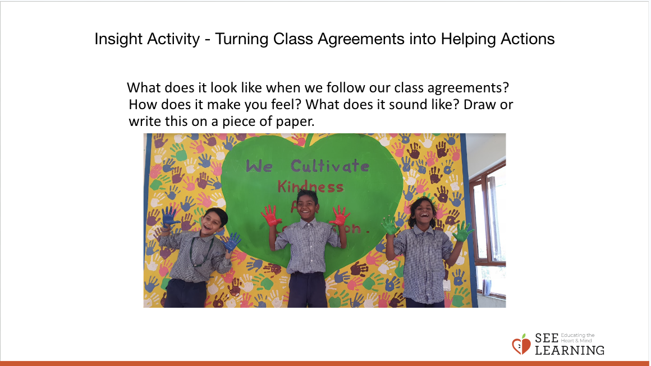 | Sample Script  - “I realized that even though we can all say ______ (Choose one from your list, for example: “help each other”) we don’t always know exactly what that looks like. Do you know the word specific? It means to make something clearer with a real example. Let’s take another look at our class agreements that we made together and see if we can be more specific about some of them.  - What would it look like to __________(help each other)? ? Can we turn the idea of ________(helping each other) into real helping actions? What does it look like when we ___________(help each other)? How do you think it makes someone feel when we do this?  - If we saw someone not __________(helping), what could we say or do?”  - Try this format with several of the class agreements. When you come to a good stopping point, you can suggest returning to the rest of the agreements during other class meeting times. Eventually you will have specific ideas connected to each general agreement.

Reflective Practice: Practice and Acting Out Kindness (10 min)
Overview

In this reflective practice, the students will act out the helping actions they just created.

Content to be Explored

- We all want kindness and happiness.
- There are specific actions we can take to support each others’ happiness.

Materials

- The group agreements
- The list of concrete actions and behaviors created in the previous insight activity

Instructions

- Model the activity first yourself. Start by selecting the helping actions that you feel are most concrete and easy to model. Then ask for two or three volunteers to model the helping actions.
- Next, ask for a volunteer who can pretend to be in need of helping and one or two students volunteer to see that need and engage in the helping actions. Have the volunteers can stand up and act out a scenario in front of the class.
- Other students should be asked to watch quietly and closely so that they can share later what they saw.
- After the scenario has been acted out, which may only take a minute, allow those who volunteered to share what they saw and felt.
- Then ask the students who observed what they saw and felt.
- Then do another example of that helping action or move on to the next helping action and do a scenario modeling that one.
- Repeat for all of the group agreements.

Teacher Tips

- In some cases, there won’t be a particular person in need, but you can create other scenarios that might arise in the classroom related to that class agreement and the helping actions that came from it.
- You may find that 10 minutes is not enough time to practice all the helping actions that were generated during the previous insight activity. You can repeat this reflective practice several times, each time emphasizing different class agreements or activities
Slide 4: Practicing and Acting Out Kindness  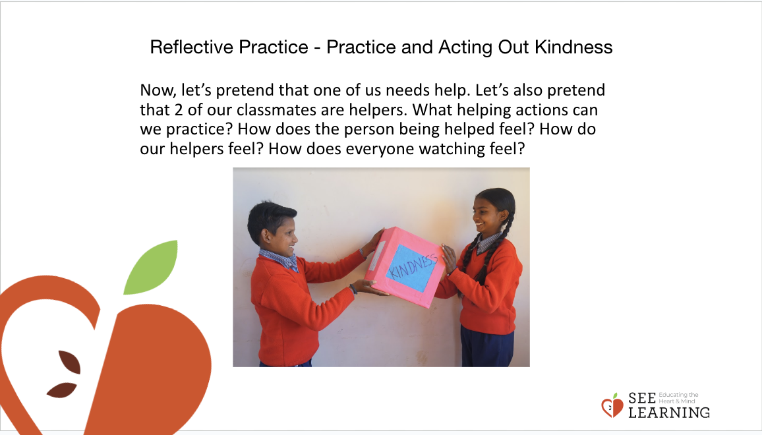 | Sample Script  - “You all came up with a lot of ideas on how we can help each other here in the class. Now we can see more clearly what these class agreements will look like.  - It might be even clearer if we practiced a few of the helping actions we just talked about.  - Maybe we can pretend that one of us needs help and we can see what helping actions we can practice? Which helping action should we start with? Would two or three of you come up here to do the helping action?  - I’ll start by being the person who needs some help. Then those of you who came up here can practice this helping action when you see that I need help. [Act out a scenario.]  - That was great! Now I’ll tell you what I felt. [Share a statement about what it felt like to be helped in that way, such as “It made me feel happy,” or “It made me feel better,” or “It made me feel safer.”]  - Now I’d like to ask those who helped me. What did it feel like for you to help me in that way?  - Now I’d like to ask those of you watching. What did you see and feel?  - Now maybe one of you could be the person who needs some help and we could try some other helping actions.”

Debrief (4 min)
Slide 5: Debrief  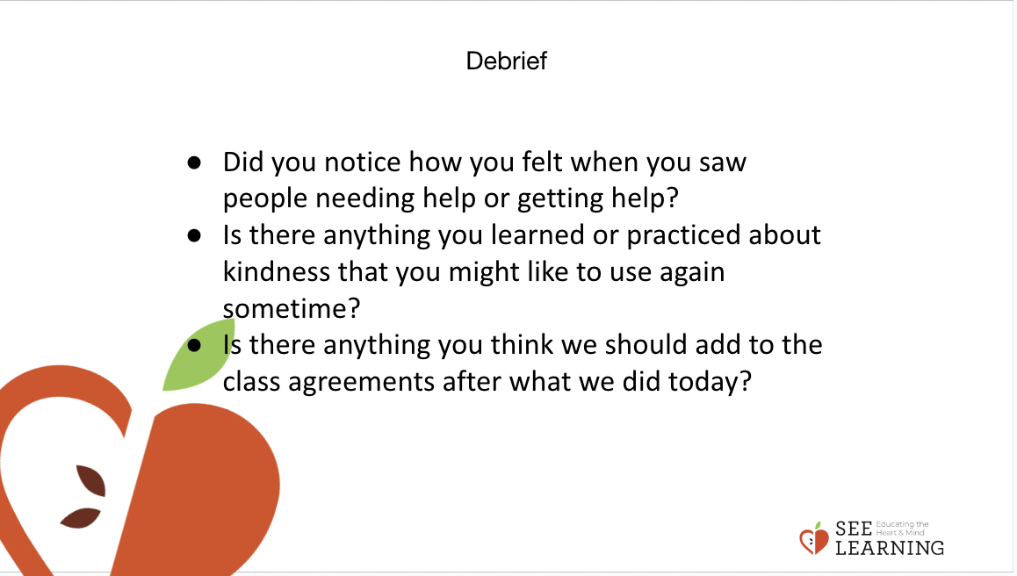 | Sample Script  - “Let’s take a moment to sit and think about what we just saw and felt.  - Did you notice how you felt when you saw people needing help or getting help? It often feels good not just to get help but to give it, and even to see someone being helped. It can make us feel happier and safer when we are helped by others and when they show us kindness.  - Is there anything you learned or practiced about kindness that you might like to use again sometime?  - Is there anything you think we should add to the class agreements after what we did today?”

