Habits of a System’s Thinker: Considering Impact

Purpose:
In this learning experience, students will continue to examine a system/issue of their choice. Students will continue to engage in systems thinking by practicing ethical discernment when considering the impact of personal and group choice and responsibility within a system. Students will consider both short- and long-term consequences of actions, identifying possible root causes of a problem, noticing unintended consequences and devising possible solutions to the problem. The final reflection will prompt them to investigate the downsides of not engaging in systems thinking and the benefits of being a systems thinker
Learning Objectives:  Students will be able to:  - Engage in systems thinking when considering both short- and long-term consequences of actions, identifying a possible root cause of a problem, and notice unintended consequences.  - Practice ethical discernment when considering the impact and responsibility of an individual or group choice.  - Cultivate a sense of connection to others and a sense of purpose to support their wellbeing just as they support yours. | Primary Core Component  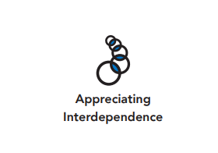  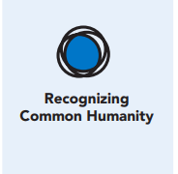
Length  45 Minutes | Materials Required  - Chart paper and markers  - Completed Exploring Complex Issues or Achievements handout in Chapter 7, Learning Experience 4  - Cell Phone Issues Example  - Negative Self-talk Example 45 minutes  - Impacts and Solutions handout

Check-In (5 min)
Slide 2: Check-In  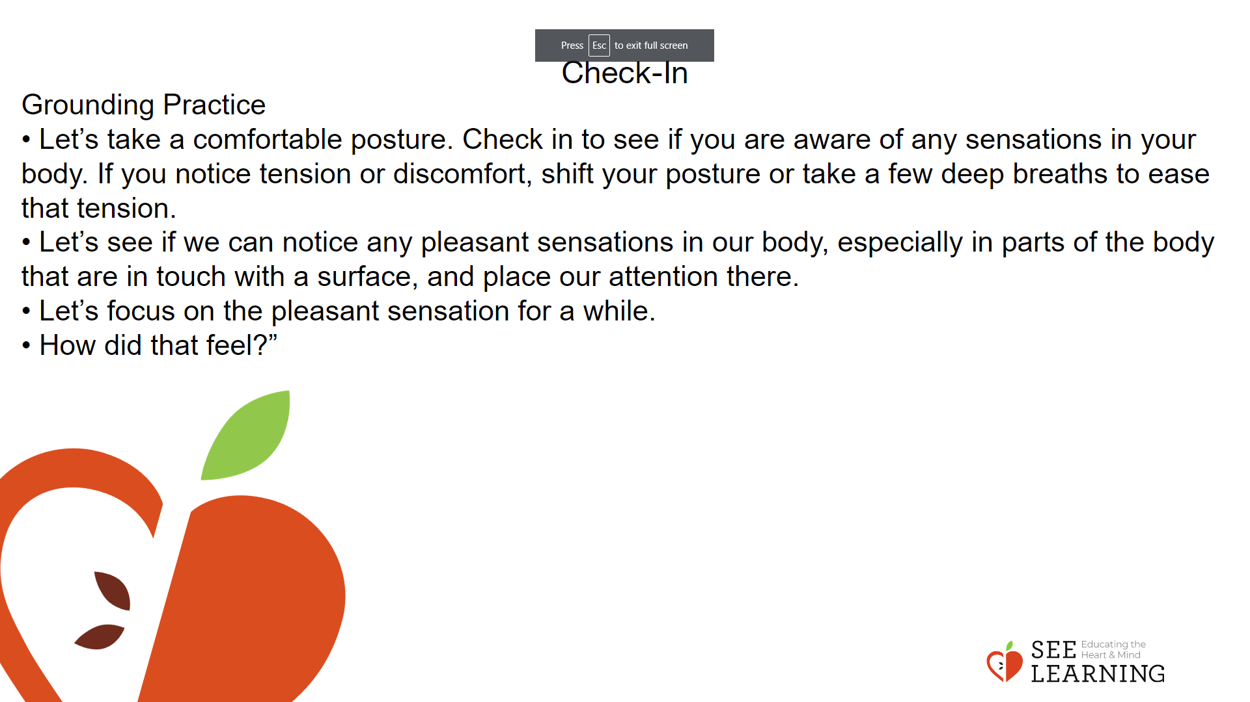 | Instructions and Guided Language  [PAUSE]s can be up to 10 seconds each  Grounding Practice  Guiding Language  • “Let’s do grounding practice together. If at any time you feel uncomfortable, feel free to do a resourcing practice instead.  • Let’s take a comfortable posture. Check in to see if you are aware of any sensations in your body. If you notice tension or discomfort, shift your posture or take a few deep breaths to ease that tension.  • Let’s see if we can notice any pleasant sensations in our body, especially in parts of the body that are in touch with a surface, and place our attention there. Stay with any pleasant or neutral sensation for 10-15 seconds. [PAUSE]  • If the stability of the chair gives you comfort, let that be your grounding point. [PAUSE]  • Let’s focus on the pleasant sensation for a while. [PAUSE] • If the sensation is or becomes unpleasant, try to shift your attention to another sensation that is more pleasant. • How did that feel?”

Presentation/Discussion(10 min)

Overview
Thinking about impacts and consequences is an important habit of a systems thinker. Reflecting on consequences of one’s choices, decisions, and actions, be it short-term effects or longterm, could help students connect their actions with consequences and thus develop an ethical discernment

Teaching Tip
Emotional intelligence is being able to notice and choose to impact your emotional state. One’s emotional state includes emotions such as fear, anger, sadness, hope, loneliness, joy, and compassion. Regulation of one’s emotional state is essential for a healthy life and healthy interactions with others. The following strategies can help return you to your well-being zone: grounding, resourcing, and self-compassion.

Slide 3: Presentation/Discussion  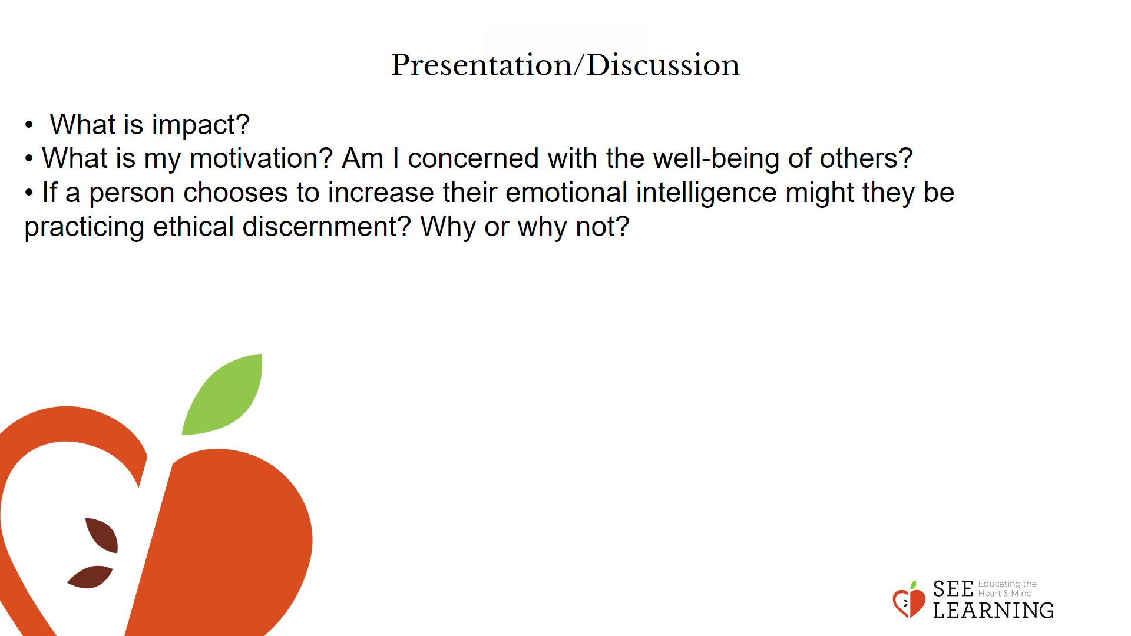 | Instructions and Guided Language  After defining impact, use the prompts to engage the class in discussion:  “What is impact?  • When we impact something we cause a direct effect on it. Our everyday choices can have short- and long-term impacts on the systems we are a part of.  • Considering the impact of one’s decisions and actions is an important habit of a systems thinker.  When we consider impact and allow it to guide our actions we are practicing ethics.  When we engage in ethical discernment or value-based decision making, we can ponder the following questions:  • What choices do I have related to this decision?  • What are some likely outcomes of those choices?  • Which course of action will most likely yield long-term benefits for oneself and others?  • What is my motivation? Am I concerned with the well-being of others?”  Engage the class in a discussion by using the following prompts and questions:  • “How do our personal choices impact the greater systems we are a part of? Let’s consider this question by looking at emotional intelligence. Can we make choices to increase our emotional intelligence? What are they? Our overall health and well-being? Our interactions with others and our relationships? Our success at work?  • We each have a choice as to how we care for our nervous system. Intentionally increasing our emotional intelligence impacts our own health and well-being and our ability to have positive and meaningful interactions with others. All people experience challenges and emotions. Many people notice and are able to describe times when they feel happy, sad or angry. Some people have grown their ability to recognize a wide range of emotions and are skilled at knowing what may contribute to feeling that way.  • And some people have practiced being able to consistently recognize their feelings in the moment, name them and pause (stop before acting), in a way that helps them take care of themselves and interact with others in healthy and productive ways. Everyone has the potential to do this. How does the way we care for our nervous system and choosing to support growing our emotional intelligence influence systems? Personal? Local?  • The choices we make every day impact personal, local and global systems. If a person chooses to increase their emotional intelligence might they be practicing ethical discernment? Why or why not?

Insight Activity - (20 mins)

Activity Overview
In this insight activity, students will further explore the issue they have identified in the last two lessons and analyze the impacts of our choices on the issue and evaluate possible solutions to the problem.

Slide 4: Insight Activity  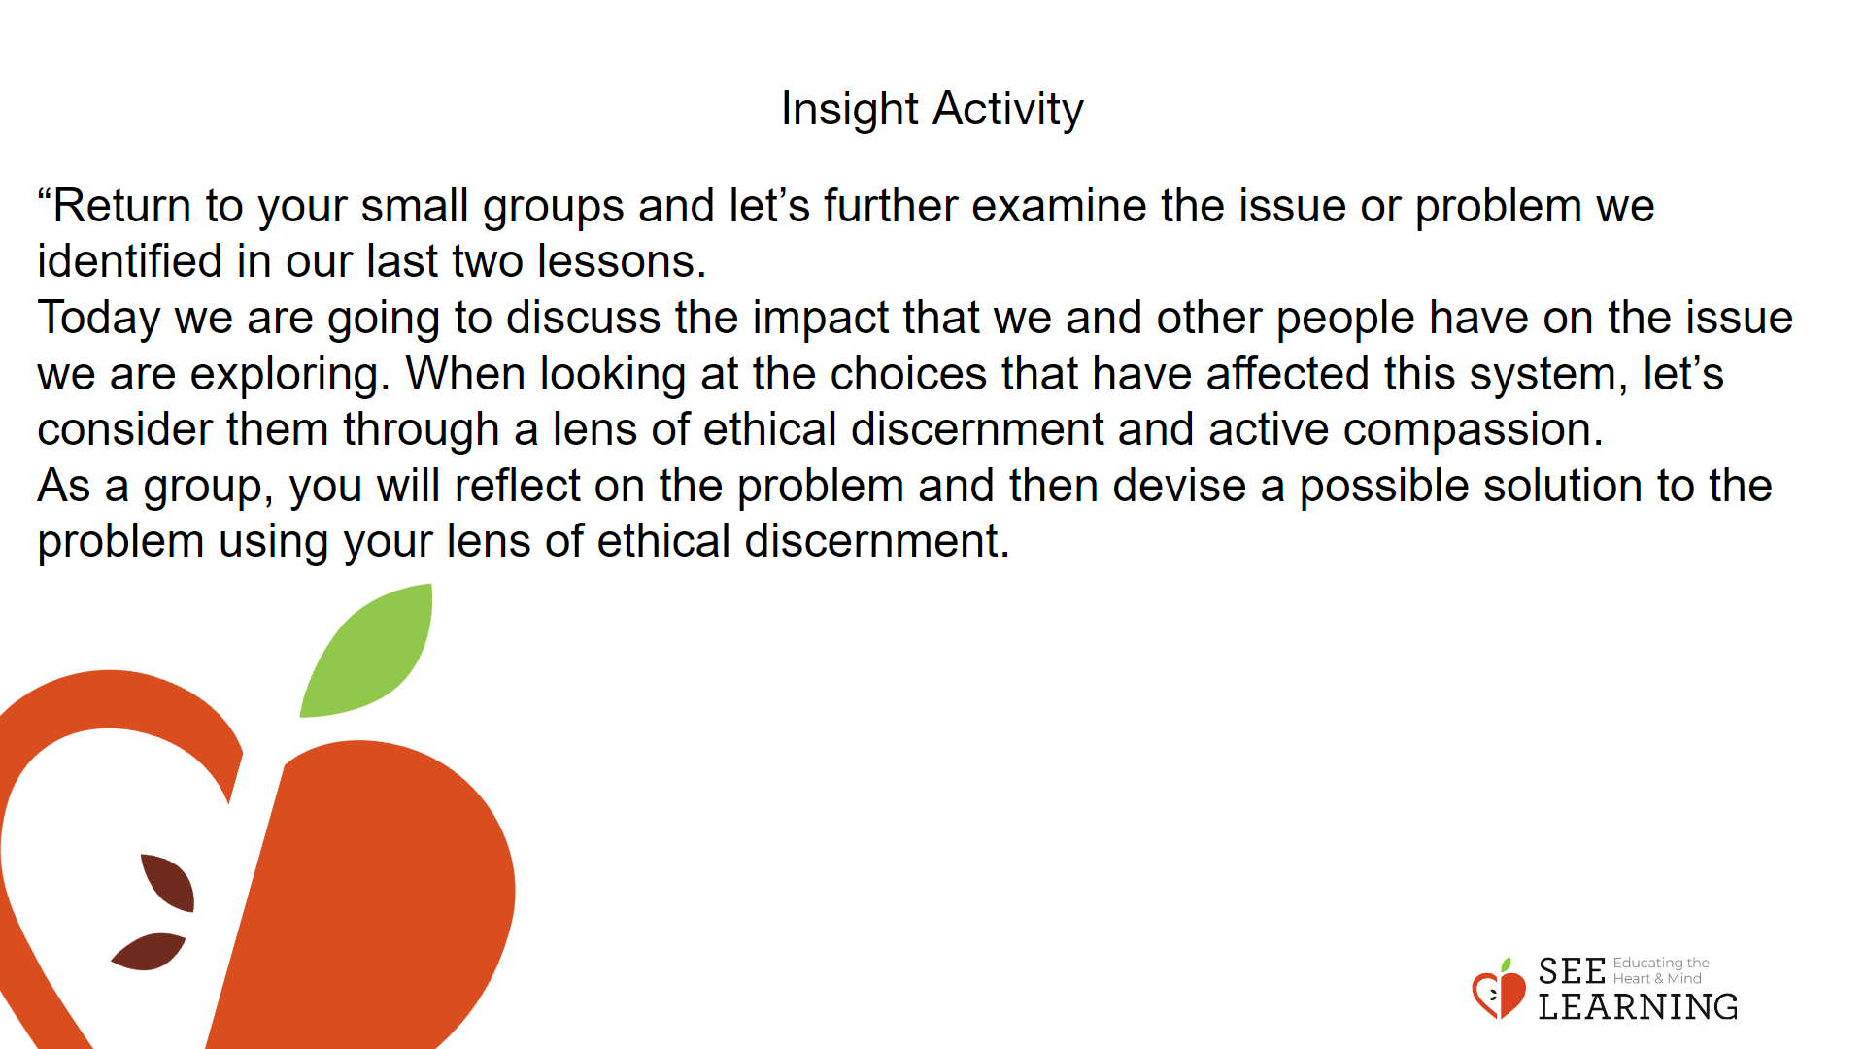 | Instructions and Guided Language  If possible, allow students to be in the same groups as in the previous lesson. Introduce the Impacts and Solutions document. Model the process by reviewing the document with one example, Impacts and Solutions together as a class and then ask students to return to their groups to complete the document.  The document has two parts: Part A asks students to consider the impacts of our choices on the issue and Part B asks students to devise possible solutions to the problem. Part A will have 10 minutes and B will have 10 minutes. “Return to your small groups and let’s further examine the issue or problem we identified in our last two lessons.  Today we are going to discuss the impact that we and other people have on the issue we are exploring.  When looking at the choices that have affected this system, let’s consider them through a lens of ethical discernment and active compassion.  As a group, you will reflect on the problem and then devise a possible solution to the problem using your lens of ethical discernment.”

Reflective Practice (10 mins)
Slide 5: Reflective Practice  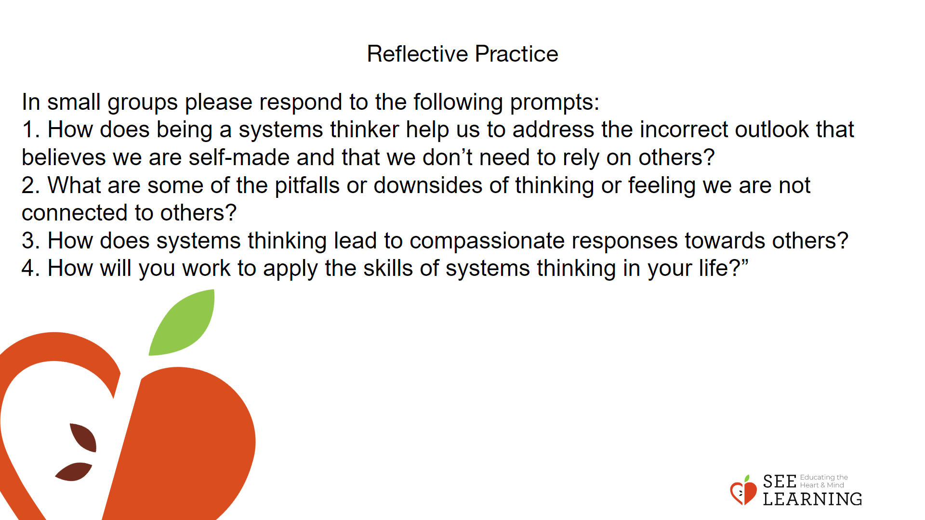 | Instructions and Guided Language  Students select one question to discuss within a small group and share out with the whole class.  This reflection engages students in a small and then whole group discussion. The aim of this reflection is for students to see the downsides and benefits of being a systems thinker through the lens of relationships and feelings of connection with others.  Through their discussion, students should identify that a lack of systems thinking can lead people to experience loneliness which can lead to an erosion of trust towards others and suspicion of intentions. This hinders our ability to trust others and work collaboratively with them.  Whereas being a systems thinker reminds us of the connections we have with others and cultivates both a sense of appreciation and gratitude towards others.  Having developed our understanding of ethical discernment and having gained experience with it, we can begin to apply it throughout our life. We can also embrace the insights garnered from being a systems thinking as we foster gratitude, appreciation, and a sense of connection to others.  In small groups please respond to the following prompts:  1. How does being a systems thinker help us to address the incorrect outlook that believes we are self-made and that we don’t need to rely on others?  2. What are some of the pitfalls or downsides of thinking or feeling we are not connected to others?  3. How does systems thinking lead to compassionate responses towards others?  4. How will you work to apply the skills of systems thinking in your life?”

