Developing Holistic Perspective

Purpose:
In this learning experience, students will work in small groups to analyze a complex issue that affects them, and see how the same issue could be perceived in different ways, noticing that each perspective can help in finding solutions. They will practice considering all of the facts of the issue by engaging in holistic perspective taking with the goal of approaching each other with curiosity and practicing mindful listening to truly consider each other’s perspectives.
Learning Objectives:  Students will be able to:  - Develop big picture thinking skills by considering issues on personal, local, regional, and global levels  - Recognize how people perceive and experience the same issues, events or things in different ways | Primary Core Component  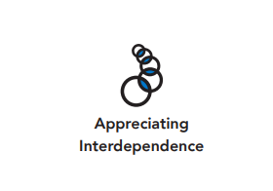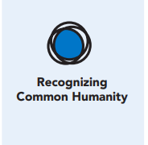
Length  45 Minutes | Materials Required  - Chart paper  - Markers

Check-In (5 min)

Slide 2: Check-In  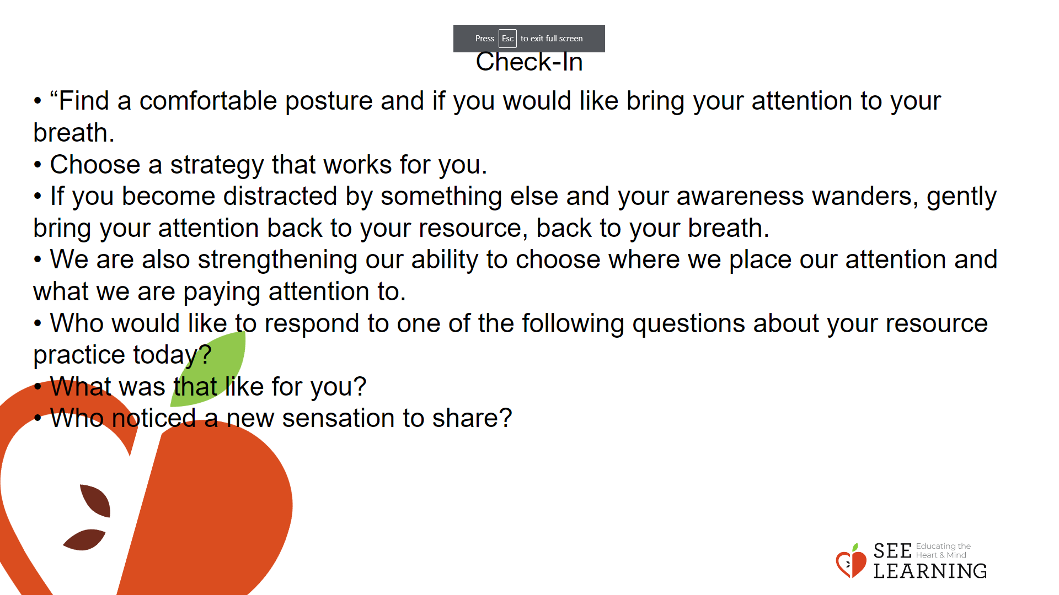 | Instructions and Guided Language  [PAUSE]s can be up to 10 seconds each  Resourcing Practice Guiding Language  • “Find a comfortable posture and if you would like bring your attention to your breath.  • Choose a strategy that works for you. You may notice the breath moving in and out at the base of the nostril, you may notice the belly and chest rising and falling with the inhale and exhale or you might just feel the breath moving more slowly and deeply into the body. [PAUSE]  • For the next few moments, do your best to focus on a resource of your choice.[PAUSE]  • If you become distracted by something else and your awareness wanders, gently bring your attention back to your resource, back to your breath. [PAUSE]  • We are also strengthening our ability to choose where we place our attention and what we are paying attention to.  • Take one more deep breath in and as you breathe out open your eyes if they are closed.  Who would like to respond to one of the following questions about your resource practice today?  • What was that like for you?  • Who noticed a new sensation to share?  • Who has a thought or insight to share?”

Presentation/Discussion (10 min)

Overview
Students will learn about perspective taking, how to cultivate holistic perspective and the benefits of having holistic perspectives.

Slide 3: Presentation/Discussion  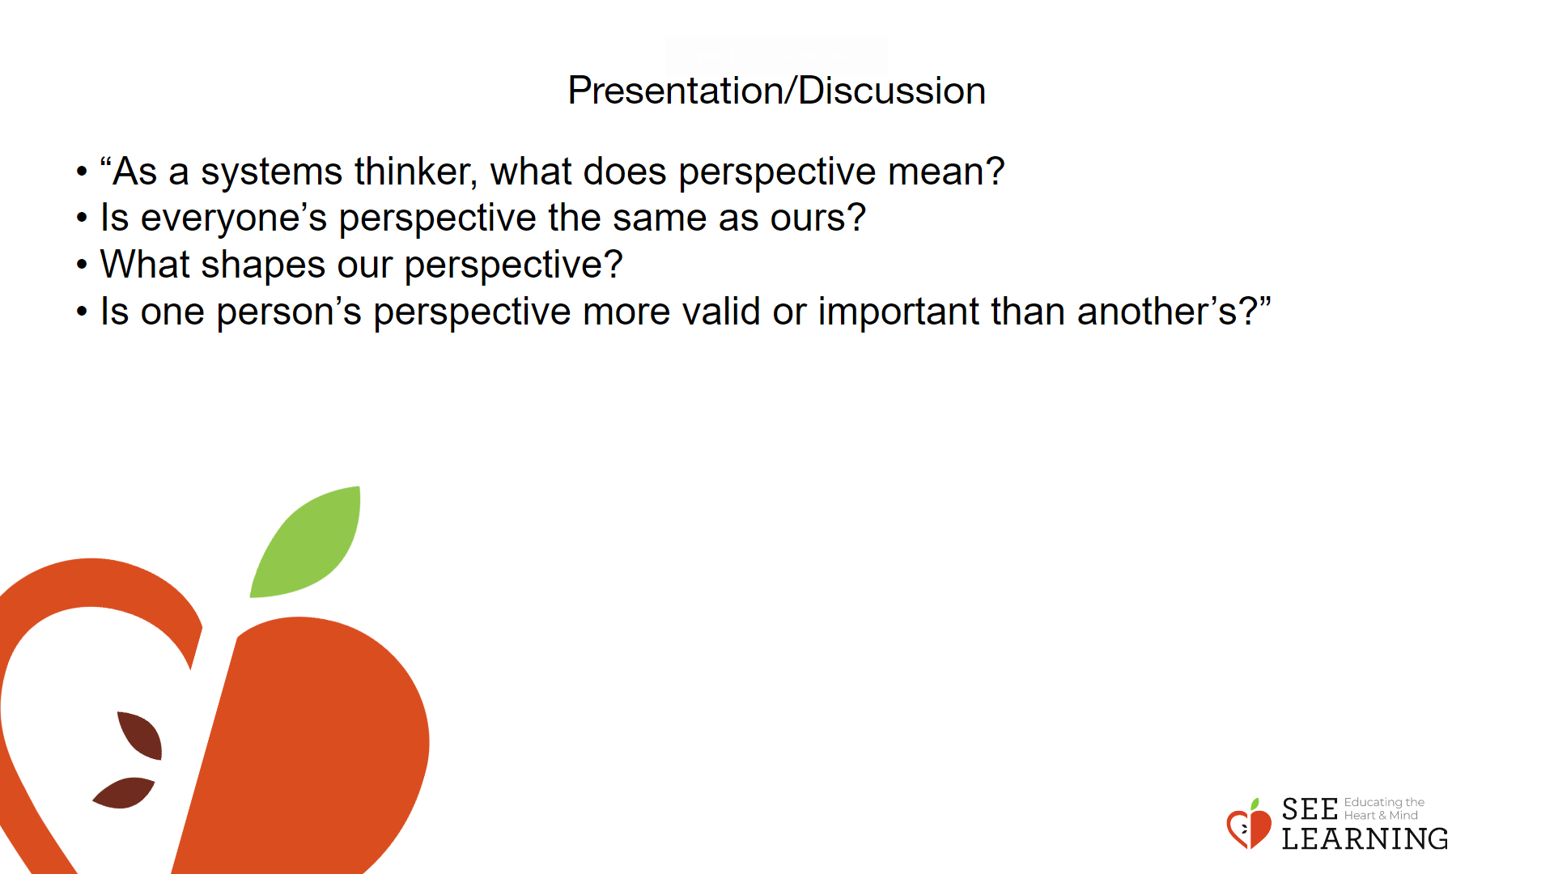 | Instructions and Guided Language  Use the following questions and prompts to engage the class in discussion:  • “As a systems thinker, what does perspective mean?  • Is everyone’s perspective the same as ours?  • What shapes our perspective?  • Is one person’s perspective more valid or important than another’s?”  Using the ideas in the discussion and the definition, offer/create a definition.  “For example: Perspective is the way that one looks at something. Our perspectives differ based on our personal beliefs and experiences. We can bring very different perspectives, thoughts and ideas to the same experience or idea.  Let’s do a check in to illustrate this point. Come up to the board and write a few words about how you feel about rainy days.  Review the answers and notice if there are different responses to a rainy day. Now let’s look from another’s perspective:  • How might a farmer feel about a rainy day?  • People who are living in a drought?  • People living in a tropical rainforest?  • A highway construction worker?  • A family who are about to go on vacation?  When we can look at something from many points of view, we are exercising “holistic perspective taking,” an aspect of systems thinking. We are looking at the big picture from different angles which is one key habit of a systems thinker. Taking a holistic perspective is one way we can think in “big picture terms.” A holistic perspective can:  • allow us to understand complex issues more deeply, and thus find better solutions.  • help us understand others better and have empathy and compassion for them  • help us cultivate humility so we can learn from others  • help see through thinking traps that come from a limited perspective  • help us regulate our emotions if we were seeing things too narrowly or taking our limited perspective as absolute”  Conclude by saying the following to your class:  “Applying a holistic perspective to a problem can help you explore all sides of an issue and address it better. This can be beneficial for increasing knowledge, empathy, and well-being.”

Insight Activity - (20 mins)

Activity Overview
In this insight activity, students will analyze an issue from multiple angles and form a bigger picture. They will practice considering all of the facts of the issue by engaging in holistic perspective taking with the goal of approaching each other with curiosity and practicing mindful listening to truly consider each other’s perspectives.

Teaching Tips
Remember that you and your students come from diverse backgrounds and experiences. This can shape current understandings of an issue. By applying a holistic perspective, students can learn to analyze different contexts and the implications they might bring, from both local and global perspectives.

Slide 4: Insight Activity  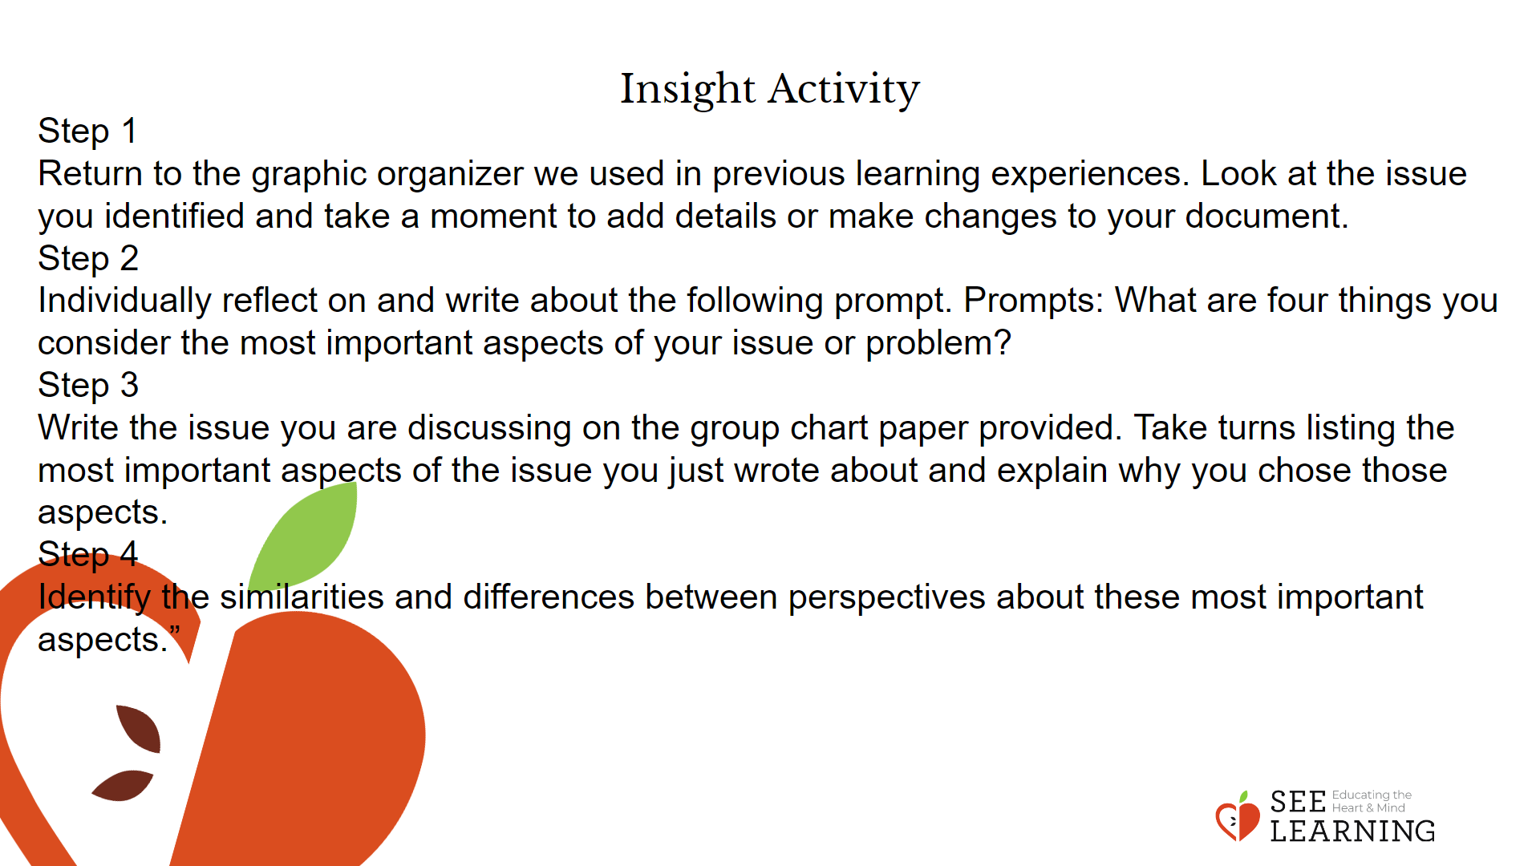 | Instructions and Guided Language  If possible, put students in the same group.  “Please form small groups. We will continue engaging in systems thinking by looking at the issue we chose in previous learning experiences from different angles to develop a more holistic perspective.  When we use holistic perspective-taking, we engage in big-picture thinking. We consider diverse facts about the issue. When we engage in holistic perspective-taking, we are not trying to convince each other or come to a consensus. We aim to approach each issue with curiosity, practice mindful listening to hear other people’s perspectives, and open our minds to all the facets of the issue. You will engage in systems thinking in your groups by challenging yourself to use holistic perspective-taking and big-picture thinking.  Process  Step 1  Return to the graphic organizer we used in previous learning experiences. Look at the issue you identified and take a moment to add details or make changes to your document.  Step 2  Individually reflect on and write about the following prompt.  Prompts: What are four things you consider the most important aspects of your issue or problem? (Examples may include: who is affected by the issue, how widespread is the issue, what makes it significant, what its consequences are, who are the parties involved, etc.  Step 3  Write the issue you are discussing on the group chart paper provided. Take turns listing the most important aspects of the issue you just wrote about and explain why you chose those aspects. Notice how others’ understanding of the issue differs from one’s own.  Step 4  Identify the similarities and differences between perspectives about these most important aspects.”

Reflective Practice (10 mins)

Teaching Tips
Have your students choose between writing this prompt in a journal or discussing it in pairs.

Slide 5: Reflective Practice  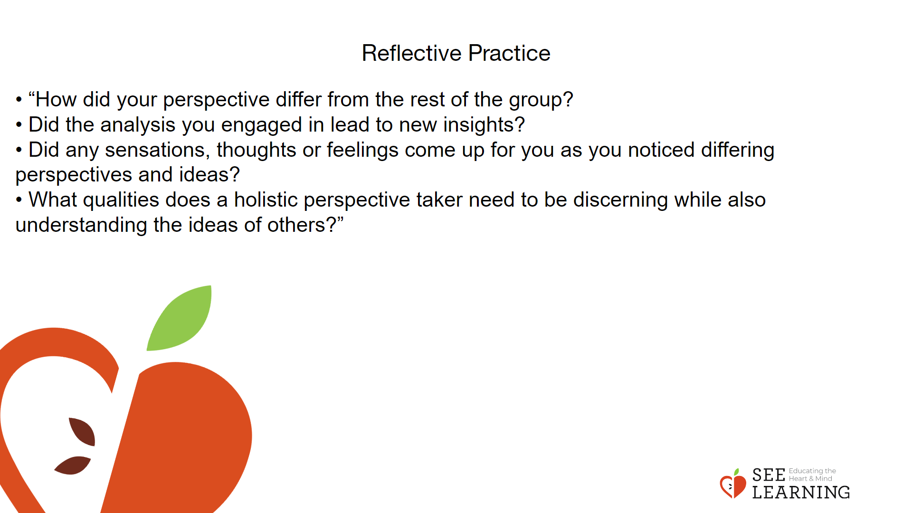 | Instructions and Guided Language  Ask students to write on the following questions:  • “How did your perspective differ from the rest of the group?  • Did the analysis you engaged in lead to new insights?  • Did any sensations, thoughts or feelings come up for you as you noticed differing perspectives and ideas?  • What qualities does a holistic perspective taker need to be discerning while also understanding the ideas of others?”

