Understanding Complex Issues

Purpose:
In this learning experience, students will identify and explore personal, local and global systems, and understand the benefits and problems related to such systems. Students will choose one complex issue to explore more deeply and use systems thinking to address the issue. This learning experience will enable students to apply the skill of discernment as they work to understand systems at different levels.
Learning Objectives:  Students will be able to:  - Continue exploring systems by brainstorming and categorizing personal, local and global systems  - Describe the benefits that come from certain systems as well as the complex issues and problems that can exist within those systems  - Discern how issues affect larger systems, social structures and personal wellbeing | Primary Core Component  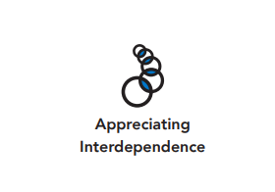  
Length  45 Minutes | Materials Required  - Chart paper  - Markers  - Writing utensils and paper  - Exploring Complex Issues or Achievements handout

Check-In (5 min)

Overview
Lead your students through a resourcing practice. You can use the following script to lead the resourcing practice. Use a timer if needed. Pauses can be up to 10 seconds each.

Slide 2: Check-In  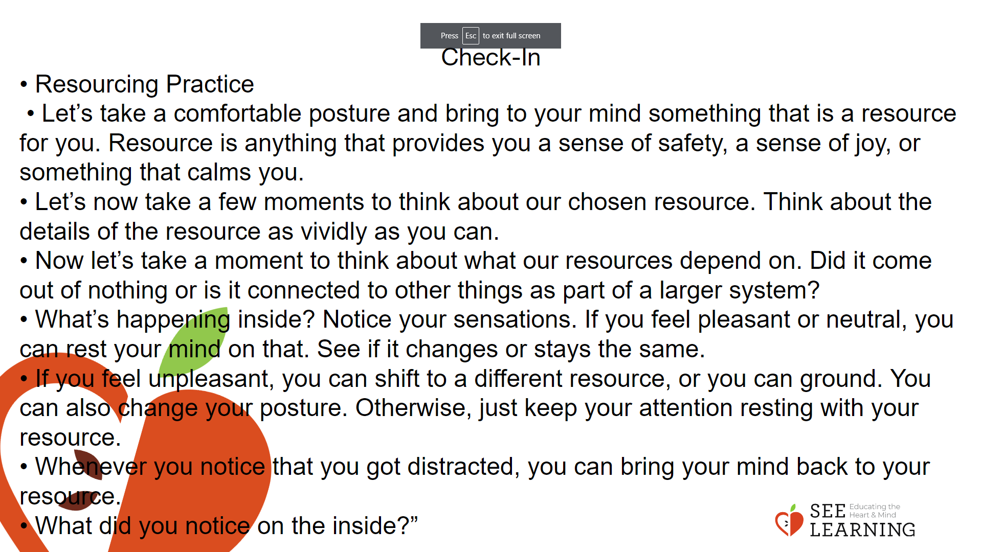 | Instructions and Guided Language  “We will start with some resourcing practice.  • Let’s take a comfortable posture and bring to your mind something that is a resource for you. Resource is anything that provides you a sense of safety, a sense of joy, or something that calms you. It can be a kindness that you have received, or a kind act that you have shown to someone else. Or it can be something else.  • If you’d rather do grounding, find a comfortable way to sit or something comfortable to hold or touch and bring your attention to the point of contact.  • Let’s now take a few moments to think about our chosen resource. Think about the details of the resource as vividly as you can. [PAUSE]  • Now let’s take a moment to think about what our resources depend on. Did it come out of nothing or is it connected to other things as part of a larger system?  • What’s happening inside? Notice your sensations. If you feel pleasant or neutral, you can rest your mind on that. See if it changes or stays the same. [PAUSE]  • If you feel unpleasant, you can shift to a different resource, or you can ground. You can also change your posture. Otherwise, just keep your attention resting with your resource. [PAUSE]  • Whenever you notice that you got distracted, you can bring your mind back to your resource. [PAUSE]  • What did you notice on the inside?”

Presentation/Discussion (15 min)

Overview
Students will deepen their understanding of systems by exploring them at different levels: personal, local and global. They will examine complex issues, identify contributing factors causing them, and analyze how such issues can affect us at personal, social and systems level

Teaching Tips
If you have students struggling to understand this concept, perhaps just analyze each system for its benefits and potential problems. Remind students of the definition of a system and how we can use the systems checklist to explore something as a system. The following are some other examples that you can use for these three categories. Under the personal category, you can have the nine systems of the human body, or the whole organism. Under the local or social category, you can have a family or neighborhood; under the global category, a government. A key insight is that the systems checklist isn’t simply a way of determining if something is a system, since anything (even an atom, or a person) can be explored as a system. It’s therefore a way of exploring anything as a system, since systems thinking is a skill that can be applied widely to many aspects of life.

Slide 3: Presentation/Discussion  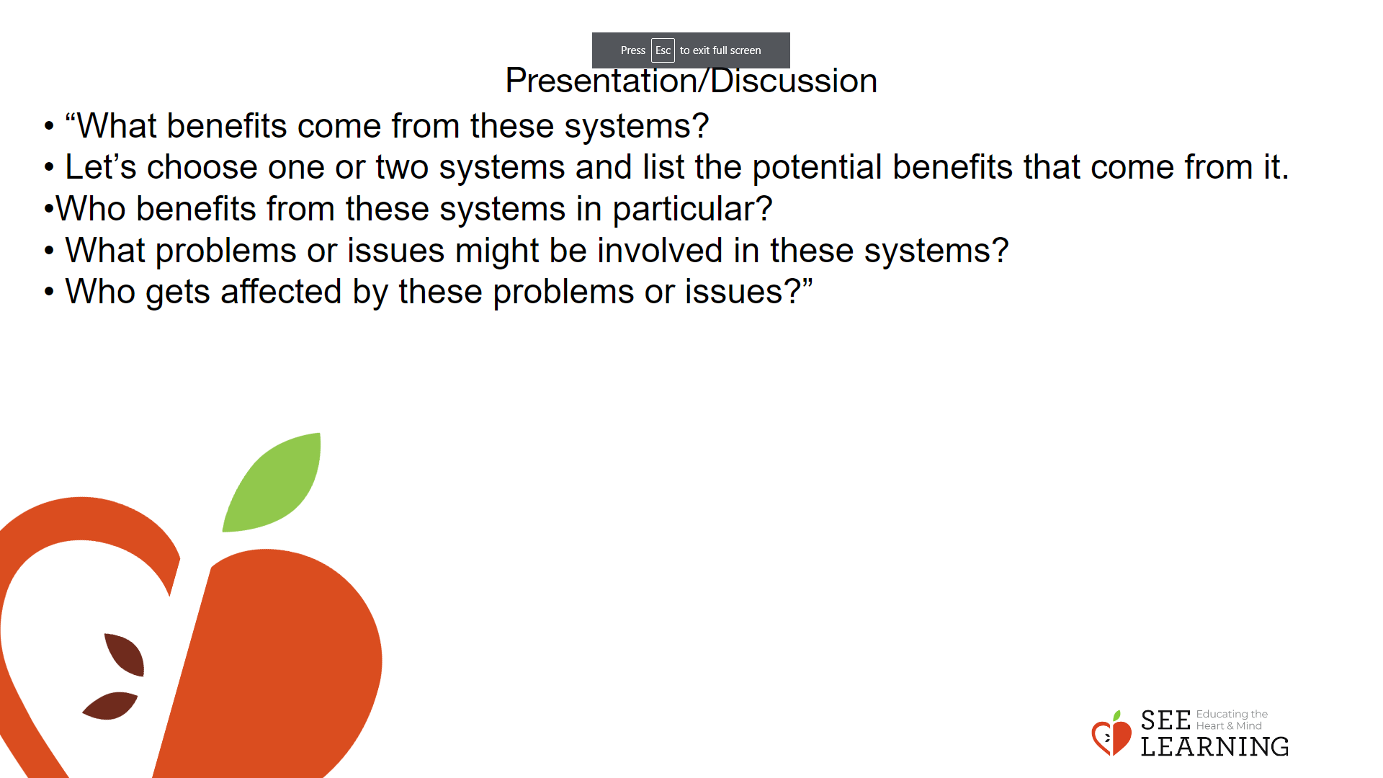 | Instructions and Guided Language  Display this table of systems at three levels and engage students in an active discussion using the prompts and questions below. There can be many ways to categorize systems. Here we use the personal, local and global as three categories of systems. Local could be a small social group such as a class, a school or a community in one’s locality, and global a much larger system up to worldwide.  Students will work in small groups and have 3 -5 minutes to list as many examples of personal, local and global systems as they can. One example for each category has been provided in the chart.  Personal Local Global A student A school An educational system  Introduce the table and together as a class. Generate 1-2 examples of each type of system. Then each small group generates additions to each category.  After 3-5 minutes have passed, ask groups to share what they found and record ideas on a class chart/the board. Finally ask students the following debrief questions:  • “What benefits come from these systems?  • Let’s choose one or two systems and list the potential benefits that come from it. (Write these on the board or ask students to write benefits in their small groups.)  • Who benefits from these systems in particular?  • What problems or issues might be involved in these systems? (Write these on the board or ask students to write benefits in their small groups.)  • Who gets affected by these problems or issues?

Insight Activity - (15 mins)

Overview
In this insight activity, students will study complex issues as systems and analyze contributing factors, how the issues affect us and ways to address the issues.

Teaching Tips
A good example of a complex issue that students can easily relate to might be the issue of how to prevent or minimize food waste. It happens at all stages of the food system — production, processing, distribution, retail and consumption — and in all the countries around the world. This issue is multifaceted, which would allow students to analyze it in various ways. They could complete the graphic organizer by viewing food waste at home, school, their local community, or nationally. Remind students of your class strategies for assuring that all voices are heard in the group.

Slide 4: Insight Activity  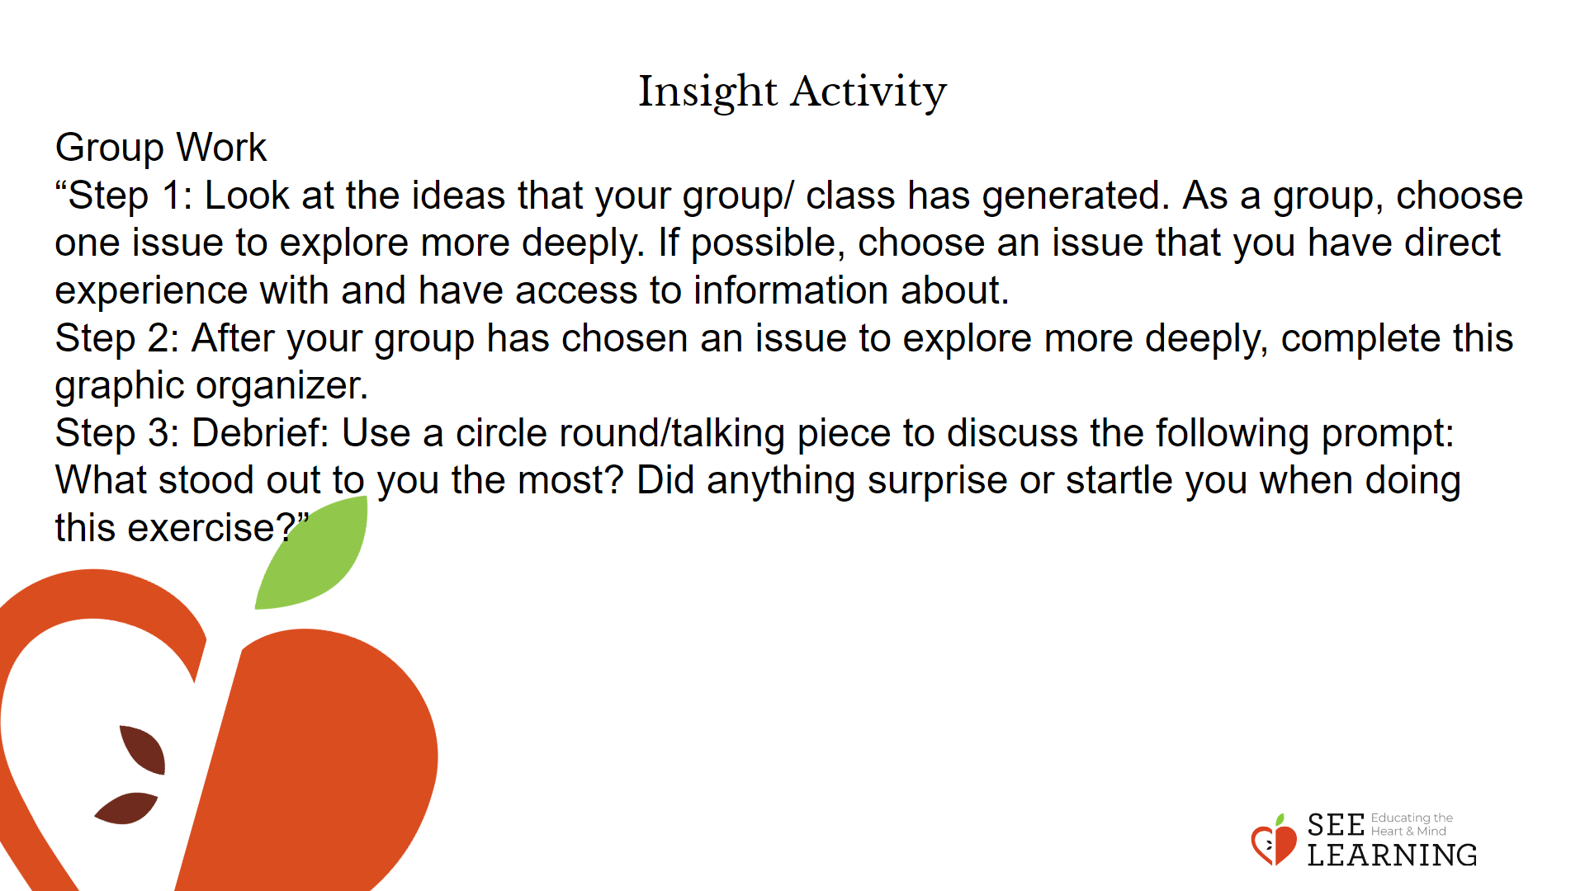 | Instructions and Guided Language  This insight activity has two parts. In the first part, students will work in groups to come up with several examples of complex issues and fill the table given below. Each group will then choose one issue to explore further using a graphic organizer.  “A complex issue is an issue that can be approached from multiple perspectives and may have multiple possible solutions. We can use systems thinking to explore complex issues, analyzing which systems are involved and how, if we change one part in one system, we affect other parts in the system or in other systems. When we apply systems thinking to complex issues or problems, we can identify possible solutions for them.  Let’s return to our groups and each group will come up with a list of three complex issues. Specifically, you will think of three things you think would be beneficial on a personal, social or systems level. Then apply discernment to consider how actions can be engaged in on each level (personal, social, and systems) to address those issues.  For the first prompt, examples could be benefits:  • Systems level: you might list “ending food poverty” or “eliminating discrimination”  • Social level: you might list “feeling a strong sense of community pride”  • Personal level: you might list “more selfconfidence” or “better health”  For the second prompt, examples could be on using discernment to address the issue identified:  • Systems level: you might list “joining a coalition to address food insecurity” or “voting for anti-discrimination policy”  • Social level: you might list “developing a community event”  • Personal level: you might list “developing a new skill” or “eating healthier””  After 3-5 minutes have passed, ask groups to share what they found and record ideas on a class chart/the board.  Group Work  “Step 1: Look at the ideas that your group/ class has generated. As a group, choose one issue to explore more deeply. If possible, choose an issue that you have direct experience with and have access to information about.  Step 2: After your group has chosen an issue to explore more deeply, complete this graphic organizer.  Step 3:  Debrief: Use a circle round/talking piece to discuss the following prompt: What stood out to you the most? Did anything surprise or startle you when doing this exercise?”  Facilitate a 2-3 minute debriefing/sharing experience.

Reflective Practice (10 mins)
Slide 5: Reflective Practice  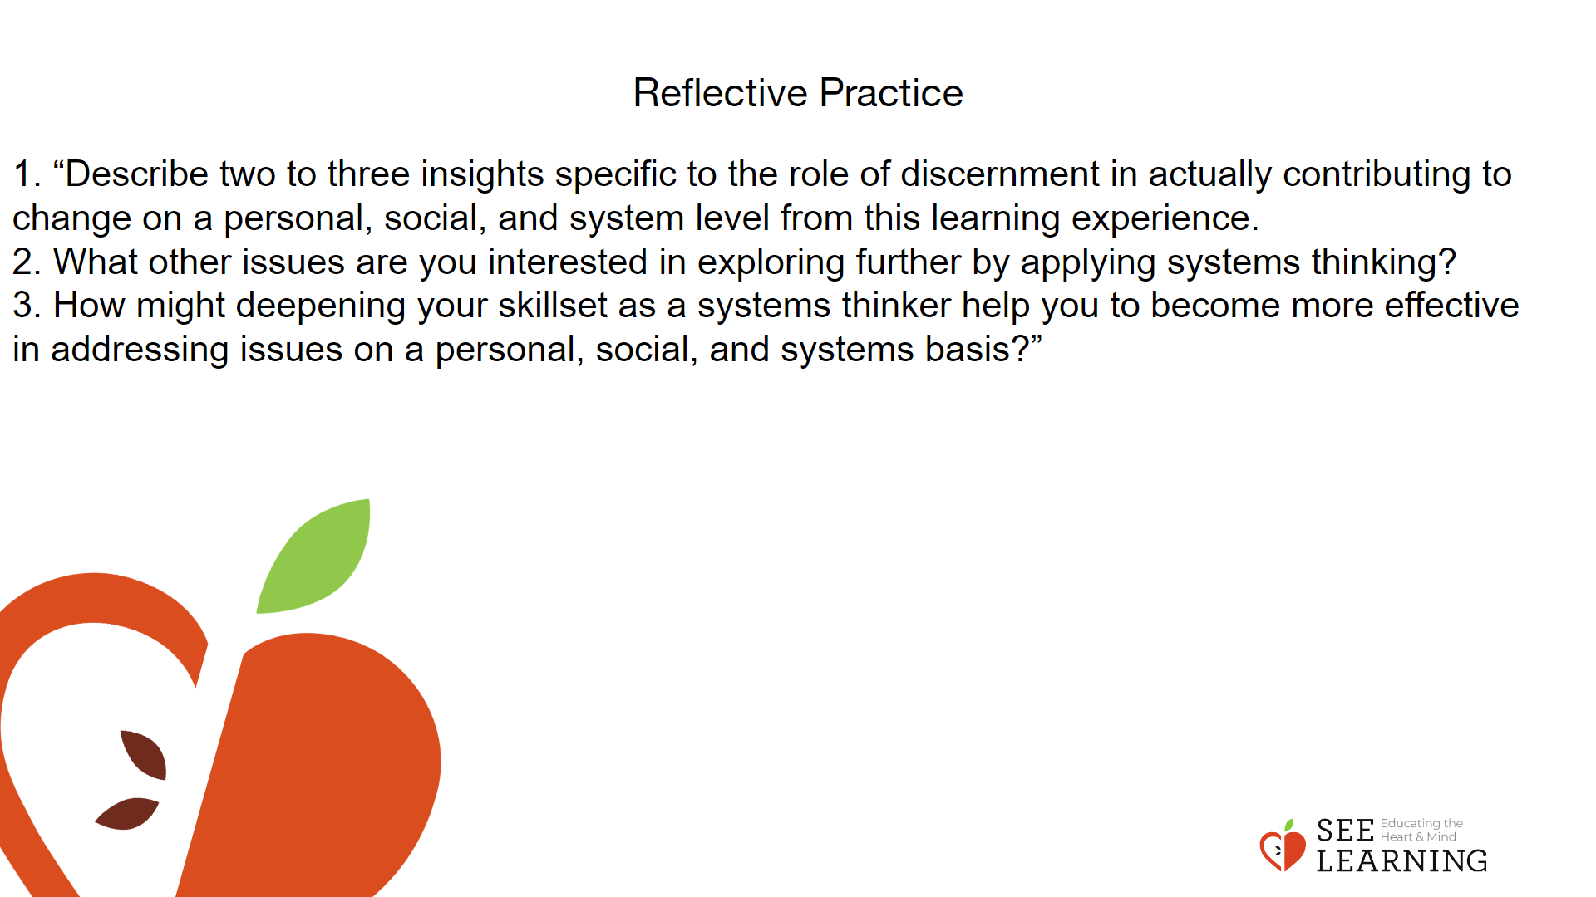 | Instructions and Guided Language  As a class, discuss the following questions. If time allows, ask students to share. Remind students to be kind to each other and respectful of whatever others offer.  1. “Describe two to three insights specific to the role of discernment in actually contributing to change on a personal, social, and system level from this learning experience.  2. What other issues are you interested in exploring further by applying systems thinking?  3. How might deepening your skillset as a systems thinker help you to become more effective in addressing issues on a personal, social, and systems basis?”

