Exploring Systems Thinking

Purpose:
In this learning experience, students learn about “system” and “systems thinking.” First, students are provided with a simple “Systems Thinking Checklist” that can be used to see the systemic nature of any person, object, or event. They then analyze their circulatory system as a system. Finally, students will continue to explore the role of discernment through systems thinking that can cultivate ethical discernment and recognizing common humanity
Learning Objectives:  Students will be able to:  - Apply the principles of systems thinking.  - Examine how changing one part of a system leads to changes (some intended, some unintended) in other parts of the system.  - Recognize how the cultivation of recognition of common humanity and systems thinking enable our discernment and ethical engagement. | Primary Core Component  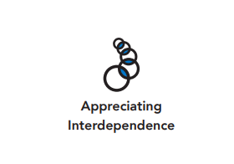  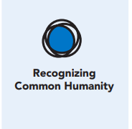
Length  45 Minutes | Materials Required  - Writing utensils and paper  - Colored pencils  - Computer (research)  - Circulatory System image  - Common Humanity image

Check-In (5 min)
Slide 2: Check-In  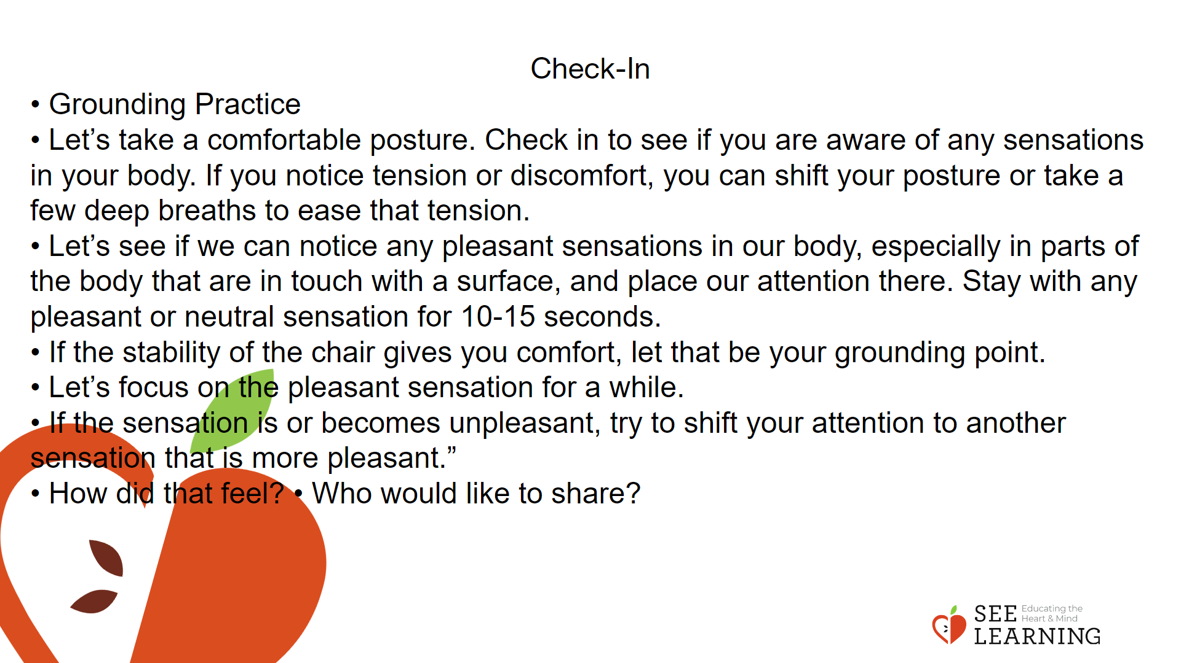 | Instructions and Guided Language  Overview  Lead students in a grounding practice.  Instructions and Guiding Language  • “Let’s do grounding practice together. If at any time you feel uncomfortable, feel free to do a resourcing practice instead.  • Let’s take a comfortable posture. Check in to see if you are aware of any sensations in your body. If you notice tension or discomfort, you can shift your posture or take a few deep breaths to ease that tension.  • Let’s see if we can notice any pleasant sensations in our body, especially in parts of the body that are in touch with a surface, and place our attention there. Stay with any pleasant or neutral sensation for 10-15 seconds. [PAUSE]  • If the stability of the chair gives you comfort, let that be your grounding point. [PAUSE]  • Let’s focus on the pleasant sensation for a while. [PAUSE] • If the sensation is or becomes unpleasant, try to shift your attention to another sensation that is more pleasant.”  Write the debriefing questions on the board. If no students volunteer, you can share your experience while reading the resource practice with the class.  “Would anyone like to answer one of the following questions about your grounding practice today:  • How did that feel?  • Who would like to share?”

Presentation/Discussion (15 min)
Overview
In this presentation, students will explore systems and systems thinking. They will also investigate more deeply the relationship between recognizing common humanity and cultivation of ethics.
Teaching Tips
Systems are everywhere. If you don’t feel comfortable discussing the circulatory system, feel free to use other examples for your systems checklist. Using examples that meet the interest of your student population is recommended. In Part II, feel free to select 2 to 3 questions to discuss instead of all five questions. Finally, there are a lot of good videos explaining systems thinking. We recommend both Peter Senge “Introduction to Systems Thinking” and “Systems Thinking: A Cautionary Tale” (cats in Borneo). Both videos provide an excellent definition of systems thinking but provide different examples.

Slide 3: Presentation/Discussion  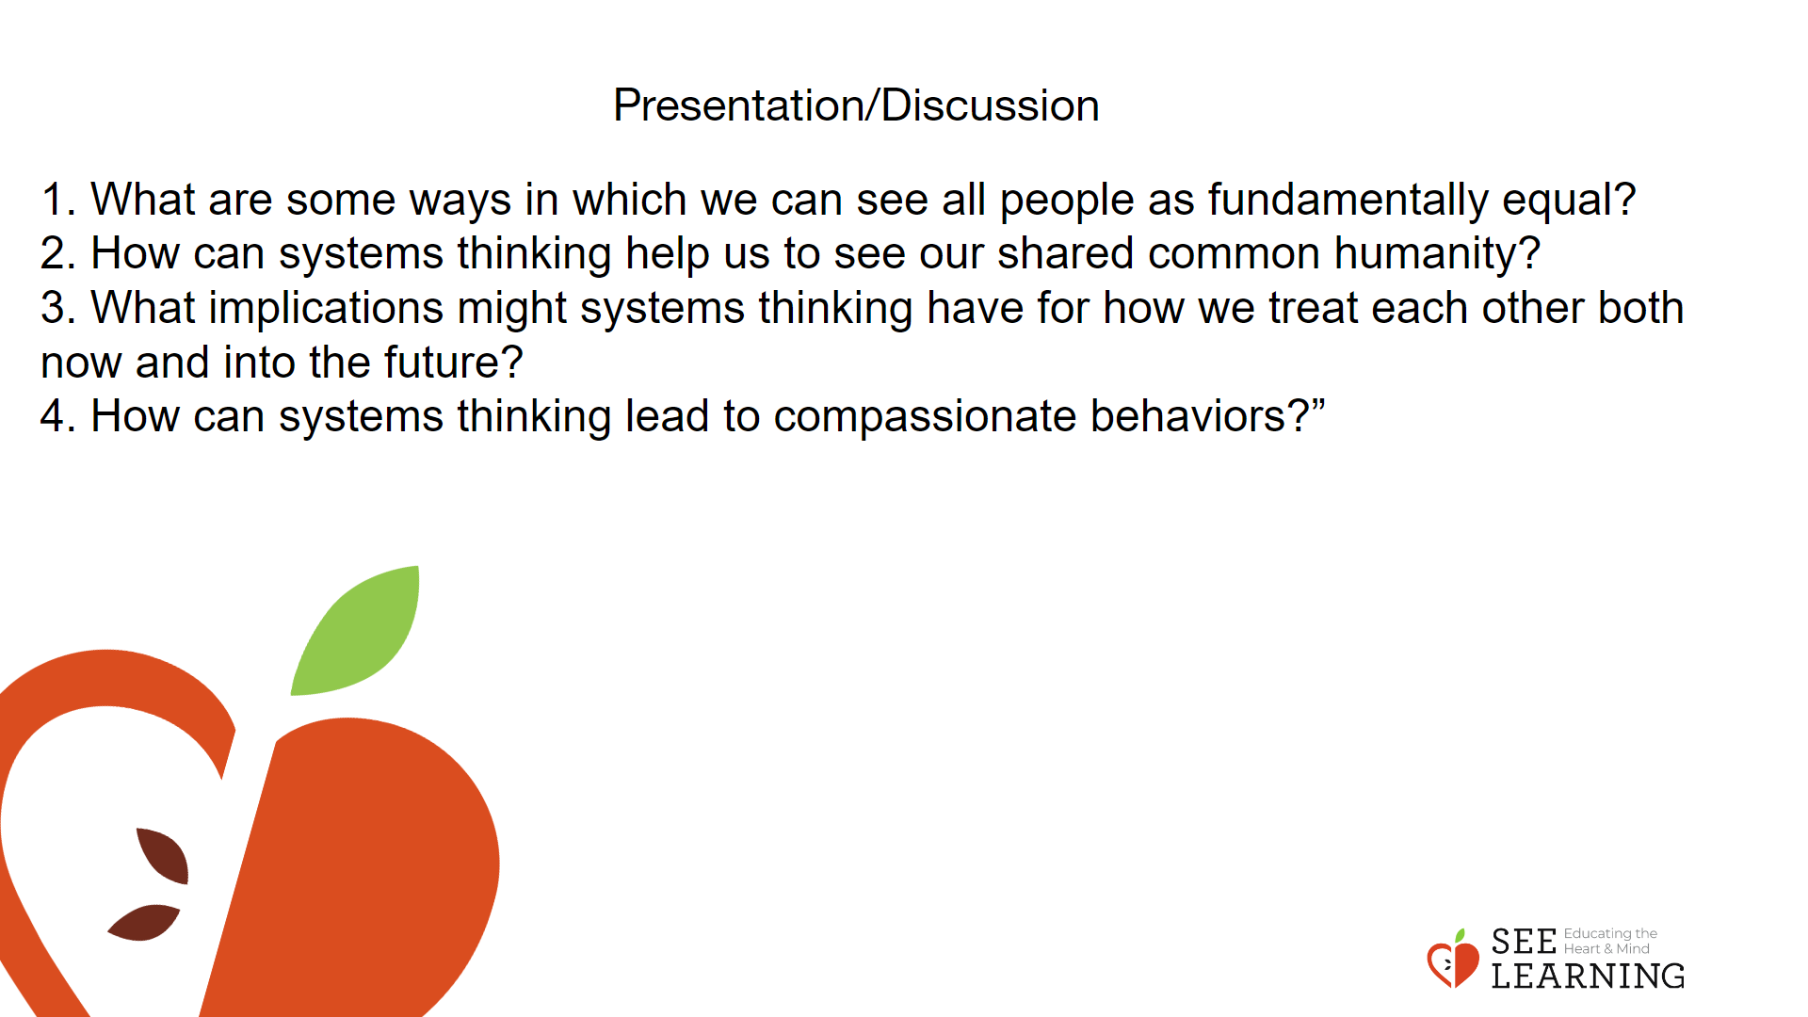 | Instructions and Guided Language  Students will have a class discussion on ethics and common humanity. Write the following vocabulary words along with the definition on the board: system, systems thinking, and common humanity.  Common Humanity and Ethics (Class Discussion)  “Common humanity refers to the idea that all people, regardless of their differences, are similar and therefore equal at a fundamental human level, be it our wish to flourish and grow, our tendencies to avoid unnecessary suffering, our capacity to feel, or our dependency on others. Cultivating an understanding of common humanity can help us develop a more inclusive viewpoint, strengthen others that extends beyond our immediate community, and thus increase our capacity for compassion.  Systems thinking becomes especially powerful and relevant when combined with compassion and concern for all involved. As part of our common humanity, we prefer kindness and compassion from others. Systems thinking can help us see the consequences of our decisions and actions, such that we can act in ways that are more beneficial to our well-being and the wellbeing of others both locally and globally.  As a class, let’s discuss the following questions:  1. What are some ways in which we can see all people as fundamentally equal?  2. How can systems thinking help us to see our shared common humanity?  3. What implications might systems thinking have for how we treat each other both now and into the future?  4. How can systems thinking lead to compassionate behaviors?”  Allow 3-4 minutes per question over systems thinking and common humanity our sense of identification with

Insight Activity - (15mins)
Overview
In this insight activity, students will examine how changing one part of a system leads to changes (some intended, some unintended) in other parts of the system

Teaching Tips
You can have bigger groups, depending on your class size. Feel free to assign groups and make each group complete both parts (A and B). The last question, “What did you notice from doing this activity” should allow students to share their thoughts and feelings. If you don’t feel comfortable discussing the circulatory system, you can talk about another system in the human body (i.e., Digestive System). Thinking about systems helps us realize how important each part is and how important each person is.

Slide 4: Insight Activity  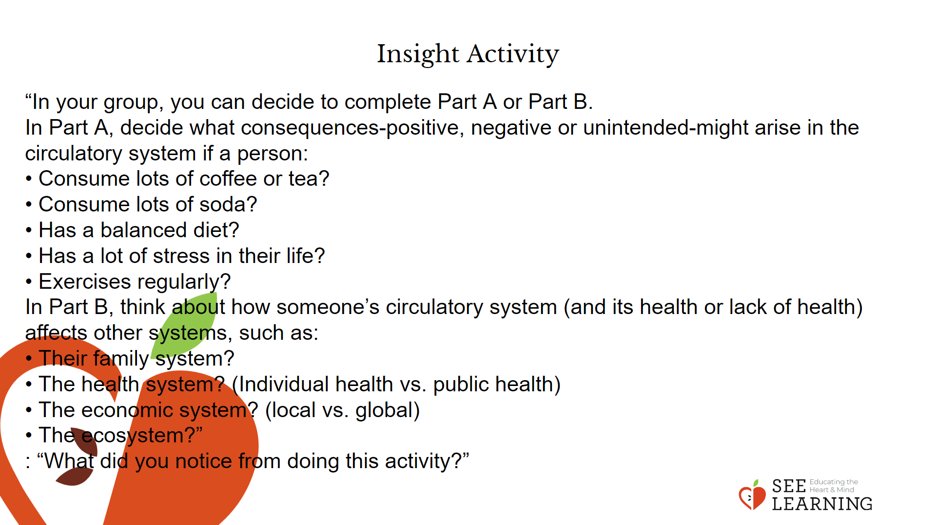 | Instructions and Guided Language  Allow students to select their own groups. Each small group should have 3 to 4 students. Provide each group with a large piece of chart paper.  “Today’s insight activity is on systems thinking. Remember that systems thinking involves discernment, which is the ability to understand how you might respond to a situation on a personal, social, and systems level. In order to engage in the practice of discernment we need to look for connections between things and how they make up a more significant, interconnected whole. It is important to note that changing one part of the system can cause “unintended consequences” in another part of the system.”  Allow students 2 to 3 minutes to select whether they want to do Part A or Part B.  “In your group, you can decide to complete Part A or Part B. When your group agrees, get started.  In Part A, decide what consequences-positive, negative or unintended-might arise in the circulatory system if a person:  • Consume lots of coffee or tea?  • Consume lots of soda?  • Has a balanced diet?  • Has a lot of stress in their life?  • Exercises regularly? In Part B, think about how someone’s circulatory system (and its health or lack of health) affects other systems, such as:  • Their family system?  • The health system? (Individual health vs. public health)  • The economic system? (local vs. global)  • The ecosystem?”  Remind students that for both parts they should be able to explain their answers. Monitor each group to provide help or guidance.  Allow students to share (3 minutes per group).  Conclude by asking your class the following question: “What did you notice from doing this activity?”  Allow students to discuss this experience.

Reflective Practice (10 mins)

Teaching Tips
You can also do this reflective practice in pairs (i.e., Think-Pair-Share). If time is an issue, select one question for the entire class to discuss together

Slide 5: Reflective Practice  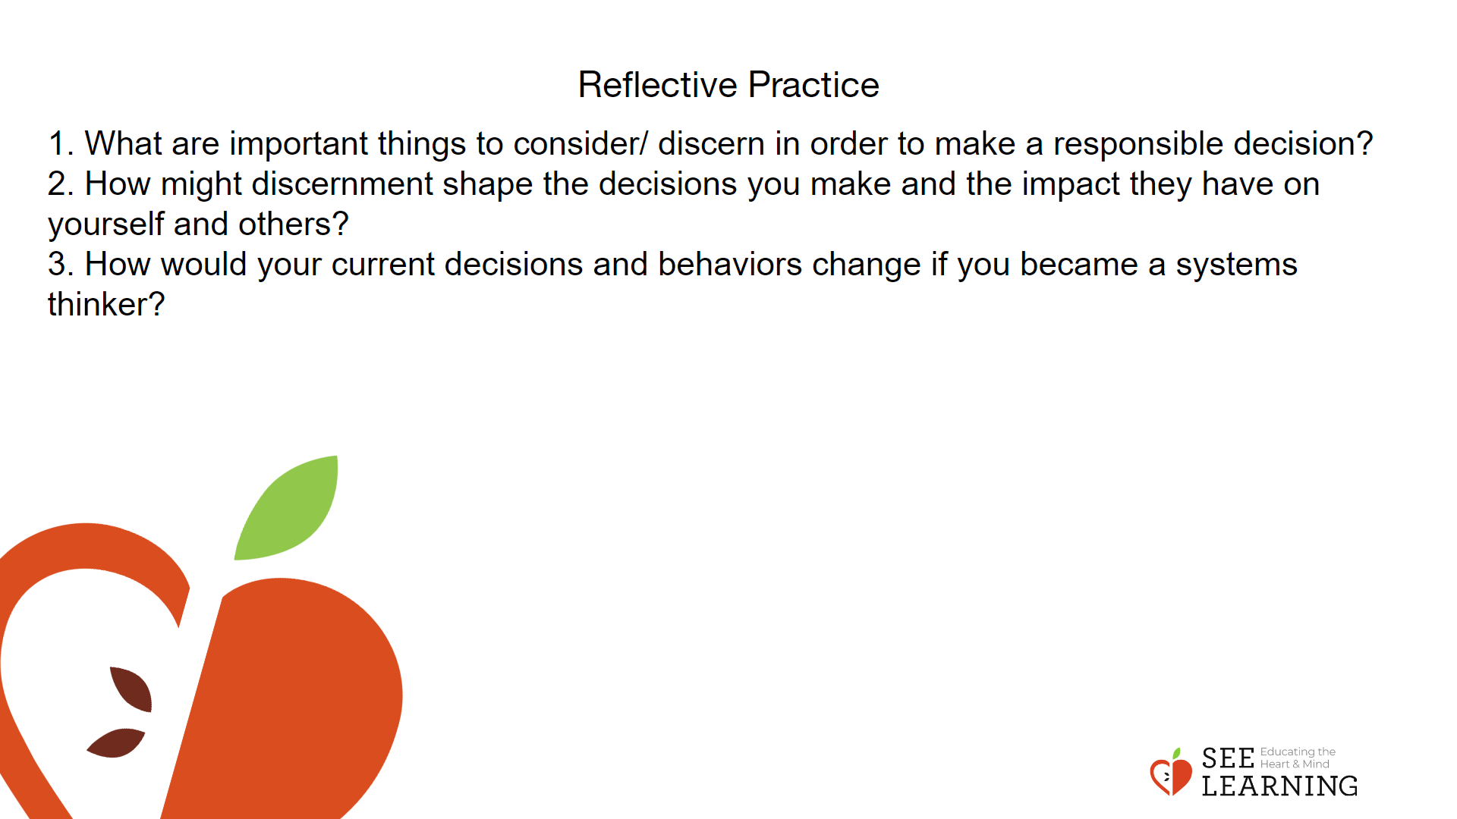 | Instructions and Guided Language  In the same groups, allow students to select 2 of the following questions to discuss. Then, if you have time, get a couple of students to share.  “Thinking about systems helps us realize how important each part is and how important each person is. Let’s end this lesson by selecting two of the following questions to discuss with your group.  1. What are important things to consider/ discern in order to make a responsible decision?  2. How might discernment shape the decisions you make and the impact they have on yourself and others?  3. How would your current decisions and behaviors change if you became a systems thinker?”

