Developing Discernment

Purpose:
In this learning experience, we introduce students to the life cycle analysis of a cell phone, and they will apply the analysis to things they use regularly. Through an awareness of how the different components of an object have different life spans and varying impacts, students will begin to think about the likely consequences of using and eventually discarding everyday objects and thus cultivate an ethical discernment toward the usage of daily objects.
Learning Objectives:  Students will be able to:  - Analyze the life cycle of a cell phone and an object they use on a daily basis.  - Understand the role of discernment in our life and our wellbeing | Primary Core Component  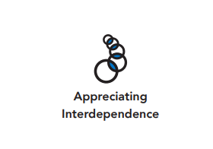  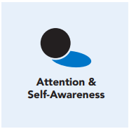
Length  45 Minutes | Materials Required  - Colored pencils, markers  - Writing utensils and paper  - Timer  - Computer  - Life Cycle of a Cell Phone handout

Check-In (5 min)
Slide 2: Check-In  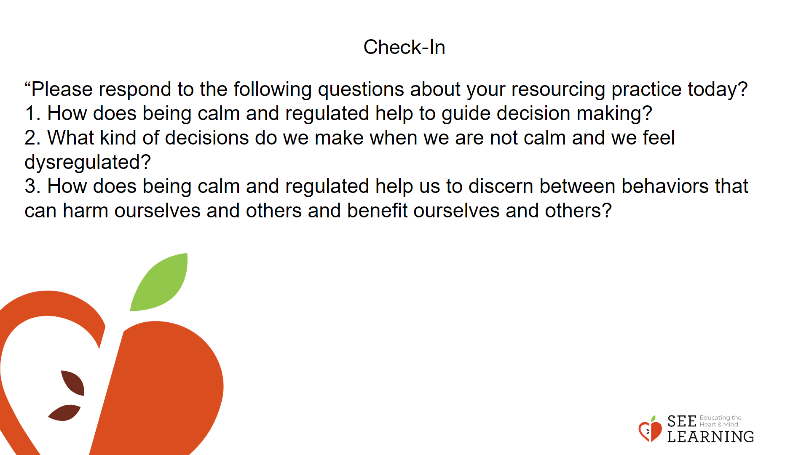 | Instructions and Guided Language  Overview  Lead students in a resource practice.  Use a timer for 4 minutes for the practice and 1 minute for the debrief questions.  Guiding Language  “Let’s take a moment to get comfortable. This may be sitting with your back straight, or, leaning against your chair, or sitting on the floor. You can keep your eyes open or have them closed. Whatever is comfortable for you. [PAUSE]  • Now I invite you to think of a resource, something that makes you feel better, stronger, or more resilient. It could be a person, place, thing, something about yourself, or a memory of a kind act that you have experienced. Your resources can be real or imaginary.  • Take a few moments to focus on your resource. Notice the details of your resource. What do you see, smell, feel, hear, or taste? [PAUSE]  • What do you notice inside your body when you think about your resource? What sensations came up? [PAUSE]  • You might feel warmer or cooler, lighter or heavier, perhaps tingly, maybe you notice your breathing — just be curious. [PAUSE]  • As you notice your sensations, find a place in your body that feels pleasant or neutral and let your attention rest there for a few moments. [PAUSE]  • If you didn’t notice any pleasant or neutral sensations, that’s okay. Just be aware that you’re not feeling any sensations at the moment and continue to sit with your resource. [PAUSE]  • When you get distracted, notice that and bring your attention back to your resource or a sensation in your body. [PAUSE]  • If you become aware of unpleasant sensations, you can shift your attention to another part of your body that feels better, or choose a new resource. You can do grounding practice if you like and track your sensations, focusing on a pleasant or neutral sensation. Let your attention rest there for a few moments. [PAUSE]  • As we do this practice, we’re learning more about our bodies and how to use a resource to get in touch with sensations of well-being, which can help our body feel safe and relaxed.  • Now we’ll conclude the practice. Thank you.”  Write the debriefing questions on the board. If no students volunteer, you can share your experience while reading the resource practice with the class.

Presentation/Discussion - (15 mins)

Overview
In this presentation, students will engage in a life cycle analysis of an object that many people use daily: a cell phone. Students will be introduced to life cycle analysis or ‘cradle-tograve’ assessment through this example. They will then apply this analysis to an everyday object and consider the likely impacts of their usage on the planet. They will learn to develop ethical discernment based on their analysis.

Slide 3: Presentation/Discussion  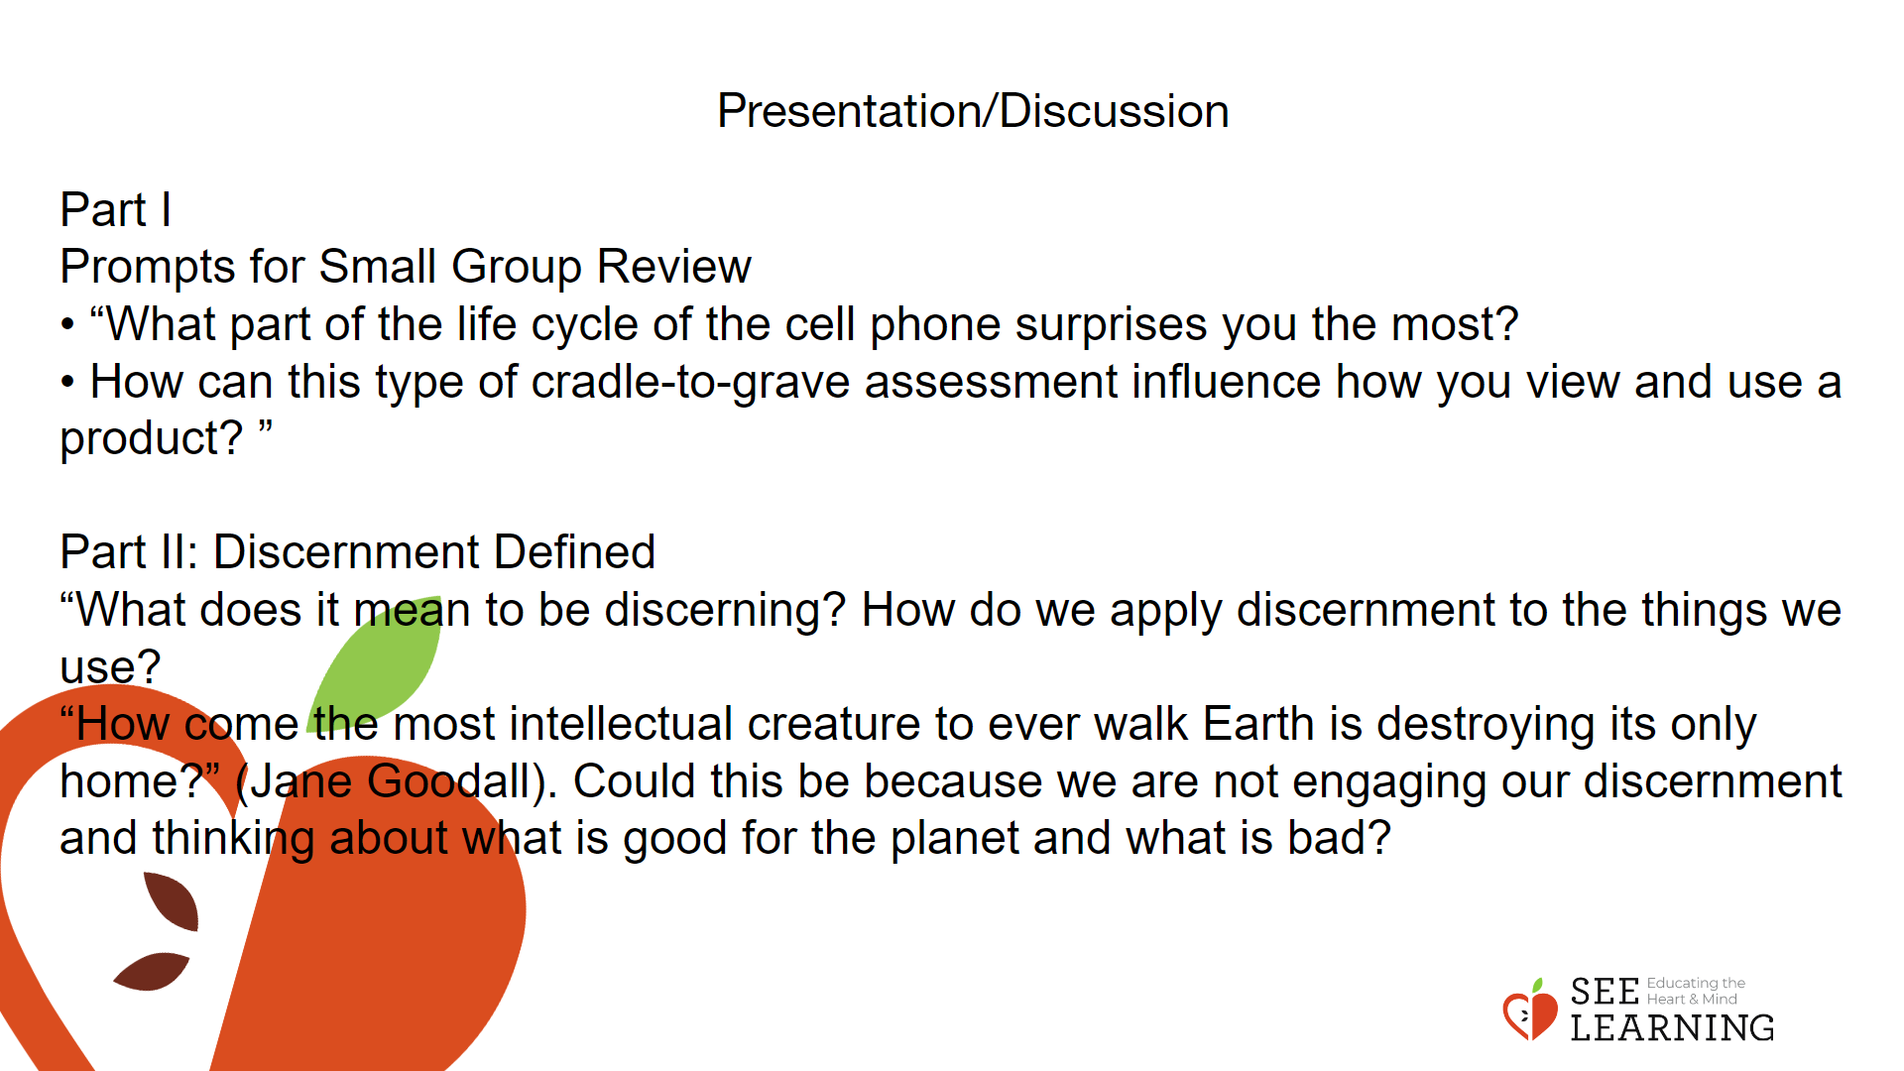 | Instructions and Guided Language  Instructions and Guiding Language In Part I, students will learn about life cycle analysis or the ‘cradle to grave’ assessment, apply it to a cell phone to understand the various stages of its life, and consider the impacts of using the product. They will analyze the information related to the life cycle of a cell phone and then reflect and respond to prompts related to discernment. In Part II, students will apply the analysis to an object of their choosing and explore the likely consequences of producing and consuming the object to the planet, to their and others’ well being.  Part I:  Review Life Cycle Analysis or Cradle-to-Grave Approach  “Have you ever wondered where the things we use come from, or what happens to them when we finish using them? Do you know how the products we use impact the environment or the planet?  To consider these, let’s take a moment to look at ‘life cycle analysis’, also known as the ‘cradle-to-grave’ approach. It involves evaluating various aspects–often the environmental impacts–of a product as it goes through all stages of its life cycle.  According to the European Environment Agency, “assessment that considers impacts at each stage of a product’s life-cycle, from the time natural resources are extracted from the ground and processed through each subsequent stage of manufacturing, transportation, product use, and ultimately, disposal”. Such an assessment can allow us to discern the wider dimensions of products or issues and their impacts on us.  In small groups, I would like you to review the handout related to the life cycle of a cell phone, reflect upon the five phases outlined and respond in your small group to the prompts at the end of the handout.  After you finish your discussion please respond to the prompts below.”  Provide time for students to review the handout and respond to the prompts.  Prompts for Small Group Review  • “What part of the life cycle of the cell phone surprises you the most?  • How can this type of cradle-to-grave assessment influence how you view and use a product? ”  Part II:  Discernment Defined (Class Discussion)  “In this part, we will apply the life cycle analysis to an object of your choosing and think about ethical discernment. Just like cell phones, other things have their own life cycles. As we become more aware of the life cycle of items we use everyday and their impacts on our wellbeing, we become more discerning about how we use them, how we dispose of them, and the impacts of our actions on ourselves, others, and the environment.” Allow students to respond: “What does it mean to be discerning? How do we apply discernment to the things we use?  Discernment, as applied to ethical discernment, is the ability to assess and understand actions that are beneficial versus those that are harmful. It helps us consider the likely consequences of our actions and distinguish actions that are most harmful to ourselves and others from those that are beneficial. It, thus, helps us learn to identify behaviors that need to be cultivated and those that need to be regulated.  Discernment originates from critical thinking and reasoning. We use our intelligence to understand and analyze how our behaviors affect others and vice versa. This can lead to an acknowledgement of numerous ways in which others contribute to our wellbeing and a deeper sense of appreciation of others. It can be further enhanced by repeated reflection on particular ways in which our well-being is supported by others. Discernment plays an essential role in developing ethical awareness.  “How come the most intellectual creature to ever walk Earth is destroying its only home?” (Jane Goodall). Could this be because we are not engaging our discernment and thinking about what is good for the planet and what is bad?”

Insight Activity (15 mins)

Activity Overview
In this insight activity, students will work in small groups to choose an everyday item and create a life cycle analysis. The students can use the internet to search about the various stages of the product’s life and the impacts of producing these objects on a massive scale. They will reflect on how they are contributing to the life cycle of the product and its impacts.

Slide 4: Insight Activity  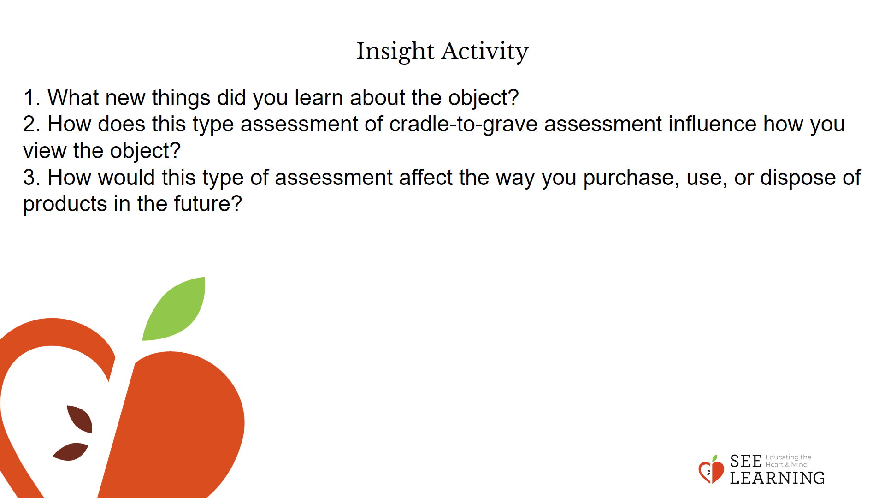 | Instructions and Guided Language  “In this part of the activity, you will choose an object that you regularly use and subject it to the life cycle analysis. You will work in groups of four to create the different phases of your chosen object’s life while reflecting on the likely consequences and the impacts of the object on the environment, on your wellbeing, and that of the larger community. This activity requires the use of the internet to do research. So, open your computer and start your research.  While doing the life cycle analysis, reflect on how you are part of the object’s life cycle and what can you do to minimize the negative impacts of the object, if any, and maximize the positive impacts. After completing the assessment, you will reflect as a group on the following questions and share your reflection with the class.  1. What new things did you learn about the object?  2. How does this type assessment of cradle-to-grave assessment influence how you view the object?  3. How would this type of assessment affect the way you purchase, use, or dispose of products in the future?

Reflective Practice (10 mins)
Slide 5: Reflective Practice  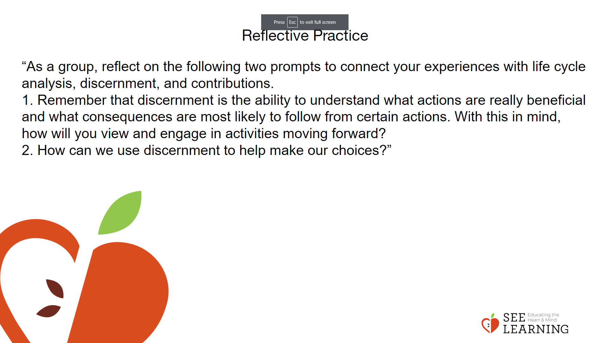 | Instructions and Guided Language  In the same groups, ask students to select 2 of the following questions to discuss. Build in time at the end for several students to share.  “As a group, reflect on the following two prompts to connect your experiences with life cycle analysis, discernment, and contributions.  1. Remember that discernment is the ability to understand what actions are really beneficial and what consequences are most likely to follow from certain actions. With this in mind, how will you view and engage in activities moving forward?  2. How can we use discernment to help make our choices?”

