Applying Compassion to One’s Life

Purpose:
Students will apply compassion to their own lives through student-constructed examples. Through these insights, students will gain experience with the three main components of active compassion: having affection for someone, understanding their needs and wants, and taking responsibility to help them. They will also explore how active compassion needs to be coupled with critical thinking, systems thinking, and ethics. Students will also examine the need to sometimes say no in order to set personal and social boundaries.
Learning Objectives:  Students will be able to:  - Apply compassion to one’s life by making connections to their own personal experience.  - Reinforce previous knowledge: three components of active compassion: affection for someone, understanding their needs and wants, and taking responsibility to help them.  - Become aware of how compassion sometimes requires saying no or standing up to someone. | Primary Core Component  
Length  45 Minutes | Materials Required  - Examples of aspirational and active compassion from students  - Fishbowl Activity Protocol handout

Check-In (5 min)
Slide 2: Check-In  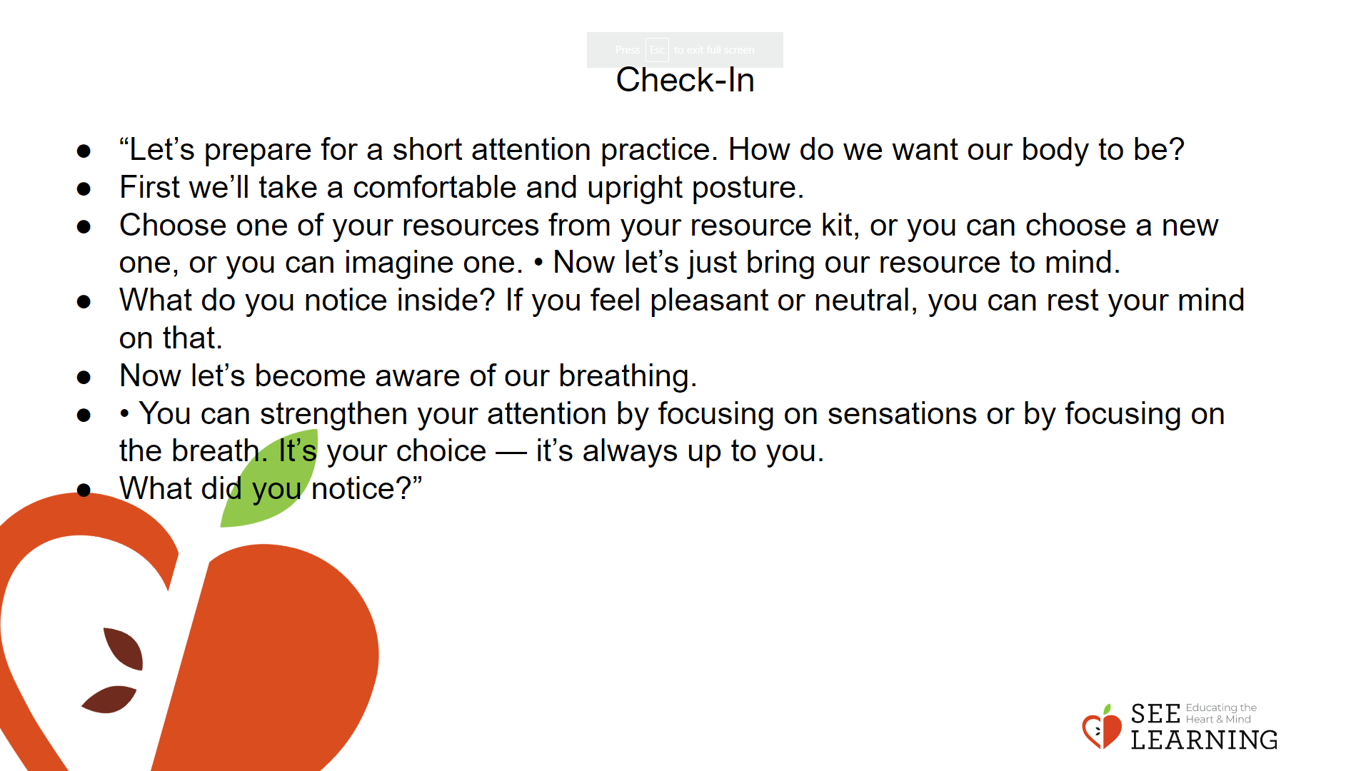 | Instructions and Guided Language  [PAUSE]s can be up to 10 seconds each  Attention Practice  • “Let’s prepare for a short attention practice. How do we want our body to be?  • First we’ll take a comfortable and upright posture. Then we’ll keep our eyes on the ground or close them.  • Before we strengthen our attention, we’ll do some resourcing or grounding to calm our bodies. Choose one of your resources from your resource kit, or you can choose a new one, or you can imagine one. [PAUSE]  • Now let’s just bring our resource to mind. And let’s see if we can just pay attention to our resource with our mind for a few moments quietly. Or if you’d rather do grounding, you can do that too. Whichever you choose, we’re going to rest quietly and pay attention for a few moments. [PAUSE] • What do you notice inside? If you feel pleasant or neutral, you can rest your mind on that.  • If you feel unpleasant, you can shift to a different resource, or you can ground. You can also change your posture but try not to disturb anyone else if you do that. Otherwise, just keep your attention resting with your resource. [PAUSE]  • Now let’s become aware of our breathing. Let’s see if we can pay attention to the breath as it enters and leaves our body.  • If you find paying attention to the breath uncomfortable, then feel free to go back to your resource or grounding, or just take a small break, making sure not to disturb anyone else. [PAUSE for 15-30 seconds.]  • If you ever get distracted, you can just return your attention to the breath. You can also count your breath. [PAUSE for a longer time, such as 30-60 seconds or longer.] • You can strengthen your attention by focusing on sensations or by focusing on the breath. It’s your choice — it’s always up to you.  • What did you notice?” [Share aloud.]

Presentation/Discussion (10 min)

Activity Overview
Students will review their class definition of compassion. Students will be asked to analyze and revise the definition. They will do this based on their understanding of the science of compassion and the application of compassion by historical figures (as expereinced in previous learning experiences).

Slide 3: Presentation/Discussion  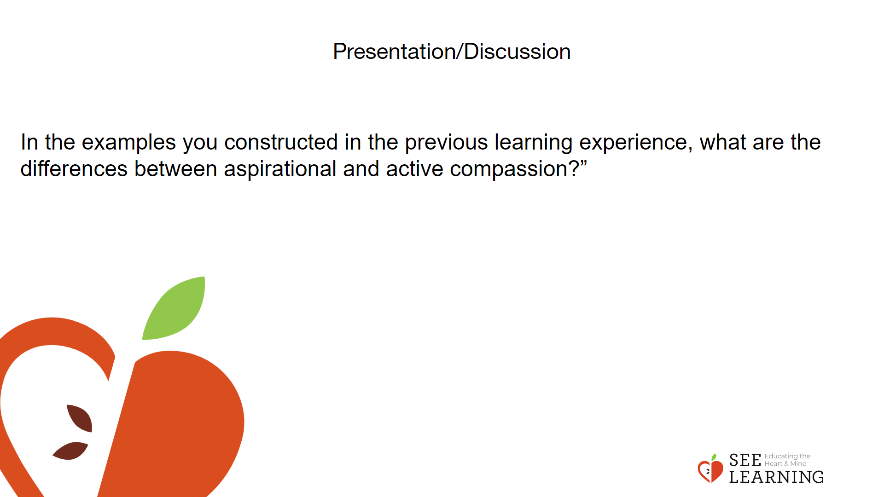 | Instructions and Guided Language  Lead a whole group discussion on the definition of compassion previously developed by the class.  “Think back to our recent learning experience when we explored aspirational and active compassion.  Aspirational compassion is the sincere wish that others be free of suffering. Active compassion goes one step further by taking responsibility for the other, leading one to engage oneself to do whatever one can do to relieve their suffering. Active compassion is a stronger motivational state of compassion. It is a state of mind that assumes responsibility for another.  In the examples you constructed in the previous learning experience, what are the differences between aspirational and active compassion?”  Allow time for discussion and revision

Insight Activity - (20 mins)
Activity Overview
In this activity students construct a role play scenario based on an experience from their own life. They will then act them out in a fishbowl experience. A fishbowl experience is an authentic learning activity in which a small group of students engage in a demonstration in the center of the classroom while the remaining students take on active, designated roles as observers. If this is the first time your students have participated in a fishbowl, teach the

Slide 4: Insight Activity  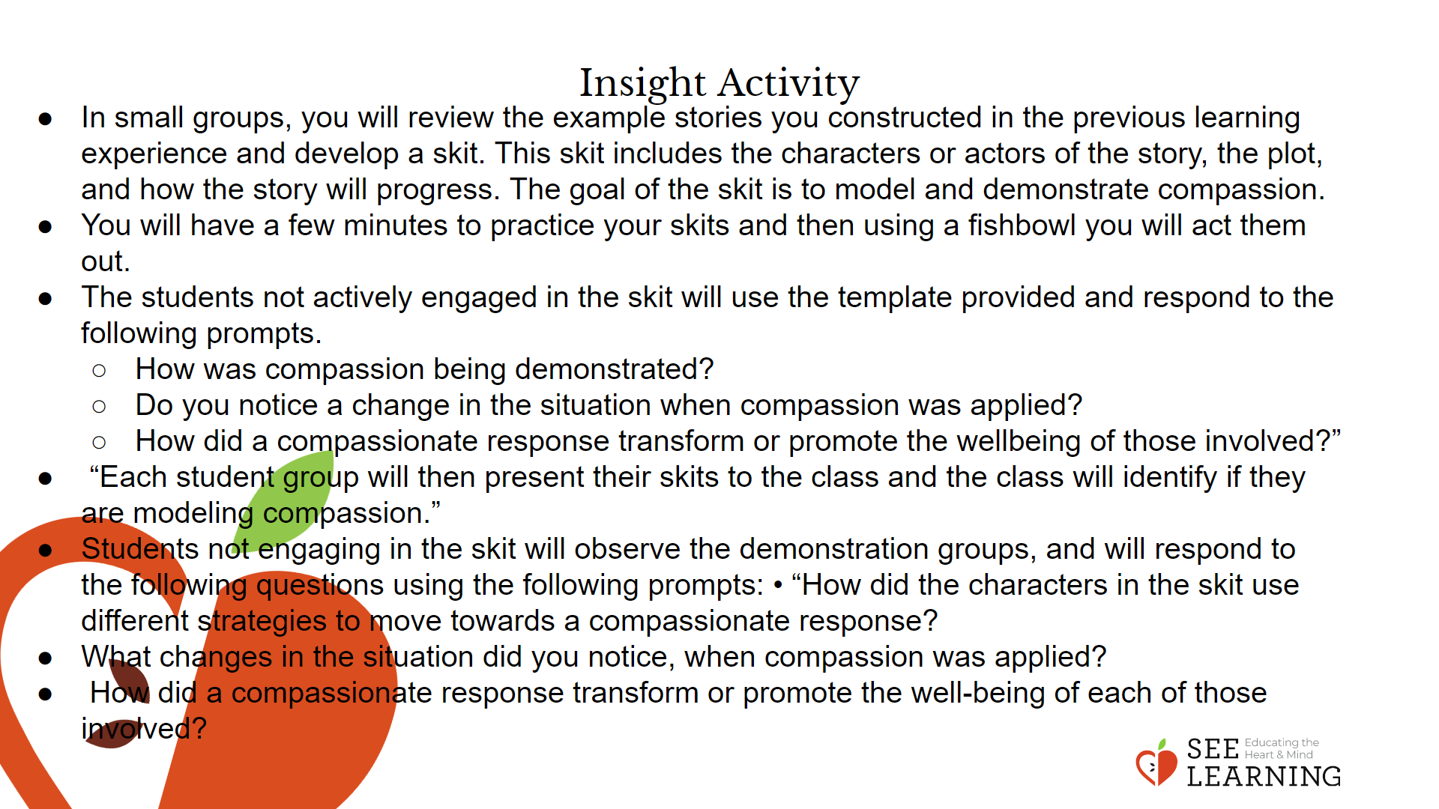 | Instructions and Guided Language  Students will review the example stories of compassion. They will construct scenarios from their own lives in which they observed or engaged in compassion. Students will form small groups (3-4 students) to share personal and observed example stories of compassion. In small groups, students will construct a scenario they can act out from their example stories. They will need to identify the characters of the story, the plot that will be acted out, and to practice their scenarios. The students not participating in the active demonstration serve as observers. Using reflection questions that are outlined on the observer worksheet, these students will engage through written reflection and prepare to share what they observe.  “Today we will have the opportunity to transform our example stories of compassion from your own life or from your observations into skits.  In small groups, you will review the example stories you constructed in the previous learning experience and develop a skit. This skit includes the characters or actors of the story, the plot, and how the story will progress. The goal of the skit is to model and demonstrate compassion.  You will have a few minutes to practice your skits and then using a fishbowl you will act them out. The students not actively engaged in the skit will use the template provided and respond to the following prompts.  • How was compassion being demonstrated?  • Do you notice a change in the situation when compassion was applied?  • How did a compassionate response transform or promote the wellbeing of those involved?”  Provide time for students to brainstorm and draft scenarios.  “Each student group will then present their skits to the class and the class will identify if they are modeling compassion.”  Students not engaging in the skit will observe the demonstration groups, and will respond to the following questions using the following prompts:  • “How did the characters in the skit use different strategies to move towards a compassionate response?  • What changes in the situation did you notice, when compassion was applied?  • How did a compassionate response transform or promote the well-being of each of those involved?”  Provide directions and a list of prompts for students on a handout or displayed on anchor chart.

Reflective Practice (10 mins)
Activity Overview
In this reflection experience students will review their Wish, Outcome, Obstacle, and Plan (WOOP) statement to see if they need to make any changes or adjustments to it to better reflect their lives. purpose and process. If all of your students are familiar with this strategy, have volunteers review the purpose and process, preferably referencing related signage posted in the classroom.
Description of a Fish Bowl Activity
A fishbowl is an instructional strategy that allows students to present information to other students and for the observing students to be engaged through a note taking protocol. The set up for this fishbowl activity will require you to change the arrangement of desks or tables in the classroom so that you have one group in the middle of the classroom presenting and then the observing students arranged around in a circle the presenting student group. The purpose of this activity and classroom arrangement is to create an efficient and engaging opportunity for students to present and for observing students to be engaged.

Slide 5: Reflective Practice  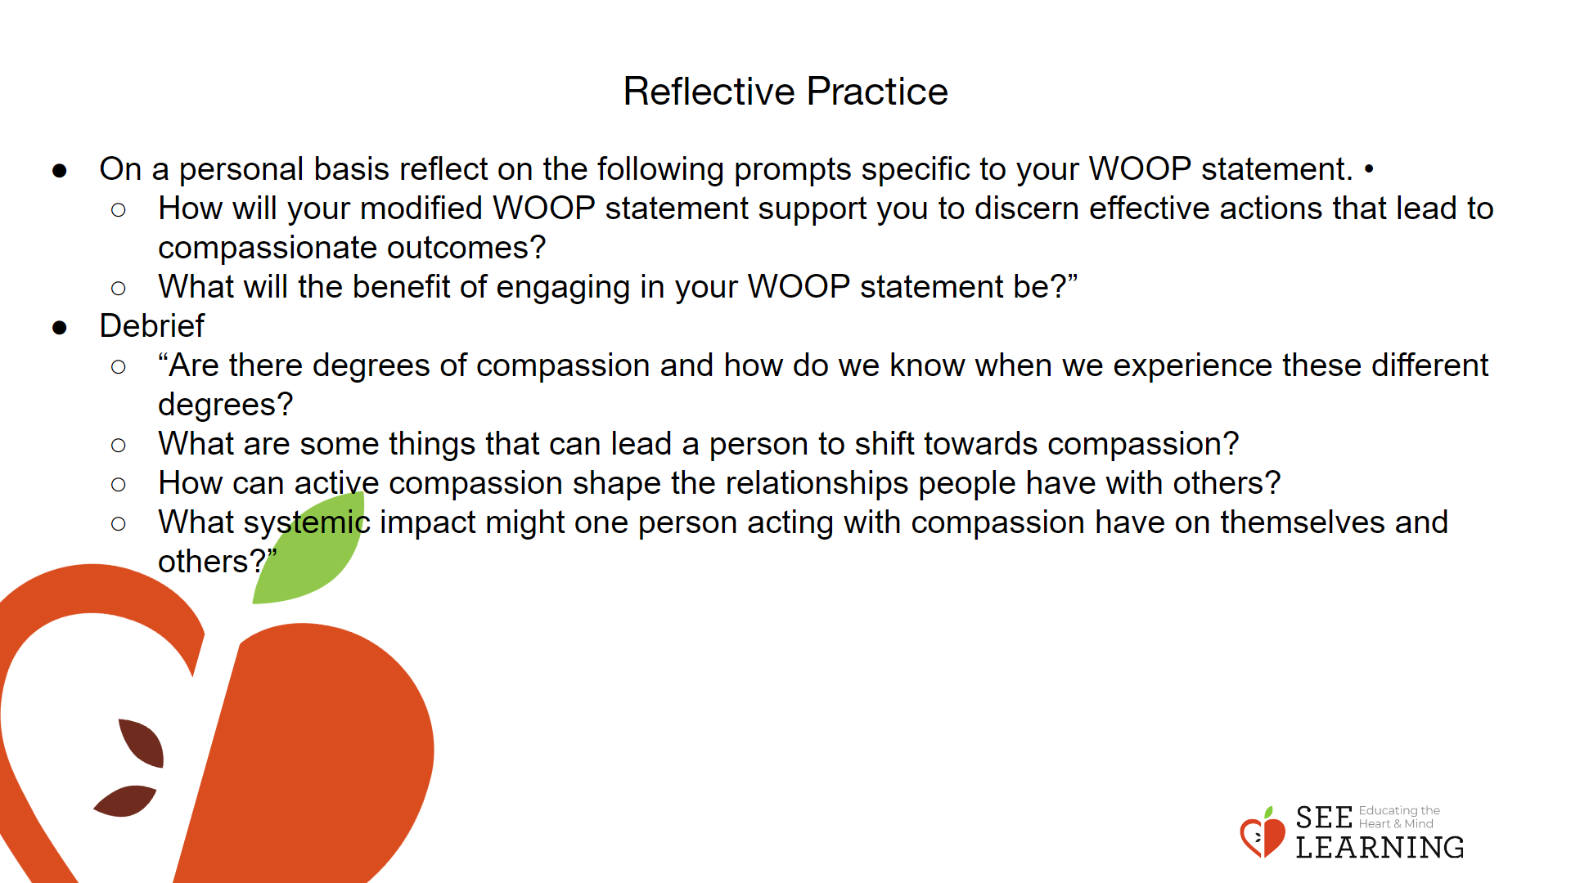 | Instructions and Guided Language  Students will reflect on and review their WOOP statements created in previous lesson(s). Having engaged in a review of real life situations, students may want to provide additional detail to their WOOP statement or adjust it to be more representative of who they are and how they want to show up for themselves and others.  “Today we will spend time reviewing our Wish, Outcome, Obstacle, and Plan (WOOP) statements and modify them, if you think it is helpful to better reflect your growing understanding and desire to show up for yourself and others.”  Allow time for reflection and revision.  Allow students to engage in a final reflection on their WOOP statement.  “On a personal basis reflect on the following prompts specific to your WOOP statement. • How will your modified WOOP statement support you to discern effective actions that lead to compassionate outcomes?  • What will the benefit of engaging in your WOOP statement be?”  Lead students in a debrief using one or more of these questions:  • “Are there degrees of compassion and how do we know when we experience these different degrees?  • What are some things that can lead a person to shift towards compassion?  • How can active compassion shape the relationships people have with others?  • What systemic impact might one person acting with compassion have on themselves and others?

