Exploring Active Compassion

Purpose:
In this learning experience, students will explore more deeply the concept of active compassion, which involves taking responsibility for another and acting to protect them. This two-part lesson engages students in developing an understanding from examples from their life of compassion. In the second part of the learning experience, students will create a Wish, Outcome, Obstacle, Plan (WOOP) statement to identify where they can cultivate acts of compassion in their own lives.
Learning Objectives:  Students will be able to:  - Define compassion through their own personal experience.  - Identify three components of active compassion: affection for someone, understanding their needs and wants, and taking responsibility to help them.  - Determine how compassion sometimes requires saying no or standing up to someone  - Construct a personal plan to develop and embody compassionate responses towards others | Primary Core Component  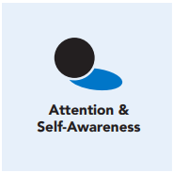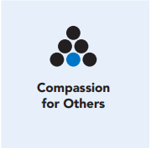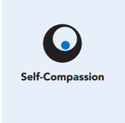
Length  45 Minutes | Materials Required  - Writing utensils and paper

Check-In (5 min)
Slide 2: Check-In  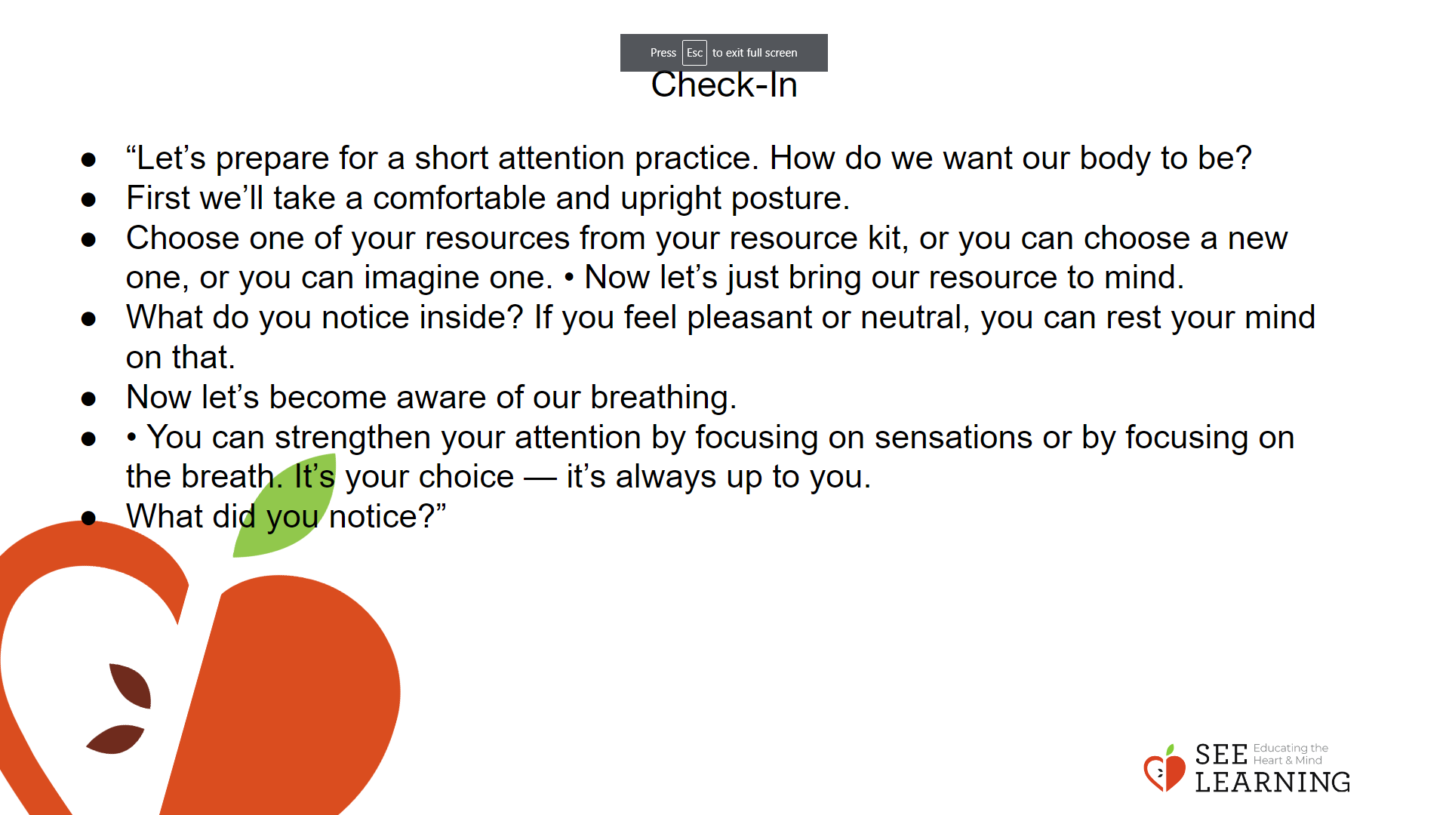 | Instructions and Guided Language  [PAUSE]s can be up to 10 seconds each Attention Practice • “Let’s prepare for a short attention practice. How do we want our body to be?  • First we’ll take a comfortable and upright posture. Then we’ll keep our eyes on the ground or close them.  • Before we strengthen our attention, we’ll do some resourcing or grounding to calm our bodies. Choose one of your resources from your resource kit, or you can choose a new one, or you can imagine one.  • Now let’s just bring our resource to mind. And let’s see if we can just pay attention to our resource with our mind for a few moments quietly. Or if you’d rather do grounding, you can do that too. Whichever you choose, we’re going to rest quietly and pay attention for a few moments. [PAUSE] • What do you notice inside? If you feel pleasant or neutral, you can rest your mind on that.  • If you feel unpleasant, you can shift to a different resource, or you can ground. You can also change your posture. Try to keep your attention resting with your resource. [PAUSE]  • Now let’s become aware of our breathing. Let’s see if we can pay attention to the breath as it enters and leaves our body.  • If you find paying attention to the breath uncomfortable, then feel free to go back to your resource or grounding, or just take a small break, making sure not to disturb anyone else. [Pause for 15-30 seconds.]  • If you ever get distracted, you can just return your attention to the breath. You can also count your breath. [Pause for a longer time, such as 30-60 seconds or longer.] • You can strengthen your attention by focusing on sensations or by focusing on the breath. It’s your choice — it’s always up to you.  • What did you notice?” [Invite students to share aloud.]

Presentation/Discussion (10 min)
Activity Overview
Students will construct an applied and personalized definition of compassion.

Slide 3: Presentation/Discussion  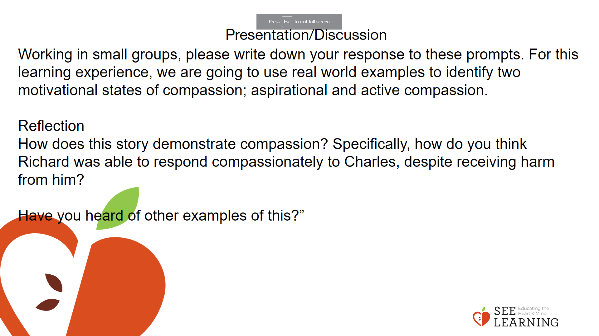 | Instructions and Guided Language  Ask students to independently write down three descriptive words related to compassion on a piece of paper.  “Remember last week we explored the science of compassion.  • What are some benefits of compassion?  • What are some ways we cultivate and strengthen compassionate responses?  Please write down your response to these prompts. For this learning experience, we are going to use real world examples to identify two motivational states of compassion; aspirational and active compassion. In a few minutes I am going to ask you to break into small groups and develop examples from your life or things you have observed that demonstrate compassion.  Before we create our own examples, I would like to share an example with you about a man named Richard Moore.  On Thursday May 4th, ten year old Richard Moore was walking home from school in Northern Ireland. As he passed by a guard station, he was shot at close range with a rubber bullet. This impact of the bullet blinded him for the rest of his life. Richard went on to have a fulfilling and meaningful life. He was a successful businessman and then founded the charity Children in Crossfire that helps children who live in extreme poverty. Throughout his life Richard harbored no ill will towards the soldier who shot him. In January of 2006, over thirty years after he was blinded, Richard wrote a letter to Charles, the soldier who shot him, telling him that he had Richard’s forgiveness. They met in person and became good friends, and now often give talks together. Richard’s example of forgiveness has inspired many people. In his talks, he often says that forgiveness is a choice, and “a gift you give yourself.”  Now I would like to review the SEE Learning definition of compassion.  ‘Compassion is an emotion involving the wish to relieve or prevent the suffering of another out of a genuine concern for their well-being and a sense of tenderness and care for them.  It refers to a way of relating to oneself, others, and humanity as a whole through kindness, empathy and a concern for both happiness and suffering.’” SEE Learning Companion, p. 106  After sharing the story, provide a moment for student reflection and then ask the following prompt to the class.  “How does this story demonstrate compassion? Specifically, how do you think Richard was able to respond compassionately to Charles, despite receiving harm from him?  Have you heard of other examples of this?”

Insight Activity - (15 mins)
Activity Overview
Students will identify examples of aspirational and active compassion through the construction of personal examples from their life or from experiences they have observed.

Slide 4: Insight Activity  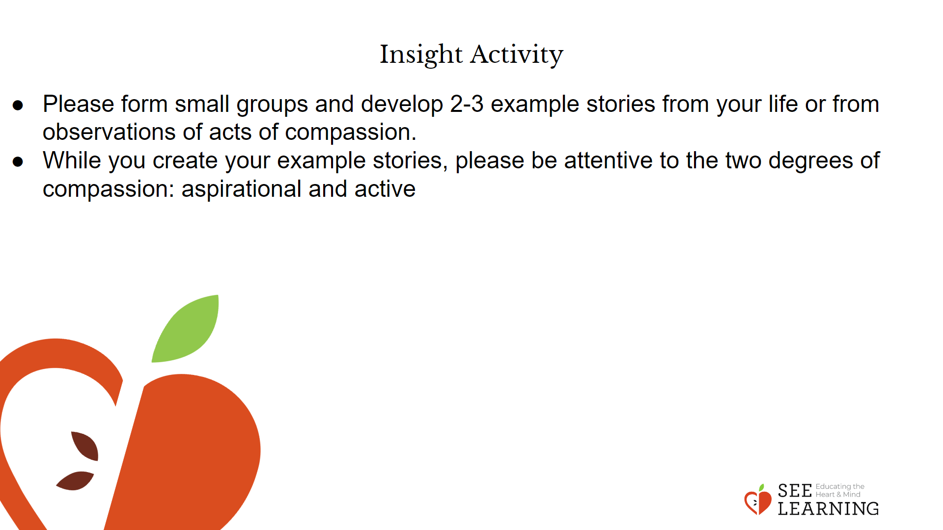 | Instructions and Guided Language  Ask students to form small groups and ask them to construct 2-3 stories from their life or from what they have observed regarding acts of compassion. While creating the example stories ask the students to be attentive to the difference or nuance between aspirational and active compassion.  “Please form small groups and develop 2-3 example stories from your life or from observations of acts of compassion. While you create your example stories, please be attentive to the two degrees of compassion: aspirational and active.  Aspirational compassion is the sincere wish that others be free of suffering. Active compassion goes one step further by taking responsibility for the other, leading one to engage oneself to do whatever one can do to relieve their suffering. Active compassion is a stronger motivational state of compassion. It is a state of mind that assumes responsibility for another.  For example, when some hear of the suffering of others, such as children who have no food or clean water, they are genuinely moved and wish they could lessen that suffering. That is compassion. Others are so moved by this suffering that they devote their lives to ending that suffering: they take responsibility for themselves to do whatever they can to end the suffering. Both are legitimate forms of compassion.”

Reflective Practice (15 mins)
Activity Overview
Students will create a Wish, Outcome, Obstacle, and Plan (WOOP) statement then partner with a peer to share and make revisions.

Slide 5: Reflective Practice  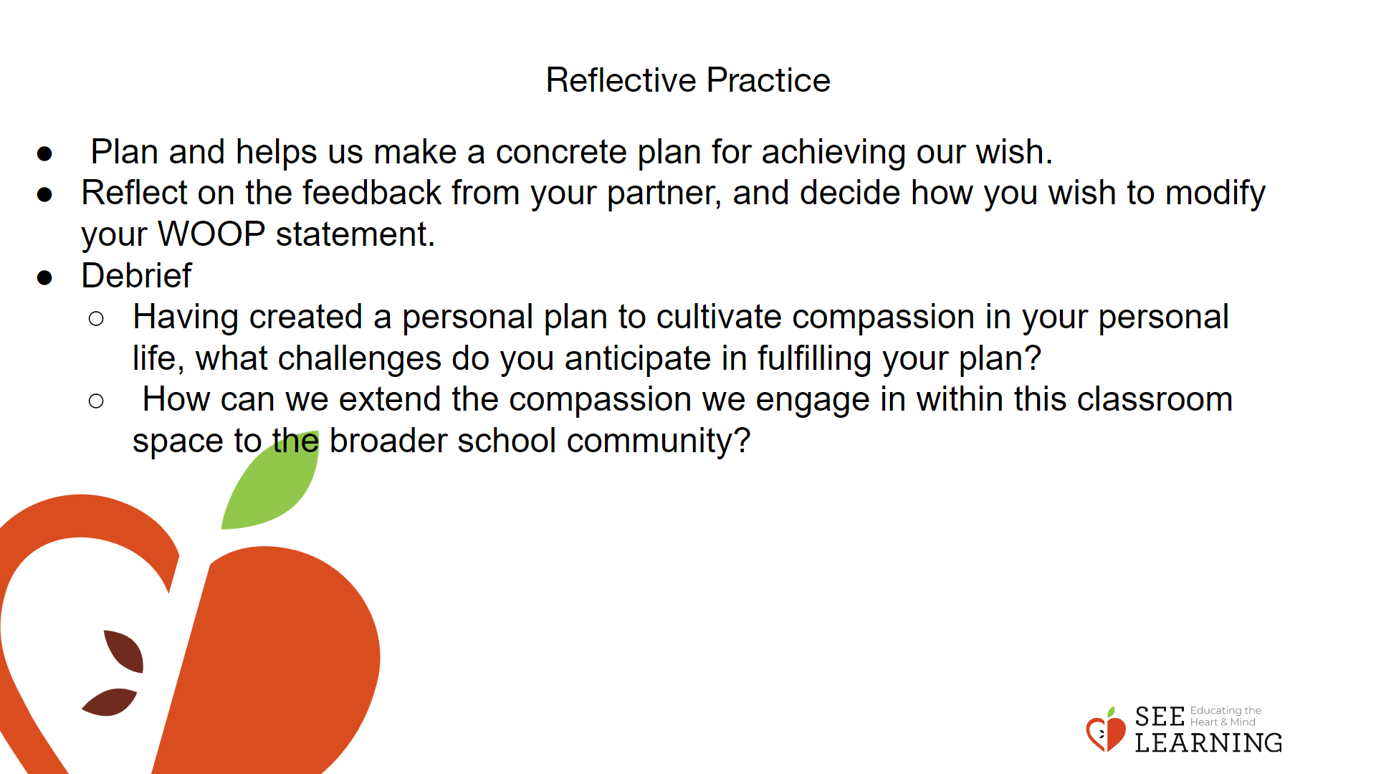 | Instructions and Guided Language  Instructions  The teacher will review the concept of a WOOP statement. A WOOP statement stands for Wish, Outcome, Obstacle, Plan. Using the WOOP statement model students will create a personal WOOP statement that is focused on helping them to foster active compassion on a regular basis.  “Today we will be creating a WOOP statement. Remember that a WOOP statement stands for Wish, Outcome, Obstacle, Plan and helps us make a concrete plan for achieving our wish.”  Student Protocol for WOOP Statement  1. Create a personal WOOP statement that identifies how you as an individual can practice compassion in your daily life.  2. Share your WOOP statement with a classmate and provide feedback on each other’s work.  When you provide feedback be sure to think meaningfully about each element of a WOOP statement:  - Is the wish strong enough to sustain the commitment to compassion?  - Are the outcomes clearly articulated and do they seem meaningful and relevant?  - What thoughts does your partner have about the obstacles associated with engaging in compassion? How do they anticipate sustaining the courage it requires to act with compassion towards oneself and others?  - Is the plan they presented clear, and does it feel to both of you like something that can be achieved?  “Reflect on the feedback from your partner, and decide how you wish to modify your WOOP statement.”  After students have revised and edited their WOOP Statement, lead students through a brief debrief.  “Having created a personal plan to cultivate compassion in your personal life, what challenges do you anticipate in fulfilling your plan?  How can we extend the compassion we engage in within this classroom space to the broader school community?”

