Science of Compassion

Purpose:
Students will explore compassion as an area of scientific study as well as personal inquiry, investigating their own motivations for cultivating compassion in a specific area of life.
Learning Objectives:  Students will be able to:  - Define what the Science of Compassion is and determine the different fields it draws from  - Identify one field or area of life domain of inquiry within the Science of Compassion to explore further (physical health, mental health, relationship health, societal health, emotional health, sense of purpose, and wellness)  - Construct a personal plan to explore compassionate responses in a specific area (health, wellness, purpose, relationships, etc | Primary Core Component  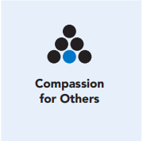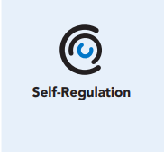
Length  45 Minutes | Materials Required  - Applying the Science of Compassion to One’s Life reading handout  - Benefits of Compassion handout

Check-In (5 min)
Slide 2: Check-In  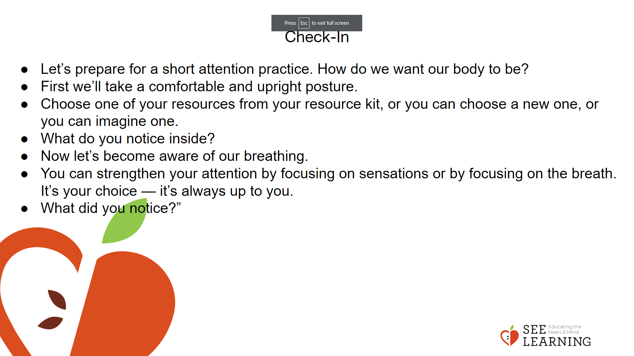 | Instructions and Guided Language  [PAUSE]s can be up to 10 seconds each  Attention Practice  • “Let’s prepare for a short attention practice. How do we want our body to be?  • First we’ll take a comfortable and upright posture. Then we’ll keep our eyes on the ground or close them.  • Before we strengthen our attention, we’ll do some resourcing or grounding to calm our bodies. Choose one of your resources from your resource kit, or you can choose a new one, or you can imagine one.  • Now let’s bring our resource to mind. And let’s see if we can just pay attention to our resource with our mind for a few moments, quietly. Or if you’d rather do grounding, you can do that instead. Whichever you choose, we’re going to rest quietly and pay attention for a few moments. [PAUSE] • What do you notice inside? If you feel pleasant or neutral, you can rest your mind on that.  • If you feel unpleasant, you can shift to a different resource, or you can ground. You can also change your posture but try not to disturb anyone else if you do that. Otherwise, just keep your attention resting with your resource. [PAUSE]  • Now let’s become aware of our breathing. Let’s see if we can pay attention to the breath as it enters and leaves our body.  • If you find paying attention to the breath uncomfortable, then feel free to go back to your resource or grounding, or just take a small break, making sure not to disturb anyone else. [Pause for 15-30 seconds.]  • If you ever get distracted, you can just return your attention to the breath. You can also count your breath. [Pause for a longer time, such as 30-60 seconds or longer.] • You can strengthen your attention by focusing on sensations or by focusing on the breath. It’s your choice — it’s always up to you.  • What did you notice?” [Invite students to share aloud.]

Presentation/Discussion (10 min)
Activity Overview
The teacher will present on some of the benefits of compassion that have been explored in science. Students will rank these benefits based on what is meaningful to them. Topics covered can include health benefits, relationship and social benefits, psychological benefits, cultivating a sense of p

Slide 3:Presentation/Discussion  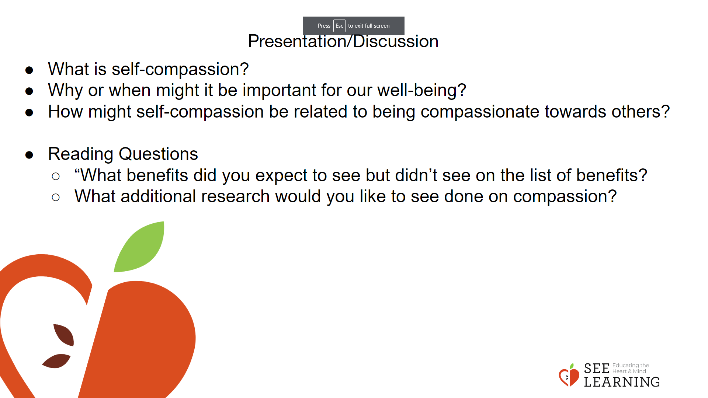 | Instructions and Guided Language  “Remember last week we explored forgiveness and self-compassion? Let’s review.  What is self-compassion?  Why or when might it be important for our well-being?  How might self-compassion be related to being compassionate towards others?  In recent years, scientists have been increasingly interested in exploring the potential benefits of compassion, particularly for health, relationships, and social well-being. Today we will learn about some of the benefits of compassion as suggested by this research.”  Present science of compassion from the student handout/reading.  • “What benefits did you expect to see but didn’t see on the list of benefits?  • What additional research would you like to see done on compassion?  Next we will break into pairs or triads based on what you listed as most meaningful to you.”

Insight Activity - (15 mins)
Activity Overview
In small groups, students review reflection questions from the Science of Compassion Benefits worksheet. They then synthesize and record their responses on the worksheetprovided or on a piece of paper that is divided into three rows.

Slide 4: Insight Activity  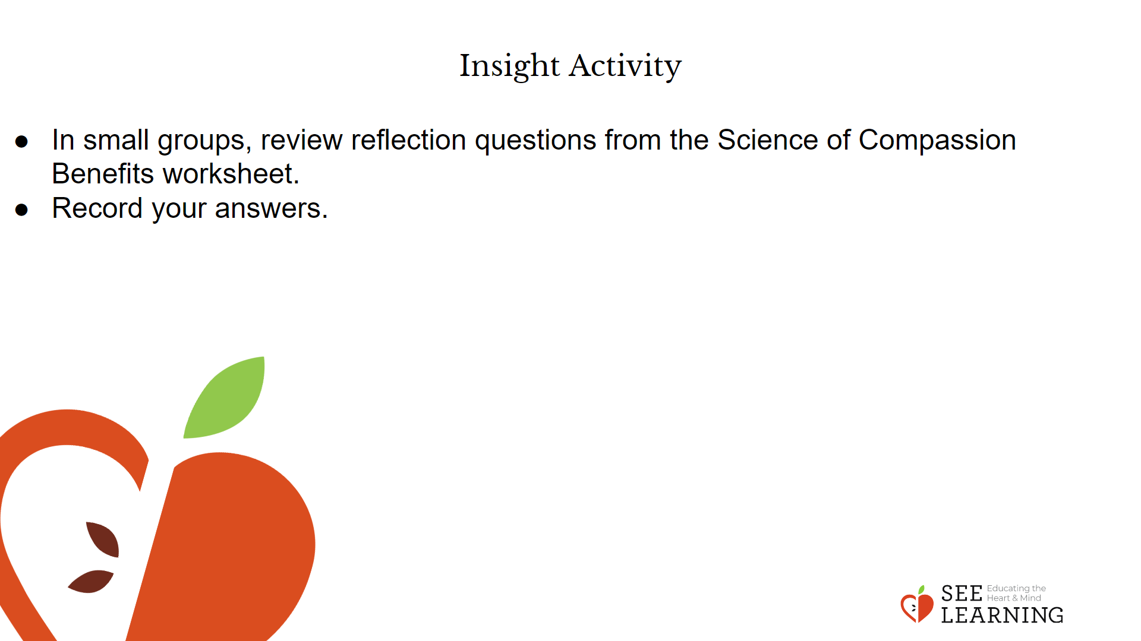 | Instructions and Guided Language  Pair/divide students into groups. Provide time for students to review the reflection questions and then discuss in their groups. Students will record their group and individual responses on their sheet.

Reflective Practice (15 mins)
Activity Overview
In this reflection students will personally connect with the benefits of compassion. Through an interpersonal reflection students will answer prompts to gain a deeper understanding of the benefits of compassion.

Teaching Tips
It can be helpful to ask clarifying questions to invite students into deeper reflection.

Slide 5: Reflective Practice  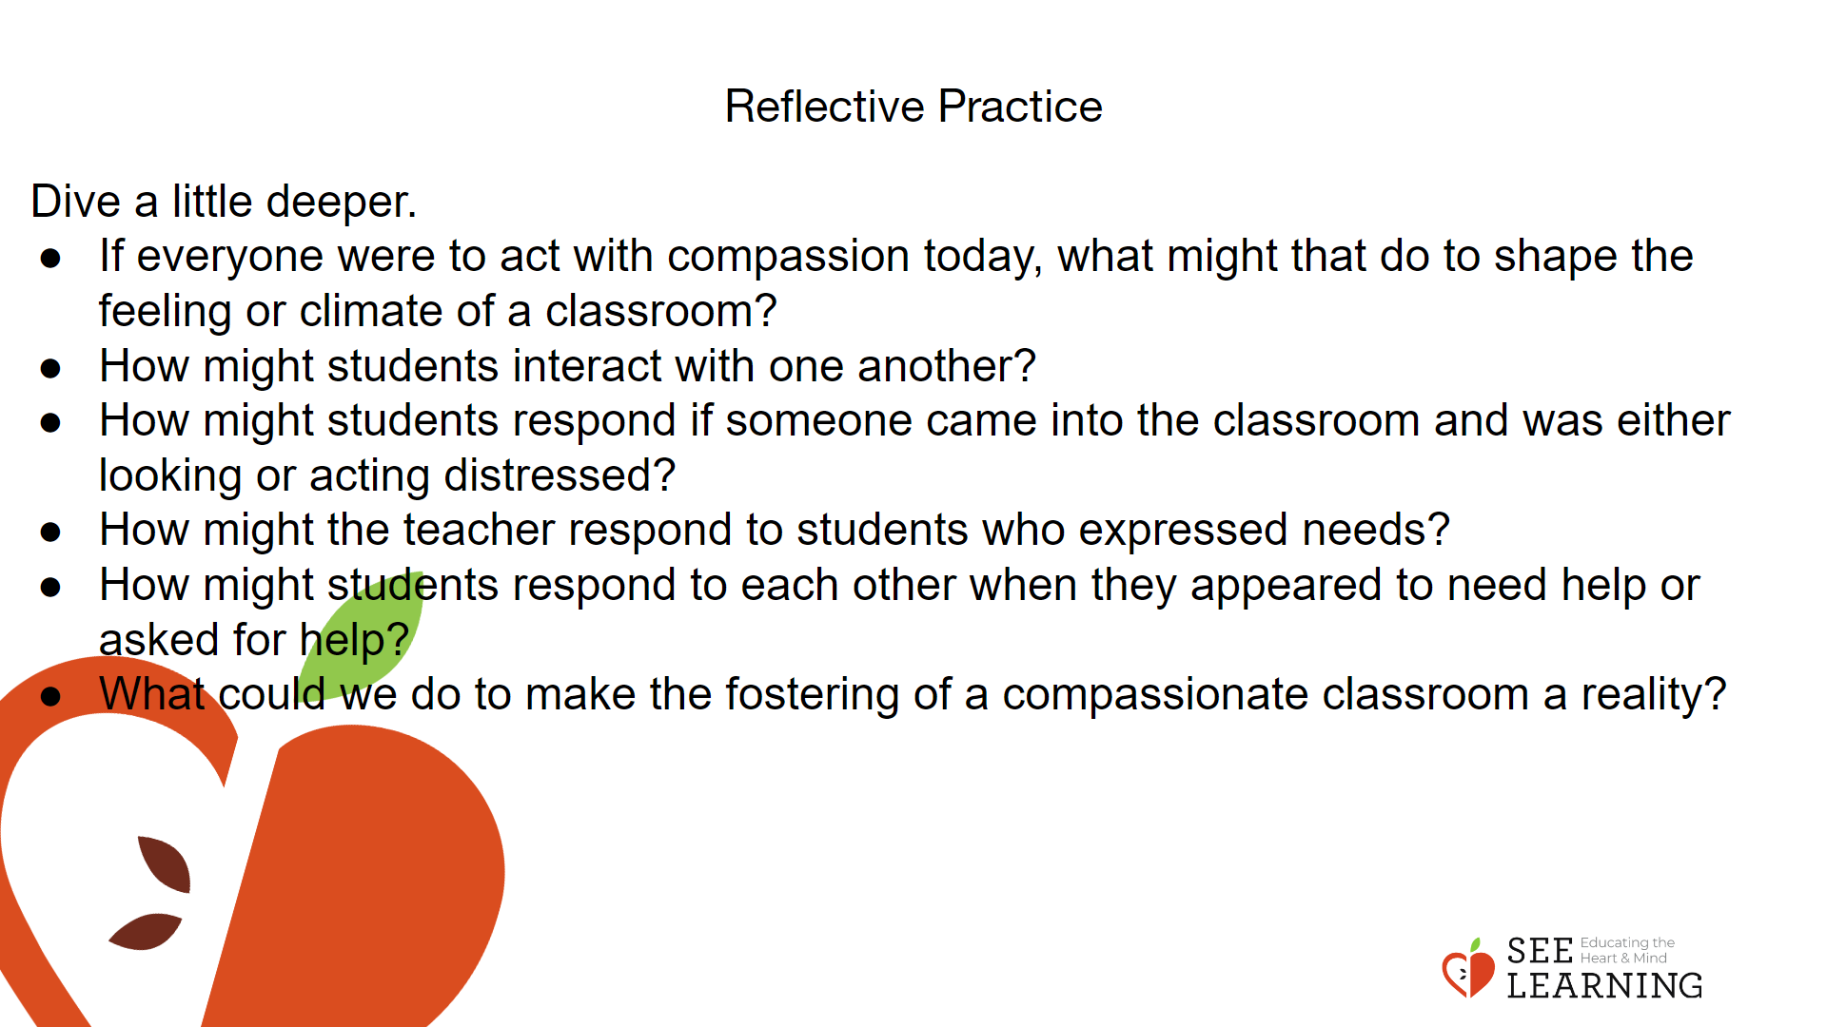 | Instructions and Guided Language  Review the benefits of compassion and allow time for reflection.  We are continuing to deepen our understanding of the benefits of compassion. To review, what are the benefits of compassion for yourself and others? Let’s think about it in the context of:  • Personal  • Social  • Systems  Now, let’s look at these prompts and reflect deeper.  If everyone were to act with compassion today, what might that do to shape the feeling or climate of a classroom? [Allow time for discussion]  How might students interact with one another? [Allow time for discussion]  How might students respond if someone came into the classroom and was either looking or acting distressed? [Allow time for discussion]  How might the teacher respond to students who expressed needs? [Allow time for discussion]  How might students respond to each other when they appeared to need help or asked for help? [Allow time for discussion]  What could we do to make the fostering of a compassionate classroom a reality?

