Practicing Forgiveness

Purpose:
In this learning experience, students engage in the practice of forgiveness as they apply strategies for forgiveness to themselves and others. Students will construct examples that identify how forgiveness is and can be applied. Students will construct a personal plan to engage in the practice of forgiveness.
Learning Objectives:  Students will be able to:  - Identify how forgiveness can become an applied skill  - Construct a personal plan to practice forgiveness | Primary Core Component  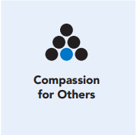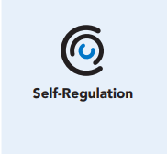
Length  45 Minutes | Materials Required  - Wish, Outcome, Obstacle, Plan (WOOP) Statement worksheet

Check-In (5 min)
Slide 2: Check-In  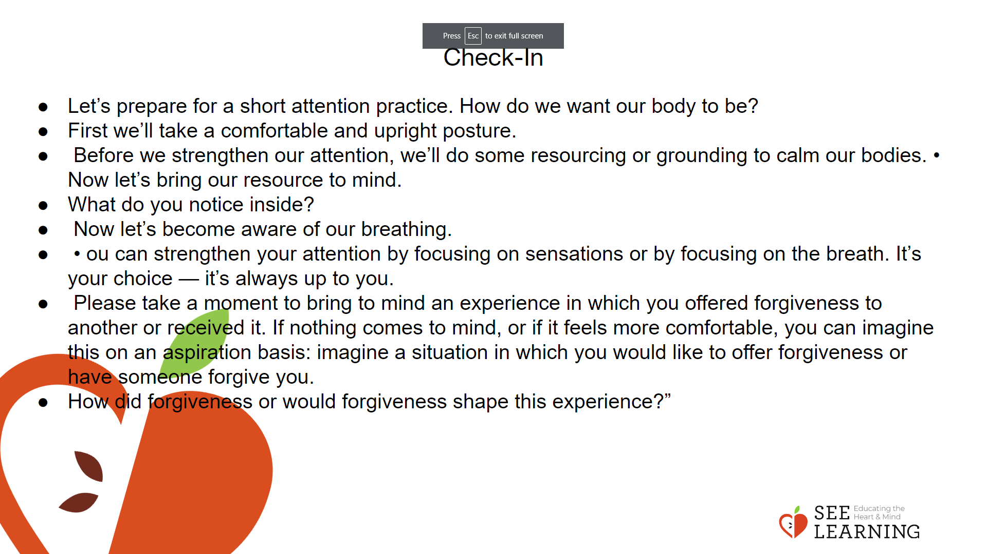 | Instructions and Guided Language  [PAUSE]s can be up to 10 seconds each  Attention Practice  • “Let’s prepare for a short attention practice. How do we want our body to be?  • First we’ll take a comfortable and upright posture. Then we’ll keep our eyes on the ground or close them.  • Before we strengthen our attention, we’ll do some resourcing or grounding to calm our bodies.  • Now let’s bring our resource to mind. And let’s see if we can pay attention to our resource with our mind for a few moments quietly. Or if you’d rather do grounding, you can do that too. Whichever you choose, we’re going to rest quietly and pay attention for a few moments. [PAUSE]  • What do you notice inside? If you feel pleasant or neutral, you can rest your mind on that.  • If you feel unpleasant, you can shift to a different resource, or you can ground. You can also change your posture. Otherwise, just keep your attention resting with your resource. [PAUSE]  • Now let’s become aware of our breathing. Let’s see if we can pay attention to the breath as it enters and leaves our body.  • If you find paying attention to the breath uncomfortable, then feel free to go back to your resource or grounding, or rest quietly asa small break. [PAUSE for 15-30 seconds.]  • If you ever get distracted, you can just return your attention to the breath. You can also count your breath. [PAUSE for a longer time, such as 30-60 seconds or longer.] • You can strengthen your attention by focusing on sensations or by focusing on the breath. It’s your choice — it’s always up to you.  • Please take a moment to bring to mind an experience in which you offered forgiveness to another or received it. If nothing comes to mind, or if it feels more comfortable, you can imagine this on an aspiration basis: imagine a situation in which you would like to offer forgiveness or have someone forgive you.  • How did forgiveness or would forgiveness shape this experience?

Presentation/Discussion (15 min)
Activity Overview
This activity gives students the opportunity to make a connection between attitudes and expectations and forgiveness by exploring examples in literature.
Teaching Tips
Through discussion, support the students in making connections between the benefit of forgiveness and the harm of non-forgiveness. This can be achieved by referring back to the benefits of forgiveness and the drawbacks of not engaging in forgiveness.

Slide 3: Presentation/Discussion  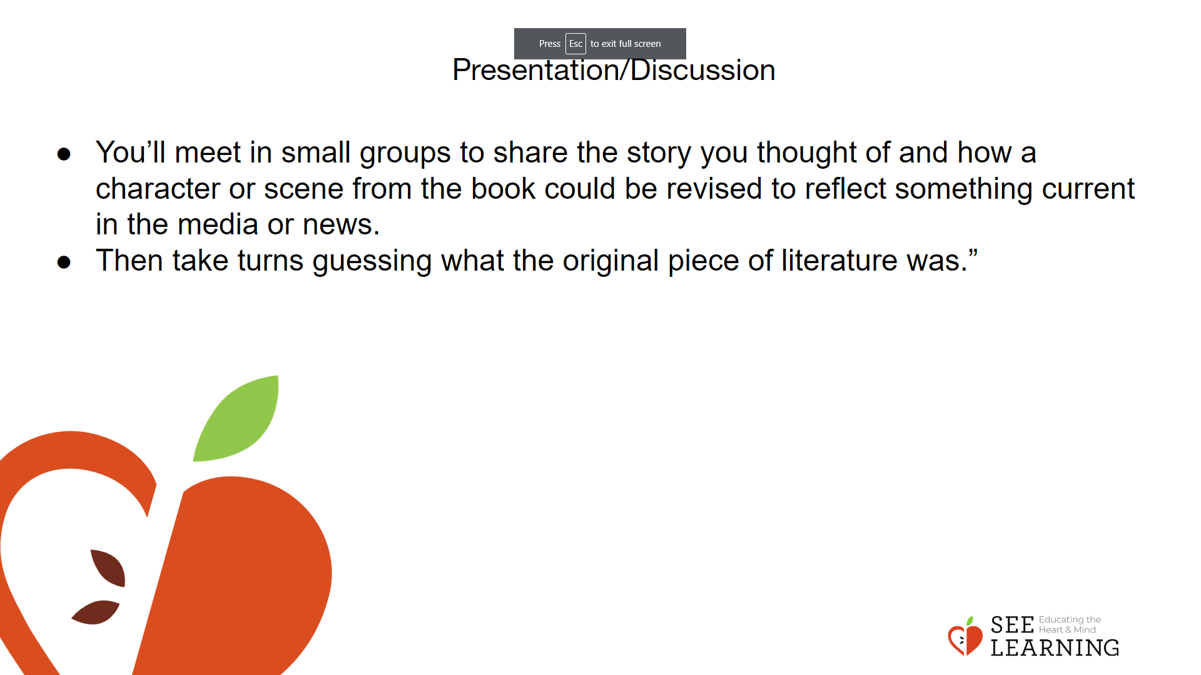 | Instructions and Guided Language  Ask students what they are currently reading in their literature class or have read in the past couple of years. Create a list for the students to reference.  Examples These examples are from the American education system and are presented here to provide a basis for you to guide students to make connections with the novels they have or are currently reading. These works were selected because they represent how forgiveness or a lack of forgiveness shapes characters and plots. If it is helpful you can use these examples for your students or reference them as you develop your own examples for students.  Gatsby  This novel is brimming with corruption and greed. Many people tolerate being poorly treated. Tom, for example, is perfectly ready to forgive Daisy for her transgressions, and she tolerates his infidelity throughout the novel. What would the novel would be like if either of them held the other up to any kind of standard? The main act of forgiveness that would change things is if George Wilson would forgive the man who had an affair with his wife. At first he thinks that is Tom Buchanan before he is corrected by Tom and realizes that it is Gatsby. George’s anger and grief lead to Gatsby’s death and George’s suicide. Frankenstein  The original sin in this novel (aside from Dr. Frankenstein trying to play God by creating his monster) is that he does not forgive his monster’s imperfections. His ill treatment of the monster from the beginning sets up the stage for all of the tragedy that follows.  Othello  The great tragedy in this play is one of misunderstanding and miscommunication, but it all starts with Iago’s anger over getting passed over for promotion. If he could forgive Othello for promoting Cassio instead of him, then he would not try to get revenge, and Othello would not kill Desdemona or himself. The racist language in the play makes it clear to me that Iago also hates Othello because he is black. Perhaps he would find a different justification for taking revenge on Othello for that reason alone.  Alice in Wonderland  This is a more comic example. If the Red Queen would forgive people and playing cards for their small and perceived errors, then there would be many fewer executions.  Lord of the Flies  Jack’s group, representing freedom and fun, cannot forgive Piggy who represents civility, order, and reason, a threat to their lifestyle. He also supports Ralph, Jack’s enemy. The group kills Piggy because they cannot forgive his different ideology.  “As we make the connection between our attitudes and expectations and forgiveness, let’s explore examples of forgiveness, or the absence of forgiveness, in literature. Think about the books you have read recently or are reading now. Remind yourself of the main elements of the plot and of the character dynamics that occurred. (5 minutes)  Now we will construct present day or real-life examples of forgiveness based on your literature examples. (5 minutes)  You’ll meet in small groups to share the story you thought of and how a character or scene from the book could be revised to reflect something current in the media or news. Then we’ll take turns guessing what the original piece of literature was.”  Model how students would change the names or context from their literature examples. You might reference the examples provided. For example, Lord of the Flies could be transformed to be a survival reality series or examples of survival that have taken place recently locally or been featured in the news.  After developing their examples the small groups will share their examples out to the whole group.  Students will share the examples they identified of forgiveness.  Facilitate a whole group discussion and exploration that highlights the benefits of forgiveness and the detriments of a lack of forgiveness on the characters and stories that were presented. Teaching Tips Through discussion, support the students in making connections between the benefit of forgiveness and the harm of non-forgiveness. This can be achieved by referring back to the benefits of forgiveness and the drawbacks of not engaging in forgiveness.

Insight Activity - (15 mins)
Activity Overview
Students will create a Wish, Outcome, Obstacle, Plan (WOOP) statements and create a plan to engage in forgiveness. The goal is for students to understand how they can foster and support the ability to forgive

Slide 4: Insight Activity  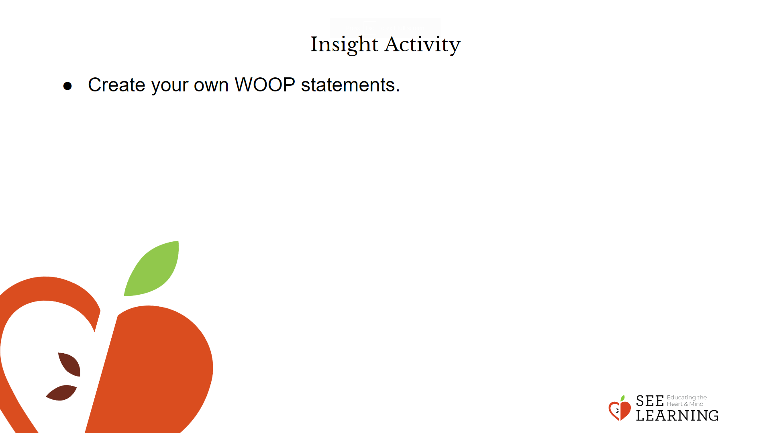 | Instructions and Guided Language  The teacher will share what a WOOP statement is and the research that supports it. A WOOP statement is an abbreviation of Wish, Outcome, Obstacle, and Plan. Students will create a personal plan to engage in forgiveness.  “As we continue deepening our understanding of forgiveness, we will learn about WOOP statements. A WOOP statement is an abbreviation of Wish, Outcome, Obstacle, and Plan.  Now we will have an opportunity to create our own WOOP statements. This will assist us in strengthening our ability to forgive.”

Reflective Practice (10 mins)
Activity Overview
In this reflection, students experience connecting forgiveness personally to the practice of forgiveness by identifying the benefits to self and others.

Slide 5: Reflective Practice  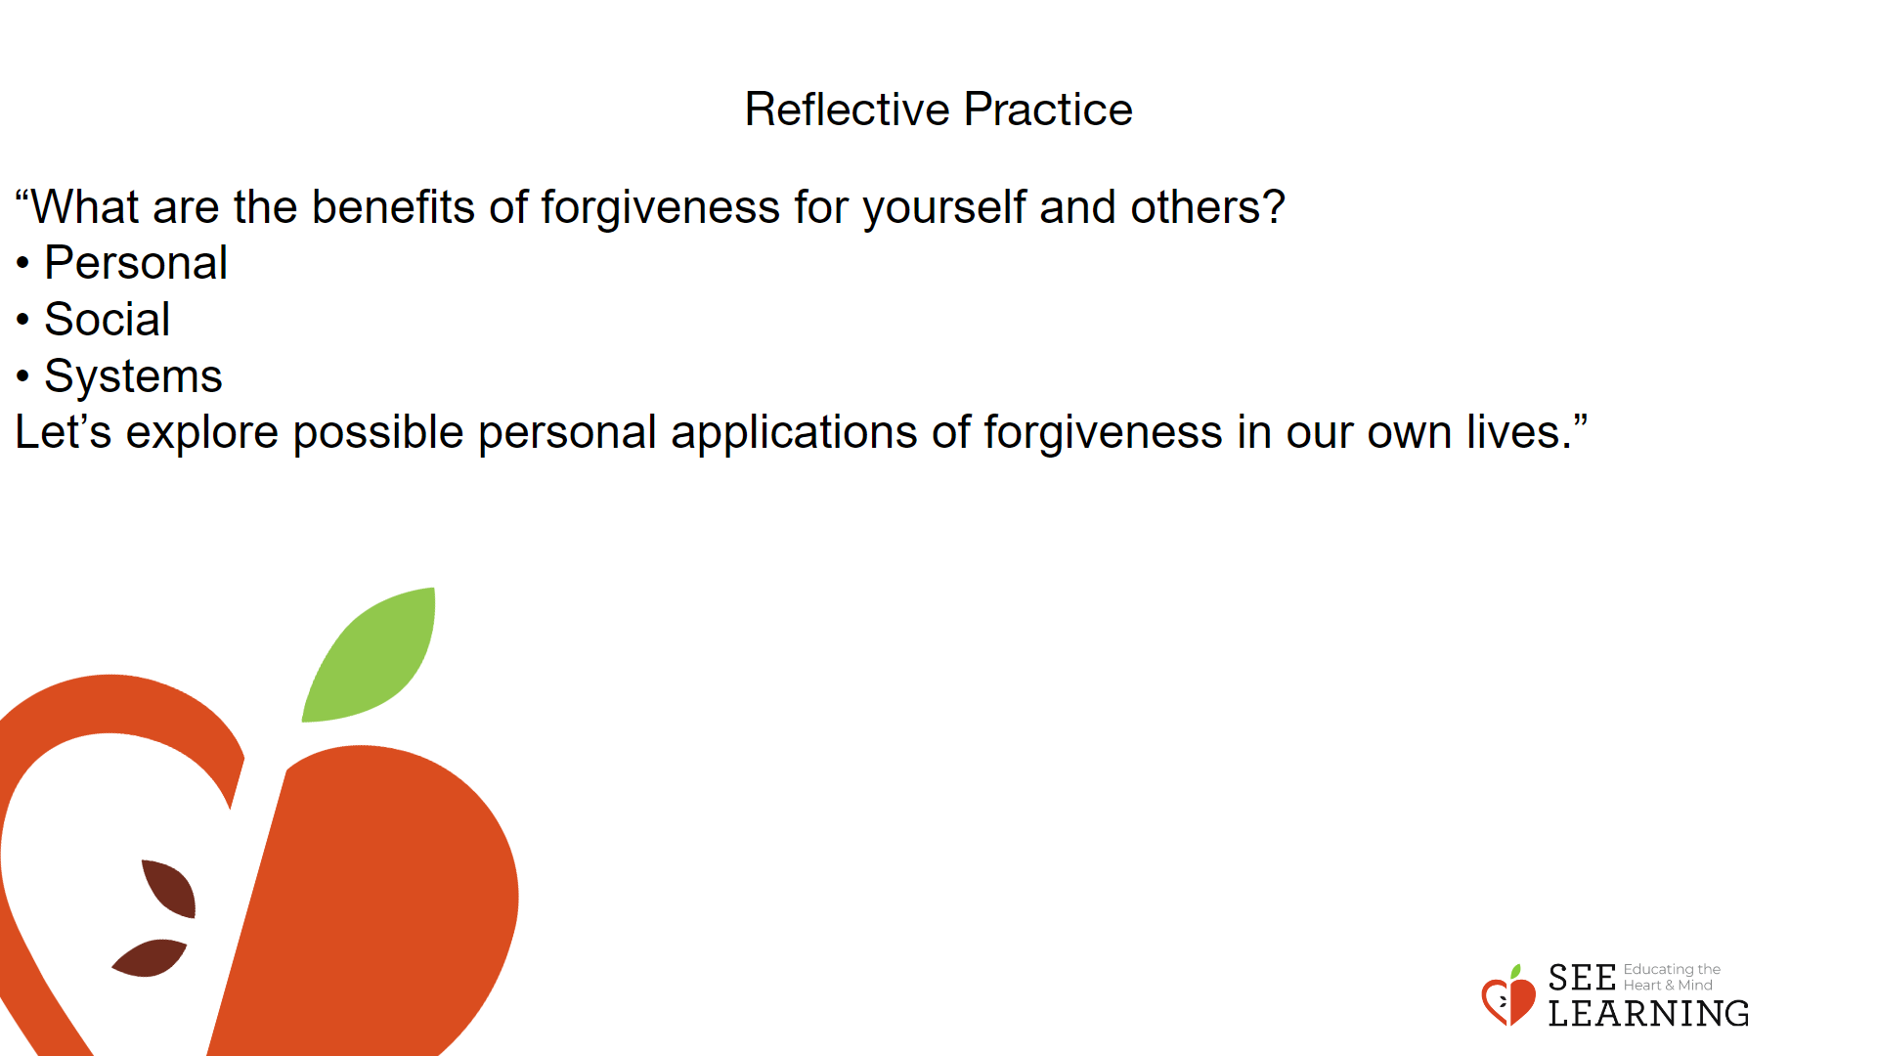 | Instructions and Guided Language  Guide students through a reflection in which they identify once again with the benefits of forgiveness for themselves and others, noticing what they remember about this from our previous Learning Experience .  “What are the benefits of forgiveness for yourself and others?  • Personal  • Social  • Systems  Let’s explore possible personal applications of forgiveness in our own lives.”  Guide students through how they can apply forgiveness in their everyday experience. This guidance can occur through sharing personal examples of how forgiveness has benefited you, people in history, or others. One practical strategy for engaging students can occur through reviewing the benefits of forgiveness and the drawbacks of not engaging in forgiveness.  Explore possible classroom applications of forgiveness. This could occur through recalling situations or events that occurred with you personally in which a mistake was made either on the part of the students as you navigated your classroom and learning experience.  What, if anything, are they willing to commit to when it comes to forgiveness: learning about it more, thinking about it, none of the above, etc.  From the examples that students provide, create a list of ways they’ve identified as ways to bring their intentions into daily practice. Foreshadow to students that in the next lesson we will review these activities and then make a commitment to engage in 2-3 of the more essential practices.

