Defining Forgiveness

Purpose:
In this learning experience, students explore the science of forgiveness and the impacts it has on our physiology, as a strategy for letting go of anger and negative emotions towards oneself and others. Students will examine how to practice forgiveness without necessarily approving of the action that led to harm. Students will define and reflect on experiences they may have had in which they let go of anger and negative emotions towards others and themselves. Finally, students will develop a classroom and personal plan to relate with forgiveness towards themselves and others.
Learning Objectives:  Students will be able to:  - Identify how the practice of forgiveness can serve as a release of negative emotions towards oneself or another person  - Understand the scientific basis for forgiveness  - Understand how seeing another person’s behavior and emotions in context may help us understand others and have compassion for them and oneself | Primary Core Component  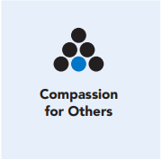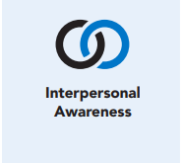
Length  45 Minutes | Materials Required  - Provide enough space for students to move around an imagined continuum line  - Science of Forgiveness reading handout  - Sign that reads “Total Forgiveness”  - Sign that reads “No Forgiveness”  - Drawing/writing utensils and paper

Check-In (5 min)
Slide 2: Check-In  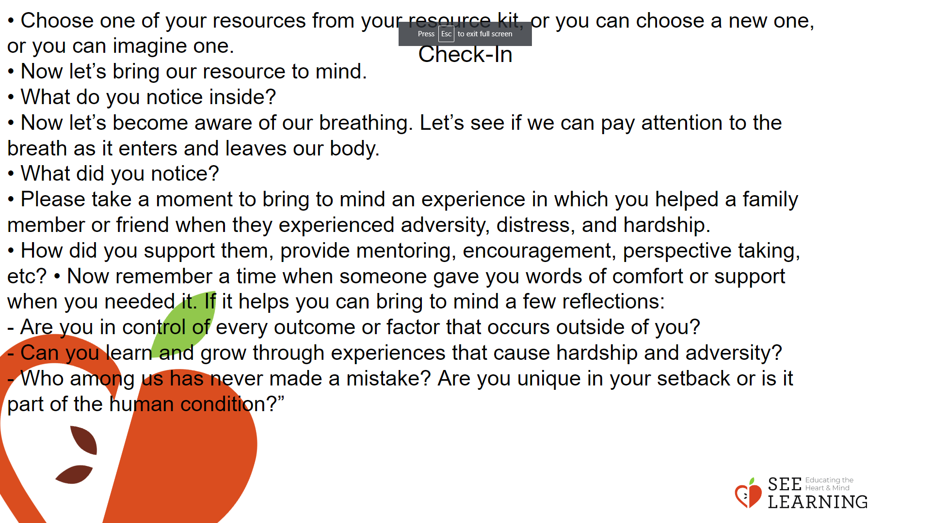 | Instructions and Guided Language  [PAUSE]s can be up to 10 seconds each  Attention Practice  • “Let’s prepare for a short attention practice. Find a posture that feels both alert and comfortable.  • One way to find an alert and comfortable posture could be to sit up right with our feet on the ground. We want to feel comfortable but not sleepy. If it helps to keep focused, you can close your eyes or look with ease at the ground, but if that feels uncomfortable feel free to leave them open.  • Before we strengthen our attention, we’ll do some resourcing or grounding to calm our bodies. Choose one of your resources from your resource kit, or you can choose a new one, or you can imagine one.  • Now let’s bring our resource to mind. And let’s see if we can just pay attention to our resource with our mind for a few moments, quietly. Or if you’d rather do grounding, you can do that too. Whichever you choose, we’re going to rest quietly and pay attention for a few moments. [PAUSE]  • What do you notice inside? If you feel pleasant or neutral, you can rest your mind on that.  • If you feel unpleasant, you can shift to a different resource, or you can ground. You can also change your posture. Otherwise, just keep your attention resting with your resource. [PAUSE]  • Now let’s become aware of our breathing. Let’s see if we can pay attention to the breath as it enters and leaves our body.  • If you find paying attention to the breath uncomfortable, then feel free to go back to your resource or grounding, or just take a small break, making sure not to disturb anyone else. [PAUSE for 15-30 seconds.]  • If you ever get distracted, you can just return your attention to the breath. You can also count your breath. [Pause for a longer time, such as 30-60 seconds or longer.] • You can strengthen your attention by focusing on sensations or by focusing on the breath. It’s your choice. It’s always up to you.  • What did you notice? [Invite students to share aloud.]  • Please take a moment to bring to mind an experience in which you helped a family member or friend when they experienced adversity, distress, and hardship.  • How did you support them, provide mentoring, encouragement, perspective taking, etc?  • Now remember a time when someone gave you words of comfort or support when you needed it. If it helps you can bring to mind a few reflections:  - Are you in control of every outcome or factor that occurs outside of you?  - Can you learn and grow through experiences that cause hardship and adversity?  - Who among us has never made a mistake? Are you unique in your setback or is it part of the human condition?”  [Close out practice]

Presentation/Discussion (15 min)
Activity Overview
Students will explore forgiveness and deepen their understanding by identifying key attributes of forgiveness.

Slide 3: Presentation/Discussion  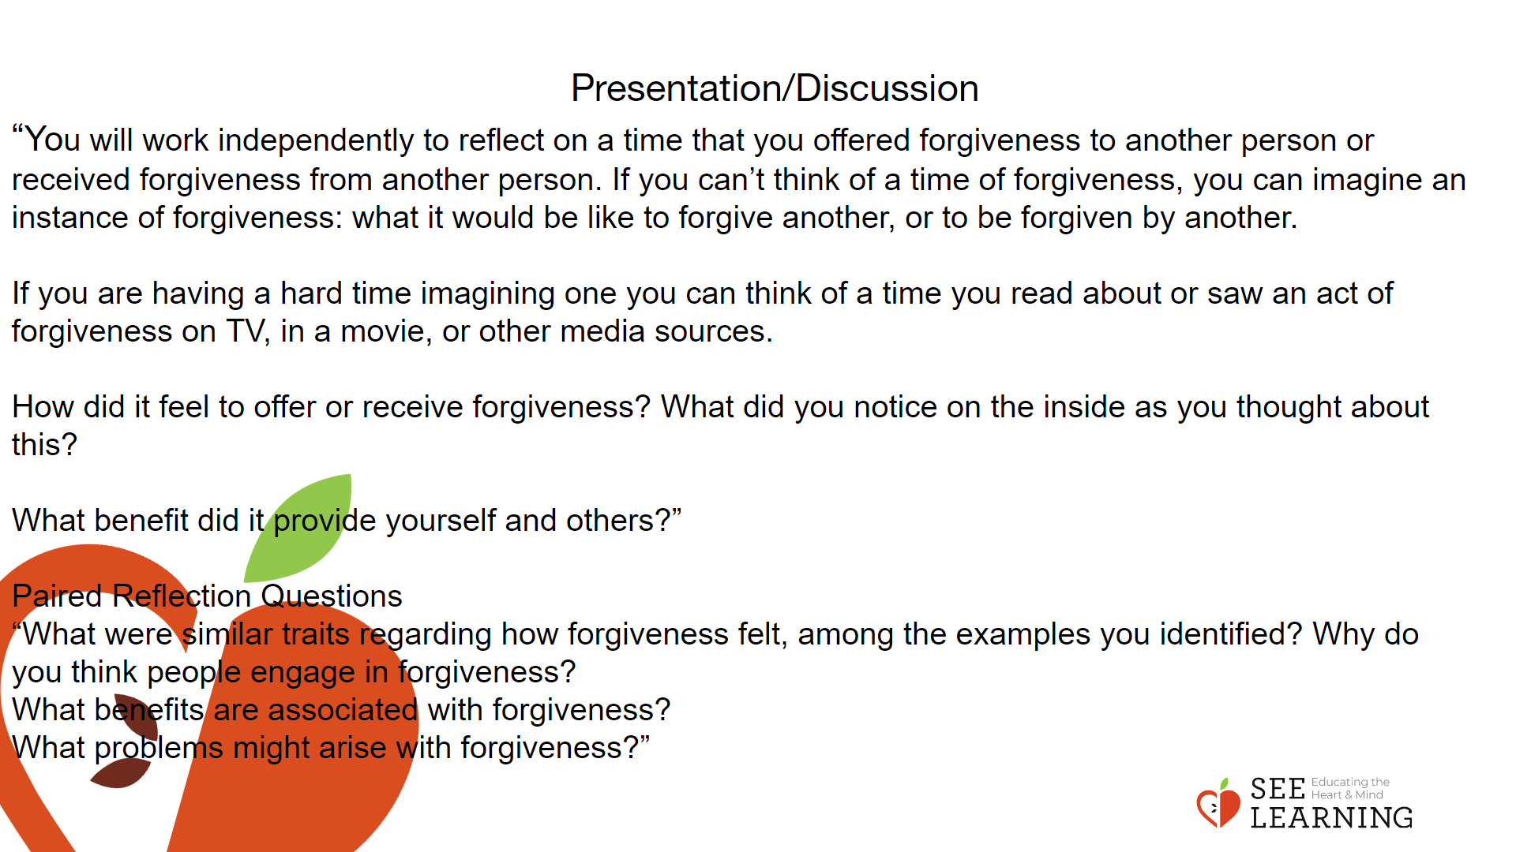 | Instructions and Guided Language  Engage students by asking them to identify an act in which they offered forgiveness to another person and/or received forgiveness from another person.  “Remember in our last learning experience we explored how attitudes and expectations shape our outlook of self and others.  How is happiness defined by society and how does that differ or align with our lived experience? Why is it important to recognize that we are not perfect and that making mistakes is both a natural extension of being human and essential in helping us to learn and grow?”  To set this activity up, have students engage in a written reflection using the following prompts:  “You will work independently to reflect on a time that you offered forgiveness to another person or received forgiveness from another person. If you can’t think of a time of forgiveness, you can imagine an instance of forgiveness: what it would be like to forgive another, or to be forgiven by another.  If you are having a hard time imagining one you can think of a time you read about or saw an act of forgiveness on TV, in a movie, or other media sources.  How did it feel to offer or receive forgiveness? What did you notice on the inside as you thought about this?  What benefit did it provide yourself and others?”  After students have constructed their responses in writing, they can then engage in a pair or triad to share. The student groups will be asked to identify key attributes of forgiveness within the examples of forgiveness that they generated. Use the following prompts:  “What were similar traits regarding how forgiveness felt, among the examples you identified?  Why do you think people engage in forgiveness?  What benefits are associated with forgiveness?  What problems might arise with forgiveness?”

Insight Activity - (15 mins)

Activity
Overview Students will identify the benefits of forgiveness on themselves (personal), others (social), and the systems that they impact and that are impacted by them.

Teaching Tips
Before engaging the students in this activity you can share an example in which you as the classroom teacher engaged in forgiveness. If that is challenging for you, feel free to share the following examples provided:

• Speaking harshly to a loved one or friend
• Breaking something due to being absent minded
• Getting agitated and losing one’s patience
• Forgetting something important
• Offending someone either intentionally or unintentionally

Please remember to share with students that although there are many benefits to forgiveness and downsides to not engaging in forgiveness, it is not alway necessary or possible to forgive another, which is perfectly all right. It is a very personal decision.

Slide 4: Insight Activity  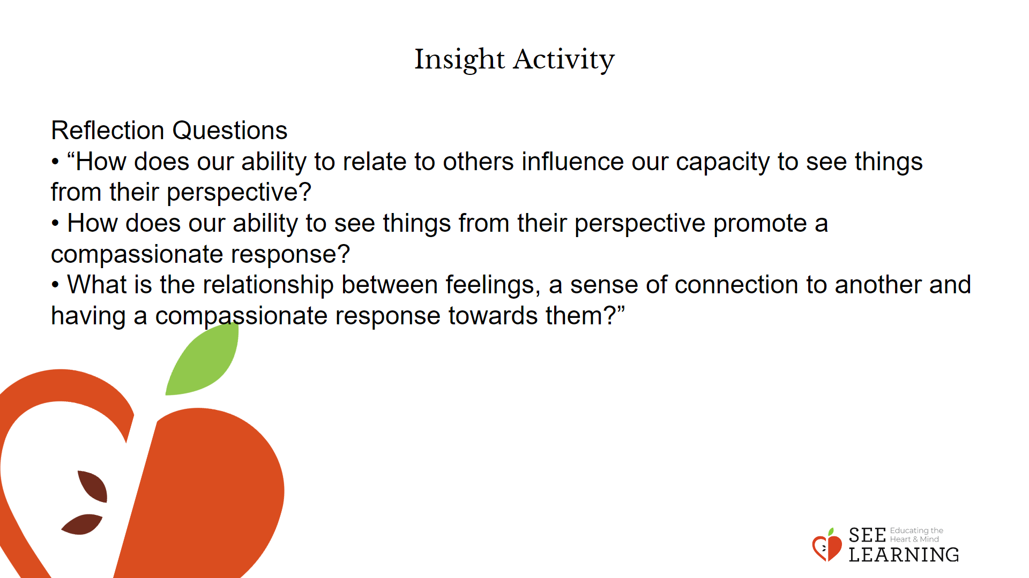 | Instructions and Guided Language  Ask students to read the Science of Forgiveness reading. Present on topics and various research studies that explore the topic of forgiveness and outline the physical, psychological, emotional, and relationship benefits of forgiveness. Students will be provided with a list of scenarios and will identify where they would respond to scenarios, using a continuum from “no forgiveness” to “total forgiveness.”  “Now that we’ve explored the topic of forgiveness, we are going to review a few scenarios and use responses ranging from “no forgiveness” to “total forgiveness, to identify where we stand. You will physically move along the line we have created.”  Prompt students to respond on the continuum, using the following examples:  Example 1: A person bumps into you and causes you to spill your drink all over yourself.  Example 2: A family member says something critical of you that triggers a strong response.  After each scenario ask a couple of students why they chose to stand where they did.  Scenarios  • A drunk driver hits another car and injures a person who was in it.  • A woman hits a pedestrian while driving, as she was trying to help her crying baby in the back seat.  • An old man loses consciousness while driving and runs into a house.  • A teenager hits a deer with their car while checking a text message.  • A corporation is caught dumping waste into the local waterway.  • A protester destroys a bulldozer that had been creating a logging road.  • A boyfriend cheats on his girlfriend with a stranger.  • A girlfriend cheats on her boyfriend with his best friend.  Allow for the relative experiences of forgiveness to highlight key enduring traits that contribute to our capacity to forgive. Please reflect on the below listed traits in the discussion:  • Intention  • Impact  • Resolve not to Commit the Action Again  • Remediation  After the activity, asks students these prompts and have them respond or reflect as you transition to the reflection activity.  • “How does our ability to relate to others influence our capacity to see things from their perspective?  • How does our ability to see things from their perspective promote a compassionate response?  • What is the relationship between feelings, a sense of connection to another and having a compassionate response towards them?

Reflective Practice (10 mins)

Activity Overview
In this reflection experience, students connect forgiveness for oneself, personally, to the broader practice of forgiveness by identifying the benefits for self and others.

Slide 5: Reflective Practice  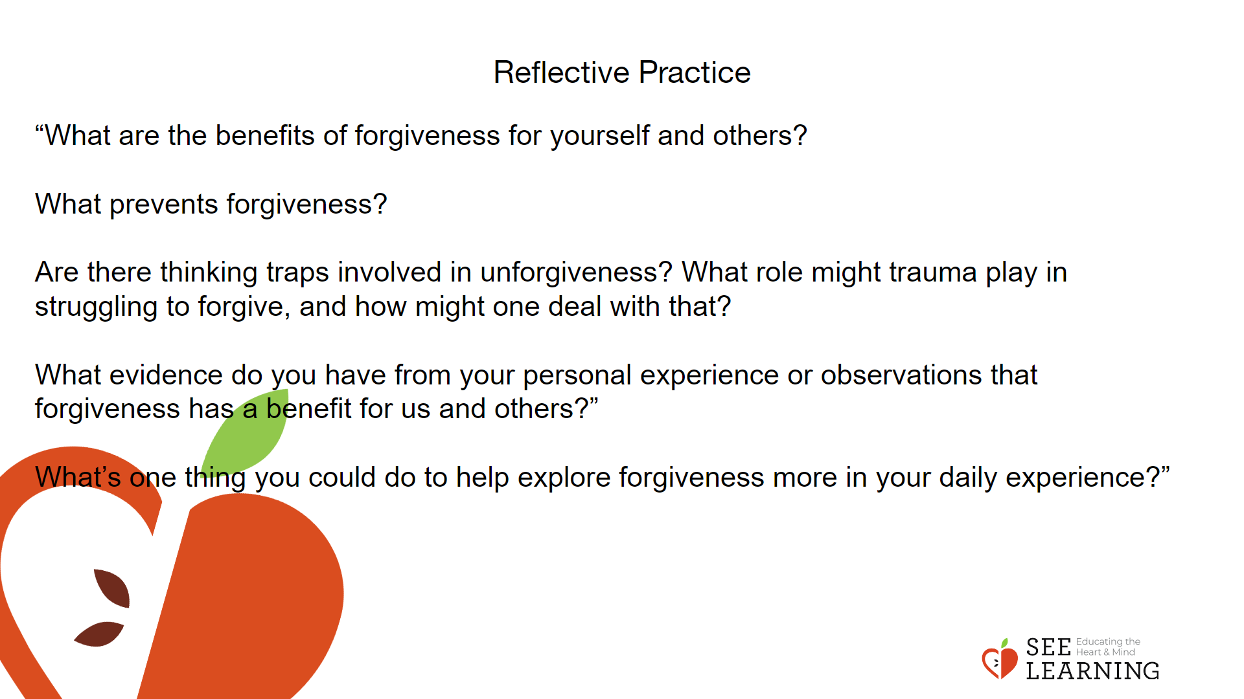 | Instructions and Guided Language  Guide students through a reflection of the learning experience in which they identify once again with the benefits of forgiveness for themselves and others.  “What are the benefits of forgiveness for yourself and others?  • Personal  • Social  • Systems  What prevents forgiveness?  Are there thinking traps involved in unforgiveness? What role might trauma play in struggling to forgive, and how might one deal with that?  What evidence do you have from your personal experience or observations that forgiveness has a benefit for us and others?”  What’s one thing you could do to help explore forgiveness more in your daily experience?”  Explore possible classroom applications of forgiveness. Prompt students to determine how they and the class as a whole can carry these intentions for forgiveness as an applied practice within the classroom.  Let the students know that you are going to compile a list of the examples that they provided, and that in the next lesson we will review them. Make a commitment to apply forgiveness in key areas of your life. This could be cultivating patience and understanding towards people you find annoying or developing self forgiveness towards ourselves when we make mistakes.

