Exploring Attitude and Expectations

Purpose:
In this learning experience, students will explore the attitudes and expectations they hold for themselves. Students will begin by examining the messages about happiness they receive from society. Then they will reflect and evaluate their ideas about happiness. When we exercise self-compassion we can set expectations for ourselves out of a desire to be healthy and flourishing rather than from a place of self-criticism.
Learning Objectives:  Students will be able to:  - Analyze societal messages about happiness  - Evaluate their ideas about happiness  - Identify the factors and conditions that lead to happiness and flourishing | Primary Core Component  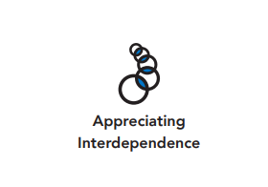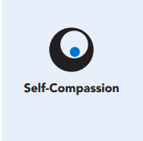
Length  45 Minutes | Materials Required  - Slides or print copies of examples of cultural messages (ie: magazine or online ads, memes, TV shows, music lyrics or videos, culturally relevant texts, news media)  - Chart paper and markers or whiteboard  - Writing utensils and paper  - Examining Our Ideas About Happiness handout  - What Do I Expect of Myself handout

Check-In (5 min)
Slide 2: Check-In  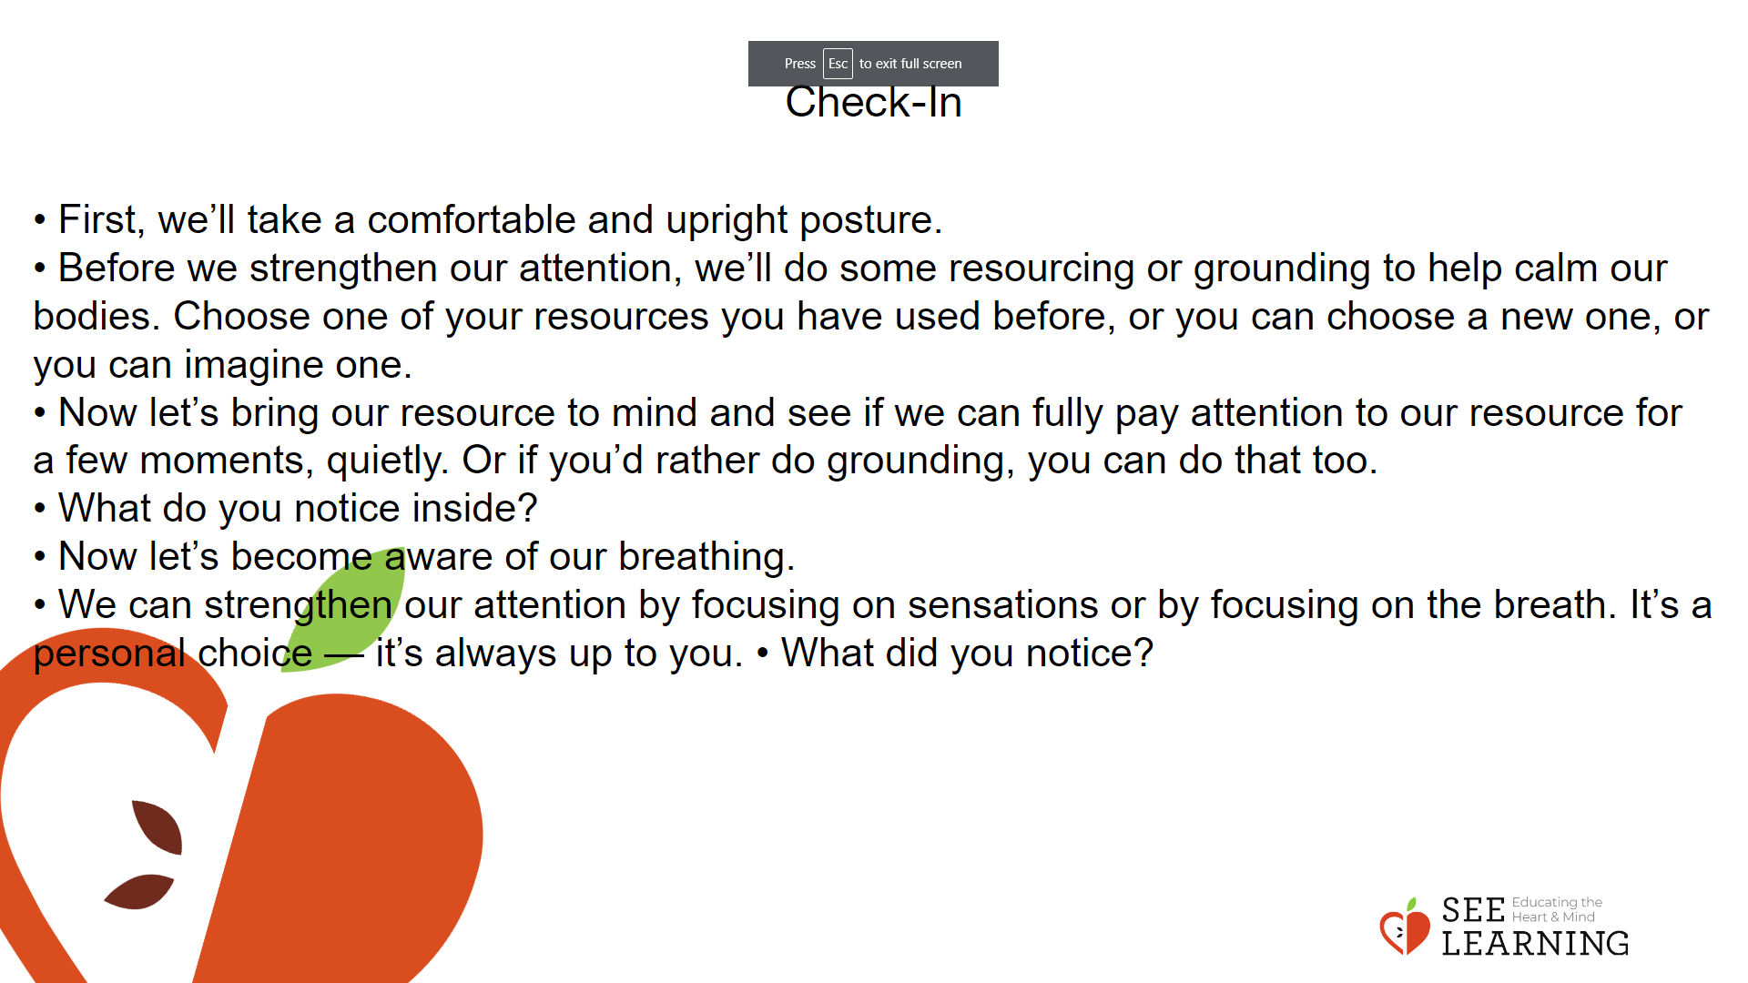 | Instructions and Guided Language  [PAUSE]s can be up to 10 seconds each  Lead students in a short attention practice.  • “We’ve been working on extending compassion to ourselves. Who can remember some of the ways we can do this? [Invite answers]  • Thank you for sharing the ways we can be compassionate to ourselves. Today we are going to look at some of the ideas and expectations we hold for ourselves and how they may or may not be helpful for nurturing our self-compassion.  • Let’s prepare ourselves by doing a short attention practice.  • First, we’ll take a comfortable and upright posture. Then we’ll rest our eyes on the ground or close them, whichever feels most comfortable.  • Before we strengthen our attention, we’ll do some resourcing or grounding to help calm our bodies. Choose one of your resources you have used before, or you can choose a new one, or you can imagine one.  • Now let’s bring our resource to mind and see if we can fully pay attention to our resource for a few moments, quietly. Or if you’d rather do grounding, you can do that too. Whichever you choose, we’re going to rest quietly and focus for a few moments. [PAUSE]  • What do you notice inside? If you feel pleasant or neutral, you can rest your mind on that.  • If you feel unpleasant, you can shift to a different resource, or you can ground. You may also want to change your posture. Settle yourself and keep your attention resting with your resource.” [PAUSE]  • Now let’s become aware of our breathing. Let’s see if we can pay attention to the breath as it enters and leaves our body.  • If you find paying attention to the breath uncomfortable, take yourself back to your resource or grounding, or take care of yourself with a private, silent break. [PAUSE for 15-30 seconds.]  • When your mind becomes distracted, you can return your attention to the breath. You can also count your breaths, if that’s helpful for building focus. [PAUSE for a longer time, such as 30-60 seconds or longer.]  • We can strengthen our attention by focusing on sensations or by focusing on the breath. It’s a personal choice — it’s always up to you.  • What did you notice?” [Invite students to share aloud.]

Insight Activity - (30 mins)

Overview
In this insight activity, students will examine examples of images or messages presented in society or by those around us. These can come from media like advertising, cultural stories/books, or other external messages like social media. Students will explore the role of interpretation and what meaning or meanings might be conveyed by messages. In particular students will notice what they suggest regarding what makes people happy or what is needed to be happy. This may include: health, nutritious food, wealth, success, particular beauty or attractiveness standards, personal safety, gender roles and norms, popularity, and more. Students will evaluate the ways these messages may be healthy and helpful or not healthy or not helpful, as well as how such messages fall into or resist common thinking traps.

Teaching Tip
In choosing images to evaluate, pick ones that will be relevant and challenge your students, but be aware that some images or topics may be too activating for your specific context and 352 High School Chapter 6 | Compassion for Self and Others students. For example, examining body image can be a powerful discussion, but may be activating for some students. If you see students becoming activated due to a particular topic, feel free to employ a Help Now! Strategy for the class

Slide 3: Insight Activity  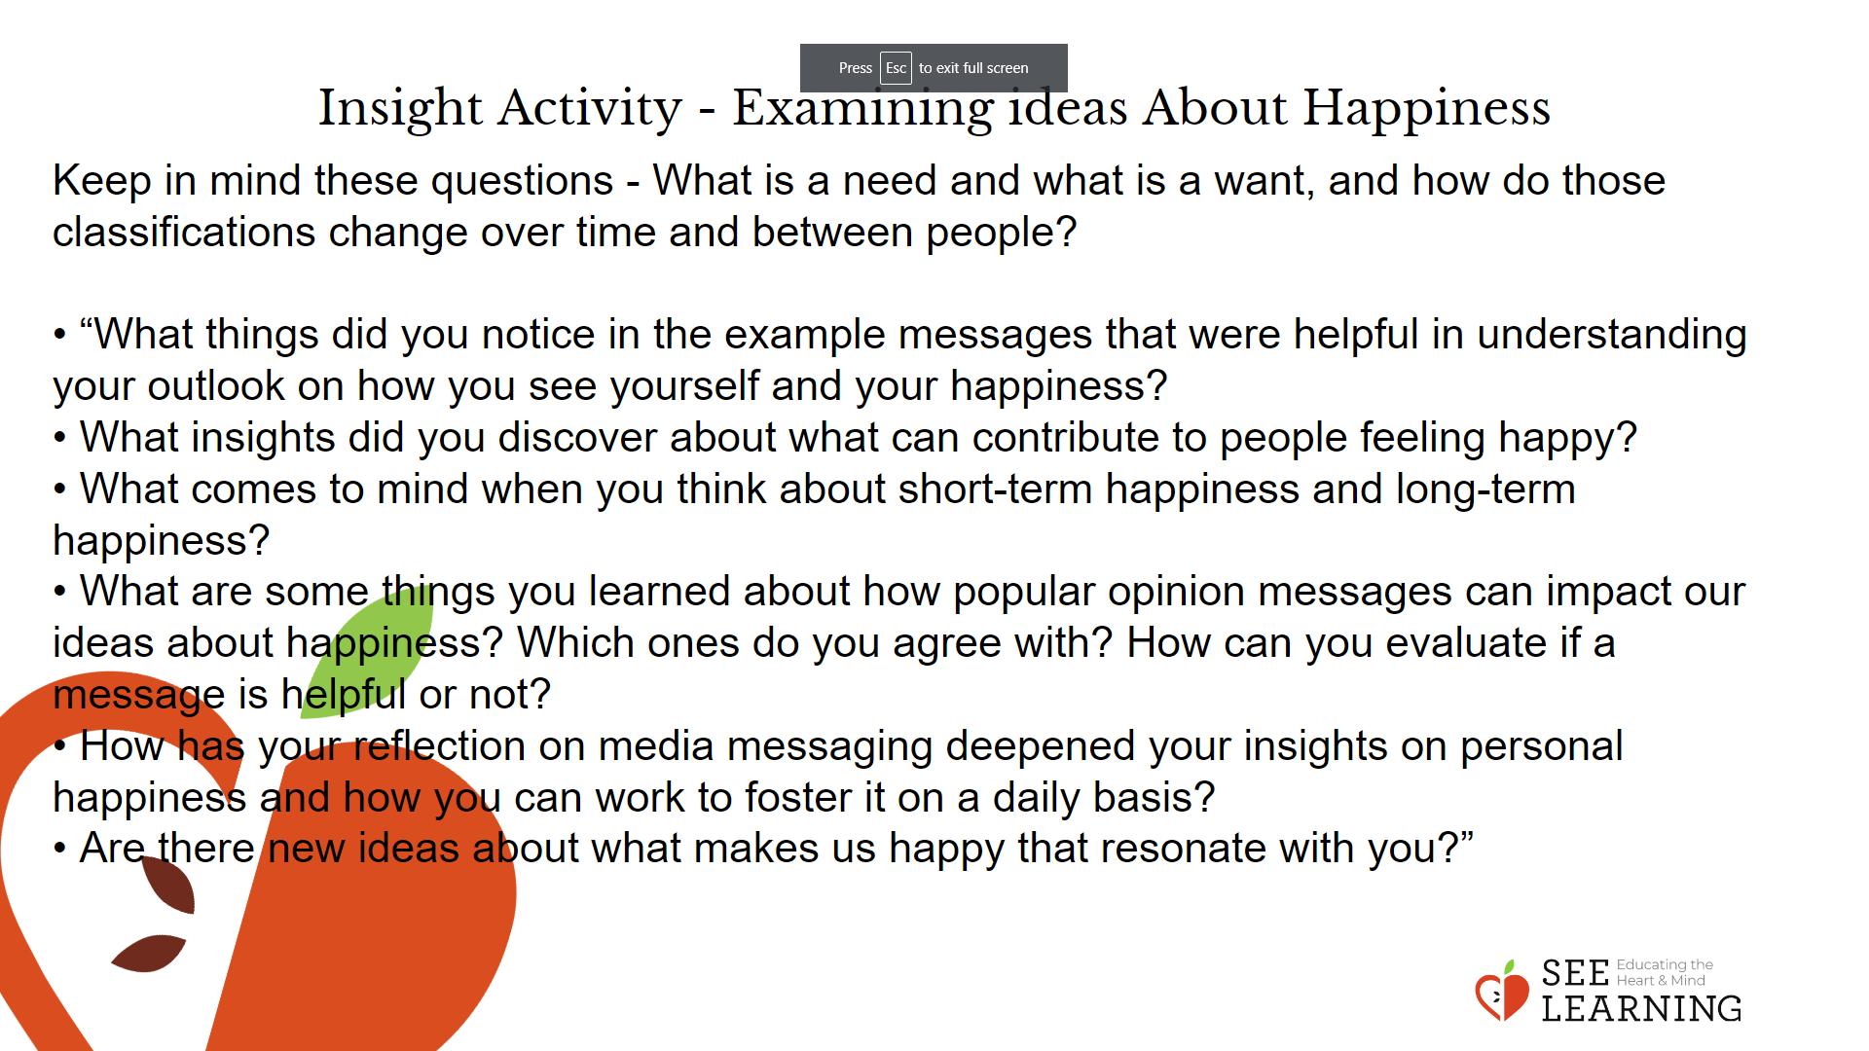 | Instructions and Guided Language  Present a series of slides/print copies of sources for review and/or invite students to find examples and share them with the class. This could be done in advance as homework if you think students have access to resources, or during this lesson by providing sources for them such as magazines or online time. You can capture the examples through screenshots or by noting the site for reference. If expecting students to find examples, also have some prepared examples to ensure a wide range of options.  In preparing for the lesson, pay particular attention to ideas that seem relevant to your students and their contexts.  Some possible themes could be messages related to body image, the value of financial success/wealth/prestige, race, social relationships, technology and social media, alcohol or drug uses, stress, and job/school success.  “Today we’re going to think together about expectations, perfectionism, and growth mindset. Throughout this learning experience it will be helpful to consider the difference between needs and wants. What is a need and what is a want, and how do those classifications change over time and between people? We’ll begin by looking at some things that society, the media, and those around us present as what we need to be happy. Some of these messages are helpful. Some we might find are not helpful.  We’ll look at examples of these messages and then discuss them. Let’s begin.”  Present a few images or other messages and explore what they suggest to us about happiness. [If students have prepared images to share, include those in this exploration time.]  After each image, explore what it suggests to us about happiness. Some possible questions to consider in your discussion:  • “Who made this image/message?  • Who is the intended audience?  • What might it be saying? And what else?  • What does this image suggest is necessary for happiness?  • Does it provide any support or evidence for what it suggests? Is it credible?  • How does this image make you feel? Does it seem helpful or harmful?  • How might this image connect with common thinking traps that people might fall into? (Such as thinking traps around perfectionism, happiness, etc.)  Now that we have looked at these examples, let’s make a list of “External messages about what makes people happy.” What do these messages suggest will make us happy?” [Invite responses and write them on the board.]  “Let’s examine these ideas.” [Use these or other questions to discuss the ideas.] (5 minutes)  • “Are these things likely to bring us lasting happiness? Why do you think that?  • Is everybody who is [example: wealthy] happy?  • Do you think if you had any or all of these things you would be completely happy? Why or why not?  • Can you think of a time when you or someone else got something they thought would make them happy, but that turned out not to be the case?  • Could any of these expectations people might have for themselves cause them problems?  Let students guide the discussion as they evaluate these external messages.  “We have a lot of messages around us about what will make us happy. It’s important to recognize which messages are helpful for us and which may place undue distress on us, or are unrealistic expectations. Next, we’ll look at some of our own ideas about happiness as well.  We receive many messages about what will make us happy from the media, ads, our society, our communities, and families. We all also have our own ideas about what will help us be happy. Some of these may come from these external messages and others may be ideas we have created ourselves, as we reflect on what’s important to us in life.  We’ll be writing down some of our own ideas about happiness and then discussing them with a partner.  Here are a few prompts that you can respond to. You can respond to any of them or all of them. This is to get us thinking about what helps to make us feel happy. Remember, there are no right or wrong answers.”  Provide independent work time for students to make lists, filling in the blank for these statements: “To be happy I need_____” ; “I will be happy when_______.” I am happy when____” or “Right now, some things that make me happy are___.” Encourage students to think about small things like their current favorite song, or things they may already have such as good health, or can look forward to, like summer break. [Students write for 5 min.]  “Now that we have had time to reflect, we’ll pair up for 5 minutes, to discuss our answers. As you share your responses, explore together what makes each statement feel true?  You may wish to consider the following questions:  • Which of your ideas about happiness might be coming from an external source like the media or people around us?  • If you are gaining messages about happiness from external sources, are those messages helpful? What about those messages feel true for you? Do they feel attainable? What are the benefits and costs to us, and to others, of thinking of happiness in this way?  • What else might contribute to them feeling happy?” After allowing discussion in pairs, invite students to share any insights with the group. (5 minutes) “Who would like to share something they noticed? Remember to share only for yourself and not for your partner.” Possible questions to prompt discussion include:  • “What things did you notice in the example messages that were helpful in understanding your outlook on how you see yourself and your happiness?  • What insights did you discover about what can contribute to people feeling happy?  • What comes to mind when you think about short-term happiness and long-term happiness?  • What are some things you learned about how popular opinion messages can impact our ideas about happiness? Which ones do you agree with? How can you evaluate if a message is helpful or not?  • How has your reflection on media messaging deepened your insights on personal happiness and how you can work to foster it on a daily basis?  • Are there new ideas about what makes us happy that resonate with you?”

Reflective Practice - Setting Expectations for Ourselves (10 mins)
Overview
In this reflective practice, students examine expectations they have for themselves and how these may be helpful or unhelpful.
Teaching Tip
Teacher can model this activity first.

Slide 4: Reflective Practice  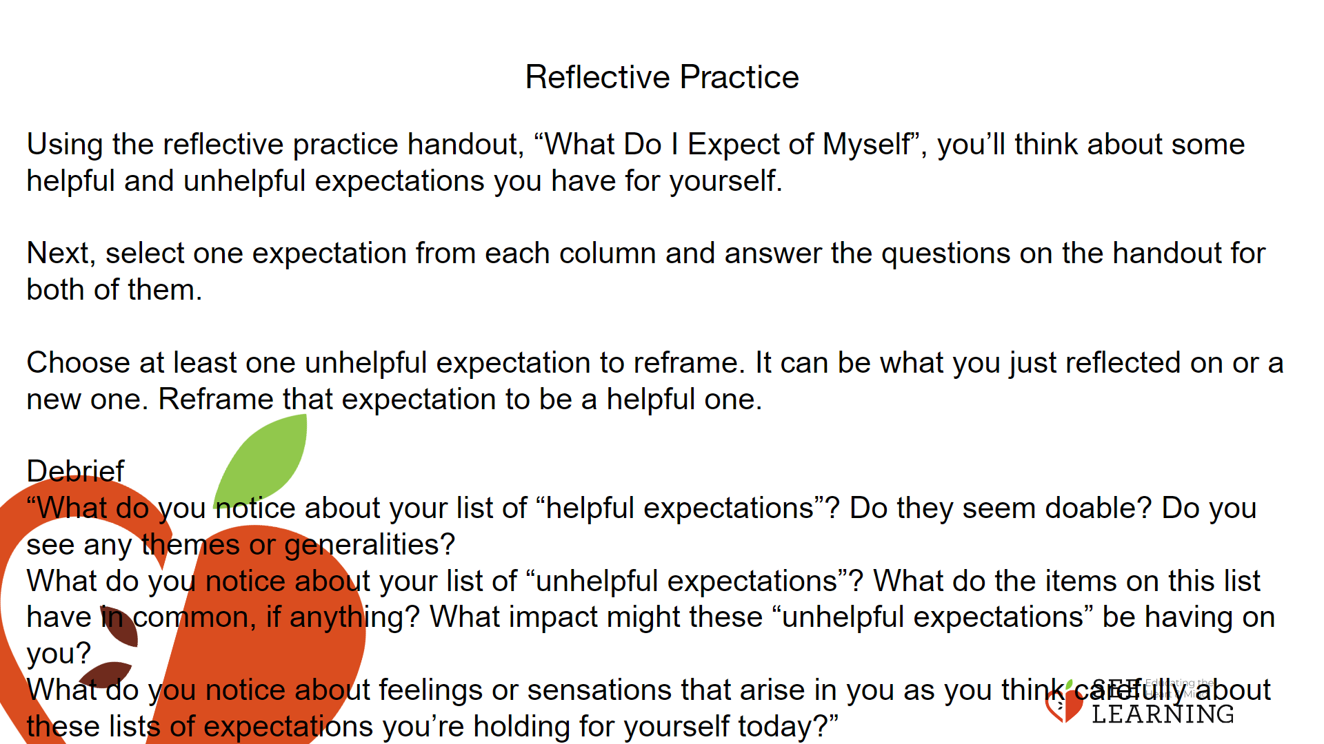 | Instructions and Guided Language  Using the handout “What Do I Expect of Myself,” model at least one helpful expectation and one unhelpful expectation for yourself. Allow students to brainstorm responses on their handout for two minutes. Set a timer for this step. Invite students to select one unhelpful and one helpful expectation from their brainstorm and answer the questions on the worksheet. Then invite them to explore an unhelpful expectation and reframe it as a helpful one.  If time allows, provide opportunity to share in the whole group, for those who want to, or to pair and share with a partner.  “You will work on your own for the first part of this reflective practice and there will be time to share at the end.  Using the reflective practice handout, “What Do I Expect of Myself”, you’ll think about some helpful and unhelpful expectations you have for yourself. This will be private writing, for your eyes only. You’ll be invited to use the ideas from this reflection during our sharing time, but the writing is just for you.  For example, for me, under the heading “helpful expectations,” I might write, “I will try to get at least 15 minutes of exercise every day.” In the column under “unhelpful expectation,” I might write, “I will try to make everybody in my family get along all the time.”  What questions do we have about doing this?  Go ahead and begin. We’ll do individual brainstorming for two minutes. Capture whatever ideas pop up for you, writing them in the columns without judging the idea or yourself. Don’t move to the next section yet—give yourself time to see what surfaces during this private silent writing time. [Allow time for reflection and writing.]  Next, select one expectation from each column and answer the questions on the handout for both of them. Again, this writing is your own. [Allow time for reflection and writing.]  Finally, turn to the next section of your worksheet. Choose at least one unhelpful expectation to reframe. It can be what you just reflected on or a new one. Reframe that expectation to be a helpful one. For example, an unhelpful expectation might be: “I need to make perfect grades so I can be successful.” A more helpful one might be: “I need to try my best in school, so that I can learn the skills I need to be my best self.”  Take a moment to finish just the thought you’re writing right now. And then look over your ideas.”  [Debrief as time allows] Share in partners and/or volunteers for the whole group, as appropriate to your group.  “What do you notice about your list of “helpful expectations”? Do they seem doable? Do you see any themes or generalities?  What do you notice about your list of “unhelpful expectations”? What do the items on this list have in common, if anything? What impact might these “unhelpful expectations” be having on you?  What do you notice about feelings or sensations that arise in you as you think carefully about these lists of expectations you’re holding for yourself today?

