Practicing Self-Compassion

Purpose:
This learning experience engages students in reflecting on their current use of self-compassion, on how to collectively evaluate common barriers to self-compassion, and will brainstorm ways to overcome them. Finally, students will make plans to take actionable steps to practice self -compassion in the near future.
Learning Objectives:  Students will be able to:  - Evaluate common barriers to practicing self-compassion  - Describe solutions to barriers to self-compassion  - Identify one’s personal use of self-compassion  - Construct a personal plan to practice self-compassion | Primary Core Component  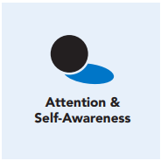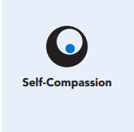
Length  45 Minutes | Materials Required  - Chart paper  - Markers  - Completed “Guided Self-Compassion Journal” worksheet (see Chapter 6, Learning Experience 1)  - Writing utensils and paper

Check-In (5 min)
Slide 2: Check-In  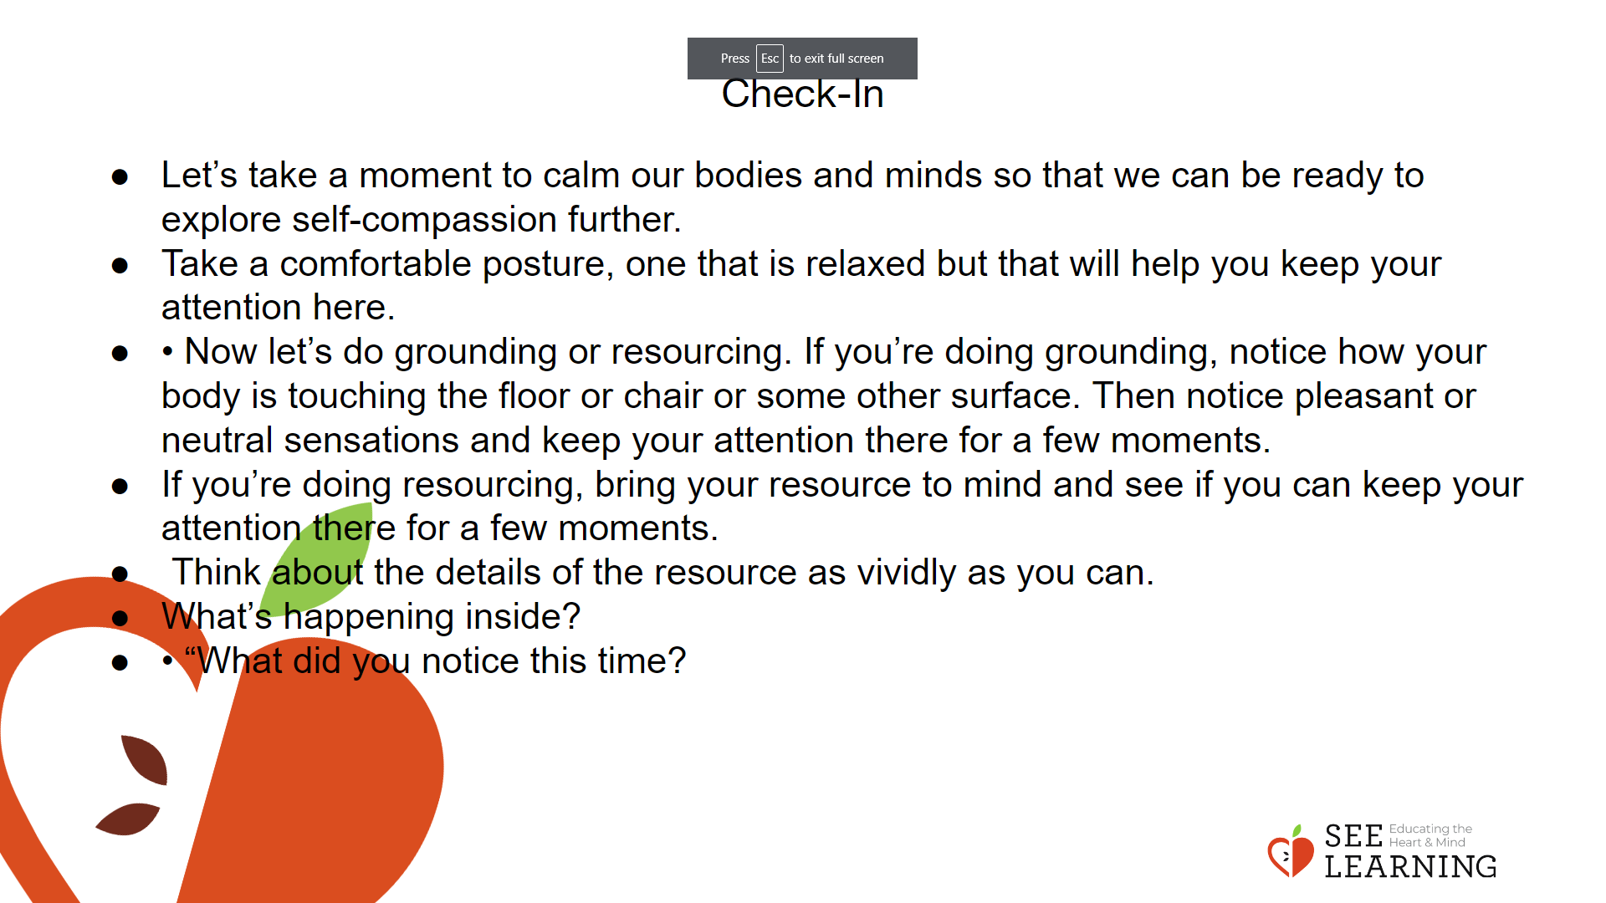 | Instructions and Guided Language  [PAUSE]s can be up to 10 seconds each  Resourcing or Grounding Practice  • “Let’s take a moment to calm our bodies and minds so that we can be ready to explore self-compassion further. Take a comfortable posture, one that is relaxed but that will help you keep your attention here. [PAUSE]  • Now let’s do grounding or resourcing. If you’re doing grounding, notice how your body is touching the floor or chair or some other surface. Then notice pleasant or neutral sensations and keep your attention there for a few moments. [PAUSE]  • If you’re doing resourcing, bring your resource to mind and see if you can keep your attention there for a few moments.  • Think about the details of the resource as vividly as you can. [PAUSE]  • What’s happening inside? Notice your sensations. If you notice a pleasant or neutral sensation, just attend to it. See if it changes or stays the same. [PAUSE]  • If you haven’t found a pleasant or neutral sensation, see if you can shift your attention to another part of your body to find a place that feels better. [PAUSE]  • If you ever feel uncomfortable, you can shift to a pleasant or neutral sensation in your body and focus on that instead, or just quietly rest your body and mind.” [PAUSE 15-30 seconds or longer as your students are able.]  • “What did you notice this time?”

Insight Activity - Obstacles to Self-Compassion (15 mins)

Overview
In this activity, students will explore common barriers we face in practicing self-compassion. This activity will begin with an initial brainstorming, followed by a gallery walk of student-generated ideas.
Teaching Tips
Spend some time learning about how self-criticism does not actually successfully motivate people. Include this element in your group’s facilitated discussion. Remember, unlike self-criticism, self-compassion motivates us to be our best selves due to a desire to be healthy, happy, and thriving rather than seeing ourselves as undesirable or not enough.

Slide 3: Insight Activity  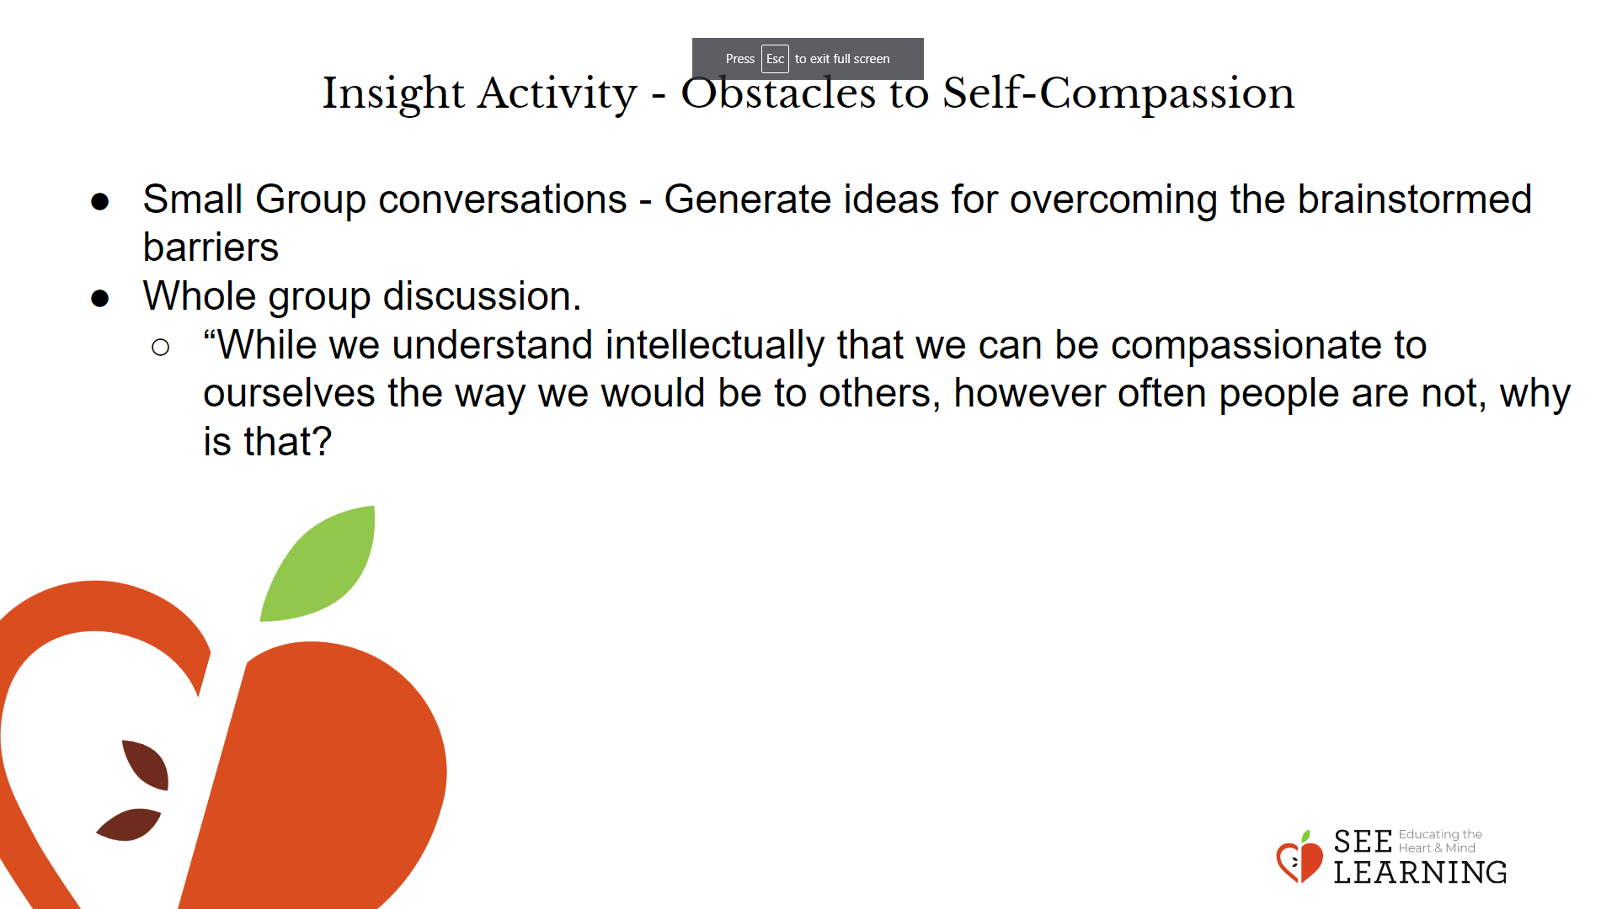 | Instructions and Guided Language  • Facilitate a discussion of why students think anyone might not practice self-compassion. Write themes on the board, grouping in topics or themes that will be part of the gallery walk exercise.  • Have students write one theme per poster paper and place them around the room. Invite students to spread out, 2-3 at each of the posters, to write suggestions on how people might overcome those obstacles, moving to subsequent posters at their own pace, as time permits.  • Students then complete a gallery walk where they reflect on each station. Small post-it notes may be used to add questions or comments during the silent gallery walk. Discuss the findings as a group.  • “Sometimes we don’t practice selfcompassion, even if we feel it would be beneficial to us. What are some reasons why you think you or others don’t practice self-compassion?” [Listen for answers and write them on the board’, offering an example if needed.]  • “Your brainstorm shows that sometimes it’s challenging to practice self-compassion. Now we are going to look at these barriers to self-compassion that you’ve identified and write down some actions that could help people move past them. We’ll post each possible barrier on a piece of chart paper around the room, to gather ideas about how to move beyond them.”  • As you walk from poster to poster, spend some time reflecting on actions you could take to help move through these barriers.”  • Have one round where students go from poster to poster at their own pace, writing in their own thoughts on each. Then a second allotment of time is given to ‘gallery walk’ all of the writing, view what’s there, reflect, and write questions or comments on post-it notes to add to the posters.  • “Let’s learn from one another. Take another walk around the posters, a silent ‘gallery walk’.” 1 minute: Instructions 6 minutes: Round One: Have small group conversations, generating ideas for overcoming the brainstormed barriers. 1 minute: Instructions 4 minutes: Round Two: The silent gallery walk to absorb what’s been generated, adding comments/questions if you decide to add that, to prepare for whole group discussion. 3 minutes: Whole group discussion.  • “While we understand intellectually that we can be compassionate to ourselves the way we would be to others, however often people are not, why is that? What may contribute to this struggle to be self-compassionate?”  • Possible reasons that may come up: - Gender stereotypes related to compassion, love and kindness - The idea that other’s opinions of us our more valid than our own - The idea that being compassionate to ourselves will make us “lazy,” “unmotivated,” or self-indulgent - The idea that others are weak or I am weak - I don’t have time to practice self-care - I am undeserving of self-compassion - I need to be perfect  • “Let’s share what we noticed.”  • Engage students in a discussion about what they noticed.  • Possible questions to use: - “What did you notice in your classmates’ responses? Did you notice any common themes? - What ideas did you see that you had not thought about? - Was there anything that stood out to you, that you think would be helpful for you to practice more self-compassion?

Reflective Practice (10 mins)

Overview
In this learning experience, students will return to the list of future events where they may need self-compassion. Students will pick one upcoming opportunity and construct a WOOP Statement (Wish, Outcome, Obstacles, Plan) to make a plan for engaging in self-compassion and moving past any obstacles

Teaching Tip
• Students could help each other with their statements.
• Teachers could model this process with an example from their own life that’s appropriate to share in class

Slide 4: Reflective Practice  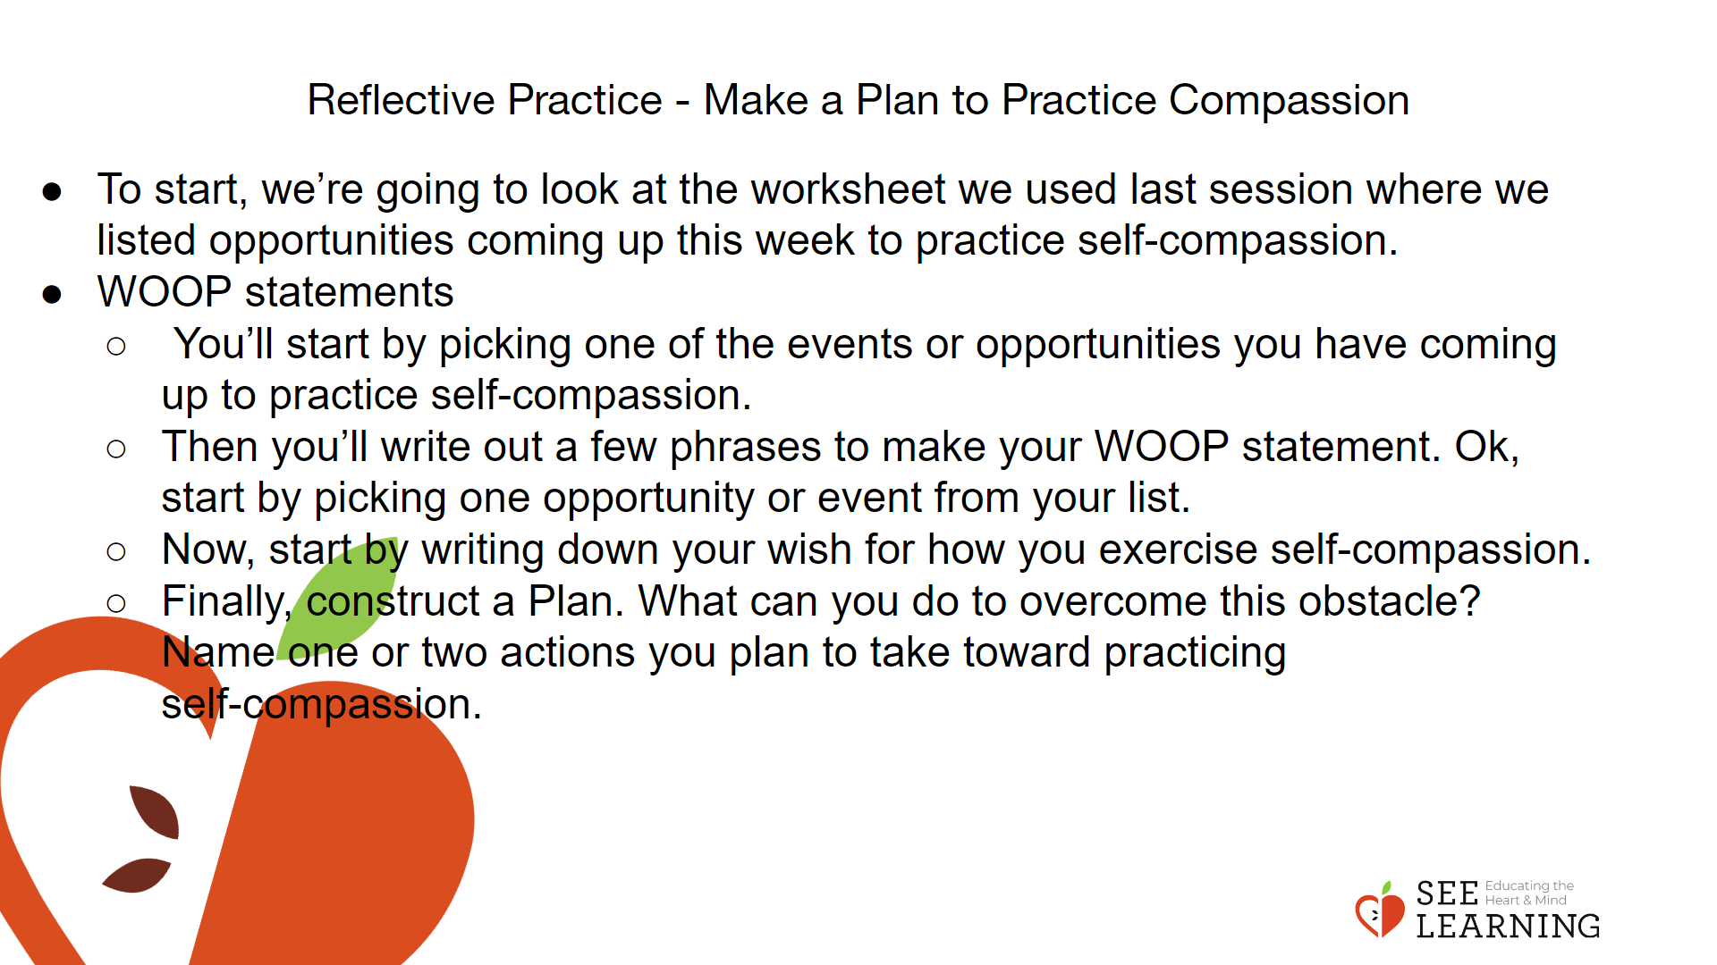 | Instructions and Guided Language  Invite students to review the list they previously created of opportunities to practice selfcompassion in their up-coming week. Students will choose one that feels challenging but doable and construct a WOOP statement. Teacher should explain the process and give examples. If helpful, teacher may model this with an appropriate example from their own life.  Process for creating a WOOP Statement  • Step One Wish: What is your wish for how you exercise self-compassion for this opportunity? Example: I want to be compassionate to myself in preparing for my math test.  • Step Two Outcome: Write down the best outcome if you fulfill your wish. Imagine that as vividly as possible. How would it feel to fulfill your wish? Example: I will feel good about myself and the work I did, regardless of the grade I receive.  • Step Three Obstacles: What might hold you back from achieving your wish? It could be something within yourself or something external, like time constraints. Examples: Procrastinating on studying (part of self-compassion is taking care of our needs); Self-Criticism (I’m not good at math.); or Striving to be perfect (I have to get an A, nothing else is good enough.)  • Step Four Plan: What can you do to overcome this obstacle? Name one or two actions you can take to move past it.  Examples: - I will allow extra time to study, so I will know I have truly done my best. - I will reach out to a classmate or adult who can help me understand the work better. - I will consistently use positive self-talk to help keep my courage and spirits up.  “To start, we’re going to look at the worksheet we used last session where we listed opportunities coming up this week to practice self-compassion. [PAUSE while students review their list.]  We know that we want to pay attention to practicing self-compassion, and we also know sometimes things come up that get in the way. We’re going to use some of the ideas we’ve already talked about to make a plan to practice self-compassion, even when it’s difficult.  A plan consists of a set of detailed and sequential steps that help us to achieve a goal.  To do this we’ll be writing a WOOP statement. This stands for “Wish, Outcome, Obstacle, Plan.”  You’ll start by picking one of the events or opportunities you have coming up to practice self-compassion. Then you’ll write out a few phrases to make your WOOP statement.  Ok, start by picking one opportunity or event from your list. [Allow time to choose.]  Now, start by writing down your wish for how you exercise self-compassion. For example, I want to be compassionate to myself in preparing for my math test.  Next, write down what the Outcome would be of fulfilling your wish. Imagine that as vividly as possible. How would it feel to fulfill your wish? For example, I will be kind to myself and appreciate the work I did, regardless of the grade I receive.  Now, let’s look at the Obstacles. What might hold you back from achieving your wish to be self-compassionate? It might be something within yourself, or something external like time constraints.  Examples: procrastinating on studying (Part of self-compassion is taking care of our needs.); Self-Criticism (I’m not good at math.); or Striving to be perfect (I have to get an A or it’s not enough.)  Finally, construct a Plan. What can you do to overcome this obstacle? Name one or two actions you plan to take toward practicing self-compassion. [Allow time.]  Thank you for taking these steps to plan for your well-being. We all want to promote our well-being and this may be one effective way to do that. Practicing anything that benefits both your and others’ well-being is an ethical engagement. By taking care of ourselves this way, we are in a better position to take care of others. Hold on to this statement and look back at it when you need to remind yourself of the plans you made, to help you build the habit of self-compassion.  Now that you have explored how you can be self-compassionate, I would like you to explore how you can extend your ability to be self-compassionate to others. How can you use the same strategies that foster self-compassion to have forgiveness towards others.  Take some time now to do a quick pair-share with the person next to you regarding how you can extend the skills of self-compassion towards the practice of forgiveness and compassion for others? Before you engage in this pair-share activity, it is important to note that forgiveness is not condoning. We need to hold others accountable, but can we also separate the actor from the action to recognize their humanity and to connect with our shared human condition.  Can you:  • Extend empathic concern and compassion to those who are not like you?  • See that others just like you share in the same human conditions (not having total control of all factors, making mistakes, learning from mistakes, etc.)?  • Put the behaviors and attitudes that others convey that you don’t agree with in a broader context?”

