Exploring Self-Compassion

Purpose:
This learning experience introduces the concept of self-care and self-compassion through prompts for critical inquiry and reflection. To generate interest and motivation in exploring the topic of self-compassion, there is a focus on (a) what self-compassion is and why it is beneficial; (b) how students are already exhibiting self-compassion; and (c) areas where they feel their self-compassion could grow. The concept of inner environments and outer environments is then introduced: just as we want an outer environment of people exhibiting kindness and consideration to us, so too do we want an inner environment (our own mind, attitudes, perspectives, and emotions) that is conducive to happiness and flourishing.
Learning Objectives:  Students will be able to:  - Define the concept of self-compassion  - Describe ways in which they are exhibiting self-compassion already  - Identify areas where their self-compassion could grow | Primary Core Component  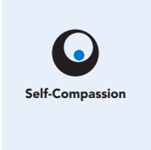
Length  45 Minutes | Materials Required  - Copies of prompts  - Timer  - Chime or bell  - Chart paper  - Guided Self-Compassion Worksheet  - Mindful Dialogue Protocol Instructions 45 minutes  - Writing utensils and paper

Check-In (5 min)
Slide 2: Check-In  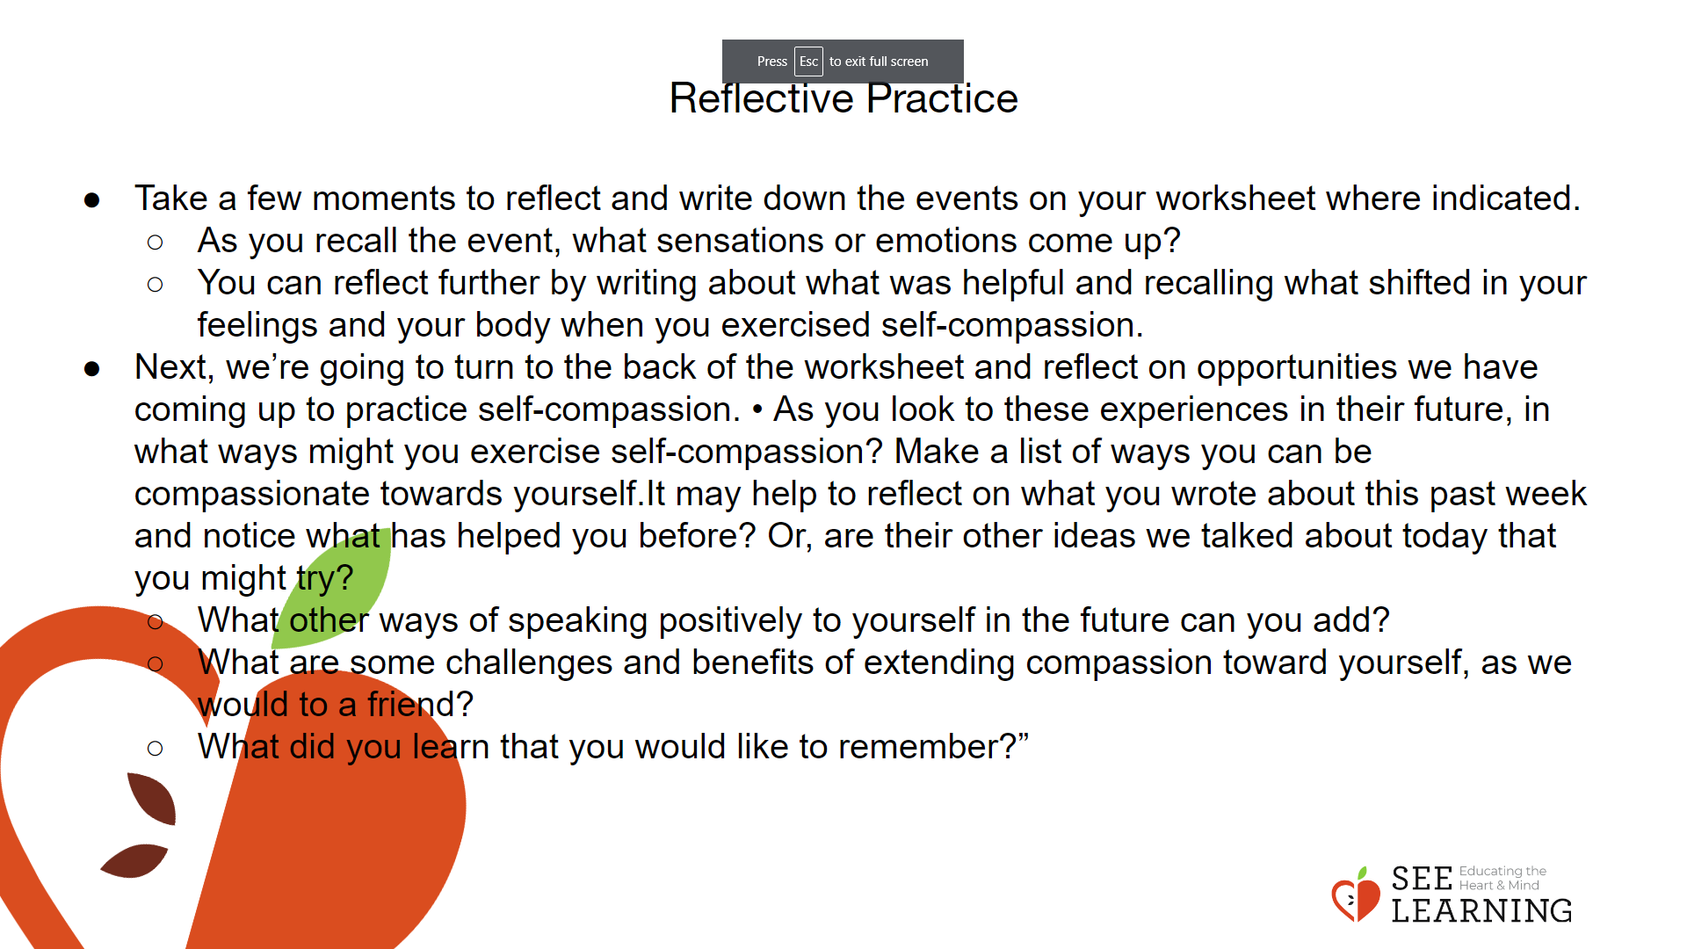 | Instructions and Guided Language  [PAUSE]s can be up to 10 seconds each  Attention Practice  • “Let’s prepare for a short attention practice. How do we want our body to be?  • First we’ll take a comfortable and upright posture.Then we’ll keep our eyes on the ground or close them.  • Before we strengthen our attention, we’ll do some resourcing or grounding to calm our bodies. Mentally select one of your resources from your list of resources, or add a new one, or you can imagine one.  • Now let’s bring our resources to mind. And let’s see if we can pay attention to our resources with our mind for a few moments quietly. Or if you’d rather do grounding, you can do that too. Whichever you choose, we’re going to rest quietly and pay attention for a few moments. [PAUSE]  • What do you notice inside? If you feel pleasant or neutral, you can rest your mind on that.  • If you have an unpleasant feeling, you can shift to thinking about a different resource, or you can ground yourself in a different way. You can shift your posture. Keep your attention resting with your chosen focus. [PAUSE]  • Now let’s become aware of our breathing. Let’s see if we can pay attention to the breath as it enters and leaves our body.  • You can strengthen your attention by focusing on sensations or by focusing on the breath. It’s your choice — it’s always up to you.  • If you find paying attention to the breath uncomfortable, make the choice that’s right for you: go back to your resource or grounding, or inwardly take a quiet break from this attention practice. [PAUSE for 15-30 seconds.]  • If you get distracted, return your attention to the breath. You can also count your breath if that’s a helpful attention focus for you. [PAUSE for a longer time, such as 30-60 seconds or longer.]  • What did you notice?” [Invite students to share aloud or make a note in their journal.]

Discussion (15 min)

Overview
This discussion explores the idea of whether one can be compassionate to oneself in the same way that one is to a friend. Students will share what common themes or ideas came up in their dialogues and how we can use that in extending compassion to ourselves. Invite students to explore how extending compassion helped shift their perspective on the situation or to notice and name their emotions and sensations as they were engaging in the conversation.
This discussion will be broken into the following segments:
• Overview of the discussion ahead
• Student debrief discussion with 3 student sharing opportunities
• Teacher talk on self-compassion followed by another opportunity for students to share
• Closing comments

Teaching Tips
• Compassionate talk with others and positive self-talk when we are discouraged are a demonstration of our common humanity: “I am not the only one who has had this experience. We are all worthy of kindness and support.”
• When we utilize self-compassion, it can shift how we see things. We can reappraise the things that occur in our life, in the lives of others, and it helps us to create a more realistic outlook.

Slide 3: Discussion  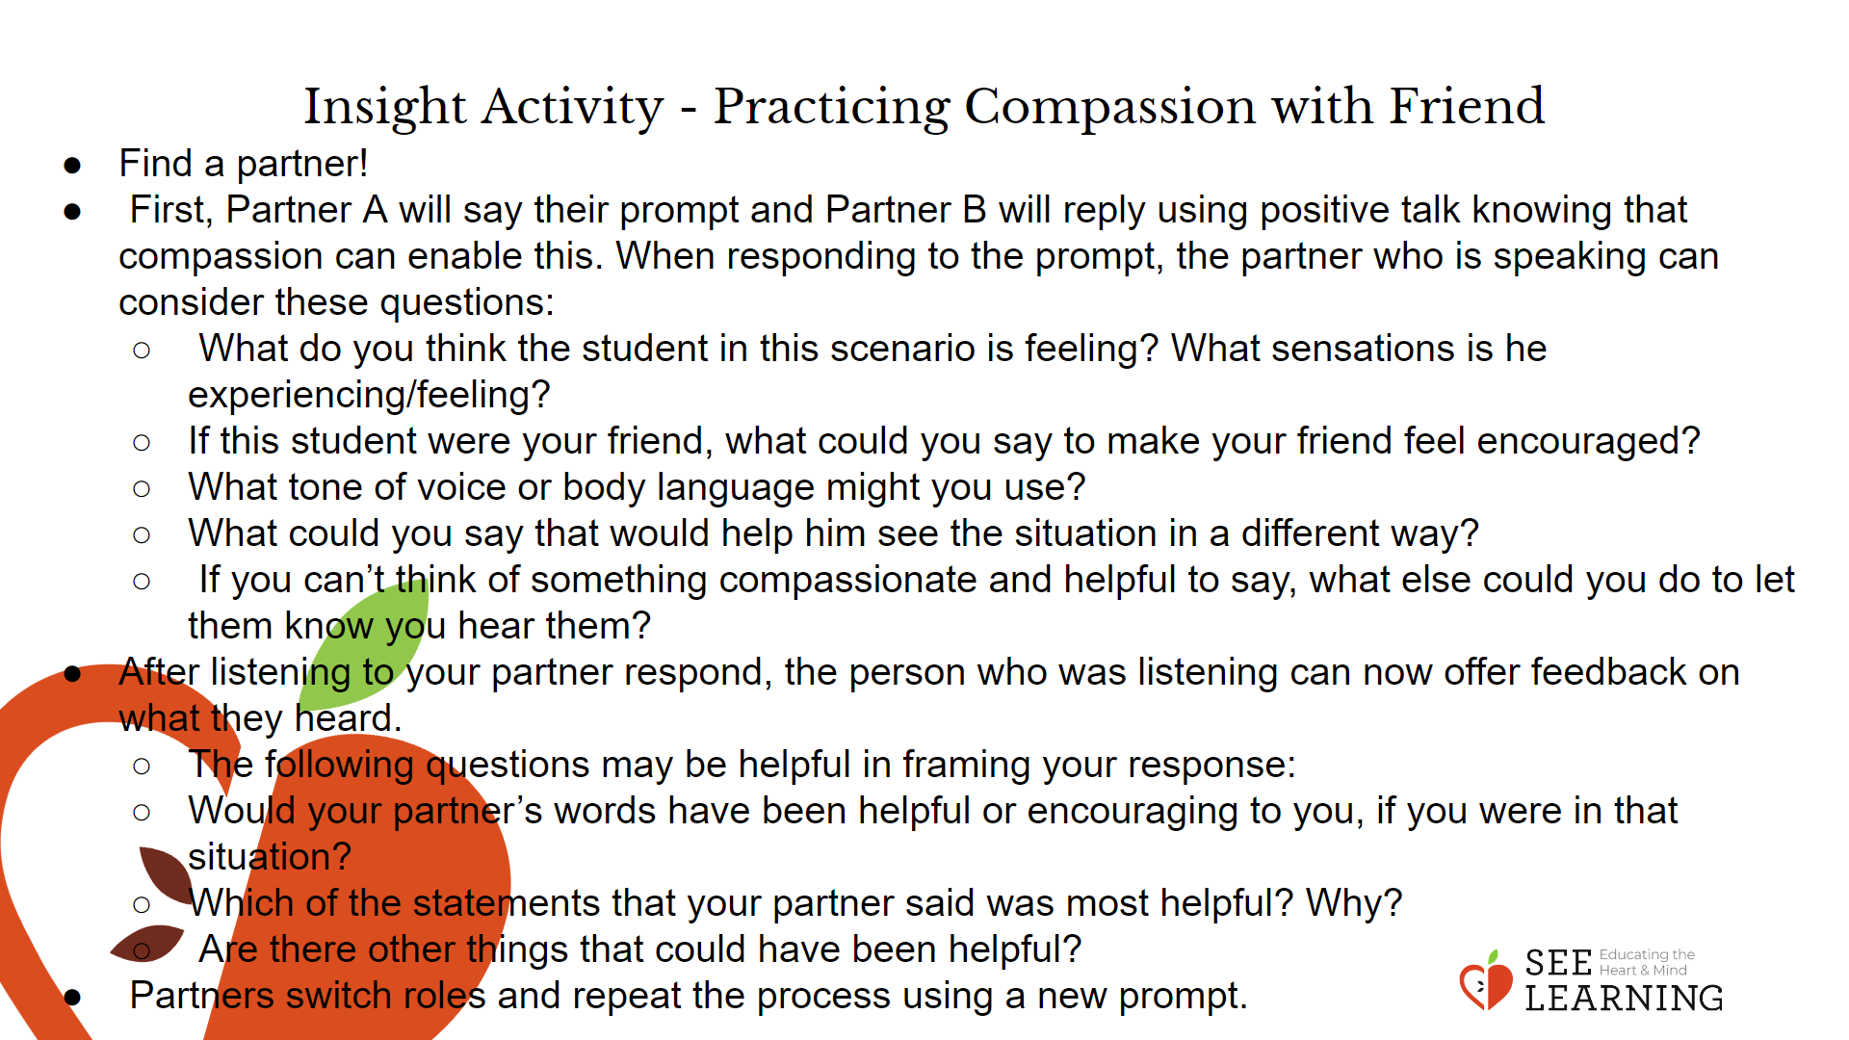 | Instructions and Guided Language  Lead a discussion with your students about what they discovered in their pairs.  What were some ways partners offered compassion? This might include positive talk or helping Partner B to reframe their experience? What were some verbal and non-verbal things their partner tried that felt especially effective?  Next, turn the discussion towards selfcompassion and how they might use those same ideas with themselves.  • Invite students to explore how extending compassion helped shift their perspective on the situation or  • Invite students to notice and name their emotions and sensations as they were engaging in the conversation.  • Encourage students to think about how we are able to use positive self-talk with ourselves when we face difficulties, treating ourselves as kindly as we would a friend.  - Explore the relationship between positive and negative self-talk and our perspectives (how we see things) on various things.  • Encourage students to think about how looking at the situation from another perspective might help them to feel better. This could include:  - Recognizing they are not alone in their distress, or the only one who makes mistakes  - Recognizing opportunities to grow from experiences of failure or disappointment  - Recognizing some things are outside of their control.  - Recognizing what strengths they have or good things are happening.  - Recognizing what they can do to help feel better in a situation.  “You’ve just explored ways to support a friend who was feeling sad or discouraged. What if it was us, ourselves, who had not succeeded and we were the ones feeling bad?  What are some examples of positive and negative ways that people sometimes respond towards their own setbacks? [Students share ideas.]  Sometimes it can be challenging at first to offer the same compassionate response to ourselves as we do our friends. Selfcompassion is when we show kindness and compassion to ourselves in the same way we do for others. Like we did for our friends, we can offer ourselves kindness or time to practice self-care. We can use positive selftalk. We can catch ourselves when we fall into thinking traps, or take time to look at our situation from a broader perspective. Doing so can help us find ways to shift what we’re thinking and take steps to feel better.  Below is an example of how a person might respond non-compassionately to themselves. For you it might be more effective to reference a time when you were younger by using an authentic personal story.  “For example, if it was me, I might say or think things to myself, like “I’m no good. I’ll never be able to do this!” And then it might get even worse. I might start to think, “I’m no good at anything!” Then, instead of trying harder or practicing more so that I can succeed, I might just give up. I might even feel like a failure for a while. This can happen for anybody sometimes.”  How might a perspective of self-compassion help a person to manage or counteract this type of self-talk or mental experience? [Give students a chance to share ideas.]  When I am kind to myself, the way I’m kind to a friend who is having problems, it can reshape an experience. When I’m kind to myself, I’m practicing self-compassion.”

Insight Activity - Practicing Compassion with Friend (15 mins)

Activity Overview
In this insight activity, students brainstorm and practice some ways to show compassion to a friend who is discouraged, using positive talk or other acts of compassion such as helping them reframe their experience, helping them recognize thinking traps, or recognize they are not alone. This will happen through a mindful dialogue protocol.

Teaching Tips
• Write discussion prompts on chart paper or provide handouts with prompts and instructions provided here. • Use a timer to help students track their turns. You can signal or make an announcement to indicate their time is over.

Slide 4: Insight Activity  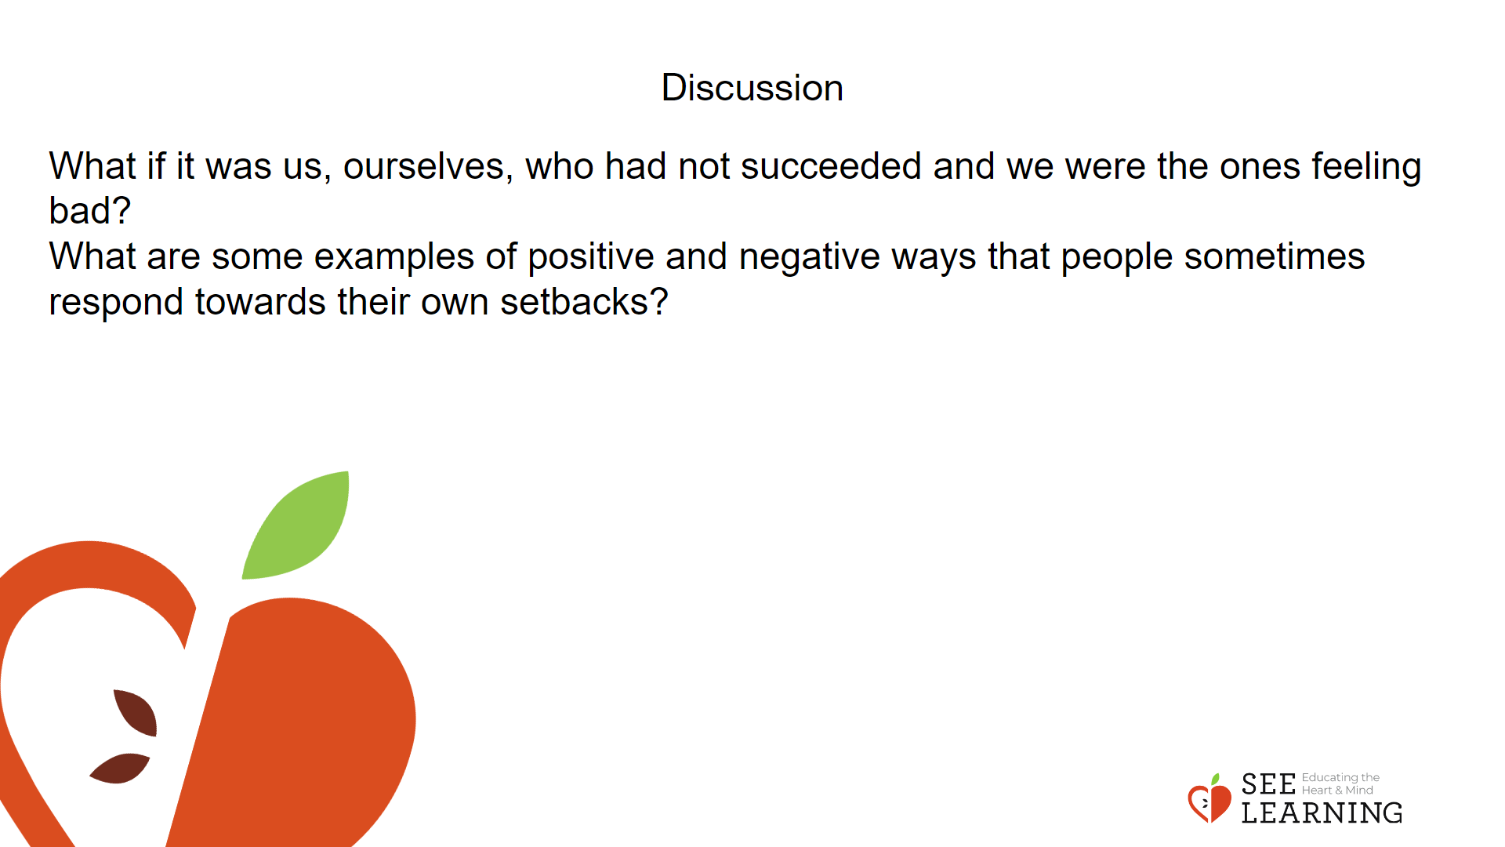 | Instructions and Guided Language  Lead a discussion about how we show compassion toward others.  “We’ve been learning a lot about why it’s important to show kindness and compassion. And we’ve learned different ways of being kind to each other. Remember, in SEE Learning, we define compassion as “an emotion involving the wish to relieve or prevent the suffering of another out of a genuine concern for their well-being and a sense of tenderness and care for them”  Compassion is way of relating to oneself, others, and humanity as a whole through kindness, empathy, and a concern for one’s own and others’ happiness and suffering. We can show compassion to ourselves and others in many ways. Moreover, in SEE Learning, we use compassion as the foundation for our ethical engagement, especially in connection with others.  During this activity, we will be exploring things we can do and say to support others who may be struggling. Let’s review now.  Let’s say we have a close friend or family member and they try to do something but it doesn’t work. How many of us have experienced a time when a friend or family member was frustrated, felt stuck and did not know what to do? [Students raise hands.]  Are there things that you did or observed someone else doing or saying that helped the other person feel better? [Students share ideas.]  What might it feel like for both the person who acted kindly and the person who received the kindness? [Students share ideas.]  By contrast, it is likely that we have observed or experienced someone doing or saying something that did not help someone else who was upset. Perhaps the person was genuinely trying to help, but in the end, what was done or said was unsupportive. What comes to mind when we think of the impact of doing or saying something that we thought may be helpful, but turned out to be unhelpful or unkind?  Having shared some ideas, what are some ways to share compassion that you heard or noticed? What are some helping actions we’ve learned that could be useful in a situation like this?” [Allow students to generate a list of ideas.] Allow students to guide the discussion, but you may want to point out some common ways of showing compassion such as the following ideas:  “I am hearing some great ideas on how to extend compassion to our friends. I want to point out some of what I heard and add a few ideas. Here are some ideas we’ve lifted up and a few others as well:  • Positive talk - This means saying things that are compassionate, kind, helpful and true. This can help others and ourselves counter negative talk, or when we are talking about things in unhelpful and unkind ways. For example, by being overly harsh. If we were to discourage someone or say things that are mean or not helpful to them, we would call that “negative talk.”  • Attentive listening  • Offering comforting touch or just being present  • Offering a different perspective to help a friend reframe their experience in a more compassionate way such as:  - ‘We all make mistakes.’ or ‘You aren’t alone, I have done that too.”  - ‘I wonder if there is anything to learn from this experience?’  - ‘Sometimes things are out of our control and can impact our outcomes.’  - ‘What are some good things happening right now?’  - ‘Is there something you can do to feel better right now?’”  In pairs, students will practice using positive talk and extending compassion in response to selected mindful dialogue prompts. Assign two of the prompts to each group, making sure the prompts given to each group are varied.  “Let’s practice extending compassion and using positive talk as though we’re talking to a friend. You’ll do this with a partner. You’ll be using scenarios to explore ways you can extend compassion. As you do this, keep in mind the different ways we can extend compassion. You may also want to keep an eye out for when you notice thinking traps arising. Remember, a few key points about thinking traps are:  • Our minds and brains can provide us with both accurate and distorted information.  • Not recognizing the difference between appearance and reality can impact our well-being by leading us to behaviors that are unproductive and even harmful to ourselves and others.  • We can use our personal experiences and critical thinking abilities to understand the world around us more clearly, and thus support our well-being.  To begin, we’ll get in pairs and I’ll give you some prompts to explore. First, Partner A will say their prompt and Partner B will reply using positive talk knowing that compassion can enable this. When responding to the prompt, the partner who is speaking can consider these questions:  • What do you think the student in this scenario is feeling? What sensations is he experiencing/feeling?  • If this student were your friend, what  could you say to make your friend feel  encouraged?  • What tone of voice or body language  might you use?  • What could you say that would help him  see the situation in a different way?  - For example, consider some of the  language of reframing or looking at  the situation differently that we just  discussed.  • If you can’t think of something  compassionate and helpful to say,  what else could you do to let them  know you hear them?  After listening to your partner respond,  the person who was listening can now offer  feedback on what they heard. The following  questions may be helpful in framing your  response:  • Would your partner’s words have been  helpful or encouraging to you, if you were  in that situation?  • Which of the statements that your partner  said was most helpful? Why?  • Are there other things that could have  been helpful? [2 minutes to reflect]  • Partners switch roles and repeat the  process using a new prompt.” [Allow time  to repeat the process.]  Mindful Dialogue Discussion Prompts for pairs:  • What in society prompts me to fall into the  thinking trap? What in society helps me to  be more realistic and see through the  thinking trap?  • Examples from life:  - I got my biology test grade back and it was  terrible. I am going to fail this class, and  now I’ll never get into college.  - Everyone I know got invited to the party  this weekend except me. Nobody likes me.  - I have three papers due this week. There’s  no way I can finish them. I’m just not as  smart as other people.  - I completely forgot about the test today.  I just don’t think I’ll ever be organized.  - Sarah made fun of my picture on social  media. She’s right, I’m such a loser.  - I looked at my phone this morning and my  (significant other) broke up with me!  - I overreacted to something my parents/  sibling said at the dinner table last night.  I wish I would think before I speak.  - I forgot my best friend’s birthday and now  she’s mad at me. She’s not going to want to  be my friend anymore.  You can also ask student to provide scenario  suggestions if that feel appropriate  When students have finished, bring them back for a group share out  “Ok, now let’s share out some examples of the positive talk we used.” [Allow students to share, as you record their positive talk on the board or chart.]

Reflective Practice (10 mins)
Activity Overview
In this reflective journaling practice, students apply what they have been learning to their own lives by reflecting on how they are already practicing self-compassion when discouraged. They then think of additional ways they believe they could be kinder to themselves.

Teaching Tips
• The teacher authentically models the exercise first to alleviate confusion, gain experience and awareness and to model vulnerability and curiosity when learning about a new topic.
• When modeling, it’s important to use appropriate self-disclosure. Teachers should choose an example that is not overly personal, and one they feel comfortable sharing.
• This practice invites students to reflect on experiences that may have been challenging or difficult. It is important to use invitational language so they know they have choices on how they want to reflect and on what experiences they choose to reflect on.
• If it will be more than a week before you engage in the next lesson, ask students to think about their next two weeks in the future.

Slide 5: Reflective Practice  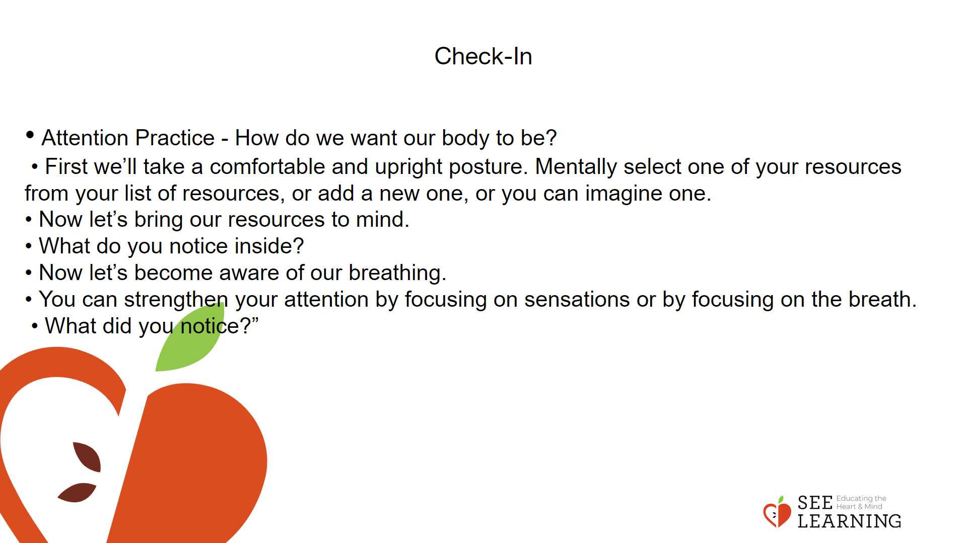 | Instructions and Guided Language  Lead students in a guided journaling time where they reflect on the past week (or longer if needed). Students will start by first recalling times where they have felt overwhelmed but were able to use positive self-talk, reappraisal, or other forms of self-compassion. If they can’t think of any specific examples, they can choose a situation where they sometimes have had difficulty in the past.  Self-compassion could also include times of selfcare like attending to their needs for food or rest, seeking help, or other actions to help them shift their perspective and alleviate distress.  On their worksheet, students write down each event. Invite them to recall the event itself and what sensations they experienced. Then write about how they engaged in self-compassion under each event on the list. Beside each event on their list in the second column, invite them to reflect further by writing about what was helpful and recalling what shifted in their feelings and their bodies.  If students feel comfortable, they can also reflect on any times they didn’t offer selfcompassion and write how they might do so next time.  Next, invite students to think ahead to their coming week.  What opportunities for self-compassion might be in their future (a stressful test, social interactions, or other times they may experience challenges).  On the back side of the worksheet they will create another list of these coming opportunities.  “Now we’re going to do our personal reflective practice. This is independent work, so you’ll have your own private time to think, write and draw about your own ideas. I’ll ask for volunteers to share, if you’d like to, in a few minutes.  Look at the handout I gave you. We’re going to start by reflecting on the last week and make a list of times we were facing a difficult situation and practiced self-compassion.  • Take a few moments to reflect and write down the events on your worksheet where indicated. If you are having trouble recalling a time, you can think back further, or just think of an imaginary situation that you often encounter.  • Spend a few moments journaling about each event underneath it. As you recall the event, what sensations or emotions come up? You can note those if you would like. Then write about how you engaged in selfcompassion.  • You can reflect further by writing about what was helpful and recalling what shifted in your feelings and your body when you exercised self-compassion. Write those in the next column beside the event.  • If you would like to, you can also reflect on any times over the last week you didn’t offer self-compassion and write how they might do so next time. [Allow time for journaling]  • Next, we’re going to turn to the back of the worksheet and reflect on opportunities we have coming up to practice selfcompassion.  • Think ahead to your coming week. What opportunities for self-compassion might be coming up for you in the next week. This could be something like taking a stressful test, social interactions, or any times you may experience challenges. Make note of those opportunities on the worksheet.  • As you look to these experiences in their future, in what ways might you exercise self-compassion? Make a list of ways you can be compassionate towards yourself.  • It may help to reflect on what you wrote about this past week and notice what has helped you before? Or, are their other ideas we talked about today that you might try?  • We are going to allow time to share if anyone would like to share an example of self-compassion. Would anyone like to share? [Allow students to share with the class. It is okay if no one wants to share. A teacher can also share to model an example.]  • What other ways of speaking positively to yourself in the future can you add? Go ahead and do that now.” [Allow time to write.] Ask students to keep this list about their plans for being compassionate in the future. We will return to it in the next learning experience.  • “What are some challenges and benefits of extending compassion toward yourself, as we would to a friend?  • What did you learn that you would like to remember?

