TITLE

Purpose:

Learning Objectives:  Students will be able to: | Primary Core Component
Length  45 Minutes | Materials Required

Check-In ( min)
Slide #:  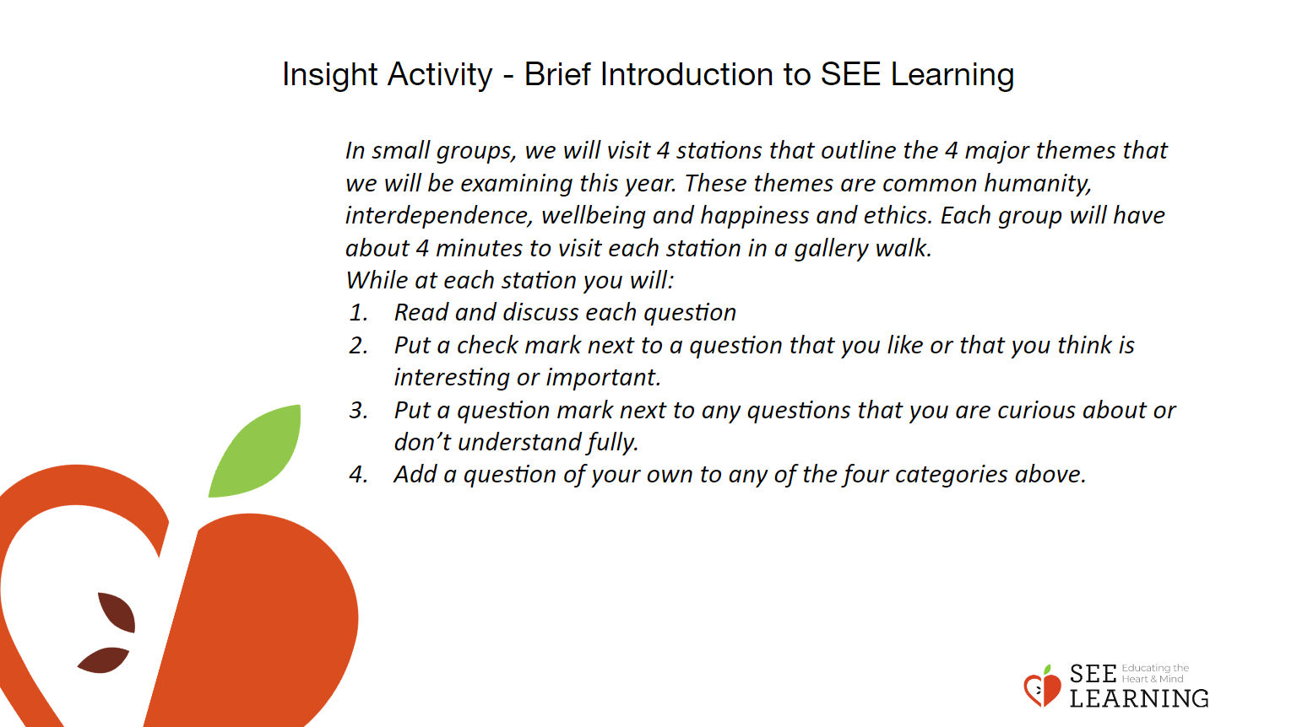 | Instructions and Guided Language

Check-In ( min)
Slide #: | Instructions and Guided Language

Insight Activity - ( mins)
Slide #: | Instructions and Guided Language

Reflective Practice ( mins)
Slide #: Reflective Practice  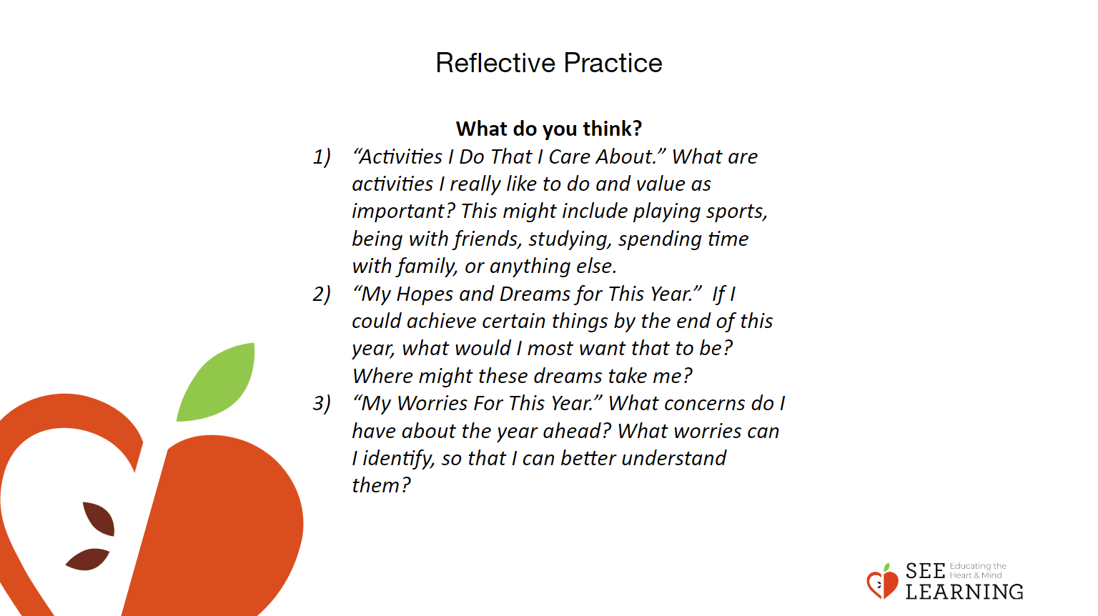 | Instructions and Guided Language

Debrief ( mins)
Slide #: Debrief  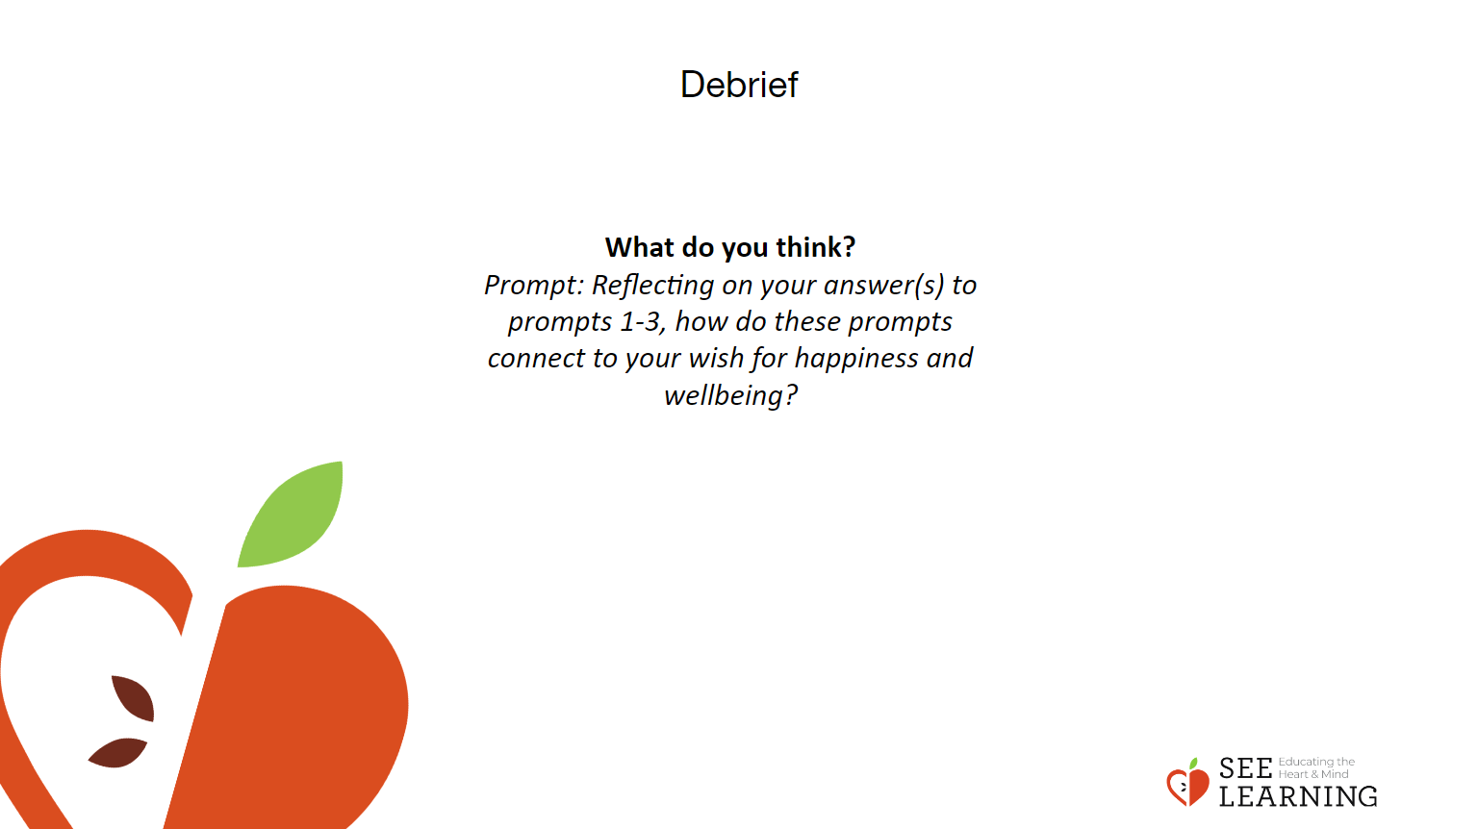 | Instructions and Guided Language

