Exploring Empathy

Purpose:
“Exploring Empathy” enables students to examine the concept of empathy and practice associated skills. Empathy has three components: being able to take another’s perspective (cognitive empathy), being able to feel an emotional resonance with the person (affective empathy), and the capacity to respond either through aspiration or action to alleviate another’s distress (empathic concern). Empathic concern becomes the pathway for felt and embodied experiences of compassion. This learning experience focuses on building the skill of perspective-taking. Without this skill we can misinterpret the motivations and actions of others. Through sharing the perspectives of characters in stories and listening to their peers, students can experience more deeply the complexity of one person’s perspective, and how it is itself an expression of that person’s needs, feelings, and prior experiences. Listening to and appreciating different perspectives can lead to greater humility and willingness to learn, better problem-solving, and more positive relationships.
Learning Objectives:  Students will be able to:  - Define empathy through its three components (cognitive, affective, and empathic concern)  - Engage in the practice of perspectivetaking by reflecting on a character’s needs, feelings and thoughts  - Determine how to listen to different points of view  - Provide examples of the value of perspective-taking in building positive relationships and solving problems | Primary Core Component  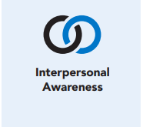
Length  45 Minutes | Materials Required  - Writing utensils and paper  - Timer

Check-In (5 min)
Slide 2: Check-In  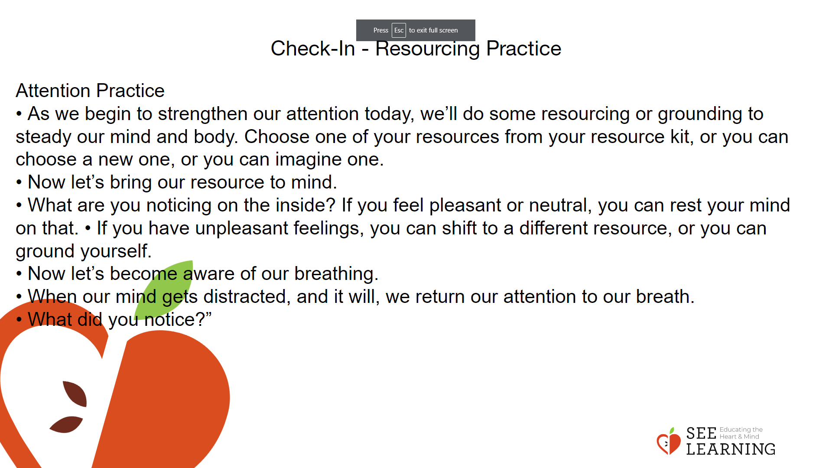 | Instructions and Guided Language  [PAUSE]s can be up to 10 seconds each  Engage in a Resourcing Practice Guiding Language  • “As we begin our attention practice, let’s pay attention to our body, taking a comfortable and upright posture, closing our eyes or resting them by gazing at the ground.  • As we begin to strengthen our attention today, we’ll do some resourcing or grounding to steady our mind and body. Choose one of your resources from your resource kit, or you can choose a new one, or you can imagine one.  • Now let’s bring our resource to mind. And let’s see if we can give our full attention to our resource for a few moments quietly. Of course, if you’d rather do grounding, you can always choose to do that. Whichever you decide, we’re going to rest quietly and pay attention for a few moments. [PAUSE]  • What are you noticing on the inside? If you feel pleasant or neutral, you can rest your mind on that.  • If you have unpleasant feelings, you can shift to a different resource, or you can ground yourself. You can also change your posture, taking care that others’ focus isn’t interrupted. Otherwise, just keep your attention resting with your resource. [PAUSE]  • Now let’s become aware of our breathing. Let’s pay attention to the natural way our breath enters and leaves our body.  • If you find paying attention to the breath uncomfortable, you can always make a choice to go back to your resource or grounding, or just take a small break. [PAUSE for 15-30 seconds.]  • When our mind gets distracted, and it will, we return our attention to our breath. [PAUSE]  • We can also count our breaths if that’s helpful. [PAUSE] for a longer time, such as 30-60 seconds or longer.]  • People strengthen our attention by focusing on sensations or by focusing on the breath. It’s your choice - it’s always up to you.  • What did you notice?” [Share aloud.]

Insight Activity - Circle of Truths (30 mins)
Circle of Truths
Overview
This activity helps to fully develop the concept of empathy and its associated skills. Empathy has three components: being able to take another’s perspective (cognitive empathy), being able to feel an emotional resonance with the person (affective empathy) and the capacity to respond either through aspiration or action to alleviate another’s distress (empathic concern). Empathic concern becomes a measure or indicator of the desire a person has to address another person’s duress. Without perspectivetaking we can misinterpret the motivations and actions of others. Through sharing the perspectives of characters in stories and listening to their peers, students can experience more deeply the complexity of one person’s perspective, and how it is an expression of their needs, feelings, and prior experiences. Listening to and appreciating different perspectives can lead to greater humility and willingness to learn, better problem-solving, and more positive relationships.

Content/Insights to be Explored
• Exploring the meaning and components of empathy.
• Practicing perspective-taking by reflecting on a person or character’s needs, feelings, and thoughts.
• Practicing listening to different points of view.
• Sharing examples of the value of perspectivetaking in building positive relationships and solving problems.

Slide 3: Insight Activity  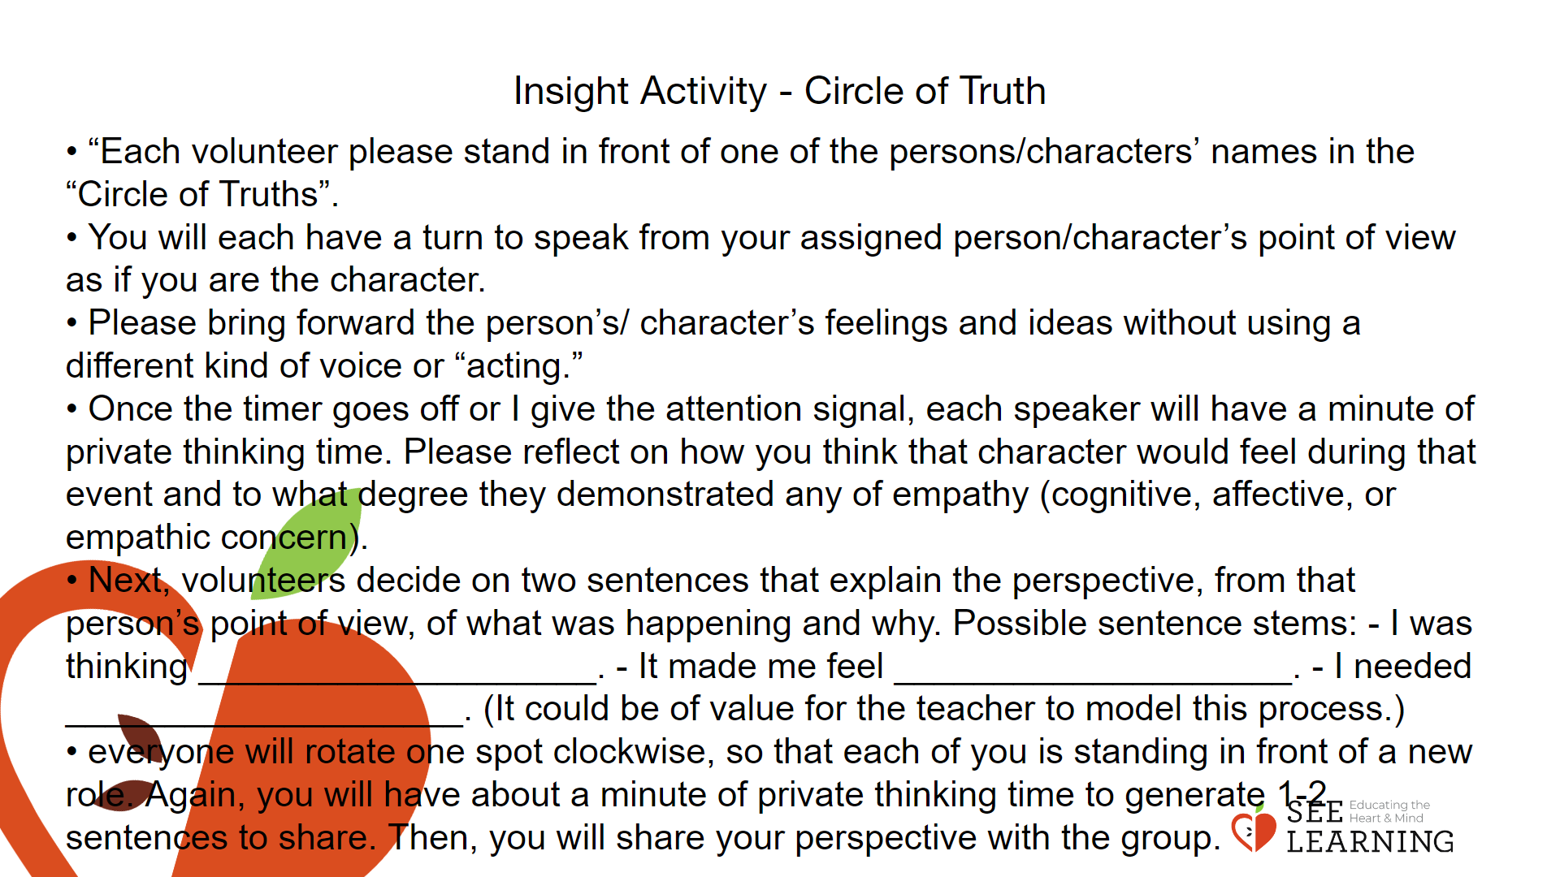 | Instructions and Guided Language  Check-in  “In the last lesson, we explored ways in which we are diverse and are similar to one another, recognizing that we are each unique and that being unique is something that we all have in common. In addition to having unique experiences and identities, we also have unique perspectives.”  Introducing Empathy  Display talking points on the board for student reference. • “Empathy is understanding and resonating with another’s emotional state. It is an umbrella term that can mean multiple things. However, in SEE Learning, we understand empathy to mean either experience sharing, thinking about others’ feelings, or caring about others’ feelings. It can be the capacity to resonate with others’ emotions, or engage in perspective taking, or it can be the aspiration to help another out of concern for their wellbeing. The first kind is called affective empathy, the second cognitive empathy, and the third empathic concern.  • Each person has a unique perspective that is informed by our life experiences, our personality and attitudes, our habits and goals, our passions and interests.  • We can’t fully know someone else’s perspective, but we can imagine what we might need, think or feel if we were in their shoes. This imagining, along with direct input from the person, whenever possible, helps us build empathy.  • Empathy involves knowing what another person is feeling (cognitive empathy) and caring about what they are feeling (affective empathy).”  Pair Up  Ask students to describe why empathy is important and/or what they think can help build empathy.  Circle of Truths Activity  In this insight activity, students will take the perspective of multiple people or characters in a literature story, current event story, pop culture story, or video clip. When choosing the story to be explored, be sure that there are at least 4 people/characters and that the content of the story or current event is not too controversial and will be interesting for the students. Students will put themselves in each person’s/character’s shoes by rotating in a circle to an assigned person/character so that they can consider what each character might be thinking or feeling. This activity focuses specifically on perspective taking.  Examples for Reference  Considering different perspectives is a key part of many classic literature texts. Authors such as Morrison, Shakespeare, Alcott, Dickens, Orwell, Steinbeck, etc., work to create different unique and varied perspectives from the characters within their stories. Those perspectives broach personal, societal, and systemic issues and outlooks. Many current and historical events can also be viewed from different perspectives, such as the World Wars, colonialism, the enlightenment, the industrial revolution, etc. When considering perception and experience, we must create the capacity to recognize how perspective is conditioned, shaped, and formed.  How Stories Evoke Empathy  The Jungle by Upton Sinclair is a story set in the early 1900’s in America that highlights the difficult and unsafe working conditions of the meat-packing industry. This story is important because it represented the workers’ perspectives on factory work and industrialization. Until this point, that perspective had rarely been shared. Summary of The Jungle  The story focuses on Jurgis Rudkis and his family who were recent immigrants from Lithuania. The book provides a portrait of the brutal working conditions of the factory and the lack of safety, hygiene, and care that were afforded to the workers of the factory. Unfair practices were highlighted that demonstrated the abuse that workers experienced on a daily basis.  Impact of The Jungle and its Connection to Empathetic Concern  The Jungle was an international best-seller and has been published in seventeen languages. Due to direct action on the part of readers, who were outraged at these conditions, a federal commission was created to investigate that eventually led to the enactment of laws to safeguard workers and the public. For generations, students have read The Jungle and experienced significant feelings of cognitive empathy, affective empathy, and empathic concern. Throughout the story, Jurgis experiences major misfortunes and his life is devastated as he loses his family, his home, and his job.  Through this story we see the perspective of another through a very powerful manner. Due to this rich and emotive description, it is possible to use empathy (cognitive, affective, and empathic concern) to help develop a sense of common humanity as we reflect on the commonalities shared between the characters and between ourselves and the characters. On the basis of this identification it is possible to see how a compassionate response emerged from fictional characters that results in an entire industry being transformed.  Instructions and Guiding Language  Step 1: Choose a story with at least 4 characters in it. It should be a story that students are aware of, have some knowledge about, and is of interest to them. Choose from current events, pop culture, video clips, or literature. Use your discretion to think about classroom dynamic and culture when choosing the material.  Step 2: As a whole class, read the story/article, or watch the video clip. Identify the characters. Choose the main person/character and discuss what that person/character was thinking and feeling and what they might need.  Step 3: Identify the rest of the characters. Write each character’s name down on a sheet of paper and place the papers on the floor in a circle. Ask all students to independently write down what each character may have been thinking or feeling.  Step 4: Fishbowl: Ask for 5 volunteers to stand in the “Circle of Truths” to do a perspective-taking exercise using the story we just listened to/read together. As we just explored, taking someone’s perspective means you place yourself in their shoes and imagine what they might need or want, or what they might be feeling or thinking.  Try to engage the students to consider if cognitive, affective, or empathic concern was demonstrated by the characters from their story. The rest of the group will be an active audience. After each round, you will ask the students in the audience if they have anything else to add that was not stated.  Explain the role of the volunteer students who are engaging in a fishbowl activity.  • “Each volunteer please stand in front of one of the persons/characters’ names in the “Circle of Truths”.  • You will have a minute to think again about what that person/character may have been thinking (cognitive empathy) and what they may have been feeling (affective empathy).  • You will each have a turn to speak from your assigned person/character’s point of view as if you are the character. Take this opportunity to consider and identify evidence from the story of your character demonstrating cognitive empathy, affective empathy, or empathic concern  • Please bring forward the person’s/ character’s feelings and ideas without using a different kind of voice or “acting.” This helps build an environment that is respectful of demonstrating a variety of perspectives. When we use our own voice, it helps us demonstrate that it is possible to relate to another person’s view of a situation even when it is not necessarily the same as your own.  • Once the timer goes off or I give the attention signal, each speaker will have a minute of private thinking time. Please reflect on how you think that character would feel during that event and to what degree they demonstrated any of empathy (cognitive, affective, or empathic concern). • Next, volunteers decide on two sentences that explain the perspective, from that person’s point of view, of what was happening and why. Possible sentence stems: - I was thinking ____________________. - It made me feel ____________________. - I needed ____________________. (It could be of value for the teacher to model this process.)  • “There is no discussion during this activity. You will each briefly share your perspective while the others listen with an open mind, and then that round will end. • When you hear the timer go off that says it’s time for the next round to begin, everyone will rotate one spot clockwise, so that each of you is standing in front of a new role. Again, you will have about a minute of private thinking time to generate 1-2 sentences to share. Then, you will share your perspective with the group.  • As you listen to each other and move around the circle to take varying perspectives, challenge yourself to share a different perspective than what a classmate may have already said.”  Repeat the directions until each volunteer has had the opportunity to take the perspective of all of the characters in the story.  After each round ask the students in the audience if they have anything new to add. • “Do any observers from the audience have any new perspectives to add?  • Would the character/s have more empathic concern if they had perceived the common humanity of the other characters?”

Reflective Practice (10 mins)
Slide 4: Reflective Practice  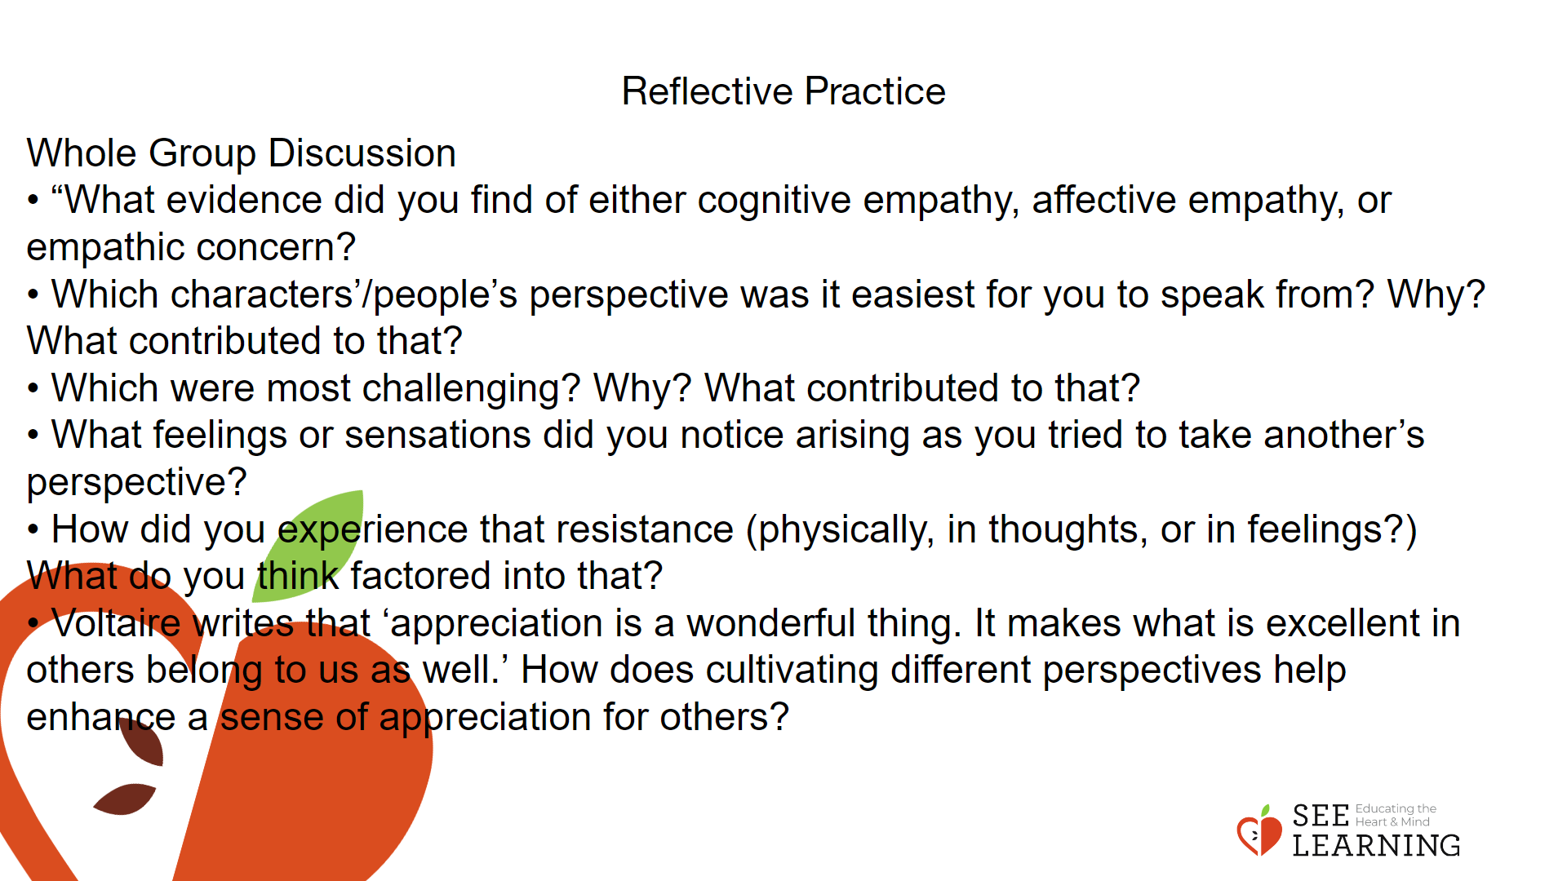 | Instructions and Guided Language  Whole Group Discussion  • “What evidence did you find of either cognitive empathy, affective empathy, or empathic concern?  • Which characters’/people’s perspective was it easiest for you to speak from? Why? What contributed to that?  • Which were most challenging? Why? What contributed to that?  • What feelings or sensations did you notice arising as you tried to take another’s perspective?  • How did you experience that resistance (physically, in thoughts, or in feelings?) What do you think factored into that?  • Voltaire writes that ‘appreciation is a wonderful thing. It makes what is excellent in others belong to us as well.’ How does cultivating different perspectives help enhance a sense of appreciation for others?”

