Appreciating Diversity and Shared Commonalities

Purpose:
In “Appreciating Diversity and Shared Commonalities,” students explore the ways in which we are different and alike. Through an insight activity, students can discover that although they are individually unique, being unique is also something they share in common with all other human beings.
Learning Objectives:  Students will be able to:  - Explore things we all have in common as human beings  - Recognize that one thing we share as human beings is that we are each unique | Primary Core Component  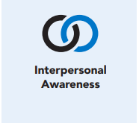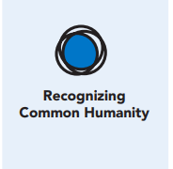
Length  45 Minutes | Materials Required  - Writing utensils and paper  - Tape

Check-In (5 min)
Slide #: Check-In  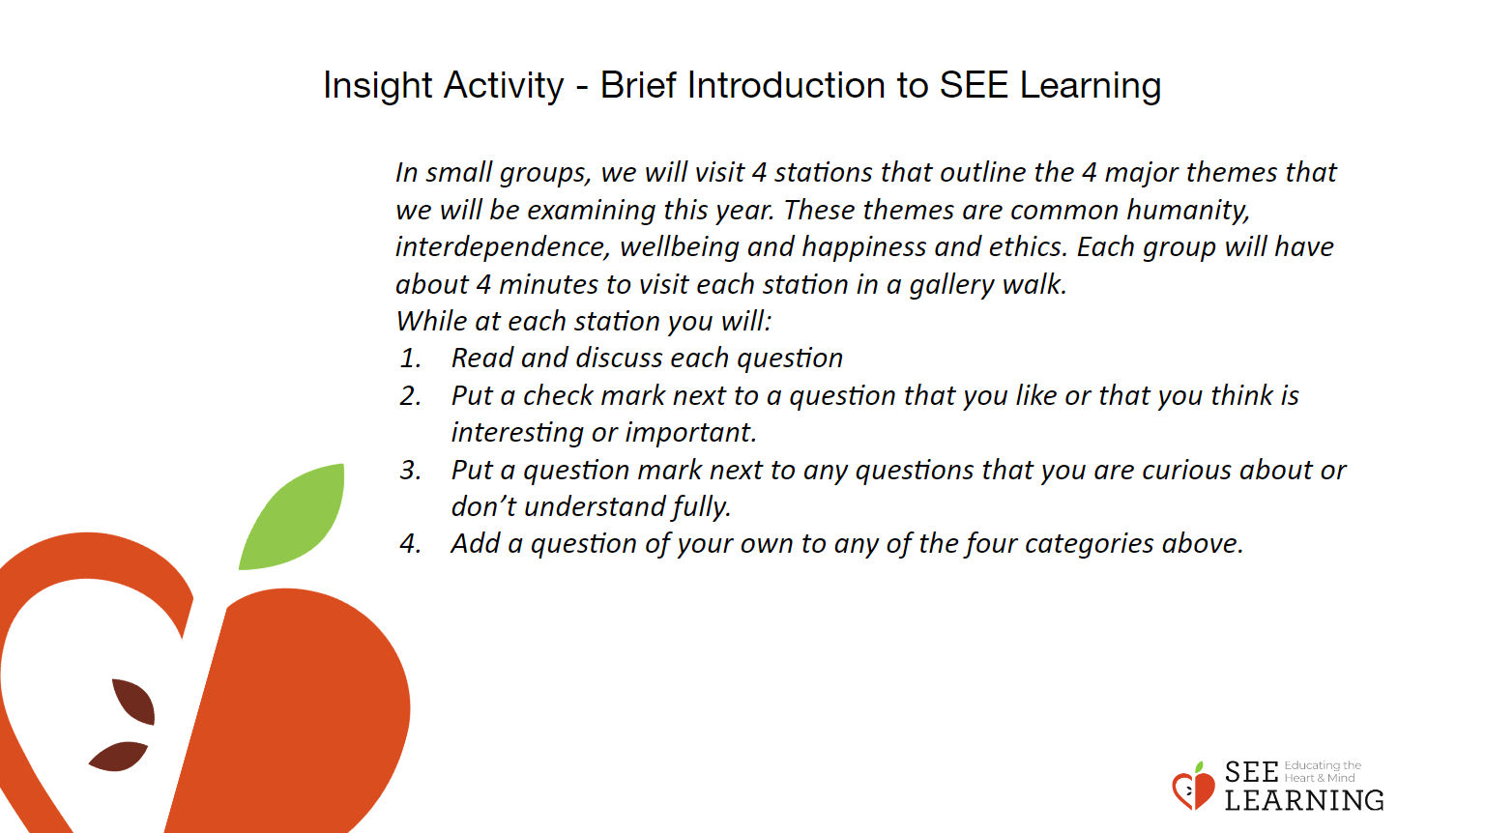 | Instructions and Guided Language  [PAUSE]s can be up to 10 seconds each  Engage in an Attention Practice Guiding Language  • “I invite you to do a short attention practice.  • First we’ll take a comfortable and upright posture. I’ll be keeping my eyes open, but you can close yours or look at the floor.  • Now choose one of your resources from your resource kit, or you can think of a new resource if you like: something that makes you feel better, safer, happier.  • Let’s bring our resource to mind and focus on it for a few moments quietly. You can also do grounding if you prefer.” [PAUSE]  • What do you notice on the inside? If you notice a pleasant or neutral sensation, you can rest your mind on that. If you notice an unpleasant sensation, you can shift to a place in your body that feels better. [PAUSE]  • Now let’s become aware of our breathing. Let’s see if we can pay attention to the breath as it enters and leaves our body.  • If you find paying attention to the breath uncomfortable, then feel free to go back to resourcing or grounding practice. [PAUSE for 15-30 seconds.]  • If you ever get distracted, you can just return your attention to the breath. You can also count your breath. [PAUSE for a longer time, such as 30-60 seconds or longer.] • Now let’s end the practice and open our eyes [PAUSE] and reflect: what was that like? Let’s hear from several people. Were you able to maintain your attention? Did anyone notice anything new about their sensations today? What else did you notice during that activity? What do you think brought that into your awareness?” [Share aloud.]

Check-In (5 min)
Slide 2: Check-In  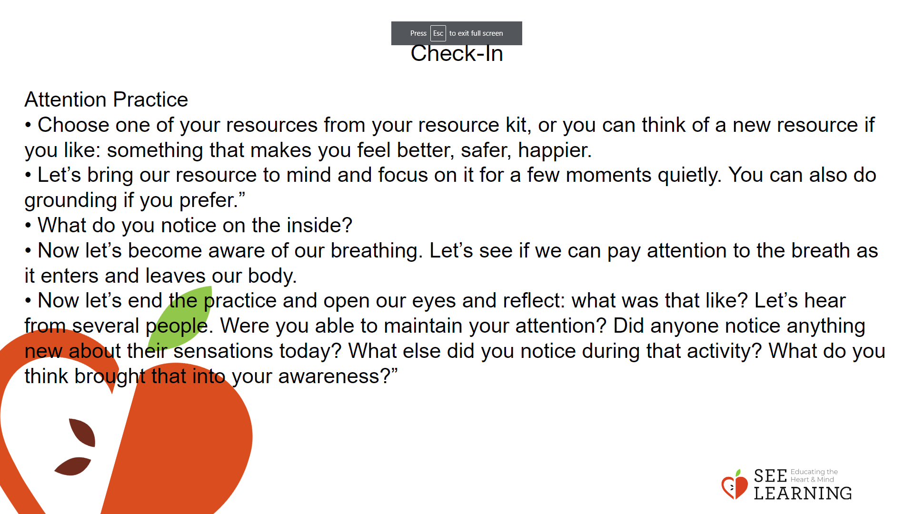 | Instructions and Guided Language

Insight Activity 1- (25 mins)
Overview
In this Insight Activity students explore the ways in which we are different and alike. Through the activity, students can discover that although they are individually unique, being unique is also something they share with other human beings.
Content/Insights to be Explored
• Exploring things we all have in common as human beings
• Recognizing that one thing we share as human beings is that we are each unique

Slide 3: Insight Activity 1  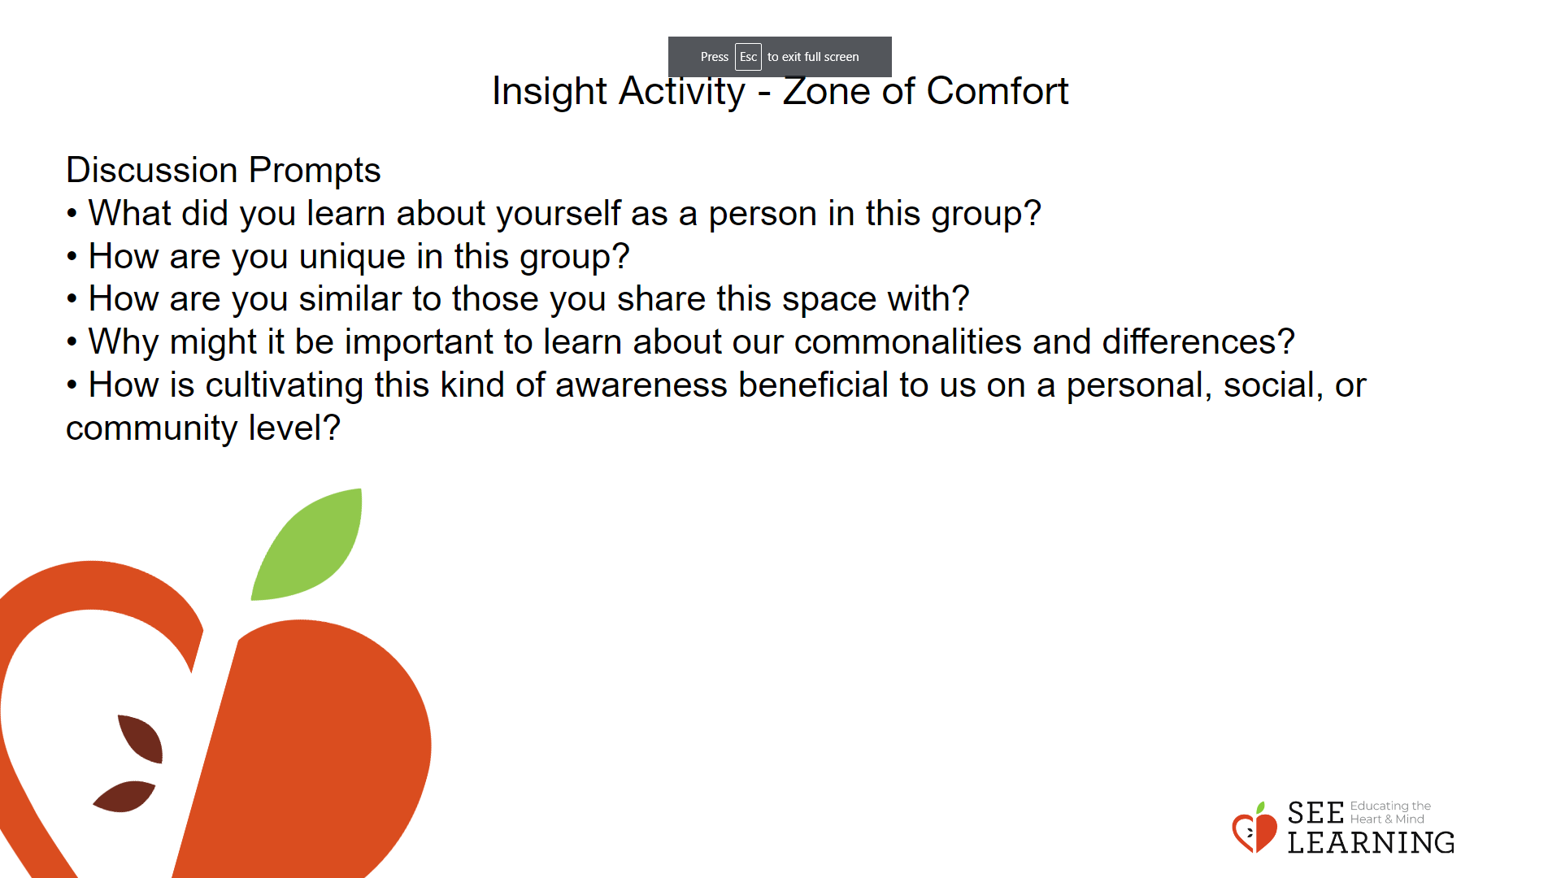 | Instructions and Guided Language  Zone of Comfort  • Draw the following diagram on the board, using three concentric circles. The innermost circle is labeled “comfort”, the middle circle is labeled “risk or learning”, and the outermost circle is labeled “danger.”  • As a group, briefly define each area: - “Take a look at this visual. Look at each concentric circle and the corresponding label. Talk with a partner about what you think these zones might mean based on their location on the visual and their label.” - Explain. “The center circle is labeled comfort. Within this zone, a person feels comfortable and a task or experience would feel easy and natural. The middle circle is considered the risk zone. Within this zone, a person is uncomfortable but can get through the experience and probably learn something new. The outermost circle is considered the danger zone. When a person identifies with the danger zone, they may experience feelings of fear or inability to do the task at hand. As individuals, we experience feelings of comfort, risk or danger when opportunities and experiences present themselves. We all experience the world differently. For example, while one of us may feel comfortable with algebra, for another, it feels like a healthy stress, we can learn about it. For others it is completely out of our comfort level and we feel fearful of the task or experience.”  • Identify the zones spatially on the floor. You can use a piece of tape and identify the middle of the room as the comfort zone and space by the walls the danger zone. Any place in between can be varying levels of the risk/learning zone.  • Ask the group a series of prompts that will reveal commonalities and differences among the group.  Examples: “Where in the zone would you stand if: - You were asked to walk into a new school/program where you do not know anyone else in the room? - If you were asked to do the morning announcements (over the loudspeaker)?  - If you were invited to travel to a foreign country where you do not know the culture or the language?  - If you were asked to sing a solo?  - You were asked to present your project in front of the whole class?  - You were asked to meet your significant other’s parents for the first time?  - You were given a job interview?” After each prompt, ask one or two students standing on the most inner and outer edges of the circle to share why they chose to stand there. Ask students to return to their seats and choose one or more prompts to think/write about.  • What did you learn about yourself as a person in this group?  • How are you unique in this group?  • How are you similar to those you share this space with? • Why might it be important to learn about our commonalities and differences?  • How is cultivating this kind of awareness beneficial to us on a personal, social, or community level?

Reflective Practice (15 mins)
Slide 4: Reflective Practice  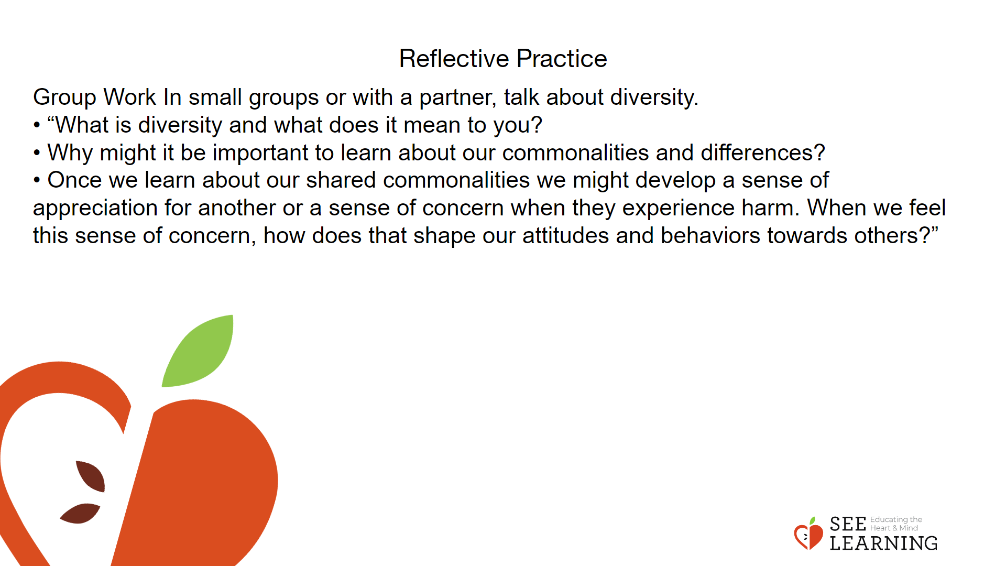 | Instructions and Guided Language  Group Work  In small groups or with a partner, talk about diversity.  • “What is diversity and what does it mean to you?  • Why might it be important to learn about our commonalities and differences?  • Once we learn about our shared commonalities we might develop a sense of appreciation for another or a sense of concern when they experience harm. When we feel this sense of concern, how does that shape our attitudes and behaviors towards others?”  Ask each group to share what they discussed, write ideas on the board and create a shared definition of diversity (what and why).

