Mindful Engagement

Purpose:
“Mindful listening” means to listen respectfully and empathically with full attention, without interrupting the other person, without being distracted, and without focusing on oneself or one’s judgments. Attentive listening allows one to better understand the situation of the other and how the other person is feeling (cognitive empathy), while the act of respectful listening can show that one cares (affective empathy). “Mindful listening” reinforces students’ attentional skills because it requires focusing solely on what the other person is saying, rather than on what one wants to say in response. Students are heard without judgment by their classmates which creates a sense of safety. In “mindful dialogue” each student poses a set of provided questions to their partner, and then listens mindfully, without comment or judgment. The mindful dialogue format allows each student to both reflect personally on what they are learning and how it applies to their own life, and also to briefly share their thinking with another student.
Learning Objectives:  Students will be able to:  - Describe the different parts of our personal identity.  - Engage in the practice of mindful dialogue | Primary Core Component  
Length  45 Minutes | Materials Required  - Writing utensils and paper  - Timer

Check-In (5 min)
Slide 2: Check-In  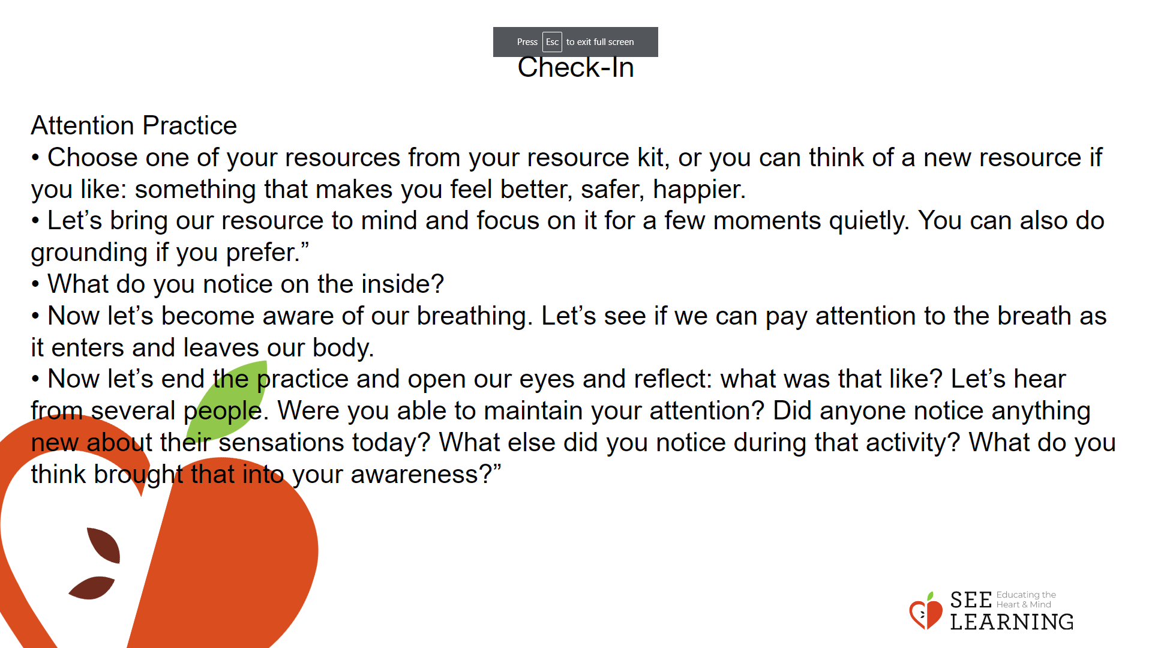 | Instructions and Guided Language  [PAUSE]s can be up to 10 seconds each  Engage in an Attention Practice Guiding Language  • “I invite you to do a short attention practice.  • First we’ll take a comfortable and upright posture. I’ll be keeping my eyes open, but you can close yours or look at the floor.  • Now choose one of your resources from your resource kit, or you can think of a new resource if you like: something that makes you feel better, safer, happier.  • Let’s bring our resource to mind and focus on it for a few moments quietly. You can also do grounding if you prefer.” [PAUSE]  • What do you notice on the inside? If you notice a pleasant or neutral sensation, you can rest your mind on that. If you notice an unpleasant sensation, you can shift to a place in your body that feels better. [PAUSE]  • Now let’s become aware of our breathing. Let’s see if we can pay attention to the breath as it enters and leaves our body.  • If you find paying attention to the breath uncomfortable, then feel free to go back to resourcing or grounding practice. [PAUSE for 15-30 seconds.]  • If you ever get distracted, you can just return your attention to the breath. You can also count your breath. [PAUSE for a longer time, such as 30-60 seconds or longer.] • Now let’s end the practice and open our eyes [PAUSE] and reflect: what was that like? Let’s hear from several people. Were you able to maintain your attention? Did anyone notice anything new about their sensations today? What else did you notice during that activity? What do you think brought that into your awareness?” [Share aloud.]

Insight Activity - (30 mins)
Mindful Dialogue
Overview
In this reflective practice students form pairs and use guiding questions to engage in personal reflection and to experience listening and speaking mindfully.

Content/Insights to be Explored
• We can learn to listen mindfully with full attention, withholding judgment.
• We can learn a great deal about each other in a short amount of time if we listen mindfully.
• Being listened to mindfully can make us feel truly heard and seen and can strengthen relationships.
• Being able to express our thoughts and feelings to someone who is listening mindfully can help us reflect more deeply and gain insights.

Teaching Tips
• It is often helpful to precede the actual mindful dialogue with a moment of reflection or a fast write or drawing on the given topic of the dialogue. This provides think time for students prior to the actual dialogue and can make the sharing richer. For example, prior to doing a mindful dialogue on students’ resources, you might have them draw or think about a resource they already have identified as valuable, or a new resource. Prior to having them do a mindful dialogue on kindness, you might have them spend a minute thinking of a moment of kindness they experienced or witnessed recently.
• Mindful dialogues, as done in SEE Learning, are brief yet concentrated. Each round should only last 6 minutes. You can use this mindful dialogue technique to explore a range of questions, but since mindful dialogues can be personal and intense, always be sure to remind students that if they prefer not to answer a question for any reason, they can instead answer a question they wish had been asked, or stay together in comfortable silence. Mindful dialogues can be great ways to prompt reflection and the personalization of knowledge in students.
• If you are unfamiliar with mindful dialogues, it is important to practice it with another adult first, outside of class, to see how it feels and how the timing works. Although it may take several tries for your students to get used to the format of a mindful dialogue done in this way, it will create an effective practice that you can continue to use to reflect on in other situations as the SEE Learning curriculum progresses.

Slide 4: Insight Activity  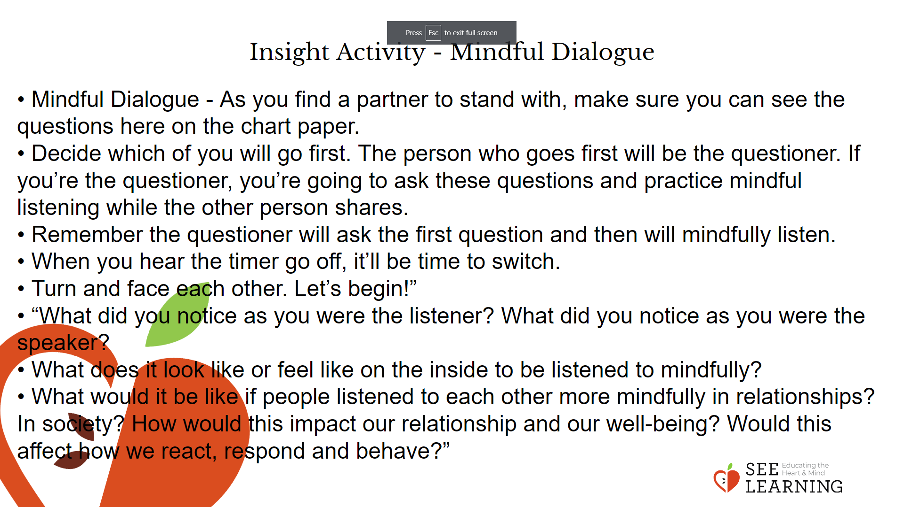 | Instructions and Guided Language  Explain the format of the mindful dialogue.  • A mindful dialogue involves the class dividing into pairs. Each pair decides who will go first. That person will be the questioner and will also be the person who will first practice mindful listening. The other student in the pair is the responder. Explain that it’s okay if the questioner has not had time to ask all three questions during the allotted time. Thinking about the question and responding fully and thoughtfully is the goal.  • If the responder has finished early, they may choose to add more thoughts directly related to the questions. Or the pair may sit together in silence until the time is up.  • The mindful listener asks a set of questions, which are posted on the board or on a piece of chart paper where everyone can see them. The responder answers each question one by one, taking as much of the allotted time as they like. The mindful listener gives full attention and doesn’t speak except for asking the questions. As the responder finishes speaking to each question, the listener thanks the responder and moves on to ask the next question. When you are in the mindful listener role, try to notice if you find it difficult not to speak, and how that shows up in your body and mind. You may wish to remind yourself that the goal is to focus on what the partner is expressing, and that you’ll have an opportunity to speak when the time comes to switch.  • Before one actually begins a mindful dialogue, it’s important that people have time to read and think about the questions they will be answering. Since everyone will take both roles, the whole class shares a few quiet minutes of reflection, reading the publicly posted list of questions.  • Mindful dialogues are confidential. What happens in your partnership stays in your partnership. Whatever you hear should not be shared with the class during the debrief or with anyone outside of your partnership.  • When you are the responder, if there’s a question you don’t want to respond to, you may choose to respond to a question you wish had been asked instead.  • Model a mindful dialogue with a volunteer student acting as the mindful listener. Have the questions for this mindful dialogue visible for all to see on a piece of chart paper. Give everyone a few moments to read and think about the questions. Then begin the mindful dialogue using these questions:  • Mindful Dialogue Questions  - General inquiry: What do you think are the most important aspects of a person’s identity?  - Personal connection: What is an aspect of your identity that you wish people understood better about you?  - Application to others: What could you do to better understand the identities of people around you?  • When modeling the mindful dialogue, the student asks the posted questions and the adult answers them in front of the class, modeling appropriate disclosure. When you each have taken a turn and have completed modeling the mindful dialogue, ask the observing students what they noticed about your dialogue.  • Explain that mindful dialogues are meant to be safe, so if they don’t want to answer a particular question, they can answer a question they wish had been on the list instead. Or they can pass, and stay in comfortable silence together until the round ends.  • “We’re going to practice listening in a mindful dialogue. A dialogue means two or more people are taking turns speaking to one another using mindful listening.  • May I have a volunteer to practice with? We’ll model this mindful dialogue process for the class, using these same questions that everyone will use when we connect in partnerships.  • [Student’s name] and I are going to demonstrate how to do a mindful dialogue. Here are the questions. You will be the questioner and I will be the one who answers, then we will switch. So you’re going to ask them all first, one by one. Then when we switch, I can ask you.  • When you ask me, you’re going to listen mindfully to my responses, and not interrupt. Then when it’s my turn to ask you, I’ll do the same. Everyone else, please watch; you’ll have an opportunity to do this next.  • Let’s first take a moment to read the questions in silence. • Okay let’s start now. Start asking me the questions, and say thank you for sharing between my responses.”  • [Student asks] “What is a piece of your identity that you value or enjoy about yourself?”  • [Student listens and models mindful listening while you share, nodding and paying full attention but not interrupting.]  • [Student says] “Thank you” and asks the next question “When did you first become aware that this was a part of your identity?” [Student listens mindfully.]  • [Student says] “Thank you. How has your identity changed over time?” [Student listens mindfully.]  • [Student says] “Thank you. Have there been parts of your identity that have gained or lost significance/importance to you over time?” [Student listens mindfully.]  • [Student says] “Thank you.What is something you wish others knew or understood about your identity?” [Student listens mindfully. When the timer goes off it’s time to switch]  • “We’re going to switch. Now I will ask the same five questions one by one. When you’re sharing, I’ll be doing mindful listening. When you finish each response, I will say “Thank you for sharing” and then I will ask you the next question. Okay?” [Engage fully.]  • After the timer goes off, ask students to answer the following questions as a class.  • “What did you all notice about the mindful dialogue?  • What did you notice about our mindful listening?  • How do you think mindful listening is a way of being kind to someone? What contributes to that?  • How might mindful listening affect our sense of safety or our nervous system?  • What if I didn’t want to answer a question. Let’s say I felt uncomfortable about answering one of the questions. What could I have done?” [Allow for suggestions, or provide a model by demonstrating this with your partner.] • “Because mindful dialogues are designed to be safe, if I don’t want to answer a question, then I can answer a question I wish the other person had asked. I can say, “I wish you had asked me about something else, so I’m going to share that instead.” And then you can share. So in that way too, we can see that mindful dialogues are all about practicing kindness and respecting the way we talk to and listen to each other.”  • Next, have the students practice with each other. Divide the class into pairs and have them stand or sit comfortably side-by-side such that everyone can see the mindful dialogue questions, turning to face each other when they begin. Explain that they will wait until they hear the timer go off to begin and again when it is time to stop and switch roles. It’s effective to use your timer/alarm to bring the room to silence at the end of the first round, pause for a few seconds, and then to signal the start and end of the second round in the same way. Then everyone begins at once, with their partner’s full attention.  • Set the timer to have them begin. Pay attention to the time and allow them to engage in the activity for between 90-120 seconds, depending on how you perceive  the group’s comfort level and engagement to be. After the timer has gone off, ask them to switch. Remind them that it’s okay if they didn’t finish all the questions. Also reinforce the skills being built, reminding everyone what it means to listen mindfully.  • Give them the same amount of time as the first round to complete the activity after they have switched, then when the timer goes off, signal the end of the mindful dialogue. If you like and have time, repeat the whole activity a second time with new partners. Note that the 3 minutes are for all five questions and it’s okay if they do not complete all the questions in time. This way an entire round of a mindful dialogue lasts only 6 minutes or so, with each person being responder and questioner for one set of five questions.  • “Let’s all practice this mindful dialogue now. As you find a partner to stand with, make sure you can see the questions here on the chart paper.  • Decide which of you will go first. The person who goes first will be the questioner. If you’re the questioner, you’re going to ask these questions and practice mindful listening while the other person shares.  • Remember the questioner will ask the first question and then will mindfully listen. When the person answering is done, the questioner will say “Thank you for sharing,” and will then ask the next question.  • When you hear the timer go off, it’ll be time to switch. Don’t worry if you’re not done with all the questions yet. That’s okay. Everyone will be answering at their own pace. Any questions?  • Turn and face each other. Let’s begin!”  • [When the round is finished and both people have had the chance to share and listen mindfully, debrief the activity with one or more of the following questions:]  • “What did you notice as you were the listener? What did you notice as you were the speaker?  • What does it look like or feel like on the inside to be listened to mindfully?  • What would it be like if people listened to each other more mindfully in relationships? In society? How would this impact our relationship and our well-being? Would this affect how we react, respond and behave?”

Reflective Practice (10 mins)
Slide 4: Reflective Practice  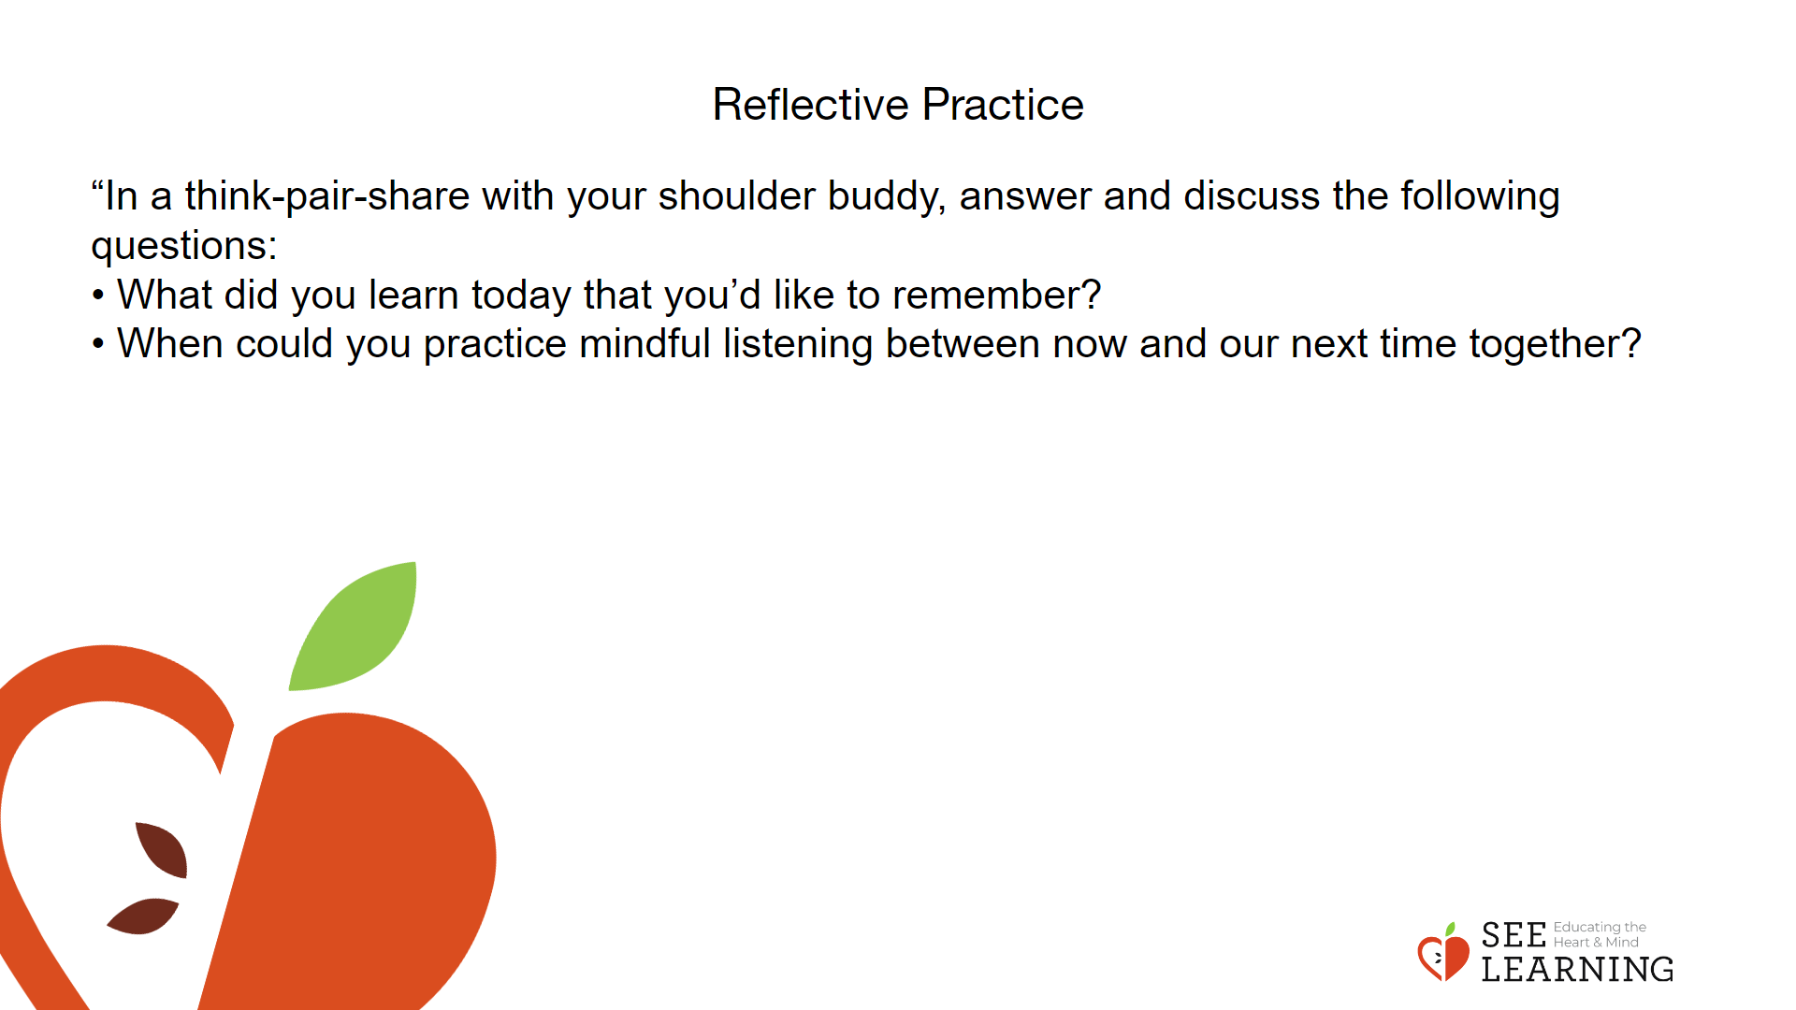 | Instructions and Guided Language  “In a think-pair-share with your shoulder buddy, answer and discuss the following questions:  • What did you learn today that you’d like to remember?  • When could you practice mindful listening between now and our next time together?

