Exploring our Social Identity

Purpose:
“Exploring Our Social Identity” provides students with an opportunity to shift their attention toward others and become more aware of their social realities. It does this through two activities that explore what they know and don’t yet know about each other. This leads to reflecting on identity and the assumptions we make about one another. They also do an activity called “Who Are You?” that helps reveal the infinite aspects of our identities that can be explored, most of which are not visible to others upon our first meeting.
Learning Objectives:  Students will be able to:  - Describe assumptions about others and how those assumptions can be inaccurate.  - Recognize that there are many things we don’t know about one another until we take the time to find out.  - Determine how every person, including oneself, has a vast number of aspects to their identity, most of which are not visible upon first seeing or meeting a person. | Primary Core Component  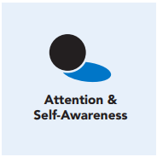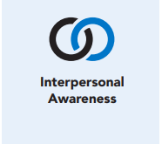
Length  45 Minutes | Materials Required  - Writing utensils and paper  - Timer

Check-In ( min)
Slide 2: Check-In  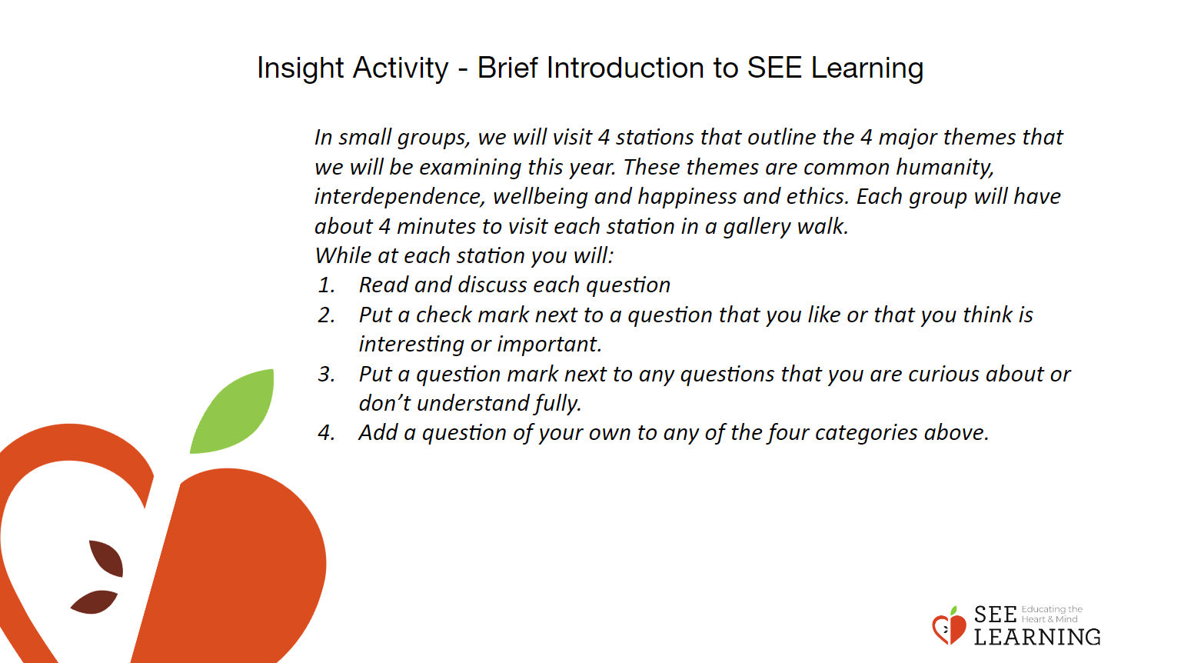 | Instructions and Guided Language  [PAUSE]s can be up to 10 seconds each  Engage in a Grounding Practice  Overview Lead students in a grounding practice of focusing their attention on the pleasant and neutral sensations resulting from noticing how the body is in contact with an object or surface. They will be invited to focus on either the point of contact with their feet on the ground or a point where their body is in contact with an object or surface that feels pleasant or neutral.  Guiding Language  • “It can help you to focus if you close your eyes. If you don’t choose to close them, it can be helpful to lower your gaze to the floor. Let’s help each other out by paying close attention to our own experience, noticing the sensation of the weight at our feet or pressure of our legs or back against the chair we are sitting in. [PAUSE]  • If it feels comfortable, bring your attention to your feet or legs; otherwise choose another point of contact. Notice what it feels like on the inside. When you notice your mind wandering, bring it back to your focus area. [PAUSE]  • If you begin to feel uncomfortable, you can stop paying attention to your focus area and focus instead on your breathing. You can also always choose to stop and relax quietly in your own way, or choose an alternate Help Now! Strategy and remain with any pleasant or neutral sensations that may bring about.  • So, let’s begin by focusing our attention on the experience of weight or pressure or gravity being enacted on the body, our feet or legs or back. [PAUSE]  • When our mind wanders, bring it back, and notice what arises on the inside. By focusing on pleasant or neutral sensations, we can generate greater well being in our bodies and regulate our nervous systems.  • “Now we’ll open our eyes. [PAUSE] And reflect: what was that like? Let’s hear from several people. Were you able to maintain your feeling of being grounded? Did anyone notice anything new about their sensations today? What else did you notice during that activity? What do you think brought that into your awareness?”

Insight Activity 1 (15 min)
Two Truths and a Lie
Overview
In this Insight Activity, students share two things about themselves that are true, and one that is not true. The goal is to help students learn about one another and to connect in a relaxed way, with humor.
Content/Insights to be Explored
• We can learn about one another and from one another
• There are many things we don’t know about one another until we take the time to find out.
• Often our assumptions about others are incorrect or incomplete
Teaching Tips
Students may know this activity as the game “Two Truths and a Lie” and may have played it before. That is fine, since there are endless facts and fictions that can be used in this game.

Slide 2: Insight Activity 1  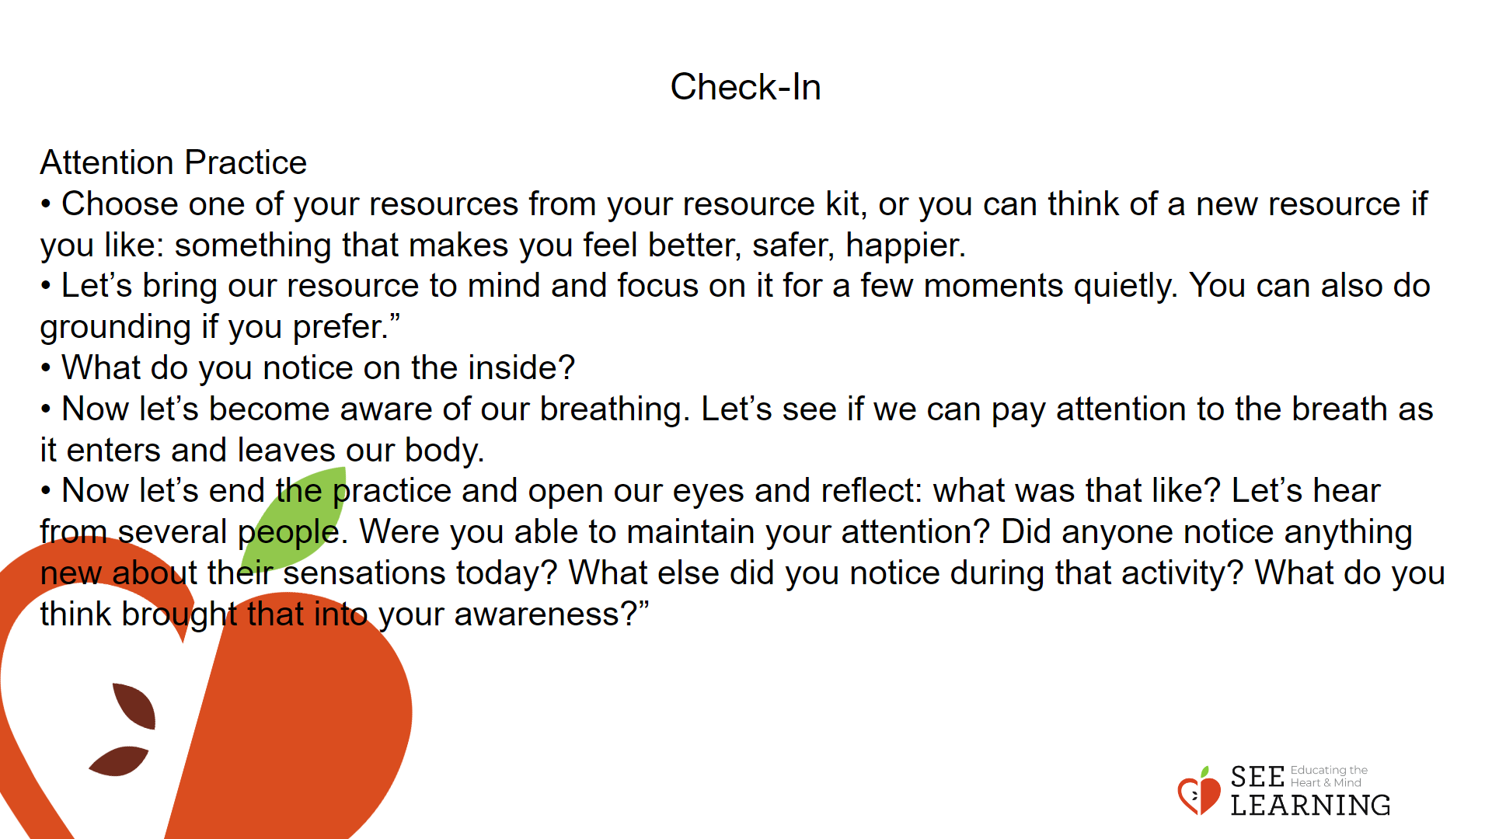 | Instructions and Guided Language  • Take a poll: ask students how well they think they know others in the group.  • “On a fist to five, fist being 0, and 5 representing 5. How well do you think you know your classmates?”  • Tell students you are going to play a game called “Two Facts and a Fiction”. The challenge is to see if others can figure out which items are true and which are false.  • Make sure they understand what is meant by “fact” (something that is true) and “fiction” (something that is false/made up).  • “We’re going to do an activity called “Two Facts and a Fiction.” This is a game that some of you may have played before. It’s for learning about each other.  • In this game we write down two things that are true about ourselves, two facts, and one thing that is not true, a fictional statement. Then the rest of the class will guess which things are true and which one is not true.  • Now, we don’t want it to be super easy. We want to think of things that are less obvious. Things that other people might not know about us. Things that are parts of our identity but are not visible from the outside. This could include interests or skills you have, places you’ve traveled to, it could be about your family or pets, causes or ideas that are important to you. You choose what you’d like others to know about you.  • Write the words “Something someone might not know about me is…” on the board or a piece of chart paper.  • Point to the board or poster with this prompt on it. • “Each of us will write three things that answer this question on your index card: two that are true and one that’s false, but in mixed up order. Then we will share and other people will have to guess which ones are true and which is false. And after they have guessed, we will reveal which ones were true and which were false.  • Do you have any questions about how to play this game? • Let’s take a few minutes to write down our three statements on our index card, and make sure your name is on your card.” [Give them a few minutes.]  • After their time is up, collect all the index cards. Pull cards at random to share, and call individuals labeled on the card to read it. (Students can choose to pass, and you will just pull the next name.) You should keep all index cards so they can share responses throughout the week, as there is not enough  • Take a poll: ask students how well they think they know others in the group.  • “On a fist to five, fist being 0, and 5 representing 5. How well do you think you know your classmates?”  • Tell students you are going to play a game called “Two Facts and a Fiction”. The challenge is to see if others can figure out which items are true and which are false.  • Make sure they understand what is meant by “fact” (something that is true) and “fiction” (something that is false/made up).  • “We’re going to do an activity called “Two Facts and a Fiction.” This is a game that some of you may have played before. It’s for learning about each other.  • In this game we write down two things that are true about ourselves, two facts, and one thing that is not true, a fictional statement. Then the rest of the class will guess which things are true and which one is not true.  • Now, we don’t want it to be super easy. We want to think of things that are less obvious. Things that other people might not know about us. Things that are parts of our identity but are not visible from the outside. This could include interests or skills you have, places you’ve traveled to, it could be about your family or pets, causes or ideas that are important to you. You choose what you’d like others to know about you.  • Write the words “Something someone might not know about me is…” on the board or a piece of chart paper.  • Point to the board or poster with this prompt on it.  • “Each of us will write three things that answer this question on your index card: two that are true and one that’s false, but in mixed up order. Then we will share and other people will have to guess which ones are true and which is false. And after they have guessed, we will reveal which ones were true and which were false.  • Do you have any questions about how to play this game? • Let’s take a few minutes to write down our three statements on our index card, and make sure your name is on your card.” [Give them a few minutes.]  • After their time is up, collect all the index cards. Pull cards at random to share, and call individuals labeled on the card to read it. (Students can choose to pass, and you will just pull the next name.) You should keep all index cards so they can share responses throughout the week, as there is not enough time to go over everyone’s in this session. Pick as many as you have time for the remainder of the activity.  • Have students share their three items, one at a time. After a student shares, the rest of the class can discuss which statements they think are true and which one is false.  • “What three things did you write?” [Have the student share their three statements.]  • “What do the rest of you think? Which ones are true and which is false? Why do you think that? What are you basing your guess on?”  • After one or two classmates have guessed, the student reveals which were the facts and which was the fiction.  • “Now let’s find out if we are right. Which ones were true and which was false?” [Let the student reveal.]  • “Okay let’s hear from the next person.” (Continue through as many students as you have time for in this allocated activity.)  • Then debrief the activity, asking one or more of the following questions as time allows:  • “What was that activity like for you? What surprised you? • What did you learn about the people in our group?  • Let’s talk about assumptions. What are some assumptions that came up for you? Were these assumptions challenged or validated by the exercise? What might be some risks of making assumptions based on our first impressions of someone? What might be a benefit of asking more questions or getting to know someone better? • What can happen when we make assumptions based on our first impression of someone? How can these assumptions affect how we perceive others, our relationship with the person, and our wellbeing?  • What can happen when we get to know each other better?  • What are some other ways we might get to know each other better during our class time? What kinds of activities or strategies have you experienced in other classes, or club or team type situations, that helped people get to know one another better?”

Insight Activity 2 - (15 mins)
Who are you?
Overview
In this insight activity students will explore the multiplicity of their own identities and gain insights about the complexities of others’ identities.
Content/Insights to be Explored
• Every person has many aspects to their identity, most of which are not visible upon first seeing or meeting them.
• There are many things we don’t know about one another until we take the time to find out.

Slide 3: Insight Activity 2  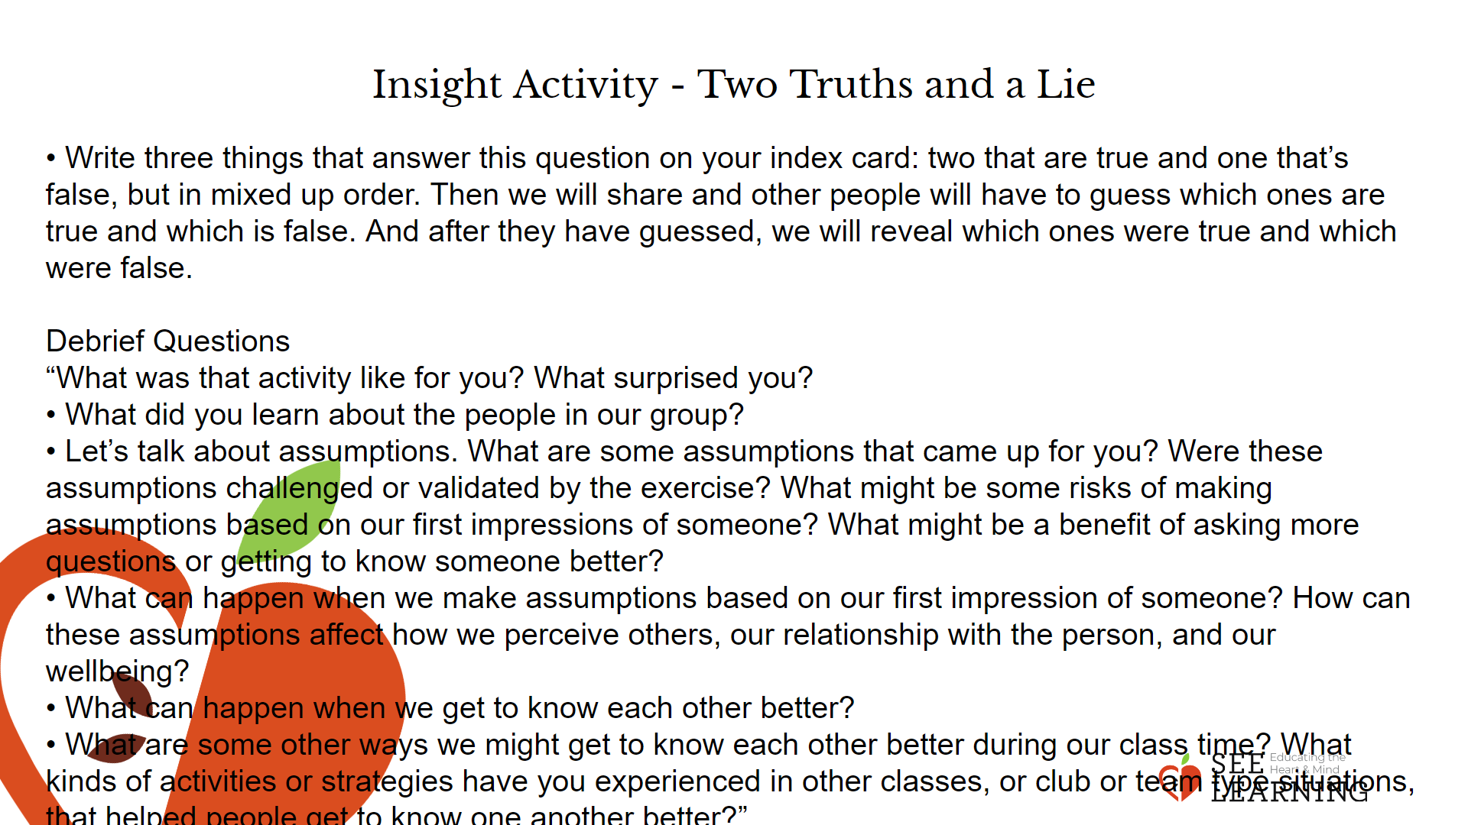 | Instructions and Guided Language  Tell students you will all be playing a game that involves learning about others and about ourselves. Tell them that you’ll all be sharing what you learn about each other during the debrief, so keep that in mind as they share with their partners.  • Organize students so everyone who is able is standing and each person has a partner. You should participate if there is an odd number of students. • Explain the rules of the game. Each person will take a 30-second turn asking their partner one question “Who are you?” The speaker’s challenge is to try not to repeat the same answer and to be confident sharing only what they wish to share about themself. Then switch roles and repeat.  • “Now we’re going to play a game that helps us learn about each other and ourselves. It’s called “Who are you?” • Everyone finds a partner. Partner 1 will be the questioner. The questioner will ask “Who are you?” to their partner. Partner 2 will then answer by saying something about themselves.  • When they’re done. Partner 1 will say “Thank you. Who are you?”  • Partner 2 gets to answer again, but this time giving a different answer. We can’t repeat something we’ve already said.  • Then Partner 1 says again, “Thank you. Who are you?” Partner 1 doesn’t comment on the responses or make additional conversation. They are in the listening role only. • You’ll do this for 30 seconds until the alarm goes off. Then you’ll switch roles, and the person who was asking the question, “Who are you?” will get to be the one who answers.  • Remember to say “Thank you” each time, before asking “Who are you?” again.”  • It’s good practice to model the activity first, with an adult playing the part of the respondent, answering authentically. You can also provide a few examples of how someone might answer the “Who are you?” question, including both low-vulnerability responses and more revealing ones, to show that students can answer in a variety of ways. (I am (full name). I am named after… I am a person who likes the color blue. I have a dog that I love. I’m scared of heights. I’m an immigrant. I am an individual who believes in liberation and fighting for social justice ...)  • “Let’s practice by asking me “Who are you?” and I’ll respond. Ask me “Who are you?” [Have them all ask you this question as a class, then respond by saying something about yourself.]  • Now say, “Thank you. Who are you?” [Have them ask you, and reply again.]  • Ask students to face their partners and choose who will go first as the questioner. Tell them when the timer goes off, they should switch roles and partner will begin asking “who are you?” They will repeat this, beginning with “thank you” as many times as possible until time is called.  • Let them do this for 30 seconds. When the alarm goes off, have them switch roles.  • After another 30 seconds, explain that they should now find a new partner. Remind them that the challenge is to try not to repeat an answer, even with new partners.  • Repeat the activity with new partners. Do this for several rounds, as time permits.  Debrief Activity  After the rounds are complete, invite them to return to their seats and debrief with some or all of the following questions:  • “What was this activity like for you?” [Be prepared to receive comments from those who did and did not find this a comfortable experience. Anticipate that it may be challenging for people who identify themselves as introverts; who find it stressful to reach out to make partnerships; who don’t like having their interaction interrupted or who don’t prefer structured protocols. That’s okay. You are asking this question to surface whatever comes up for participants, not as a judgment of the value of the activity. Notice, nod, and validate with “Thank you for sharing” every time so that no one has a sense of whether you agreed or disagreed with the speaker.]  • “Show of hands: Who learned something you didn’t know about someone else? Did anything surprising happen?  • Was it hard to keep going? If so, why?”  • How does this activity relate to the idea of identities?”  • What did you notice about how many aspects of our identity there are?  • Our sense of identity often influences the way we see other people and relate to them. And we often develop a feeling of an in-group when we identify others with ourselves. How can this activity help us develop our empathy and compassion?”  • “How many aspects of our identities do people become aware of when they first see or meet us?”  • “What difference did it make when we said “Thank you” in between asking “Who are you?” How did that affect you as a questioner and as an answerer?”

Reflective Practice (10 mins)
Slide 4: Reflective Practice  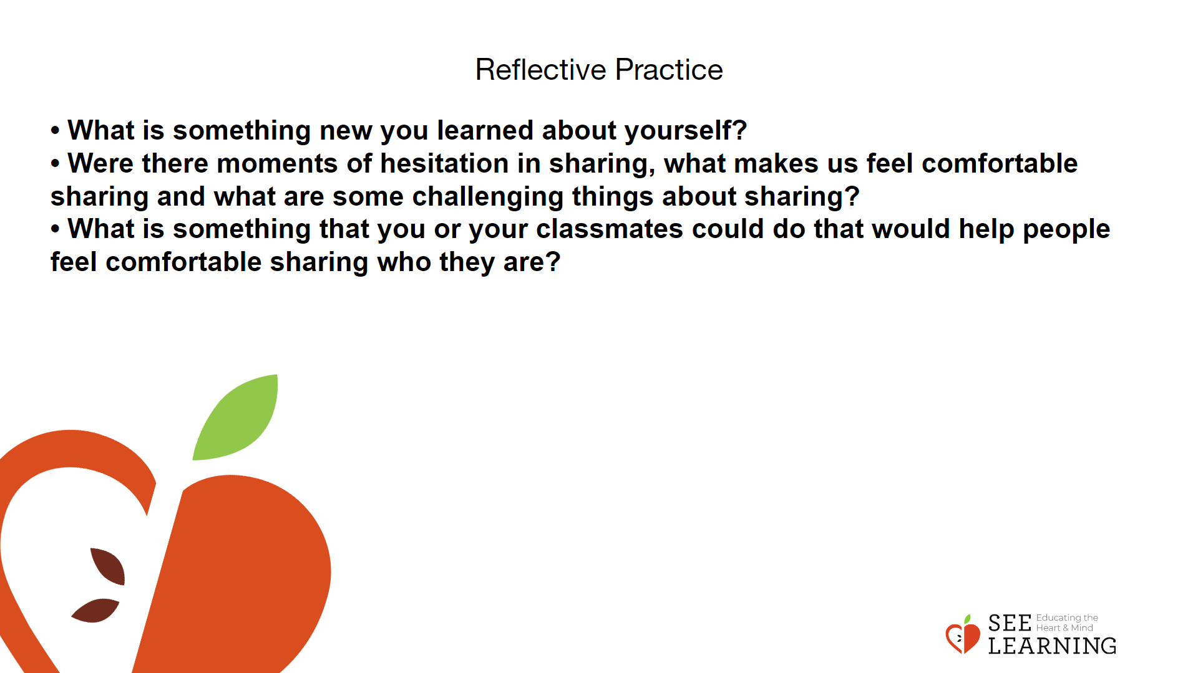 | Instructions and Guided Language  Have students journal on the following prompt:  • “What is something new you learned about yourself?  • Were there moments of hesitation in sharing, what makes us feel comfortable sharing and what are some challenging things about sharing?  • What is something that you or your classmates could do that would help people feel comfortable sharing who they are?”

