Exploring the Ethical Dimensions to Emotions

Purpose:
In this learning experience, students will identify when emotions become risky. Emotions can cause harm to ourselves and others when they grow very strong. Students will learn that they can cultivate the skills of recognizing emotions. Through this recognition they can decide whether or not to give those emotions more “fuel,” and to manage their emotions in ways that align with our values.
Learning Objectives:  Students will be able to:  - Identify the connection between emotional wellbeing and ethics  - Describe the ethical dimensions of emotions  - Examine how ethical responses can promote wellbeing and | Primary Core Component  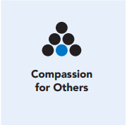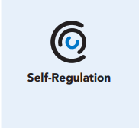
Length  45 Minutes | Materials Required  - “Cultivating the Stance of Opposition” reading  - Four A’s Protocol  - Writing utensils and paper

Check-In (5 min)
Slide 2: Check-In  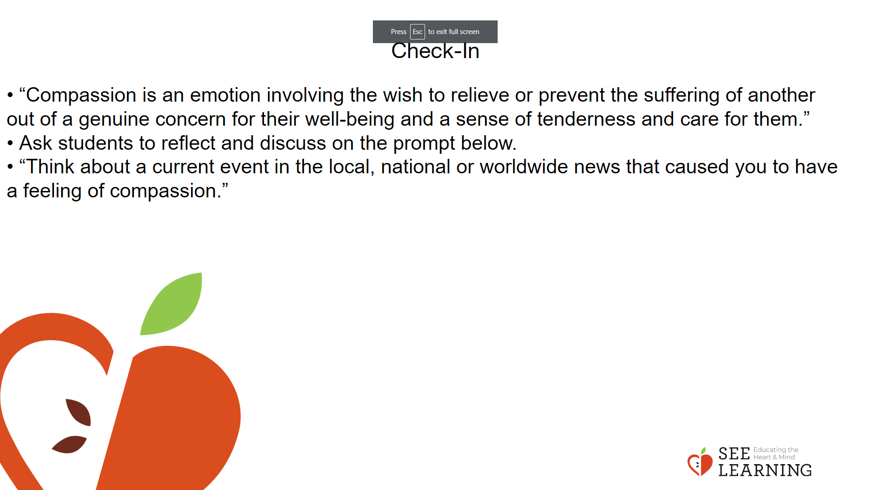 | Instructions and Guided Language  [PAUSE]s can be up to 10 seconds each  Settling Activity  • “Let’s take a moment to get comfortable and in an alert position. What does your body need right now? [PAUSE]  • For you it may be settling into your chair, or if you feel like it, leaning against a wall, sitting or lying on the floor. Please take a moment to make yourself comfortable in an alert position. Feel free to move if you need to. [PAUSE]  • Now I invite you to think of a resource, something that makes you feel better, safer, happier, or stronger.  • It could be a person, place, thing, something about yourself, or a memory of a kindness you experienced. It can be real or imaginary. Notice the details of this resource and any sensations associated with it. [PAUSE]  • Now, when you think about this resource, what do you notice happening inside your body? Notice the sensations. [PAUSE]  • Next, I invite you to bring your attention to your body and what it is in contact with. Perhaps you feel the chair against your back, your hand on your leg. Possibly the coolness of the table, the softness of your shirt, maybe the air going in and out of your nostrils. What sensations do you notice on the inside? [PAUSE]  • Scan your body for a pleasant or neutral sensation and just pay attention to that and observe it. See if it changes or stays the same. [PAUSE]  • You can always shift your body and your focus to another place that feels better. You can always focus on your resource. [PAUSE]  • If you get distracted, remember that you are human and it’s okay to get distracted. Just acknowledge you’re distracted and try to bring your attention back to your resource or a pleasant or neutral sensation in your body. [LONGER PAUSE]  • As we do this, we’re learning more about our bodies and how to calm them and make them feel better. • Now we’ll conclude the practice. If you closed your eyes, I now invite you to open them. Thank you.”

Presentation/Discussion- Revisiting Thinking Traps (10 min)
Slide 3: Presentation/Discussion  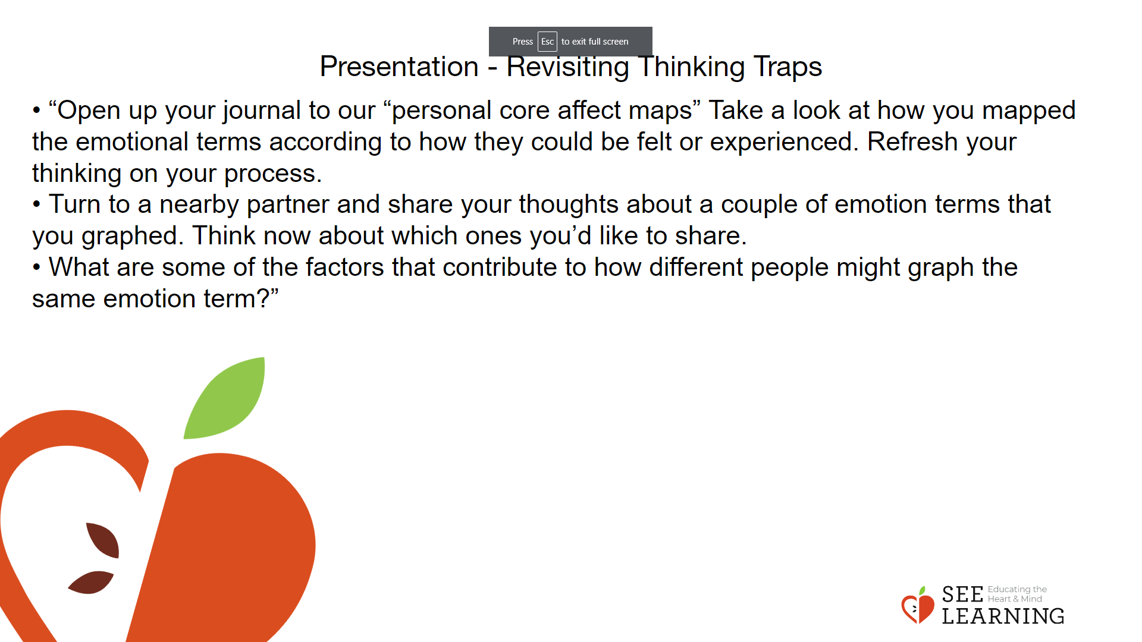 | Instructions and Guided Language  • “Open up your journal to our “personal core affect maps” Take a look at how you mapped the emotional terms according to how they could be felt or experienced. Refresh your thinking on your process.  • Turn to a nearby partner and share your thoughts about a couple of emotion terms that you graphed. Think now about which ones you’d like to share.  • What are some of the factors that contribute to how different people might graph the same emotion term?” New Information  • “We can experience more than one emotion at a time.  • These two emotions are focused on different aspects of the event of moving away.  • We can also experience more than one emotion at a time when we feel a “mixed resource.” A person might think of their best friend and how happy they are when they’re together, but then in the next moment, think of how their friend has moved away, and feel sadness that they can’t be together as often. Happiness and sadness are opposing emotions, but here they come from focusing on two different aspects of the resource.  • Only one of the two emotions can be deeply felt at the same time. For example, a person can’t feel sad at missing their best friend and happy at missing them at the same time. Another example is rage and tenderness. If I’m filled with rage towards someone, it’s unlikely that I will be feeling tenderness toward the same person. For me to feel tenderness towards them, my rage has to pass.”

Insight Activity - (20 mins)
Slide 4: Insight Activity  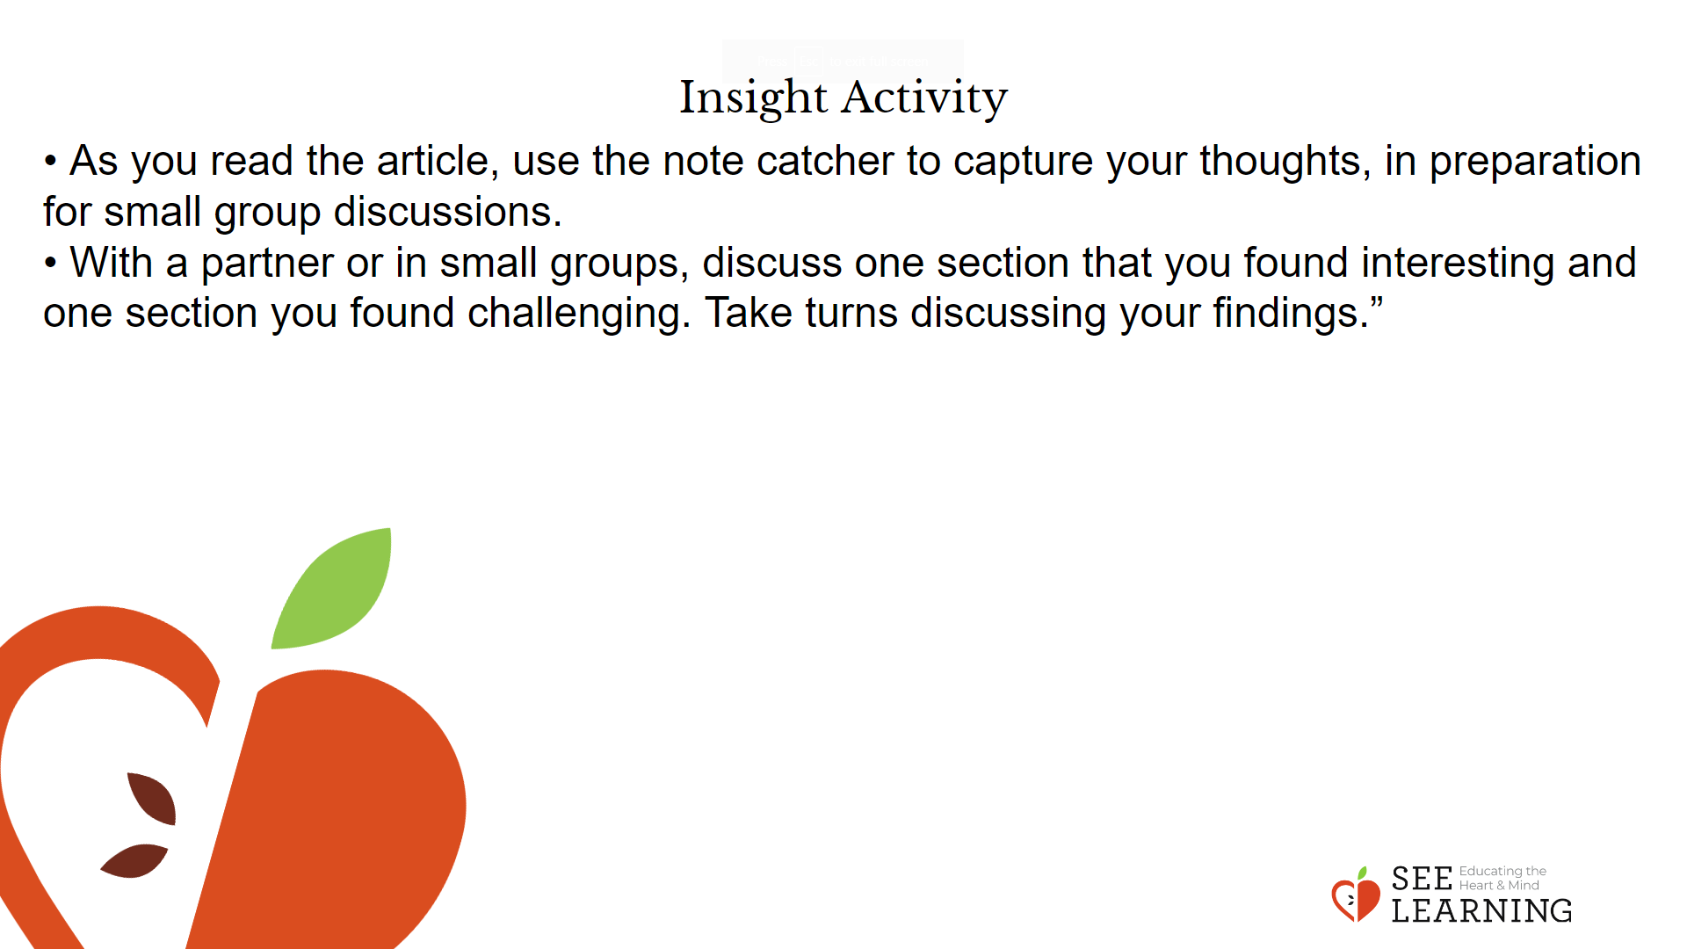 | Instructions and Guided Language  • “We’re going to read a short article about cultivating a stance of opposition that helps us gain more agency and empowerment over the emotions we are feeling.  • As you read the article, use the note catcher to capture your thoughts, in preparation for small group discussions.  • With a partner or in small groups, discuss one section that you found interesting and one section you found challenging. Take turns discussing your findings.”

Reflective Practice - Reaching for Opposing Emotions(10 mins)
Activity Overview
Students will make self-to-text connections, contextualizing their ideas about developing the Stance of Opposition to their own circumstances. They will record their thinking in their SEE Learning Journal.

Slide 5: Reflective Practice  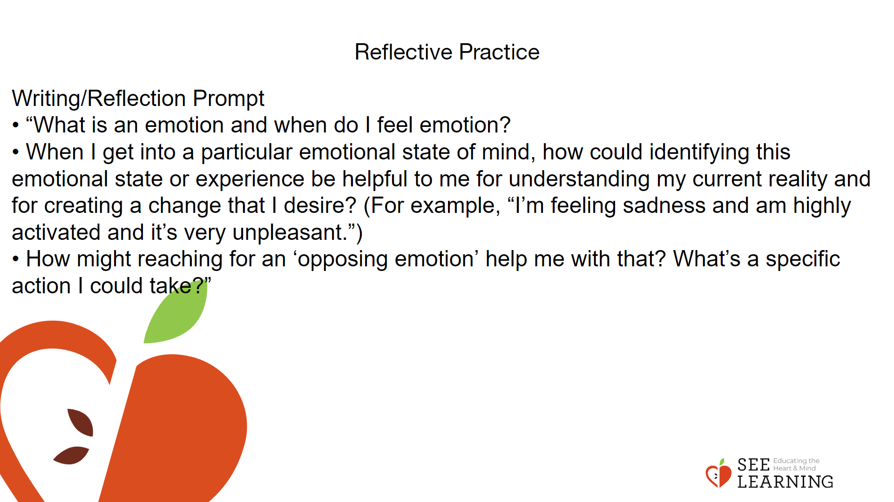 | Instructions and Guided Language  Writing/Reflection Prompt  • “What is an emotion and when do I feel emotion?  • When I get into a particular emotional state of mind, how could identifying this emotional state or experience be helpful to me for understanding my current reality and for creating a change that I desire?  (For example, “I’m feeling sadness and am highly activated and it’s very unpleasant.”)  • How might reaching for an ‘opposing emotion’ help me with that? What’s a specific action I could take?”  Guiding Language  • “We can identify certain emotions as “risky.” Emotions are risky when, if left unattended or allowed to grow very strong, they prompt us to engage in behaviors that would harm ourselves and others. We can cultivate (intentionally develop) the skills of recognizing emotions, deciding whether or not to give those emotions more ‘fuel’, and manage our emotions in ways that align with our values.  • Understanding emotions and mindsets in this way will also help us develop within ourselves a “stance of opposition” towards those emotions and mindsets that we believe are harmful to ourselves and others.  • Identify a ‘risky’ emotion that if we don’t pay attention, can lead us toward harmful ways of acting toward ourselves or one another and identify a paired emotion that we can cultivate so that when we feel the risky emotion gaining strength, we can concentrate on that opposing emotion. Write them down (on our shared chart/in your journal).”

