Cognitive Restructuring to Promote Wellbeing

Purpose:
To continue an exploration of thinking traps and discuss ways we can successfully reframe our thinking trap by engaging in “cognitive restructuring,” meaning a reframing and reappraisal of a situation. Students will apply components of self-compassion to reframe thinking traps that may arise from challenging situations and emotions.
Learning Objectives:  Students will be able to:  - Explore thinking traps around feelings of powerlessness, helplessness, or hopelessness  - Engage in “cognitive restructuring,” reframing thinking traps by applying components of self-compassion | Primary Core Component  
Length  45 Minutes | Materials Required  - Personal Reflections for Self-Compassion handout (one per student)  - Writing utensils and paper

Check-In (5 min)
Slide 2: Check-In  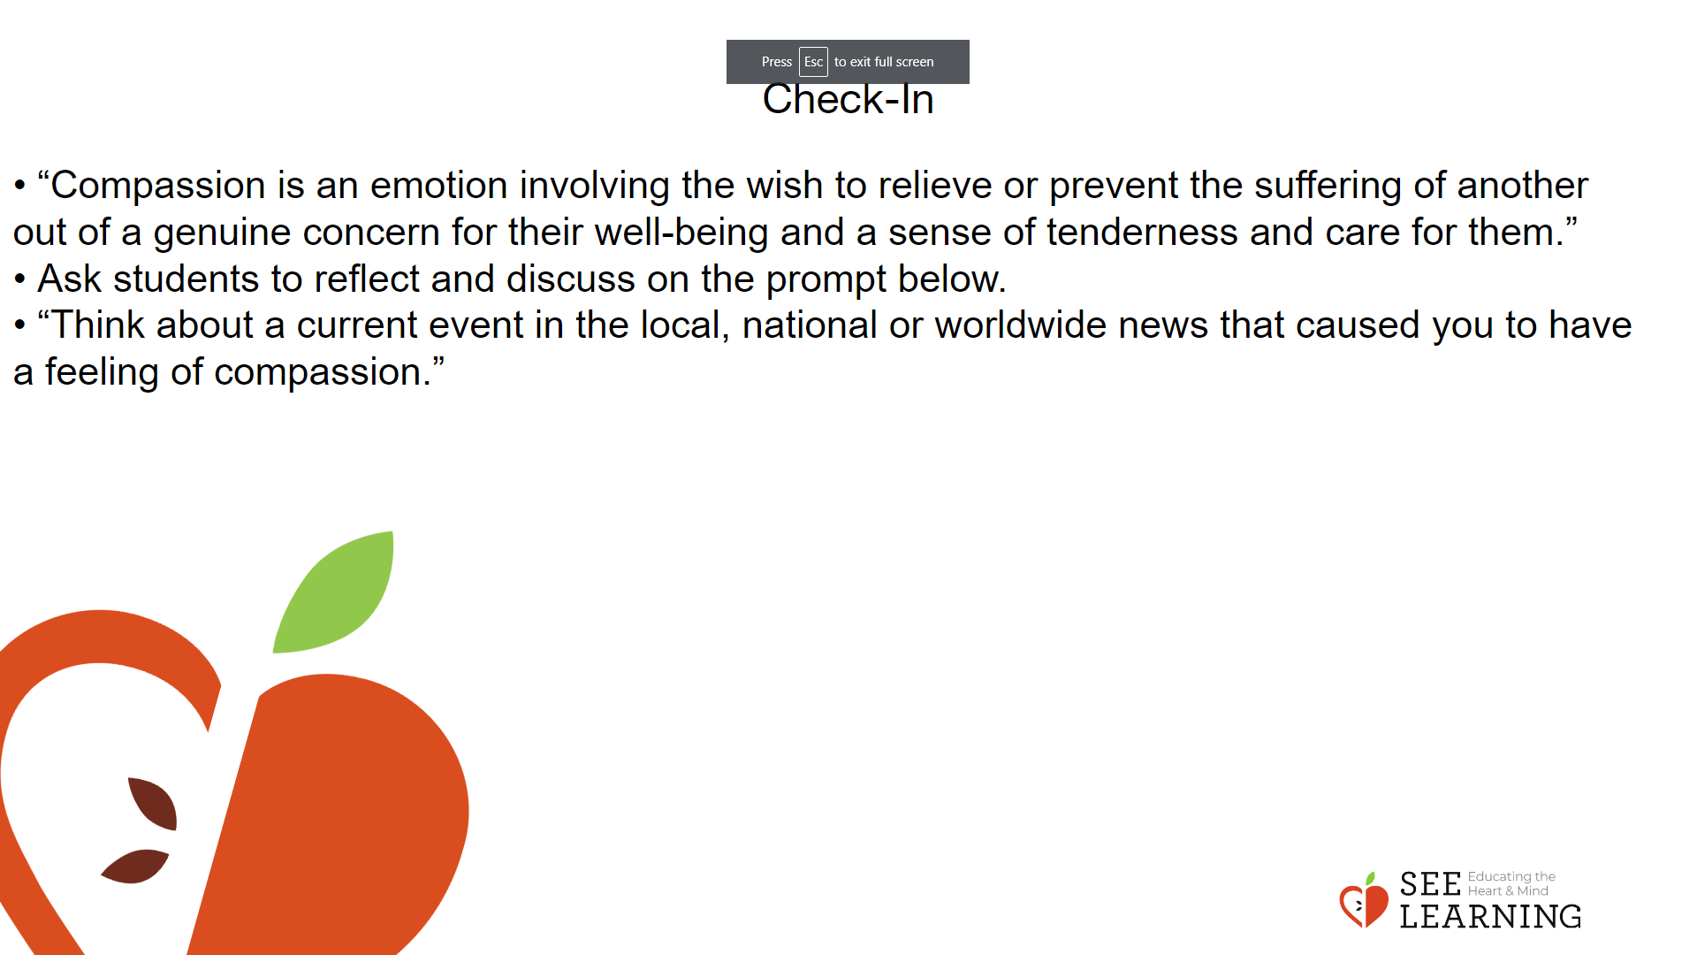 | Instructions and Guided Language  [PAUSE]s can be up to 10 seconds  each  Share Story of Compassion  • Share the definition for compassion.  • “Compassion is an emotion involving the wish to relieve or prevent the suffering of another out of a genuine concern for their well-being and a sense of tenderness and care for them.”  • Ask students to reflect and discuss on the prompt below. • “Think about a current event in the local, national or worldwide news that caused you to have a feeling of compassion.”

Presentation - Revisiting Thinking Traps (10 min)
Slide 3: Presentation  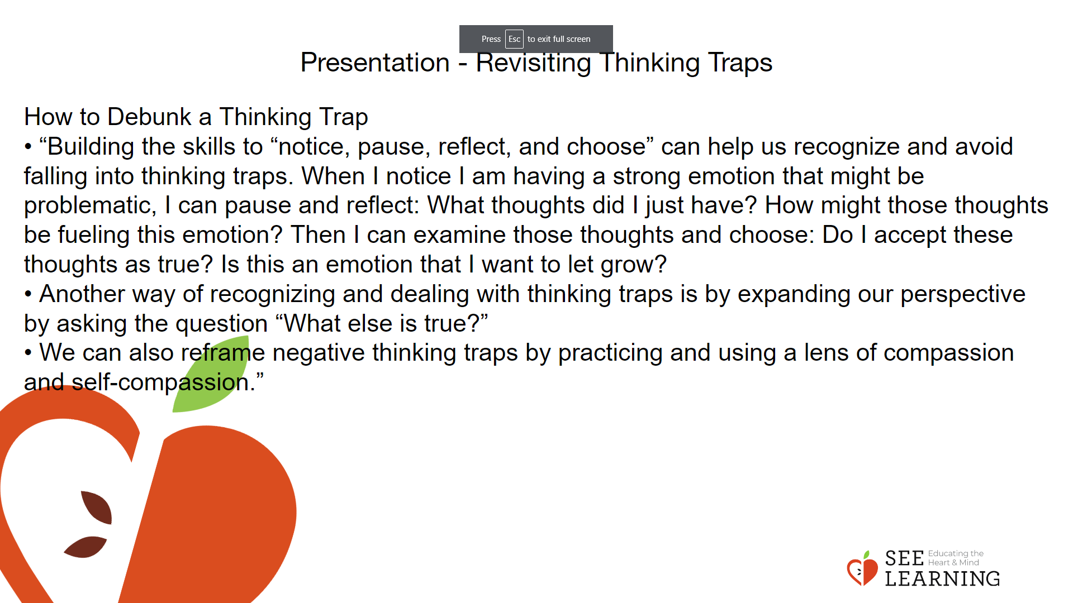 | Instructions and Guided Language  • “We’re going to revisit the idea of the thinking trap. Thinking traps happen when our minds play tricks on us and make things appear in ways that are not really true. A thinking trap is a distortion that makes things appear differently to how they really are. It exaggerates or minimizes. It hides important truths.  • When strong emotions arise, we can examine the thoughts that are connected to our emotions. We fall into a thinking trap when we try to make sense of, or justify, those emotions as evidence of a truth, such as “I feel helpless, so I must be powerless.”  • We can’t get ourselves out of a thinking trap just by telling ourselves to stop thinking or feeling that way. It’s important to look at the evidence in the situation, engage in analysis, and challenge the thinking trap. If we try to push away upsetting thoughts, or try to just not think about them, the thoughts often just come back into our mind. Or if we try to push them down and suppress and ignore them, pretending they don’t exist, we may notice an unhelpful result in our body or emotions that can even grow over time.”  How to Debunk a Thinking Trap  • “Building the skills to “notice, pause, reflect, and choose” can help us recognize and avoid falling into thinking traps. When I notice I am having a strong emotion that might be problematic, I can pause and reflect: What thoughts did I just have? How might those thoughts be fueling this emotion? Then I can examine those thoughts and choose: Do I accept these thoughts as true? Is this an emotion that I want to let grow?  • Another way of recognizing and dealing with thinking traps is by expanding our perspective by asking the question “What else is true?”  • We can also reframe negative thinking traps by practicing and using a lens of compassion and self-compassion.”

Insight Activity - ( mins)
Activity Overview
Students continue to build their understanding of Thinking Traps (also known as ‘cognitive distortions’) and their ability to get out of them (also known as ‘reframing’ or ‘cognitive restructuring’) by reviewing and reflecting on the components of self-compassion and using this practice/tool to reframe negative thinking traps.

Slide 4: Insight Activity  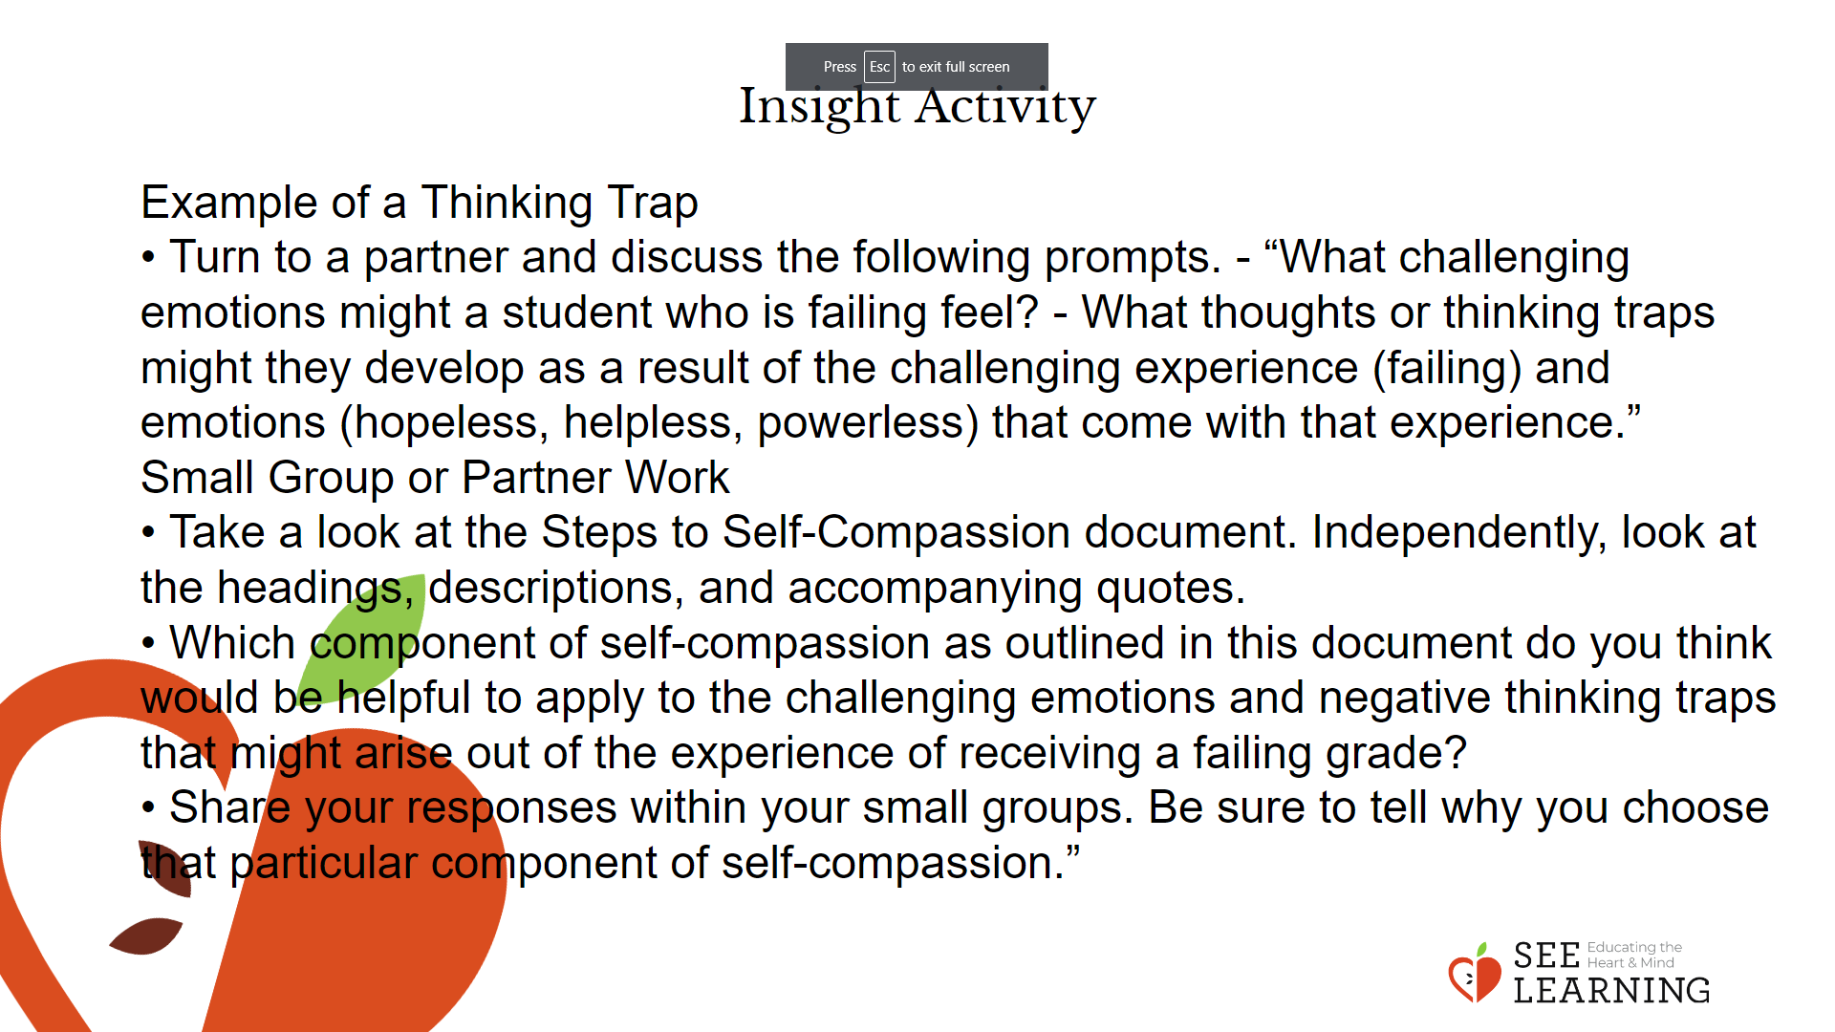 | Instructions and Guided Language  Example of a Thinking Trap  • “Think about and relate to a student who is not getting good grades in school. What might they think about and how they might get caught in negative thinking traps?”  • Turn to a partner and discuss the following prompts. - “What challenging emotions might a student who is failing feel? - What thoughts or thinking traps might they develop as a result of the challenging experience (failing) and emotions (hopeless, helpless, powerless) that come with that experience.”  Small Group or Partner Work  • “Today we will practice approaching and reframing negative thinking traps by using a lens of compassion and self-compassion.  • Take a look at the Steps to Self-Compassion document. Independently, look at the headings, descriptions, and accompanying quotes.  • Which component of self-compassion as outlined in this document do you think would be helpful to apply to the challenging emotions and negative thinking traps that might arise out of the experience of receiving a failing grade?  • Share your responses within your small groups. Be sure to tell why you choose that particular component of self-compassion.”

Reflective Practice (10 mins)
Slide 5: Reflective Practice  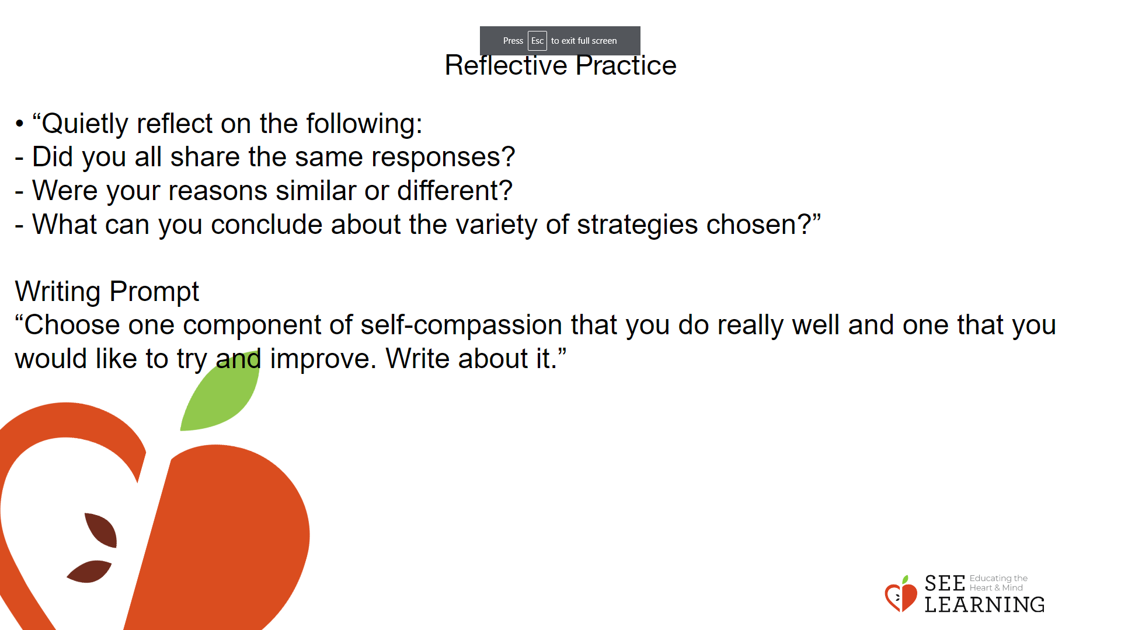 | Instructions and Guided Language  Reflection/Debrief  • Take an informal poll, asking students to raise their hand if they chose (component 1, 2, 3, 4, 5, 6, or 7 of self-compassion)  • “Quietly reflect on the following: - Did you all share the same responses? - Were your reasons similar or different? - What can you conclude about the variety of strategies chosen?”  Writing Prompt  “Choose one component of self-compassion that you do really well and one that you would like to try and improve. Write about it.”

