Mapping Emotions and Core Affect

Purpose:
In this learning experience, students continue working on developing emotional awareness through a mapping activity. Graphing emotions and experiences along these two axes provides a clear visual model for mapping what is happening in our body and mind. This in turn helps us cultivate meta-awareness and interoception, two terms for our ability to notice what is happening in our body and mind.
Learning Objectives:  Students will be able to:  - Label where experienced emotions can be placed on the “activation/feeling tone” core affect chart  - Explore which emotional states may be more or less compatible with others and why that matters for interacting with others and shaping their communities | Primary Core Component  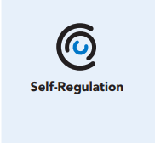
Length  45 Minutes | Materials Required  - Activation and Feeling Tone Chart handout  - Emotion Families in Chapter 4, Learning Experience 2  - Writing utensils and paper

Check-In (10 min)
Slide 2: Check-In  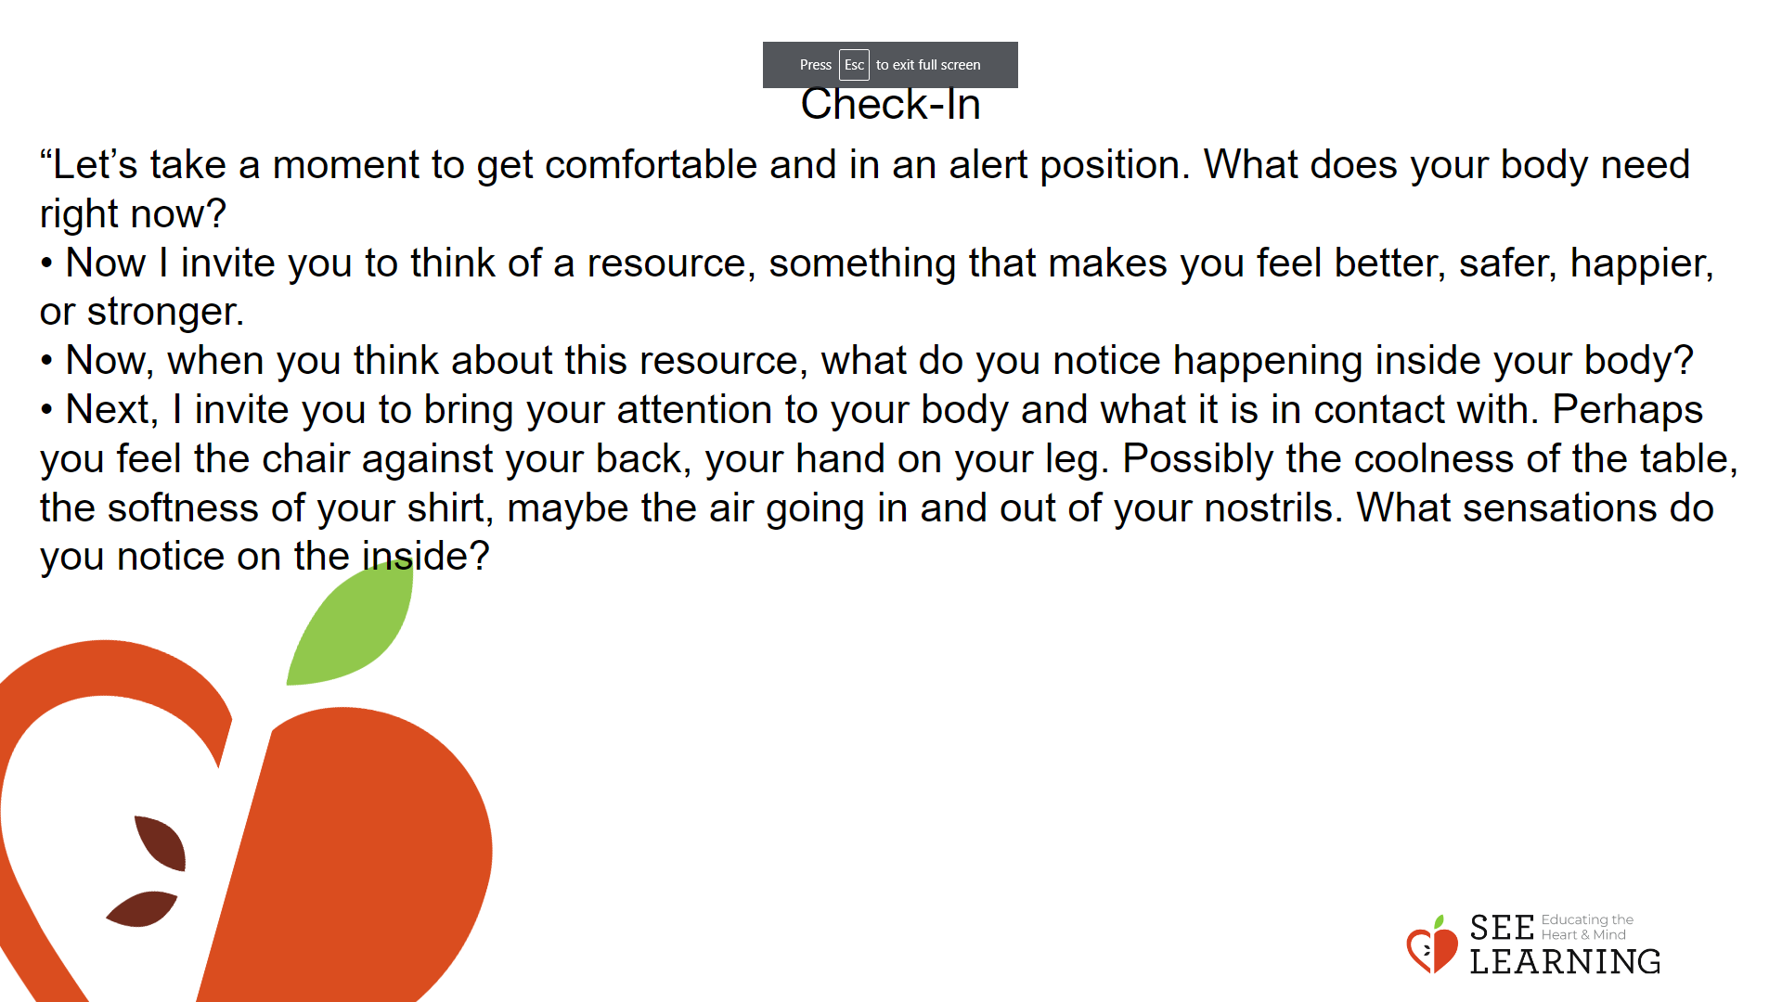 | Instructions and Guided Language  [PAUSE]s can be up to 10 seconds each  • “Let’s take a moment to get comfortable and in an alert position. What does your body need right now? [PAUSE]  • For you it may be settling into your chair, or if you feel like it, leaning against a wall, sitting or lying on the floor. Please take a moment to make yourself comfortable in an alert position. Feel free to move if you need to. [PAUSE]  • Now I invite you to think of a resource, something that makes you feel better, safer, happier, or stronger.  • It could be a person, place, thing, something about yourself, or a memory of a kindness you experienced. It can be real or imaginary. Notice the details of this resource and any sensations associated with it. [PAUSE]  • Now, when you think about this resource, what do you notice happening inside your body? Notice the sensations. [PAUSE]  • Next, I invite you to bring your attention to your body and what it is in contact with. Perhaps you feel the chair against your back, your hand on your leg. Possibly the coolness of the table, the softness of your shirt, maybe the air going in and out of your nostrils. What sensations do you notice on the inside? [PAUSE]  • Scan your body for a pleasant or neutral sensation and just pay attention to that and observe it. See if it changes or stays the same. [PAUSE]  • You can always shift your body and your focus to another place that feels better. You can always focus on your resource. [PAUSE]  • If you get distracted, remember that you are human and it’s okay to get distracted. Just acknowledge you’re distracted and try to bring your attention back to your resource or a pleasant or neutral sensation in your body. [LONGER PAUSE]  • As we do this, we’re learning more about our bodies and how to calm them and make them feel better.  • Now we’ll conclude the practice. If you closed your eyes, I now invite you to open them. Thank you.”

Presentation (5 min)
Slide 3: Presentation  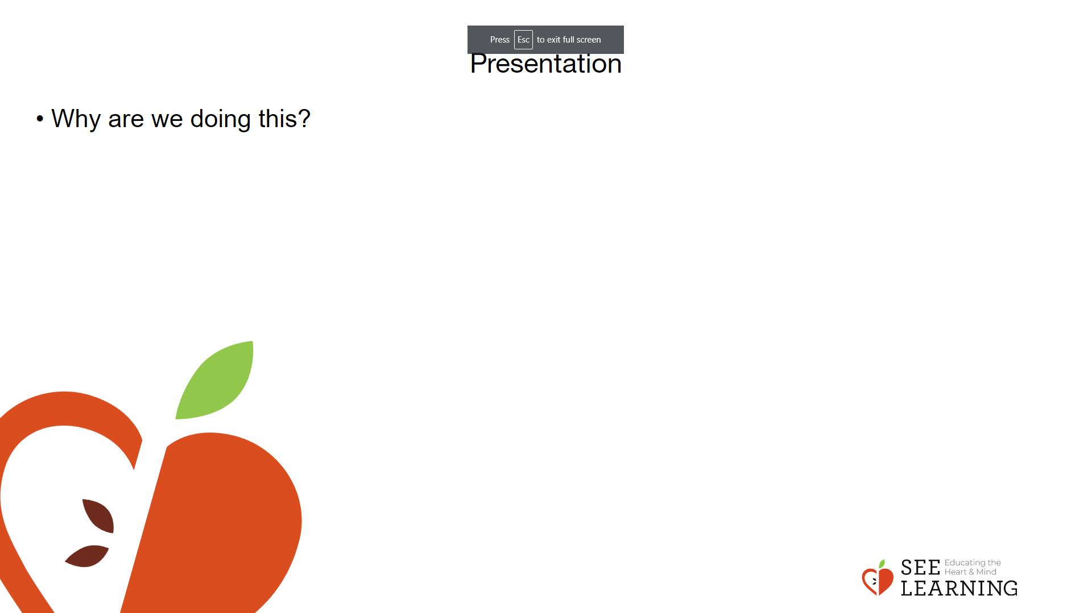 | Instructions and Guided Language  • “Today we’re going to explore a tool for mapping emotions and what they feel like in our minds and bodies. Why are we doing this? Consider the benefits of having a map when you’re traveling. You’re much more likely to reach your destination. Instead of being surprised by obstacles like rivers or lakes, you’ll know how to navigate around them. You won’t run into dead ends. You’ll know how to prepare for your journey  • Similarly, we can develop maps of our own mind and emotions. Since each of us is different, our maps may vary. But since we’re all human beings and have bodies, brains and nervous systems, there will likely be a lot of overlap too.  • Just like a map for traveling the outside world, a map of the mind helps us identify, understand and navigate emotions, feelings and thoughts. If we take the time to create these maps, we might not be so surprised when inner emotional obstacles arise for us. Instead, we’ll be better equipped to deal with them. They can even help us understand other people’s emotions better too, thereby helping us to navigate our relationships with others.  • By better understanding emotions, we can develop greater emotional hygiene. This means we develop better awareness about our emotions, and this in turn allows us to manage them more proactively, rather than letting them control us. This allows us also to better choose our behavioral responses to situations, rather than having such behaviors be driven purely by our emotions with little discernment or deliberation from our side.”

Insight Activity - Understanding Emotions Through Mapping (20 mins)
Activity Overview
Learners will map examples of how they perceive a particular emotion falling on the graph. An important purpose is to listen to one another and gain insights on how the same emotion words bring up different feelings and thoughts, depending on people’s backgrounds and current inner states. This helps build the skills of self-awareness, of not making assumptions, and of seeing a variety of perspectives that are all valid although they differ.

Slide 4 and 5: Insight Activity  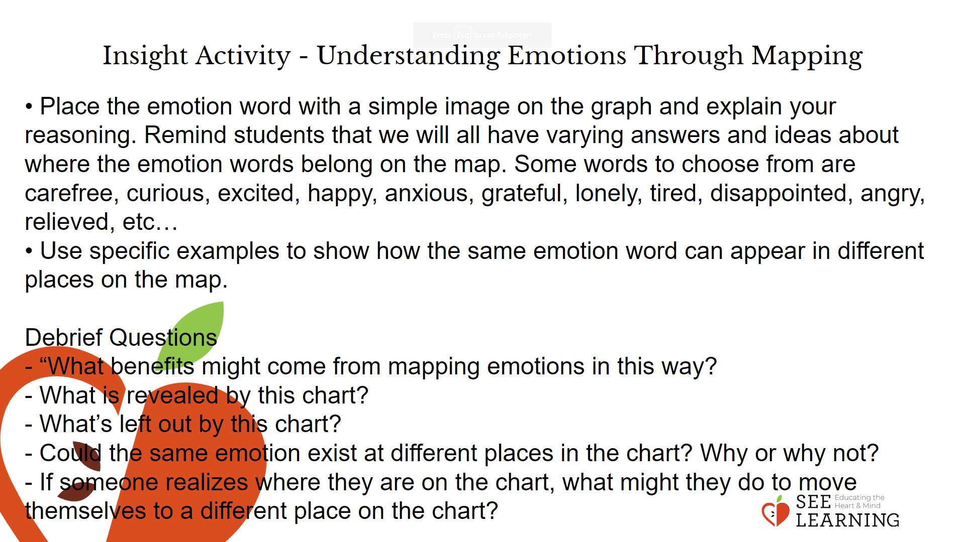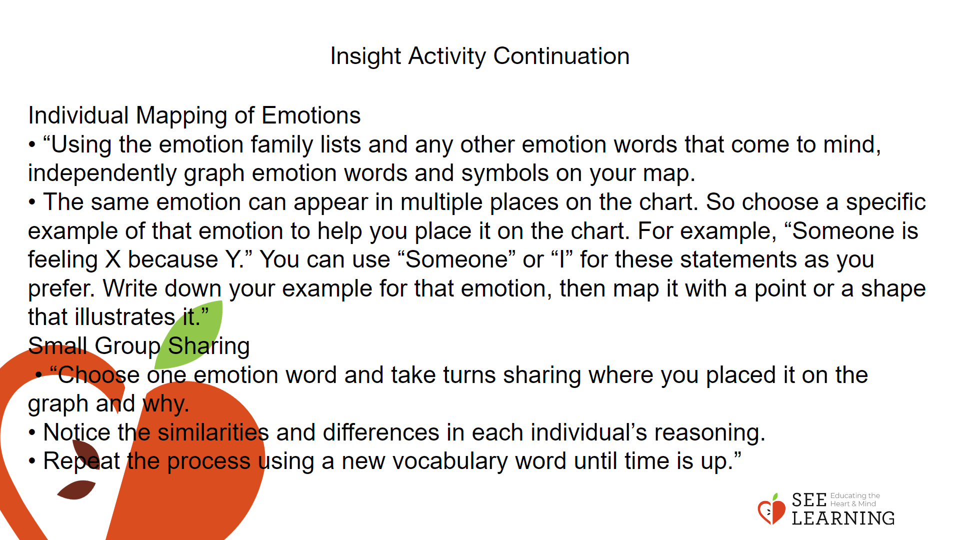 | Instructions and Guided Language  “Graphing emotions and experiences along an axis of low to high energy and along a continuum of strongly unpleasant to very pleasant, can provide a clear visual image that reinforces our opportunity to examine emotions and body states through metaawareness (the state of deliberate attention towards what you are experiencing) and interoception (the ability to perceive what’s going on inside your body).  A single emotion can exist across different levels of activation and feeling tone. Emotions vary in levels of activation in the body (high to low energy, or neutral) and in feeling tone (pleasant, neutral, unpleasant). We can learn about our emotional state by tracking our level of activation and sensations.”  • Distribute the Activation Feeling and Tone Chart handout (1 for each student).  • Give students time to look over the map and familiarize themselves with the visual and corresponding vocabulary.  • Map a few emotion words on the Feeling and Tone Chart. • Place the emotion word with a simple image on the graph and explain your reasoning. Remind students that we will all have varying answers and ideas about where the emotion words belong on the map. Some words to choose from are carefree, curious, excited, happy, anxious, grateful, lonely, tired, disappointed, angry, relieved, etc…  • Use specific examples to show how the same emotion word can appear in different places on the map. For example: I am feeling tired because I just played two games of soccer or I am feeling tired because I haven’t had a chance to eat yet today. - I’m feeling carefree because the sun is shining and I’m out for a walk. - I’m feeling a little curious because I’m hearing a sound and I don’t recognize it. - I’m feeling very excited and happy because I just found out that someone I care deeply about is coming for a visit. - I’m feeling anxious because there is an important test I’m supposed to take in a few hours. - I’m feeling grateful because someone just helped me with a problem that I was really worried about. - I feel lonely and I want to be with people. - I’m having unpleasant feelings but not overwhelmed. I feel just a little tired because something that’s been bothering me for a while. - I’m feeling slightly disappointed because I couldn’t get something I wanted. - I’m feeling angry because someone was slightly rude to me. - I’m feeling very relieved because something I was really worried about turned out to be no problem at all. - I feel a lot of fear of rejection because I want to join a particular group but I don’t know if they’ll accept me.”  • Ask the following debrief questions: - “What benefits might come from mapping emotions in this way? - What is revealed by this chart?  - What’s left out by this chart? - Could the same emotion exist at different places in the chart? Why or why not? - If someone realizes where they are on the chart, what might they do to move themselves to a different place on the chart?”  Individual Mapping of Emotions  • “Using the emotion family lists and any other emotion words that come to mind, independently graph emotion words and symbols on your map.  • The same emotion can appear in multiple places on the chart. So choose a specific example of that emotion to help you place it on the chart. For example, “Someone is feeling X because Y.” You can use “Someone” or “I” for these statements as you prefer. Write down your example for that emotion, then map it with a point or a shape that illustrates it.” Next, invite students to participate in Small Group Sharing (5 minutes)  • “Choose one emotion word and take turns sharing where you placed it on the graph and why.  • Notice the similarities and differences in each individual’s reasoning.  • Repeat the process using a new vocabulary word until time is up.”

Reflective Practice (10 mins)
Slide 6: Reflective Practice  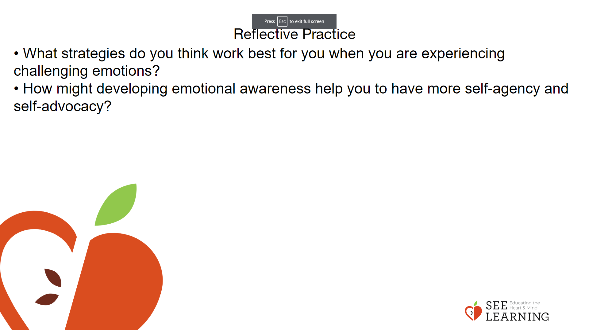 | Instructions and Guided Language  Writing Prompt  • What strategies do you think work best for you when you are experiencing challenging emotions?  • How might developing emotional awareness help you to have more self-agency and self-advocacy?

