Emotion TImeline in Action

Purpose:
In this learning experience, students will learn how to recognize and intervene in the timeline using heedfulness, mindfulness, and monitoring awareness, thereby turning potentially problematic outcomes into less harmful and even beneficial ones. Students will examine emotion timelines by applying the process to fictional characters and to their own personal experiences
Learning Objectives:  Students will be able to:  - Construct an emotion timeline to identify ways that emotions are generated and unfold  - Describe the ways emotions exist within a complex context of causes and conditions.  - Identify ways in which they can manage emotions and behaviors | Primary Core Component  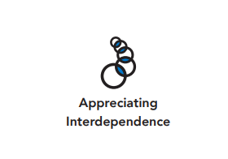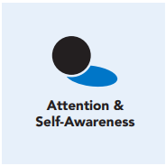
Length  45 Minutes | Materials Required  - Emotion Timeline handout from Chapter 4, Learning Experience 5  - Emotion Family posters previously created in Chapter 4, Learning Experience 2  - Print-outs of example scenarios  - Writing utensils and paper

Check-In (10 min)
Slide 2: Check-In  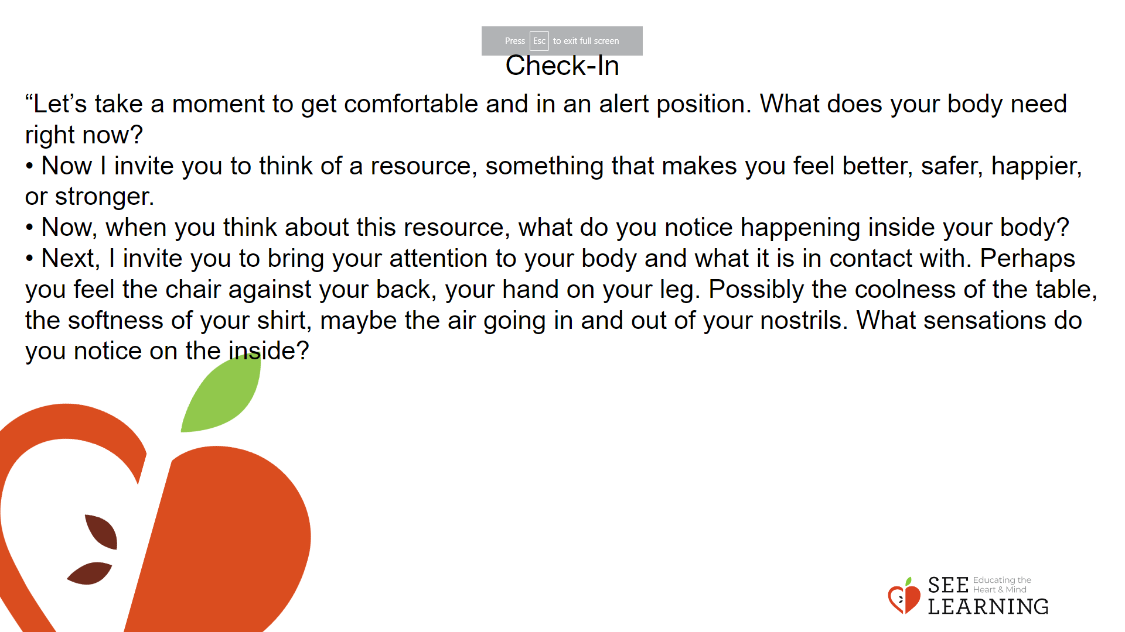 | Instructions and Guided Language  [PAUSE]s can be up to 10 seconds each  Settling Activity  • “Let’s take a moment to get in a comfortable and alert position. What does your body need right now? [PAUSE]  • For you it may be settling into your chair, or if you feel like it, leaning against a wall, sitting or lying on the floor. Feel free to move if you need to. [PAUSE]  • Now I invite you to think of a resource, something that makes you feel better, safer, happier, or stronger.  • It could be a person, place, thing, something about yourself, or a memory of a kindness you experienced. It can be real or imaginary. Notice the details of this resource and any sensations associated with it. [PAUSE]  • Now, when you think about this resource, what do you notice happening inside your body? Notice the sensations. [PAUSE]  • Next, I invite you to bring your attention to your body and what it is in contact with. Perhaps you feel the chair against your back, your hand on your leg. Possibly the coolness of the table, the softness of your shirt, maybe the air going in and out of your nostrils. What sensations do you notice on the inside? [PAUSE]  • Scan your body for a pleasant or neutral sensation and just pay attention to that and observe it. See if it changes or stays the same. [PAUSE]  • You can always shift your body and your focus to another place that feels better. You can always focus on your resource. [PAUSE]  • If you get distracted, remember that you are human and it’s okay to get distracted. Just acknowledge you’re distracted and try to bring your attention back to your resource or a pleasant or neutral sensation in your body. [LONGER PAUSE]  • As we do this, we’re learning more about our bodies and how to calm them and make them feel better.  • Now we’ll conclude the practice. If you closed your eyes, I now invite you to open them. Thank you.”

Insight Activity (20 mins)

Activity Overview
Thoughtful discussion can be an effective way of making sense of the world around us. Creating scenarios and imagining what those experiences might be like can help to increase empathy and deepen understanding of different perspectives

Teaching Tip
As an alternative activity, students can role play the scenarios they created. The audience will identify what skill (awareness, mindfulness, heedfulness) if any, the character applied.

Slide 4: Insight Activity  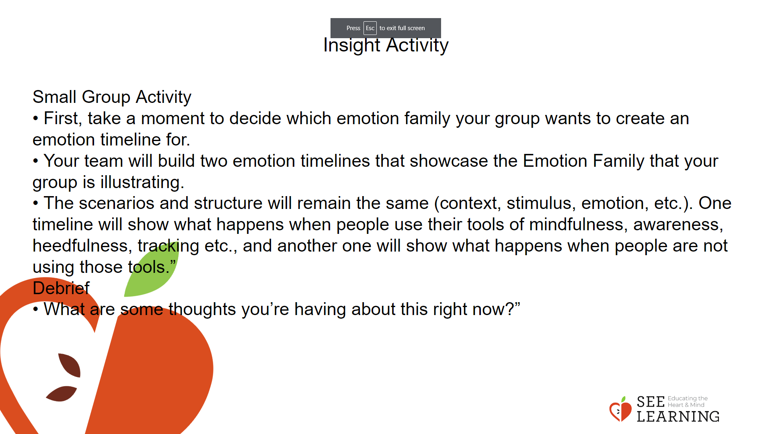 | Instructions and Guided Language  Instructions and Guiding Language  • “We’re going to work in teams to create emotion timelines based on the different emotion families we generated together last time we met. Please quickly get settled into your small group, with one person picking up your group’s poster paper and markers.  • First, take a moment to decide which emotion family your group wants to create an emotion timeline for. When your group has decided, raise your hand please and keep it up until I catch your eye to show I know you’re ready.  • Your team will build two emotion timelines that showcase the Emotion Family that your group is illustrating. • The scenarios and structure will remain the same (context, stimulus, emotion, etc.). One timeline will show what happens when people use their tools of mindfulness, awareness, heedfulness, tracking etc., and another one will show what happens when people are not using those tools.”  • If your students are having trouble creating a story or scenario, you can use the Example Scenarios to help them generate ideas.  • When each group has finished creating their timeline, have them take turns presenting their timeline to the rest of the class. Then you can hang the timelines up in the classroom or elsewhere in the school. Debrief With students  • Begin with a partner share so that all voices are heard and then invite volunteers to share their own thinking with the whole group.  • “There are predictable paths to the ways emotions can build and be responded to. What are some thoughts you’re having about this right now?”

Reflective Practice - Personal Emotional TImeline (10 mins)
Activity Overview
Using a blank emotion timeline, students will record a moment when they experienced happiness, kindness, or compassion. They will then engage in a resourcing or grounding practice.

Slide 5: Reflective Practice  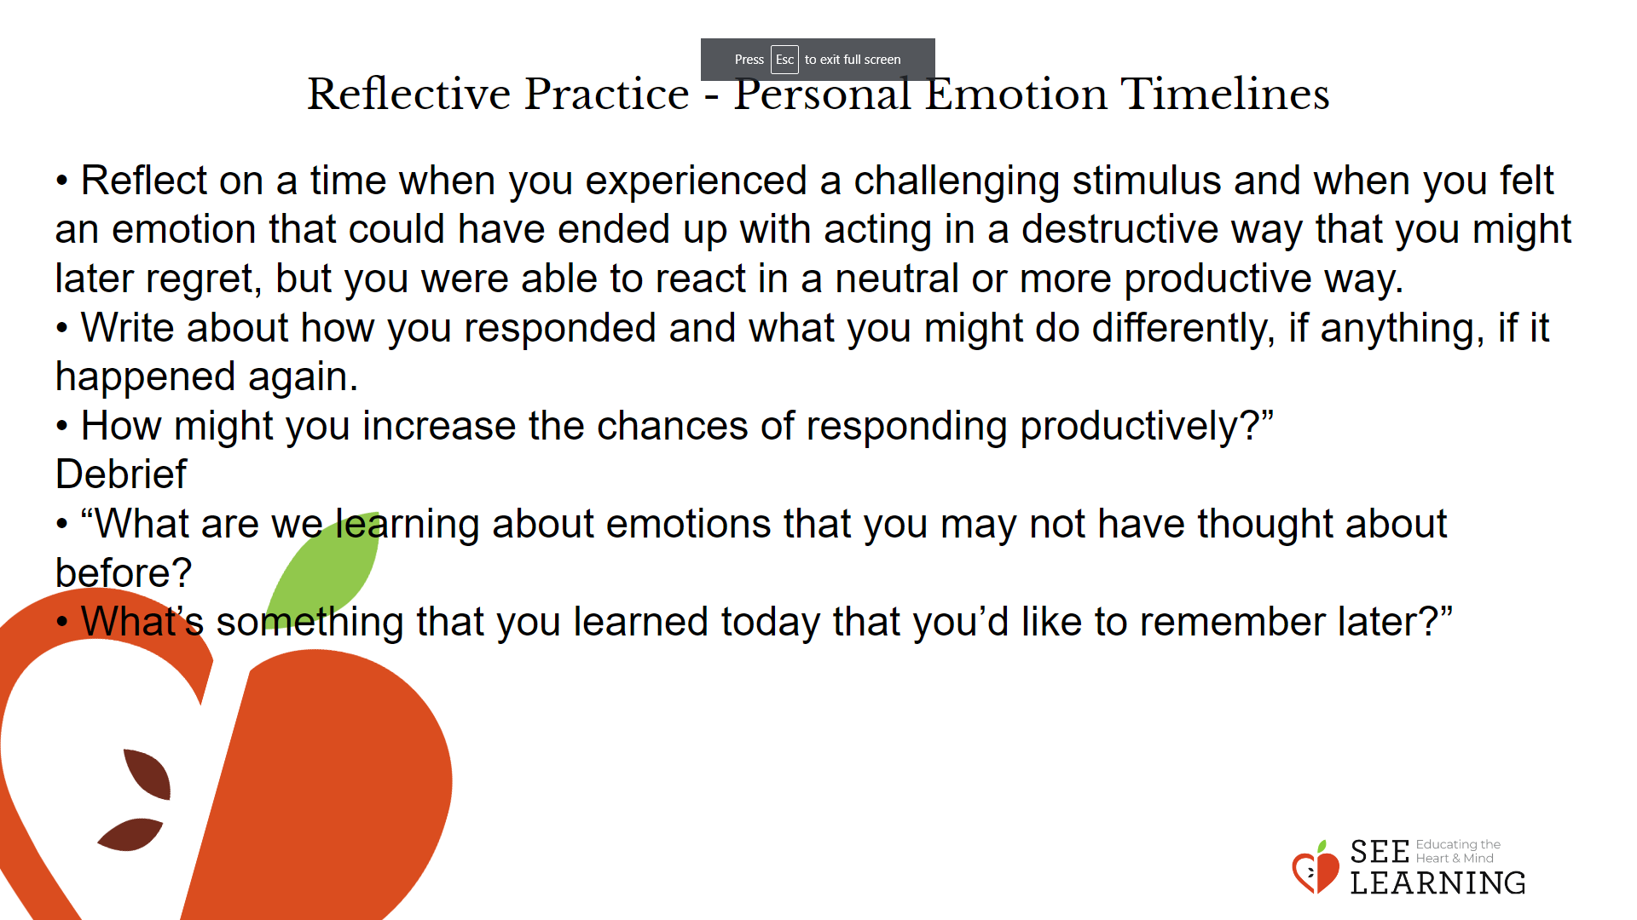 | Instructions and Guided Language  “Developing awareness skills — like mindfulness and heedfulness — allows us to prevent responding immediately to a stimuli. People can always develop deeper levels of awareness through intentional practice.  • Reflect on a time when you experienced a challenging stimulus and when you felt an emotion that could have ended up with acting in a destructive way that you might later regret, but you were able to react in a neutral or more productive way.  • Write about how you responded and what you might do differently, if anything, if it happened again.  • If you prefer, think of a challenging situation that could happen in the future to which you might be able to respond productively and with awareness. How might you increase the chances of responding productively?” [PAUSE] Debrief  • “What are we learning about emotions that you may not have thought about before?  • What’s something that you learned today that you’d like to remember later?”

