Emotion Timeline

Purpose:
In this learning experience, students will examine how emotions may seem to ‘come out of the blue,’ arising in the moment and happening automatically. Students will examine the scientific basis for emotions arising from a process that occurs along a timeline. Learning the stages of this emotion timeline can help students to map the stages of emotions and recognize where they can build greater awareness that can allow them to intervene in the emotion timeline should they wish to do so.
Learning Objectives:  Students will be able to:  - Recognize that emotions occur as part of a process  - Describe the stages of emotion processes  - Engage in practices that can create a beneficial ‘gap’ or ‘pause’ between stimulus and response | Primary Core Component  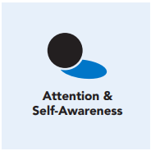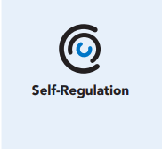
Length  45 Minutes | Materials Required  - Emotion Timeline (2 copies) (one for the Rafi and Ronan story and one for personal reflection)  - Rafi and Ronan story handout in from Chapter 4, Learning Experience 3 (one handout per pair)  - Writing utensils and paper

Check-In (10 min)
Slide 2: Check-In  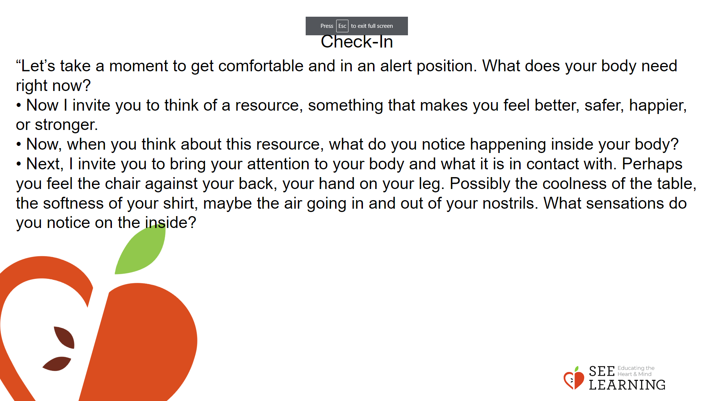 | Instructions and Guided Language  [PAUSE]s can be up to 10 seconds each  Settling Activity  • “Let’s take a moment to get in a comfortable and alert position. What does your body need right now? [PAUSE]  • For you it may be settling into your chair, or if you feel like it, leaning against a wall, sitting or lying on the floor. Feel free to move if you need to. [PAUSE]  • Now I invite you to think of a resource, something that makes you feel better, safer, happier, or stronger.  • It could be a person, place, thing, something about yourself, or a memory of a kindness you experienced. It can be real or imaginary. Notice the details of this resource and any sensations associated with it. [PAUSE]  • Now, when you think about this resource, what do you notice happening inside your body? Notice the sensations. [PAUSE]  • Next, I invite you to bring your attention to your body and what it is in contact with. Perhaps you feel the chair against your back, your hand on your leg. Possibly the coolness of the table, the softness of your shirt, maybe the air going in and out of your nostrils. What sensations do you notice on the inside? [PAUSE]  • Scan your body for a pleasant or neutral sensation and just pay attention to that and observe it. See if it changes or stays the same. [PAUSE]  • You can always shift your body and your focus to another place that feels better. You can always focus on your resource. [PAUSE]  • If you get distracted, remember that you are human and it’s okay to get distracted. Just acknowledge you’re distracted and try to bring your attention back to your resource or a pleasant or neutral sensation in your body. [LONGER PAUSE]  • As we do this, we’re learning more about our bodies and how to calm them and make them feel better.  • Now we’ll conclude the practice. If you closed your eyes, I now invite you to open them. Thank you.”

Presentation - Emotional Timeline Description and Vocabulary development (10 min)
Slide 3: Presentation  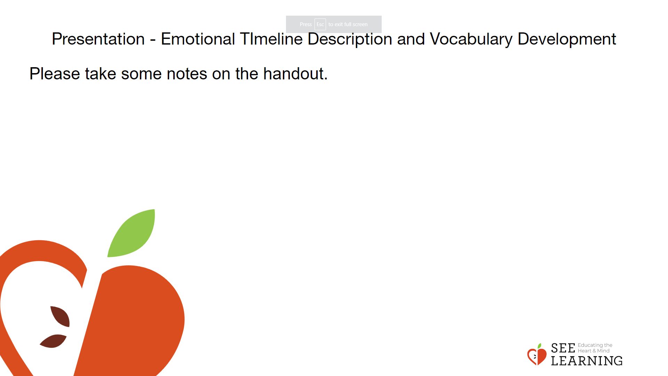 | Instructions and Guided Language  When initially picturing an emotional timeline, it can be helpful to use the terms “beginning,” “middle” and “end.” An initial stimulus and appraisal is the “beginning”; the emotion and impulse is the “middle”; and the response/ behavior and result is the “end.”  • Pass out a copy of the emotion timeline to each student and ask them to make notes on the handout as you describe its components.  • “You’ve seen timelines before, used as a tool to help understand the stages of a process. A process is something that has stages and that takes place over time.  • Where have you used or seen timelines already? [PAUSE for input.] Like most timelines, you’ll notice that this one has a beginning, middle and end. [Show sample timeline.] What else do you notice about the timeline? What do you notice, wonder, or want to clarify? [PAUSE for input.]  • Today we’ll be looking at timelines as a way of understanding the stages of a particular process — the process of how an emotion arises and influences behavior. We’re going to examine emotions and slow that process down a lot so that we can look at each stage. It’s as if we were placing an emotion under a microscope to investigate it.  • Please join your work partner for today. [PAUSE for students to be settled into pairs.] First, let’s review a few vocabulary terms together. Talk with your partner about what you think the definition of these terms are: stimulus, response, context. [PAUSE for paired discussion.]  • Thumbs up if you have heard of the word “stimulus”? What is a stimulus? [PAUSE for input.]  • Emotions begin with stimulus. Stimulus means something that causes a response. Usually this is something novel (new, different, unusual) in the environment (like seeing something, or hearing someone saying something), but stimuli can also be internal (thinking about something or remembering something).  • For Example: One day, I heard a loud sound, and I jumped up in fright and surprise. What was the stimulus? What was my response? [PAUSE for input.]  • The stimulus can also be called a trigger but this word is more specific and is generally only used for negative stimuli.  • Who has heard the word “context” before? What are some ideas of what “context” might mean in terms of the emotion timeline? [Allow time for sharing.]  • Context here means “the current state of things based on what’s come before.” We have an inner context and an outer context. The outer context is what is going on around us at that moment.  • Our inner context might include how we’re feeling that day or thoughts and feelings about what just happened or connections we are making, intentionally or ‘automatically’ to something that happened a long time ago.  • Let’s think about my example. The loud sound was the stimulus and my response was jumping in surprise or fright. After I looked around, I saw that the loud sound came from some nearby construction work. When I heard the loud sound again, I didn’t jump and I wasn’t afraid. Why? That’s because of context. Now I already knew what the sound was and that it was nothing to be afraid of. The stimulus was the same, but the context was different, my knowledge and understanding about what was currently going on was different — so my response was different  • Who found the word “appraisal” new to them? You may not have heard of it before, or may have heard it in another context, like getting an appraisal on a car or house. This definition of appraisal is a very important concept for understanding emotions. Based on where it is in the timeline, what do you think it means? It comes between “stimulus” and “emotion.” [Allow time for sharing.]  • Appraisal means to assess, judge, or evaluate a situation. In the context of emotions, appraisals often happen really fast, so we’re going to slow the process down and really think about that as we look at the Rafi and Ronan story.  • So the first time when I heard the loud sound, my appraisal was that it could be dangerous and I felt scared. But the second time I heard the sound, I was aware that it was from the construction work. So my appraisal the second time was that the sound was not dangerous to me. And I didn’t feel scared. Since I didn’t get scared, I didn’t jump. I had a different response.”

Insight Activity - Creating Emotion Timelines (15 mins)
Slide 4: Insight Activity  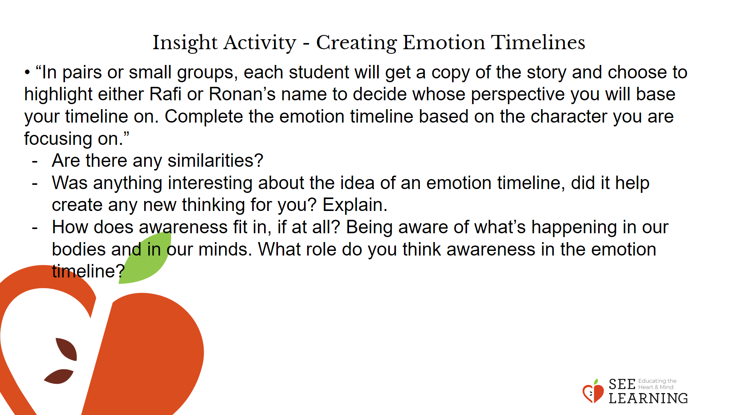 | Instructions and Guided Language  Use the Rafi and Ronan Story to map out an emotion timeline.  • “In pairs or small groups, each student will get a copy of the story and choose to highlight either Rafi or Ronan’s name to decide whose perspective you will base your timeline on. Complete the emotion timeline based on the character you are focusing on.”  • When partners have grappled with the ideas and made notes on their paper timelines, match pairs who developed Rafi’s timeline with a pair who developed Ronan’s timeline. Invite them to share their insights and then discuss the similarities and differences they notice and why they think those exist. Take time to Debrief with students:  • “What were some of the reasons you decided the differences existed between the two emotion timelines?” [Allow time for sharing. There are differences because they have different contexts; because they have different prior experiences; because they have different personalities; etc.]  • And the similarities? [Allow time for sharing. There are similarities because they are both human beings; they both have bodies and nervous systems; they are both children; etc.]  • Was anything interesting about the idea of an emotion timeline, did it help create any new thinking for you? Explain.  • How does awareness fit in, if at all? Being aware of what’s happening in our bodies and in our minds. What role do you think awareness plays in the emotion timeline?”

Reflective Practice - Personal Emotional Timeline (10 mins)
Activity Overview
Using a blank emotion timeline, students will record a moment when they experienced happiness, kindness, or compassion. They will then engage in a resourcing or grounding practice

Slide 5: Reflective Practice  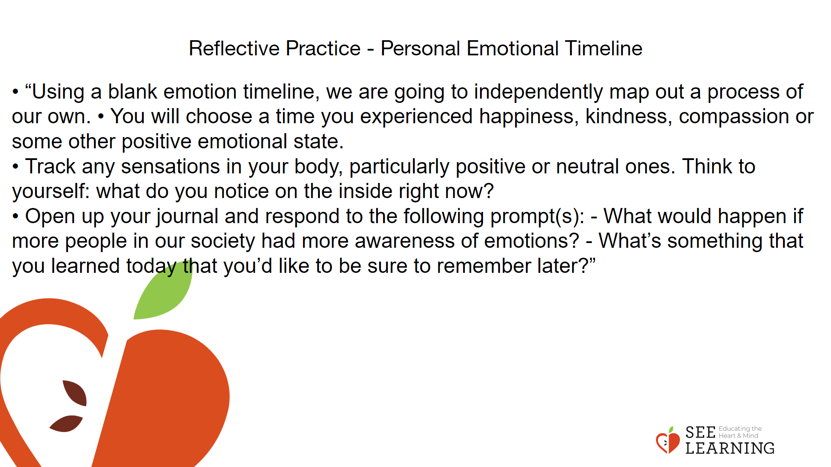 | Instructions and Guided Language  • “Using a blank emotion timeline, we are going to independently map out a process of our own.  • You will choose a time you experienced happiness, kindness, compassion or some other positive emotional state.  • Complete the timeline adding as much detail as you can. (7 minutes)  • Now let’s sit for a moment and be intentional about using this memory as a resource.  • Pay attention to how your body feels in space right now, moving to find a position that is comfortable.  • Track any sensations in your body, particularly positive or neutral ones. [Pause 30-60 seconds.] Think to yourself: what do you notice on the inside right now?  • Open up your journal and respond to the following prompt(s): - What would happen if more people in our society had more awareness of emotions? - What’s something that you learned today that you’d like to be sure to remember later?

Debrief ( mins)
Slide #: Debrief  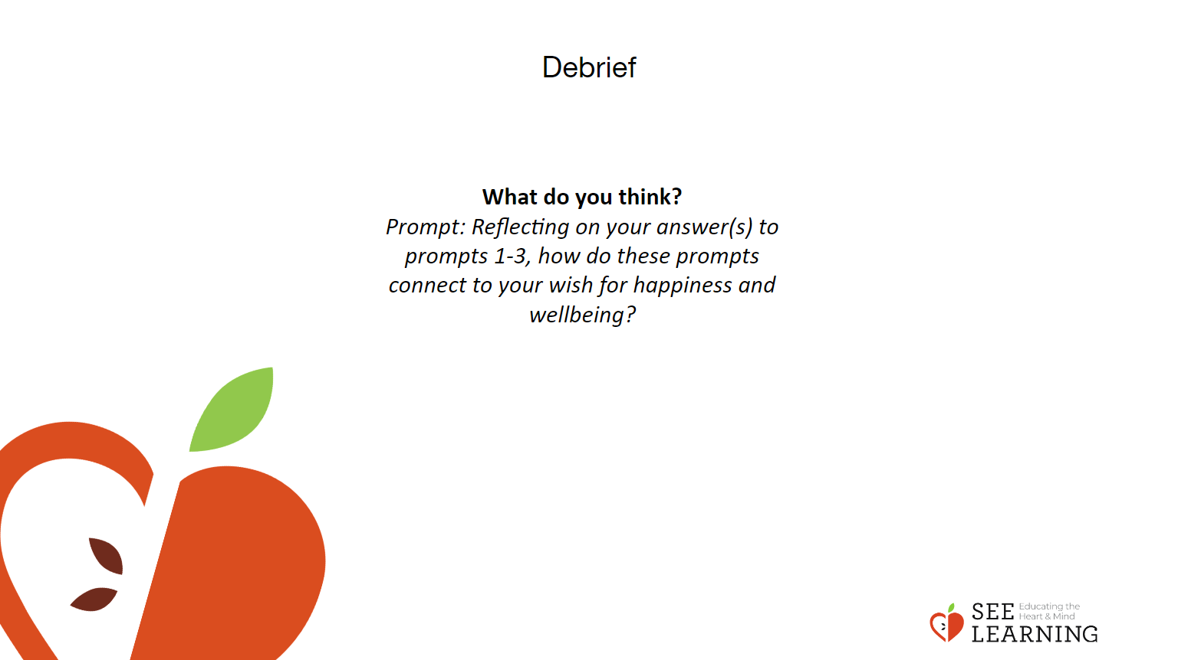 | Instructions and Guided Language

