Emotions and Needs

Purpose:
In this learning experience, students will examine the relationship between needs and emotions. This helps students to build understanding about how emotions often arise as a result of personal needs being met or going unmet. Students will engage in activities that allow them to identify needs, reflect on how met and unmet needs affect feeling states.
Learning Objectives:  Students will be able to:  - Describe their emotions and explore their underlying needs.  - Explore how difficult feelings, setbacks, and limitations are common features of everyone’s life | Primary Core Component  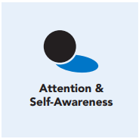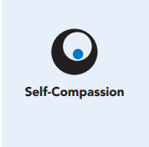
Length  45 Minutes | Materials Required  - “Shared Human Needs” handout (2 copies: one copy per student and one per small group)  - Whiteboard or chart paper and markers  - “Robin’s Difficult Day” handout (one per small group)  - An index card or small piece of paper and writing tools for each student

Check-In (10 min)
Slide 2: Check-In  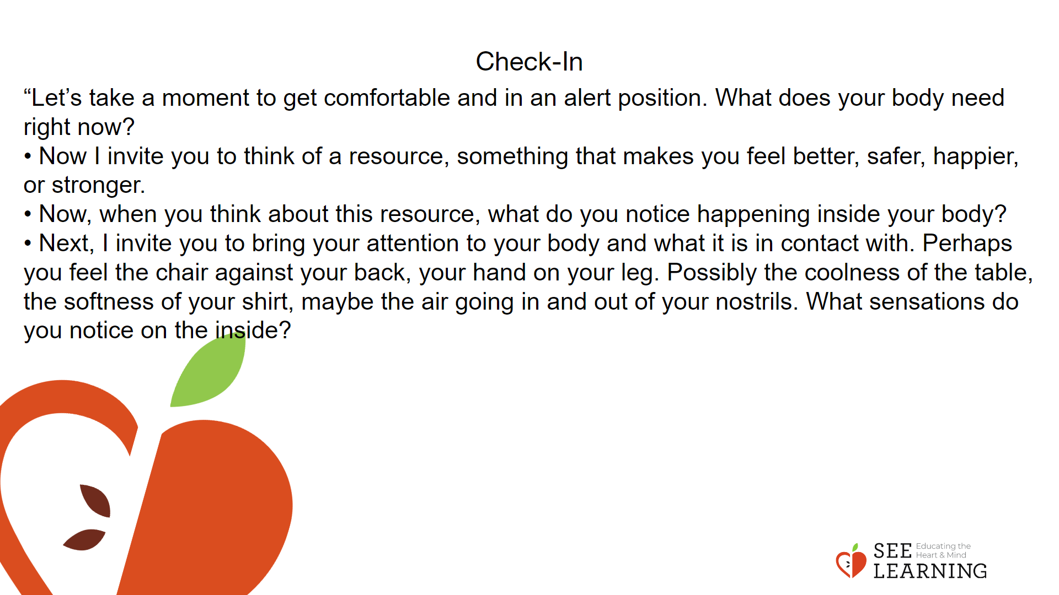 | Instructions and Guided Language  [PAUSE]s can be up to 10 seconds each  Settling Activity (3 minutes)  • “Let’s take a moment to get comfortable and in an alert position. What does your body need right now? [PAUSE]  • For you it may be settling into your chair, or if you feel like it, leaning against a wall, sitting or lying on the floor. Please take a moment to make yourself comfortable in an alert position. Feel free to move if you need to. [PAUSE]  • Now I invite you to think of a resource, something that makes you feel better, safer, happier, or stronger.  • It could be a person, place, thing, something about yourself, or a memory of a kindness you experienced. It can be real or imaginary. Notice the details of this resource and any sensations associated with it. [PAUSE]  • Now, when you think about this resource, what do you notice happening inside your body? Notice the sensations. [PAUSE]  • Next, I invite you to bring your attention to your body and what it is in contact with. Perhaps you feel the chair against your back, your hand on your leg. Possibly the coolness of the table, the softness of your shirt, maybe the air going in and out of your nostrils. What sensations do you notice on the inside? [PAUSE]  • Scan your body for a pleasant or neutral sensation and just pay attention to that and observe it. See if it changes or stays the same. [PAUSE]  • You can always shift your body and your focus to another place that feels better. You can always focus on your resource. [PAUSE]  • If you get distracted, remember that you are human and it’s ok to get distracted. Just acknowledge you’re distracted and try to bring your attention back to your resource or a pleasant or neutral sensation in your body. [LONGER PAUSE]  • As we do this, we’re learning more about our bodies and how to calm them and make them feel better.  • Now we’ll conclude the practice. If you closed your eyes, I now invite you to open them. Thank you.”

Insight Activity 1 (10 min)
Activity Overview
By co-creating lists of “Shared Human Needs” students build a foundation for deeper conversation about how some emotions that may arise when needs are met and some emotions may arise when needs are not met, and how this affects daily life. All human beings have basic needs that are common for most or all people. Although some of our needs may be specific to ourselves, many are needs that others share, too. We often experience emotions when our needs are met or when our needs go unmet.

Teaching Tips
Consolidate the entries from all of the small group brainstorms onto a large chart that is publicly posted in the classroom. Use the sample list provided to round out the chart, as desired by you and your group.

Slide 3: Insight Activity  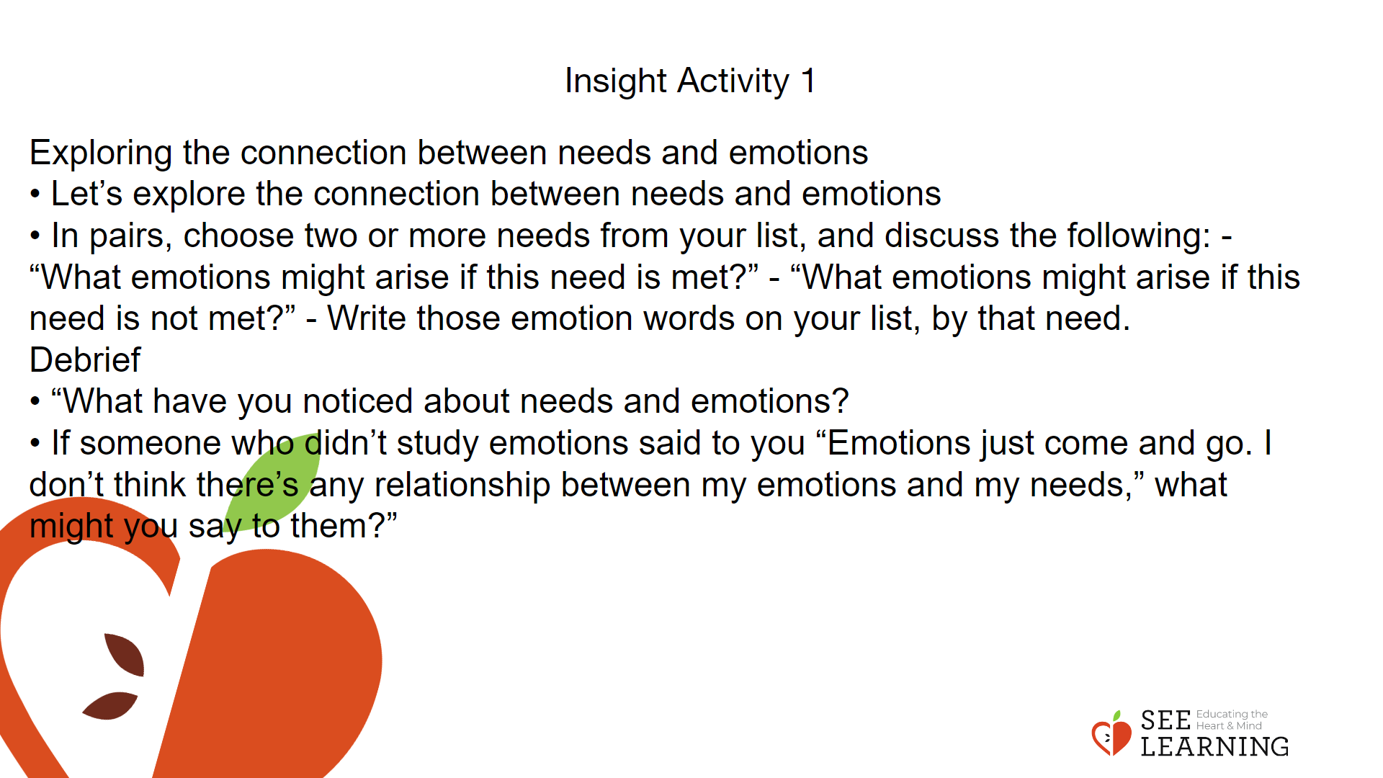 | Instructions and Guided Language  • “Today we will discuss basic human needs. These include what we need to survive, to flourish, and to be happy. Here’s a graphic organizer that you’ll use in pairs or small groups to brainstorm needs that could fall under each category. (Surviving / Flourishing / Happiness / Other). Take a look now at the starter list that you’ll be adding to. What do you notice about the headings? Can you think of an example that can go under one of the headings? Is the example a shared need or a personal need?  • In pairs or small groups, make a list of needs under each category. Put a star next to any need that your group considers to be a “shared need,” something that all people need.  Exploring the connection between needs and emotions  • Let’s explore the connection between needs and emotions  • In pairs, choose two or more needs from your list, and discuss the following: - “What emotions might arise if this need is met?” - “What emotions might arise if this need is not met?” - Write those emotion words on your list, by that need.  • Let’s do an example together first.  • Take a look at the need for “safety.” If I have a need for safety, and if my need for safety is not met and I feel unsafe, what emotions might I experience? [fear, anxiety] If my need for safety is met and I feel safe, what emotions might I experience? [contentment, happiness, joy]  • Now select the two needs you will think about and what emotions might come up if that need is met or unmet.” Debrief  Invite teams to share examples they generated of emotions that may arise from met/unmet needs.  • “What have you noticed about needs and emotions?  • If someone who didn’t study emotions said to you “Emotions just come and go. I don’t think there’s any relationship between my emotions and my needs,” what might you say to them?”

Insight Activity 2 - Exploring Needs (15 mins)
Activity Overview
Using the familiar story “Robin’s Difficult Day,” learners will examine Robin’s needs and explore how those needs are being met or unmet and what related emotions are surfacing.

Slide 4: Insight Activity 2 - Exploring Needs  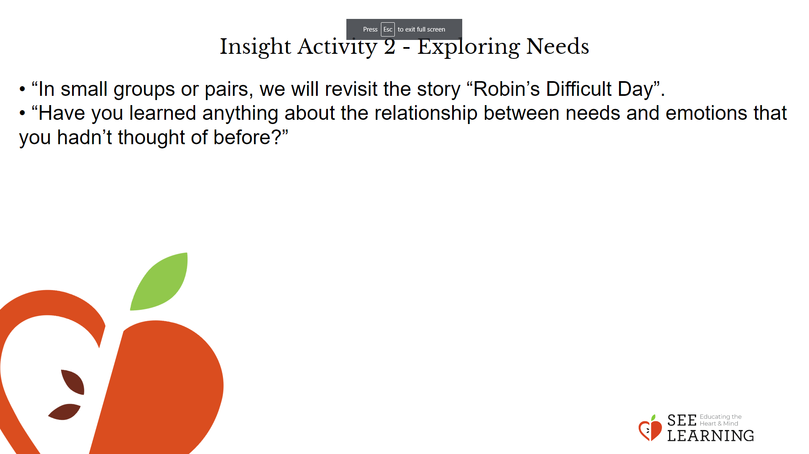 | Instructions and Guided Language  Instructions and Guiding Language  • “In small groups or pairs, we will revisit the story “Robin’s Difficult Day”.  • The last time you read the story, you noticed and discussed sparks. This time we will revisit the sparks and emotions that go with them, and also focus on looking for met and unmet needs that accompany those emotions.  • We will share one finding with the rest of the group by sharing one of Robin’s needs that you identified, the emotional response connected to it, and what (if anything) Robin did to address it.” After each group shares, ask the class to reflect and respond to the prompt below.  • “Have you learned anything about the relationship between needs and emotions that you hadn’t thought of before?”

Reflective Practice - My Needs Inventory (10 mins)
Overview
In a brief reflective practice, each person will identify a need they feel is very important to them right now, what is helping them meet it, and what it would feel like if their need was completely met. They will then combine this with tracking (noting sensations of the body). Be sure to pause between verbal directions to give students enough time to write and reflect.

Slide 5: Reflective Practice  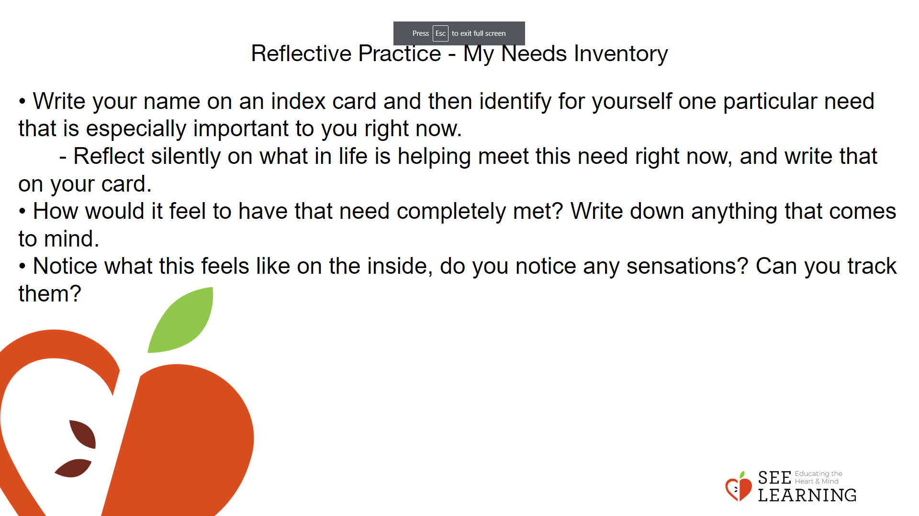 | Instructions and Guided Language  • The needs that are most important to a person can vary from time to time, and needs also vary from person to person. It is valuable to think about how our needs being met or unmet affects our emotional state and our nervous system.  • We’ve been thinking about this idea from the perspective of needs that people share. Through a private write, we will make it more personal, and apply this idea to ourselves.  • Write your name on an index card and then identify for yourself one particular need that is especially important to you right now.  - Reflect silently on what in life is helping meet this need right now, and write that on your card.  - If you can’t think of anything helping to meet that need, write what you can imagine happening that would help you meet it.  • How would it feel to have that need completely met? Write down anything that comes to mind.  • Notice what this feels like on the inside, do you notice any sensations? Can you track them? [PAUSE]

