Sparks of Emotions
Purpose:
In this learning experience, students will identify the different ways in which emotions can arise. This can be from current events or be influenced by past events. The emergence of emotions can escalate or change depending on a variety of factors. Students will see how they are similar to others through their shared experiences of changing emotions. Students will practice how to become aware of the present state of their nervous system in order to better at notice ‘triggers’ or ‘sparks’ of a particular emotion, and the level to which they’ve developed skills at containing or elevating the emotion.
Learning Objectives:  Students will be able to:  - Describe how emotions can arise from events and can escalate  - Identify how past experiences can influence current emotions  - Explain how and why emotional responses are shared human experiences and also vary from person to person | Primary Core Component  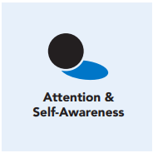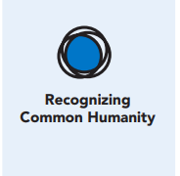
Length  45 Minutes | Materials Required  - Images previously used for the “Spark and Forest Fire” story in Chapter 3, Learning Experience 4  - Colored tape or string to map out the “Resilient Zone” on the floor.  - “Rafi and Ronan” story and questions (provided)  - “Robin’s Difficult Day” story and questions (provided)  - Copy of blank Resilient Zone

Check-In (5 min)
Slide 2: Check-In  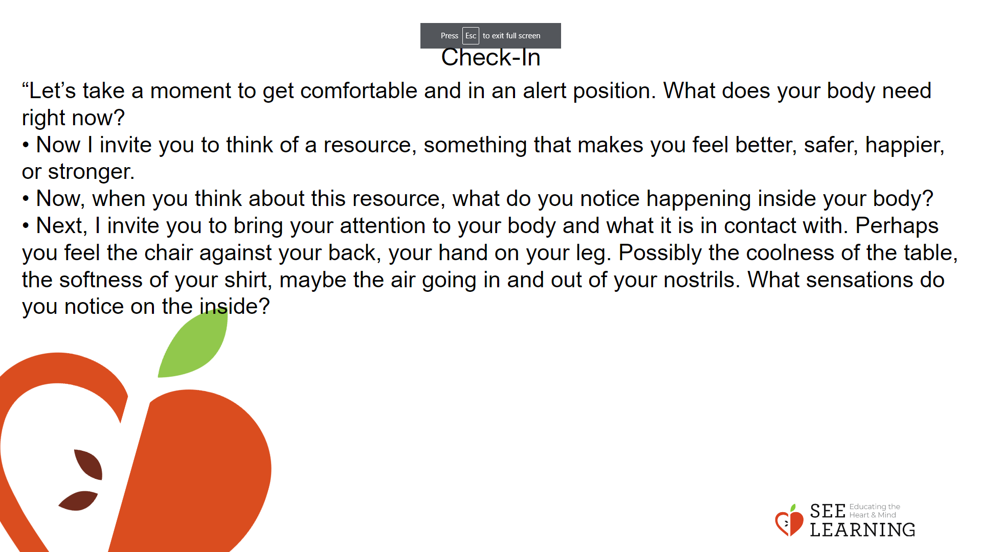 | Instructions and Guided Language  [PAUSE]s can be up to 10 seconds each  Settling Activity  • “Let’s take a moment to get comfortable and in an alert position. What does your body need right now? [PAUSE]  • For you it may be settling into your chair, or if you feel like it, leaning against a wall, sitting or lying on the floor. Please take a moment to make yourself comfortable in an alert position. Feel free to move if you need to. [PAUSE]  • Now I invite you to think of a resource, something that makes you feel better, safer, happier, or stronger.  • It could be a person, place, thing, something about yourself, or a memory of a kindness you experienced. It can be real or imaginary. Notice the details of this resource and any sensations associated with it. [PAUSE]  • Now, when you think about this resource, what do you notice happening inside your body? Notice the sensations. [PAUSE]  • Next, I invite you to bring your attention to your body and what it is in contact with. Perhaps you feel the chair against your back, your hand on your leg. Possibly the coolness of the table, the softness of your shirt, maybe the air going in and out of your nostrils. What sensations do you notice on the inside? [PAUSE]  • Scan your body for a pleasant or neutral sensation and just pay attention to that and observe it. See if it changes or stays the same. [PAUSE]  • You can always shift your body and your focus to another place that feels better. You can always focus on your resource. [PAUSE]  • If you get distracted, remember that you are human and it’s okay to get distracted. Just acknowledge you’re distracted and try to bring your attention back to your resource or a pleasant or neutral sensation in your body. [LONGER PAUSE]  • As we do this, we’re learning more about our bodies and how to calm them and make them feel better.  • Now we’ll finish the practice. If you closed your eyes, I now invite you to open them. Thank you.”

Presentation/Discussion (5 min)
Slide 3: Presentation/Discussion  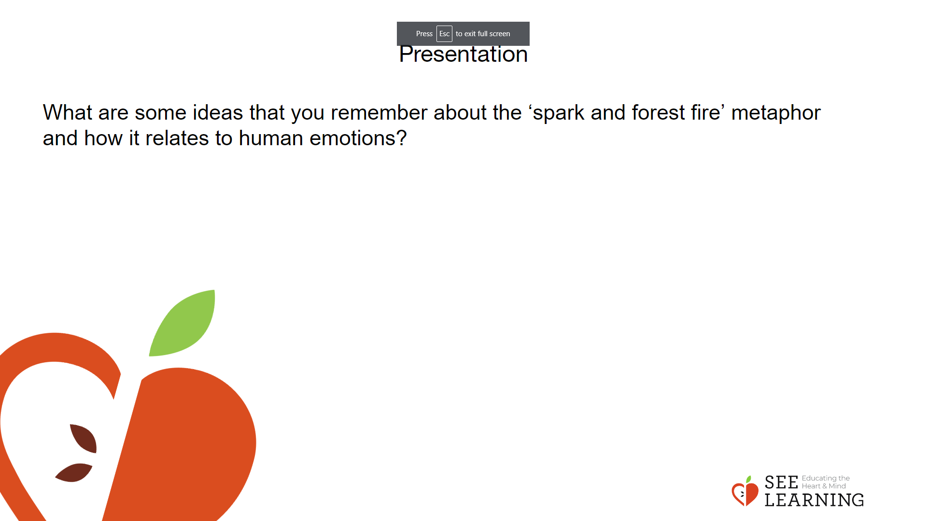 | Instructions and Guided Language  • “Today we’ll be exploring emotional reactions: what contributes to them, and what can be done to empower ourselves in response to them. We recently talked about sparks and forest fires as a metaphor for how emotions can arise. Think for a moment about what you remember from that conversation. What are some ideas that you remember about the ‘spark and forest fire’ metaphor and how it relates to human emotions?  • Something all human beings have in common is that we all experience emotions connected to the experiences we have. It’s interesting and important to understand that while we all experience emotions, we don’t all experience the SAME emotions during any given experience. People can be in the same place, sharing an external (outside) experience, yet have a very different internal (inside themselves) experience.  • Individual past history contributes to how we experience a situation. In many cases, we didn’t have control over our past experiences when they were occurring. Also, the current state of our nervous system impacts how we experience a situation, and that is something we do have some control over. And the element we may have the most control over is how we respond to the emotions we are feeling during a situation. This is a skill we can develop.”

Insight Activity 1 - Exploring Emotional Reactions (5 mins)
Activity Overview
Revisiting the spark and forest fire metaphor helps to introduce the idea that past experience can influence individual reactions to the same event. Different people can and do have very different reactions while in the same situation based on their own personal histories.
These scientific findings are useful for explaining and understanding our emotional reactions:
• Current and past experiences can trigger emotions
• People can get better at noticing and responding to emotional triggers
• All people are united in their changing experience of emotions
• What triggers emotions varies from person to person
• The state of our nervous system influences how we appraise (judge or evaluate) a situation

Slide 4: Insight Activity 1  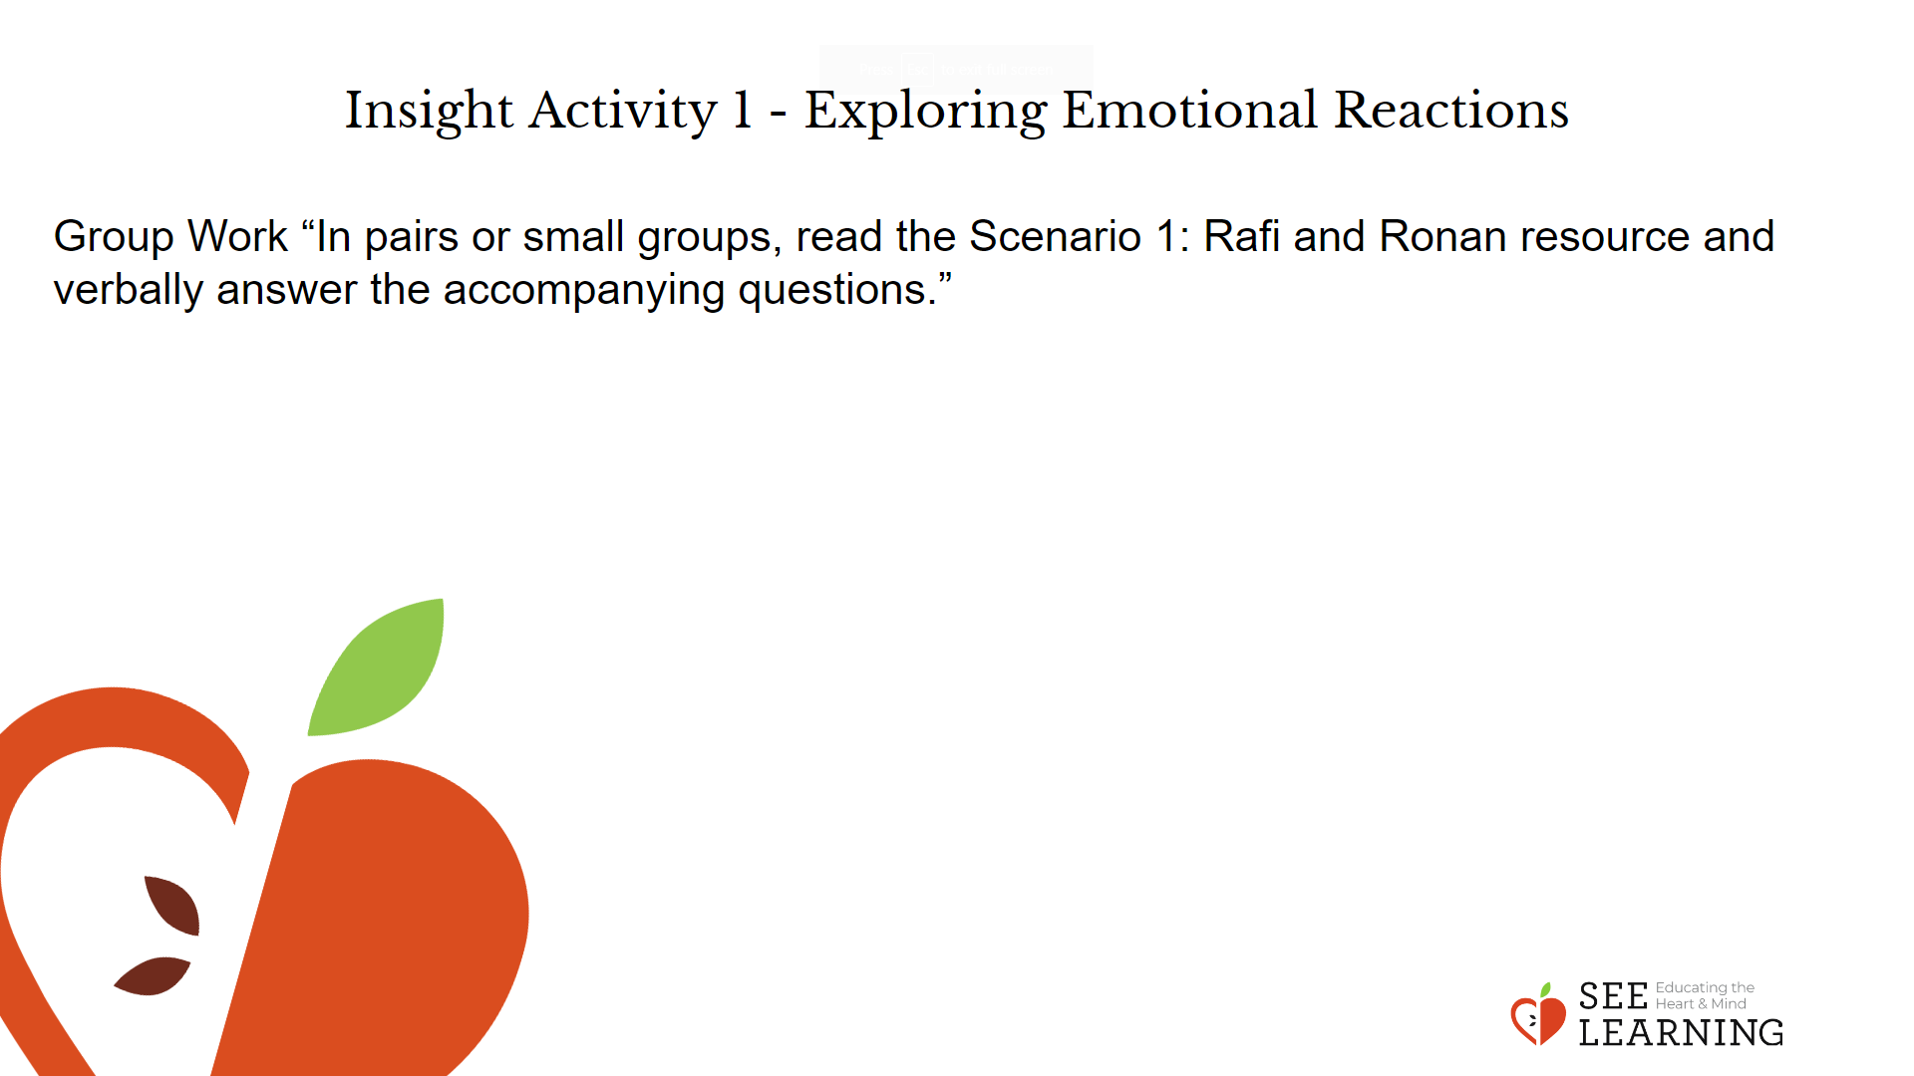 | Instructions and Guided Language  Group Work  “In pairs or small groups, read the Scenario 1: Rafi and Ronan resource and verbally answer the accompanying questions.”

Insight Activity 2 - Scenario 2: Ronin’s Difficult Day (15 mins)
Slide 5: Insight Activity 2  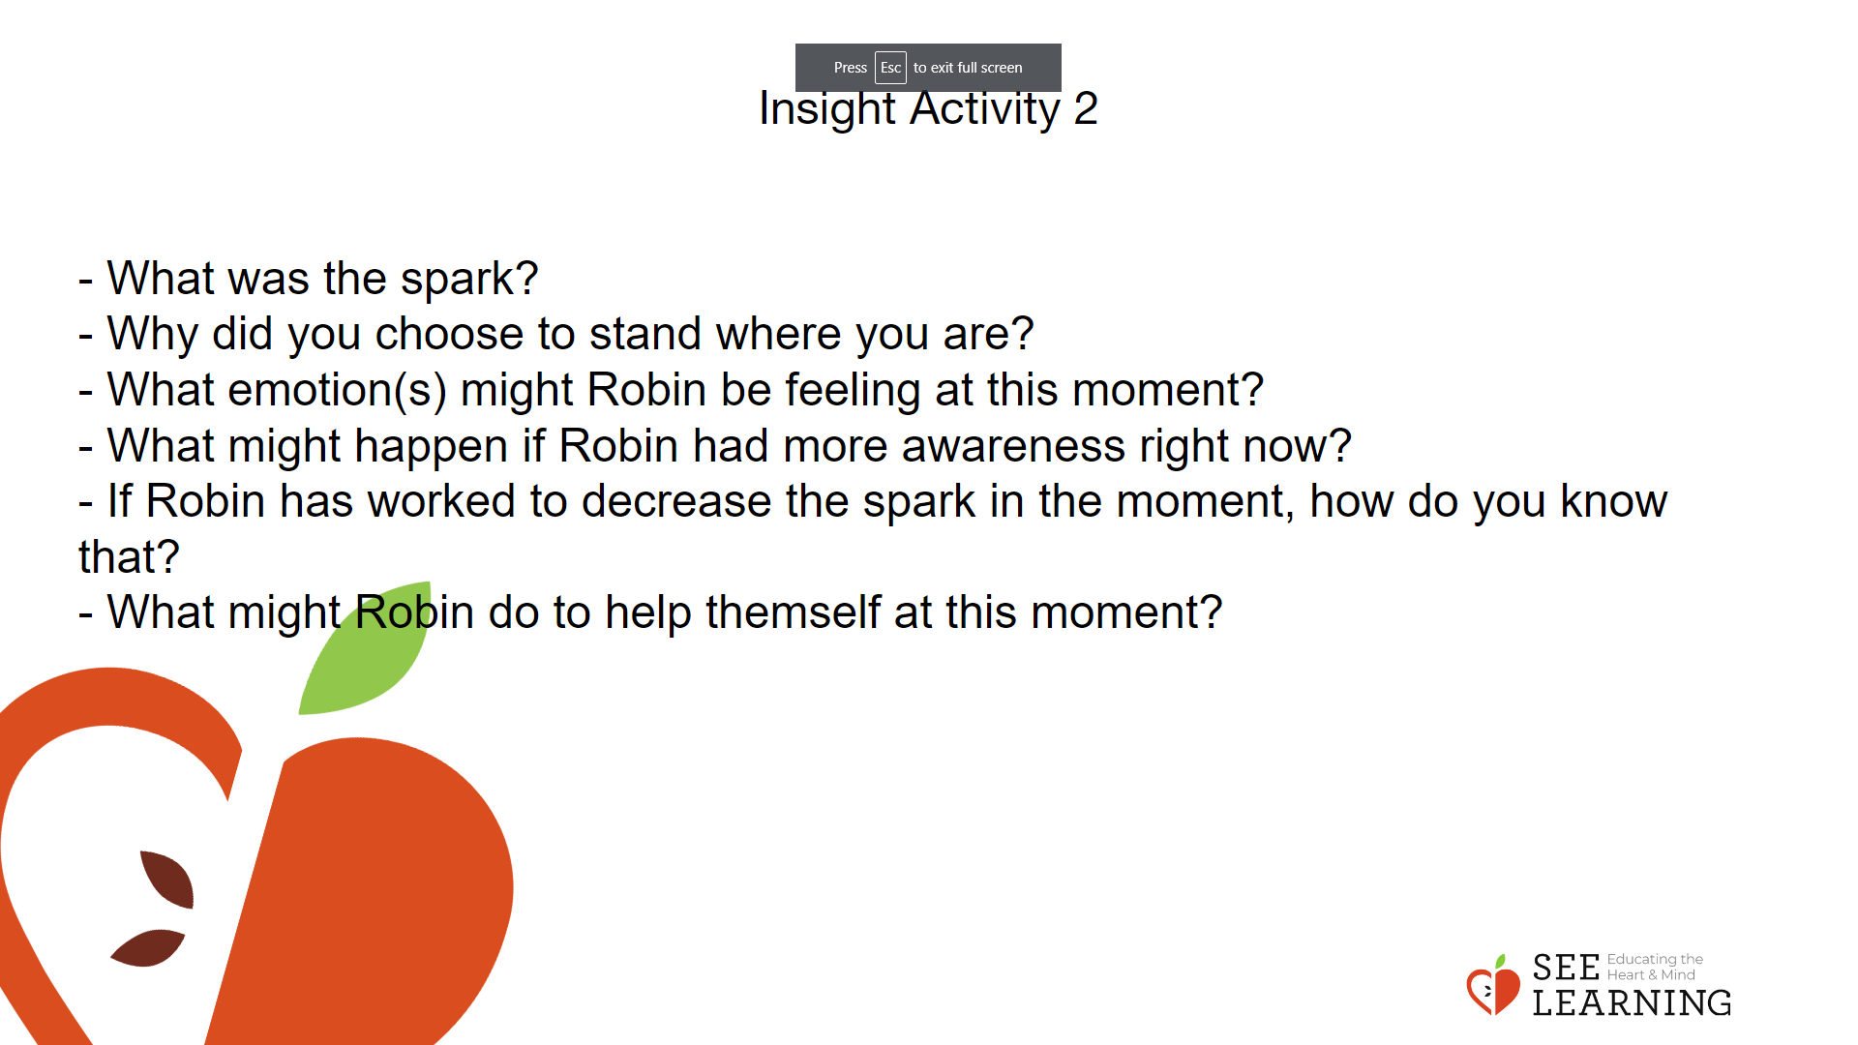 | Instructions and Guided Language  Read “Robin’s Difficult Day” aloud or ask students to read it together in small groups.  • Point out the zones on the floor or ask students to sketch a visual of the zones on a piece of paper.  • “As you listen to or read the story together, notice where the character may be experiencing a “spark” by pausing and discussing it with your group, snapping your fingers or placing an asterisk on the paper.  • Each time you notice a spark, move along the zones that are mapped out on the floor or identify where Robin might be on your paper copy of the resiliant zone.  • At each spark move along the “resilient zone map” on the classroom floor. Discuss what zone you think the character is in and why. Use the questions below to prompt discussion.  -What was the spark?  - Why did you choose to stand where you are?  - What emotion(s) might Robin be feeling at this moment? - What might happen if Robin had more awareness right now?  - If Robin has worked to decrease the spark in the moment, how do you know that?  - What might Robin do to help themself at this moment?

Reflective Practice (10 mins)
Slide 6 and 7: Reflective Practice  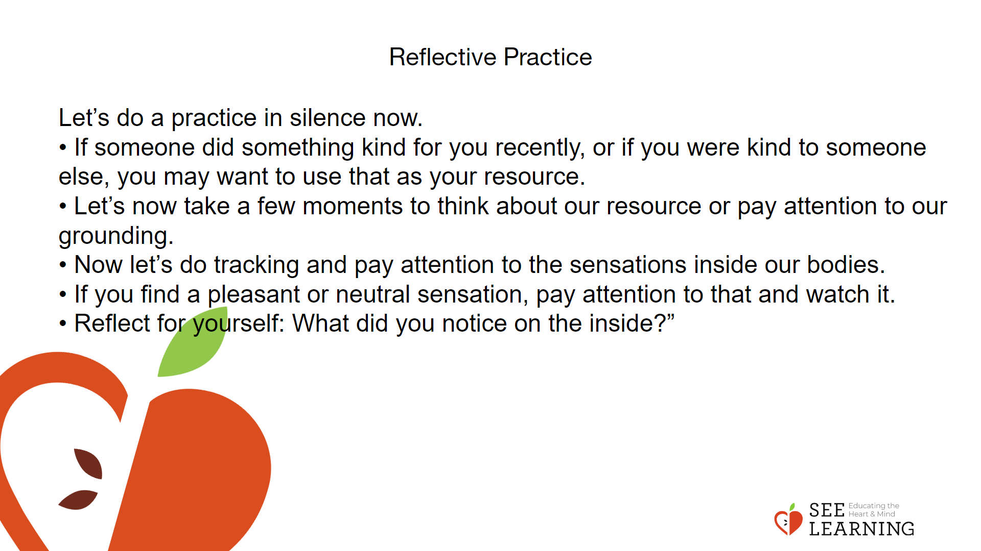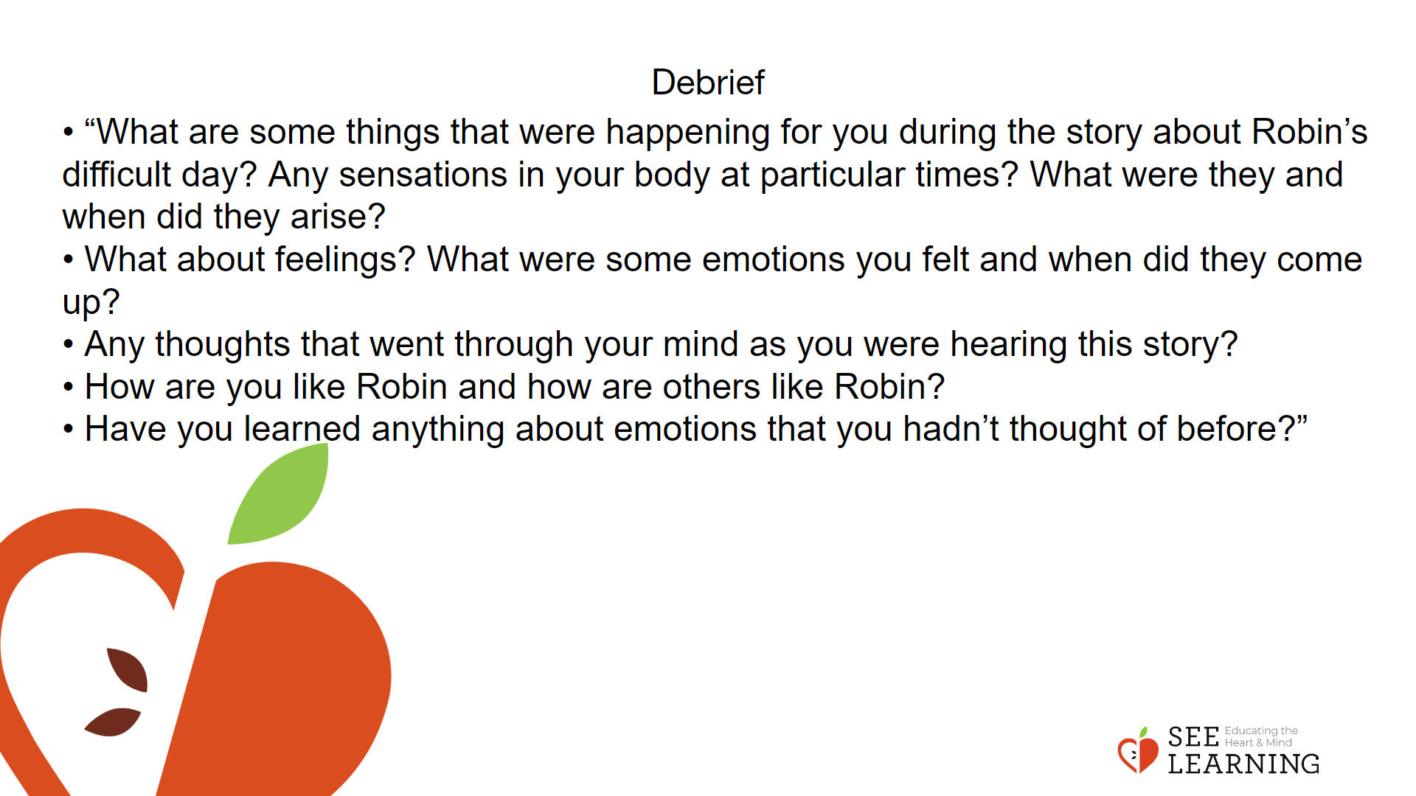 | Instructions and Guided Language  • “We all experience difficult days sometimes. Each little thing can add up until we feel overwhelmed or stressed out. Then we might do things that we wouldn’t ordinarily do, like lose our temper. That’s why we practice methods for balancing our body and mind, like resourcing, grounding, training our attention and cultivating our awareness.  • That way, anytime there is a spark, we can notice it and maybe we can relax ourselves or help ourselves feel calmer or more settled.  • Let’s do a practice in silence now. [PAUSE]  • If someone did something kind for you recently, or if you were kind to someone else, you may want to use that as your resource. If you’d rather do grounding, you can find a comfortable way to sit or something comfortable to hold or touch.  • Let’s now take a few moments to think about our resource or pay attention to our grounding. [PAUSE at least 30 seconds.]  • Now let’s do tracking and pay attention to the sensations inside our bodies. [PAUSE]  • If you find a pleasant or neutral sensation, pay attention to that and watch it. See if it changes or stays the same. [PAUSE]  • If you haven’t found a pleasant or neutral sensation, see if you can shift to another part of your body to find a place that feels better. [PAUSE]  • If you’d like, focus on your breath as you breathe normally. Count your breaths if you wish. If you find paying attention to the breath uncomfortable, make your own choice to go back to your resource or grounding, or just take a small break, thinking your own thoughts in the way that’s comfortable for you. [PAUSE for 15-30 seconds.]  • Reflect for yourself: What did you notice on the inside?” Debrief (4 minutes) Invite volunteers to share their thoughts, using one or more of these questions as a guide:  • “What are some things that were happening for you during the story about Robin’s difficult day? Any sensations in your body at particular times? What were they and when did they arise?  • What about feelings? What were some emotions you felt and when did they come up?  • Any thoughts that went through your mind as you were hearing this story?  • How are you like Robin and how are others like Robin?  • Have you learned anything about emotions that you hadn’t thought of before?”

