Exploring Emotions

Purpose:
In this learning experience, students will describe the difference between emotions, thoughts, and sensations. This will occur through reflection, using personal and small group activities. Students will then use a graphic organizer to help clarify the similarities and differences between emotions, thoughts, and sensations.
Learning Objectives:  Students will be able to:  - Describe the difference between emotions, thoughts, and sensations.  - List some of the basic characteristics of emotions and develop a working definition for emotions. | Primary Core Component  
Length  45 Minutes | Materials Required  - Sensations/Thoughts/Emotions Graphic Organizer handout  - Process of Mental Experience  - Chart paper and markers for “General Qualities of Emotions” word map  - Writing utensils and paper

Check-In (12 min)
Slide 2: Check In  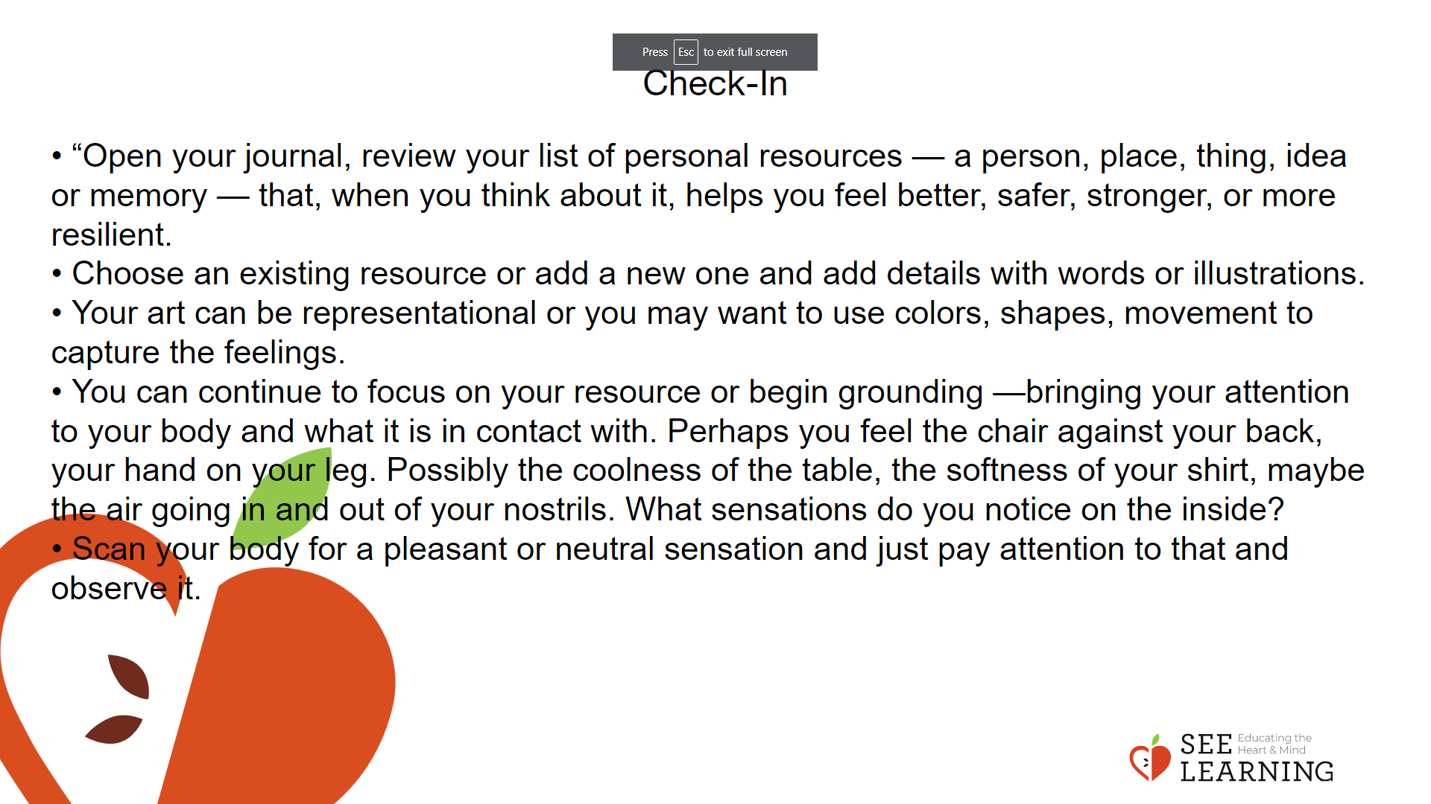 | Instructions and Guided Language  [PAUSE]s can be up to 10 seconds each  • “Open your journal, review your list of personal resources — a person, place, thing, idea or memory — that, when you think about it, helps you feel better, safer, stronger, or more resilient.  • Choose an existing resource or add a new one and add details with words or illustrations.  • Your art can be representational (intended to look like the idea and be recognizable in some way) or you may want to use colors, shapes, movement to capture the feelings. The idea is that when you look at this again, the resource you named will come alive for you again, bringing back the feelings, the memory, the sensations of that experience.  • You can choose to share your work with another person or continue to work independently.  • Put your pen and marker down and with this resource in mind, we will turn our attention inward. [PAUSE]  • You can continue to focus on your resource or begin grounding —bringing your attention to your body and what it is in contact with. Perhaps you feel the chair against your back, your hand on your leg. Possibly the coolness of the table, the softness of your shirt, maybe the air going in and out of your nostrils. What sensations do you notice on the inside? [PAUSE]  • Scan your body for a pleasant or neutral sensation and just pay attention to that and observe it.  • Now we’ll conclude the practice. If you closed your eyes, I now invite you to open them. Thank you.”

Presentation (15 min)
Activity Overview
After providing students with information about emotions, students will pair up and discuss the exploring emotions prompts. As a whole group, the class will create a word map describing emotions and create a working definition for “emotions.”

Slide 3: Presentation  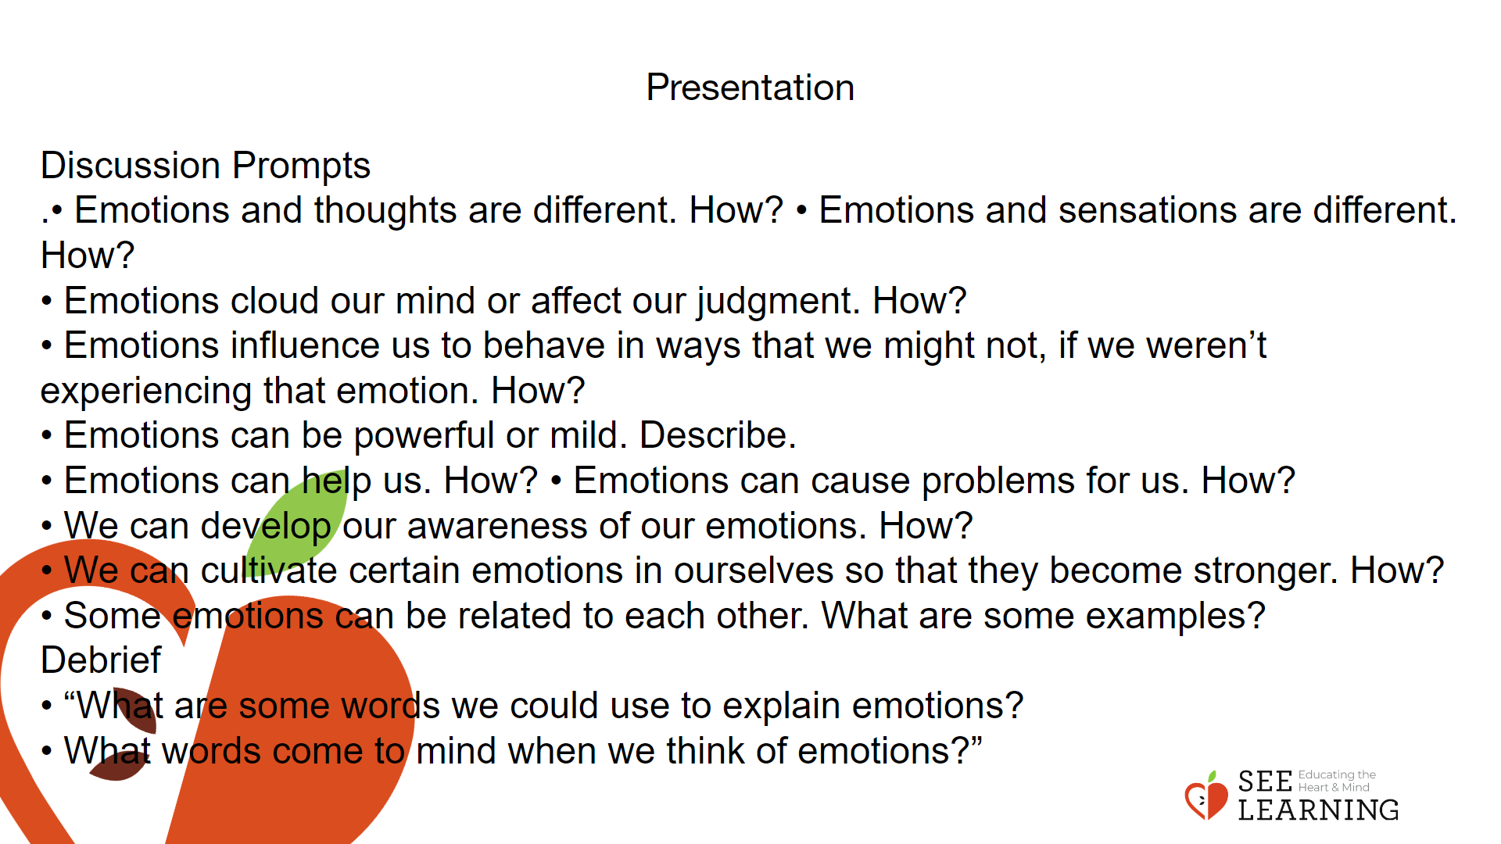 | Instructions and Guided Language  “Today we are going to learn more about how emotions compare to thoughts and sensations.  These are three useful categories when we talk about our inner experiences. We will be thinking together about the characteristics of emotions in general. The more we understand about emotions, which are a natural part of being human and are common to all humans everywhere, the more we can build our personal power around how we respond to emotions.  Sensations are physical and tend to be experienced directly in the body, and often in just one part of the body. Emotions, on the other hand, are not localizable in a specific part of the body, and are generally considered both mental and physical. For example, we can feel pain in our left hand and not our right hand, but we can’t feel anger in one hand and not the other.  When we feel an emotion like anger, we tend to feel it in ourselves as a whole. Today we will explore differences and similarities across thoughts, sensations, and emotions.”  Discussion Prompts Display the prompts on the board. Ask students to pair up and take turns discussing each prompt before moving onto the next one.  • Emotions and thoughts are different. How?  • Emotions and sensations are different. How?  • Emotions cloud our mind or affect our judgment. How?  • Emotions influence us to behave in ways that we might not, if we weren’t experiencing that emotion. How?  • Emotions can be powerful or mild. Describe.  • Emotions can help us. How?  • Emotions can cause problems for us. How?  • We can develop our awareness of our emotions. How?  • We can cultivate certain emotions in ourselves so that they become stronger. How?  • Some emotions can be related to each other. What are some examples  Debrief  On the board write the word emotions and circle it. Create a word map with the students using the prompts below.  • “What are some words we could use to explain emotions?  • What words come to mind when we think of emotions?”  As a group, create a working definition of an emotion.  • “If you were trying to explain to someone what an emotion is, what would you tell them?”  • Record the preliminary definition of emotion on the board.

Insight Activity - (10 mins)
Activity Overview
Learners use the “Sensations/Emotions/ Thoughts Graphic Organizer” and work in groups of three to agree upon examples that fit into each of these three categories. Students complete a Venn Diagram to identify the similarities and differences between thoughts, sensations and emotions.

Slide 4: Insight Activity  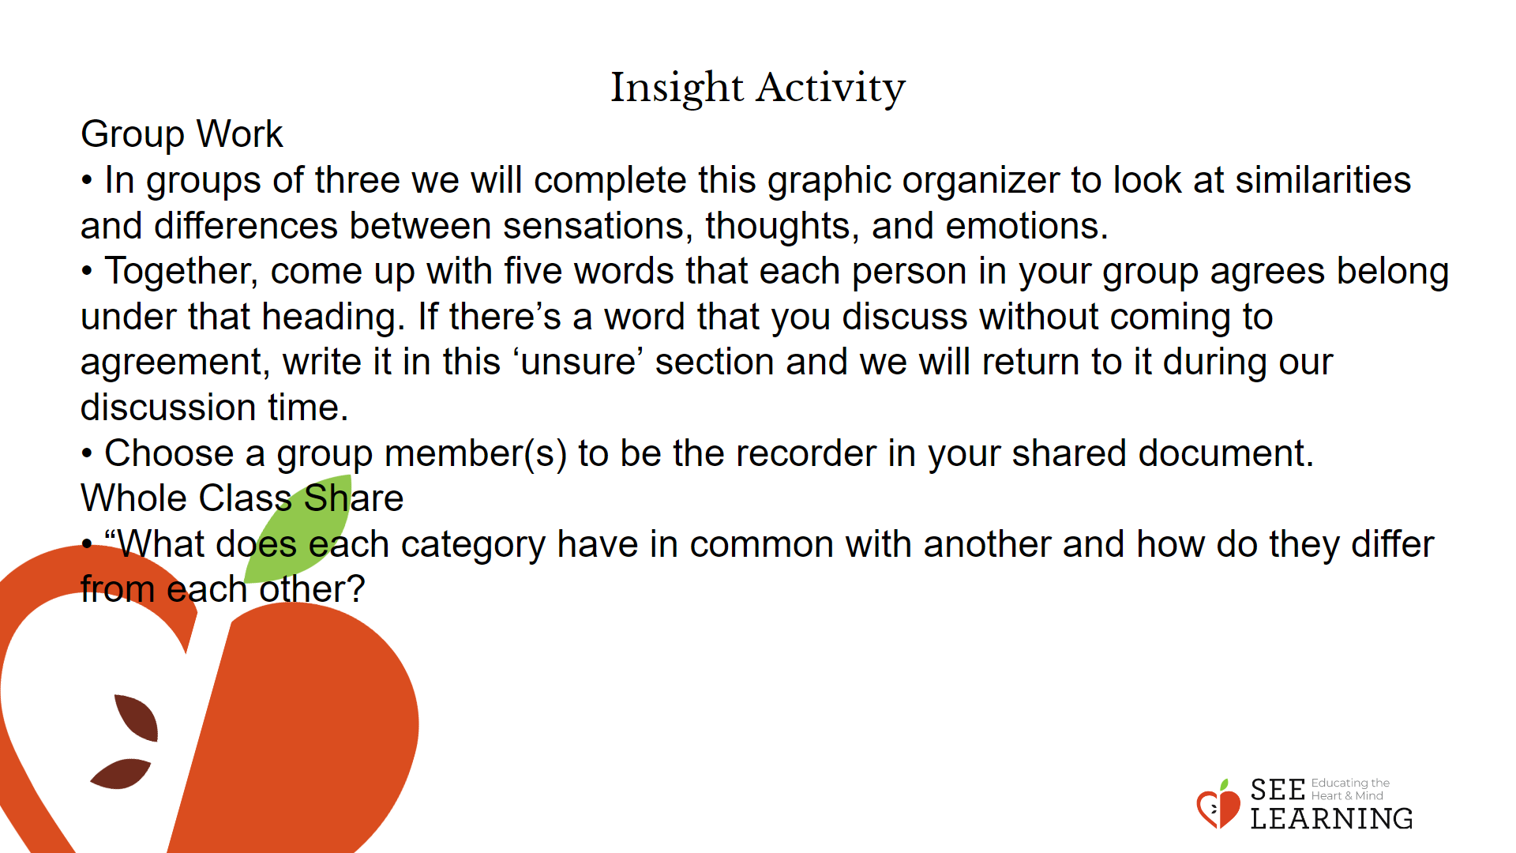 | Instructions and Guided Language  Group Work  • “In groups of three we will complete this graphic organizer to look at similarities and differences between sensations, thoughts, and emotions.  • Together, come up with five words that each person in your group agrees belong under that heading. If there’s a word that you discuss without coming to agreement, write it in this ‘unsure’ section and we will return to it during our discussion time.  • Choose a group member(s) to be the recorder in your shared document.”  Whole Class Share  Ask each group to choose one question to speak about with the rest of the class.  • “What does each category have in common with another and how do they differ from each other?”  As students share, you can choose to record answers with a Venn diagram on the board.

Reflective Practice (5 mins)
Slide 5: Reflective Practice  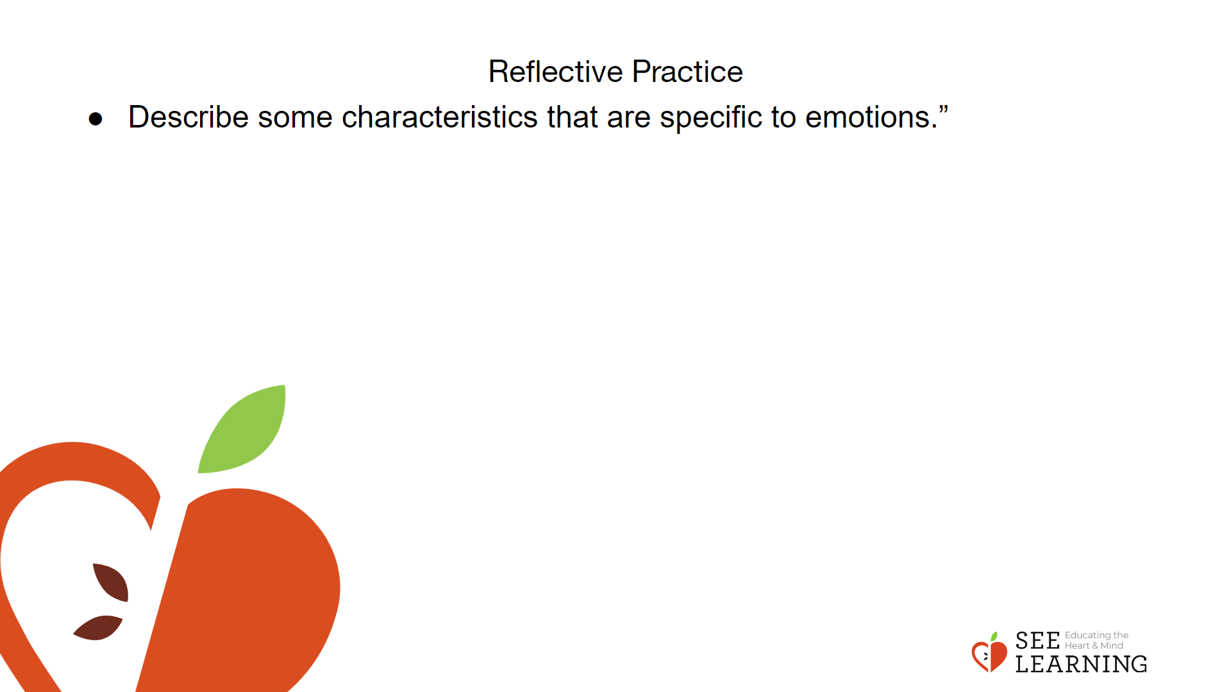 | Instructions and Guided Language  Ask each group to reflect on and discuss the prompt below.  “Let’s look at the characteristics of emotions more deeply. Describe some characteristics that are specific to emotions.”  Record answers on the board under the heading “General Characteristics of Emotions.”  A list of examples for “General Characteristics of Emotions” is provided below. If students have trouble coming up with ideas use questions and the list below to scaffold and elicit responses.  • They are usually involuntary responses to a stimulus.  • They involve an appraisal of the stimulus as positive or negative. (Often this appraisal is unconscious and seems automatic.)  • They tend to drive behavior/compel action.  • They are not neutral: they have a pleasant or unpleasant feeling tone (valence) and a level of activation in our bodies (energizing or depleting).  • While we experience sensations in particular parts of the body, emotions tend to be whole body/mind experiences, not contained in one part of the body.  • They can be attended to in mind and body, because they are often paired with sensations in the body and/or changes in our mind or thinking.  • They are usually triggered by things we value and care deeply about, and are not evoked by matters we care little about.  • They often have signals like facial expressions or tone of voice that others can observe, especially when they become strong.  Check Out  • “After engaging in this discussion, is there anything we would like to add to our definition of emotion?  • To close share an appreciation for another person, your small group, or the learning process/content.”

