Observing the Mind

Purpose:
In this learning experience, we will discuss and practice meta-awareness by discussing the metaphor of the sky and the clouds and engaging in a practice of watching the mind with open curiosity. Meta-awareness is the practice of directing attention inwardly to the mind without getting caught up in thoughts, emotions, and feelings.
Learning Objectives:  Students will be able to:  - Engage in the practice of observing their own thoughts and feelings  - Demonstrate the ability to notice and cultivate a gap between stimulus and response in order to facilitate personal impulse control | Primary Core Component  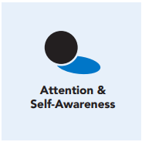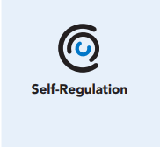
Length  45 Minutes | Materials Required  - The mind jar created in Chapter 3, Learning Experience 1  - Printed copy of image of sky (provided resource in this section)  - Writing utensils and paper  - Recorded instrumental music

Check-In (10 min)
Slide 2: Check-In  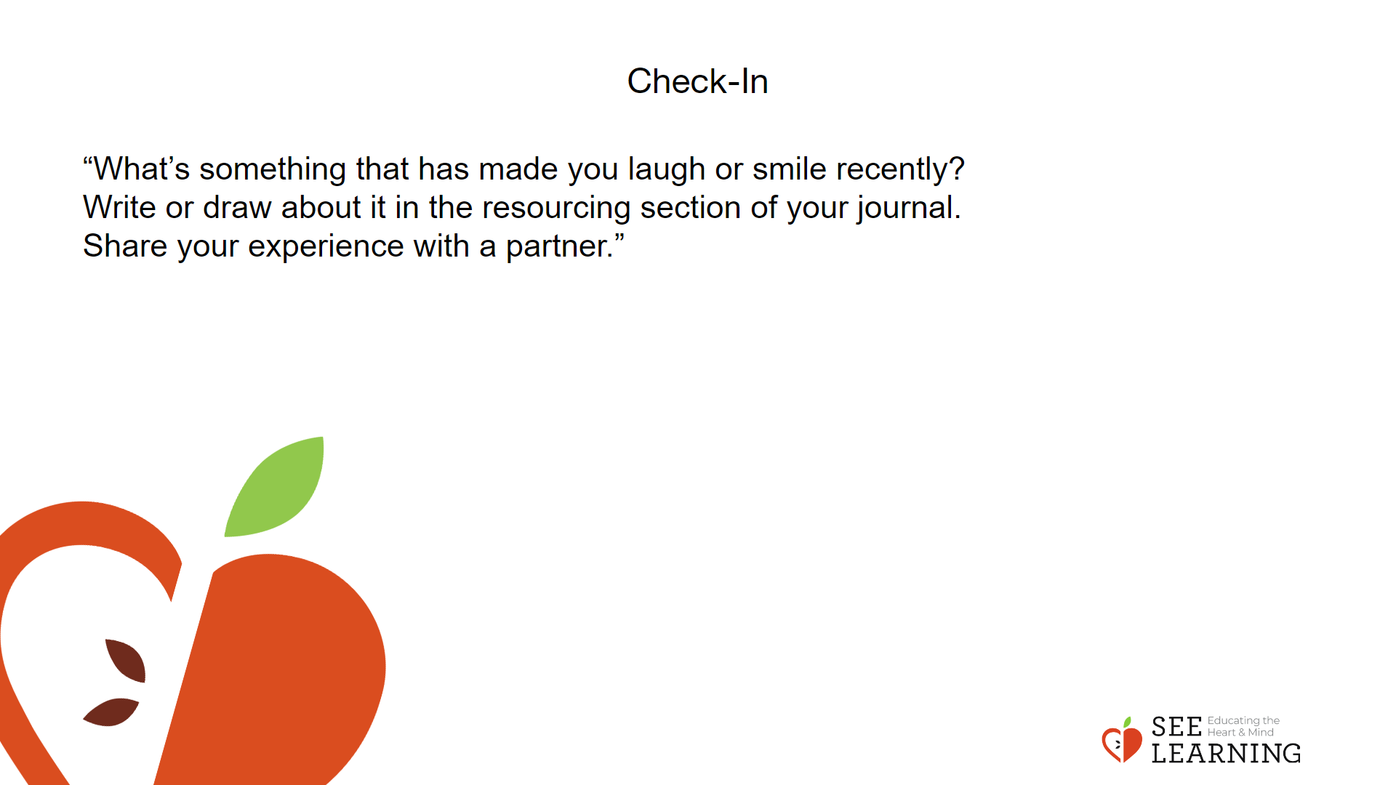 | Instructions and Guided Language  [PAUSE]s can be up to 10 seconds each  “What’s something that has made you laugh or smile recently?  Write or draw about it in the resourcing section of your journal.  Share your experience with a partner.”

Insight Activity (7 min)
Slide 4: Insight Activity  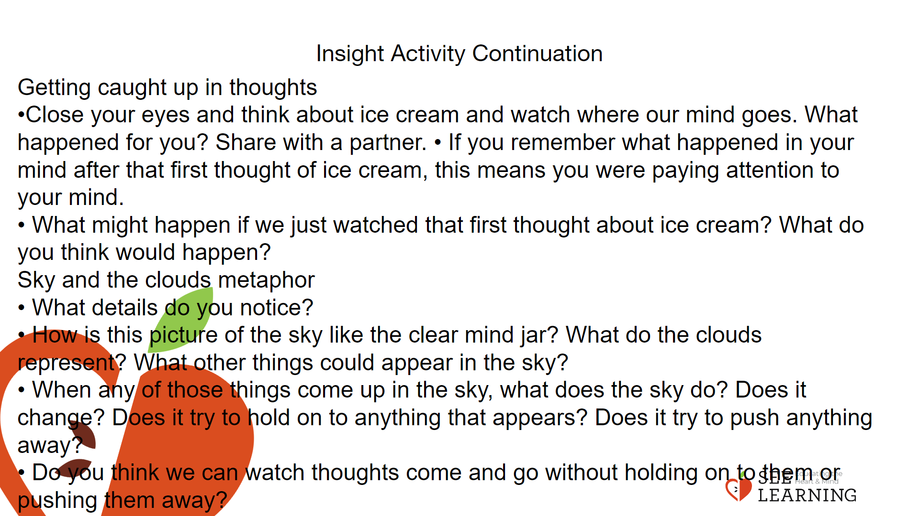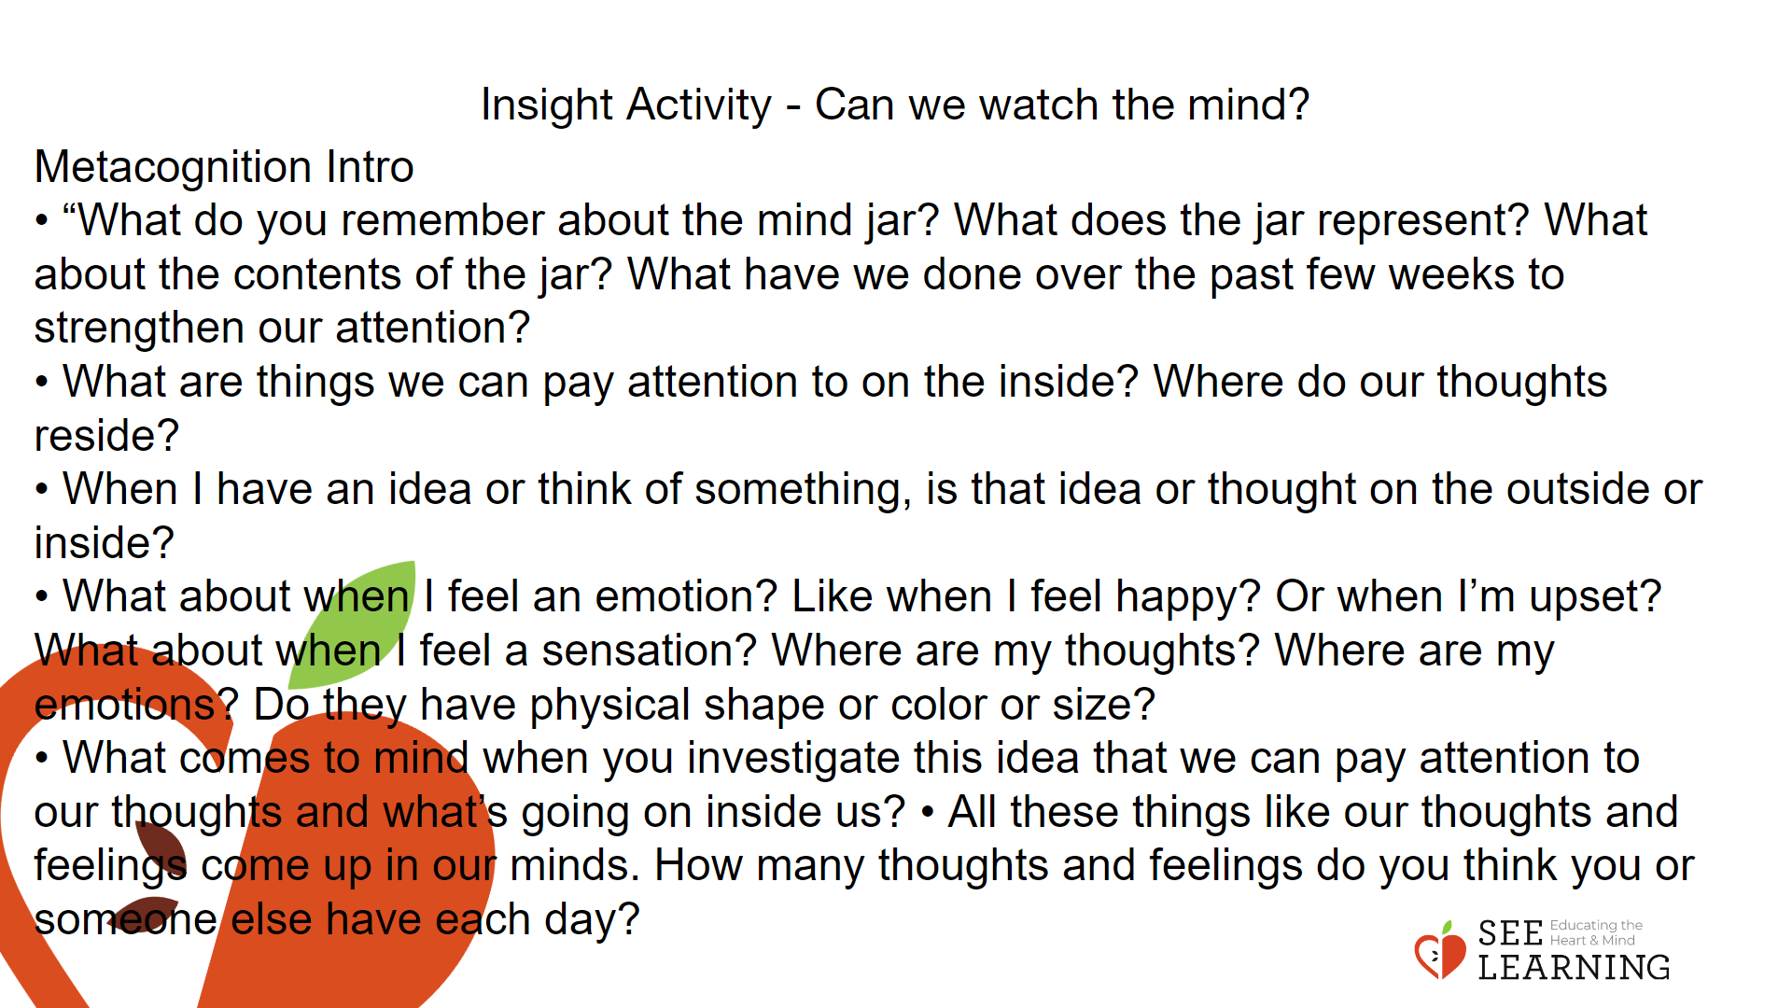 | Instructions and Guided Language  Can we watch the mind?  A poster or slide with this information, for reference, as you lead this activity.  • We can place our attention on our mind itself.  • We can notice thoughts, emotions, sensations, memories, and images as they come and go.  • We can pay attention to our thoughts and emotions in our mind.  • When we watch and simply observe our thoughts, we get less caught up in them. Watching our thoughts helps us learn about what’s going on inside us and helps us be less reactive.  • The practice of neutrally observing the thoughts creates space between thoughts and the ability to pick and choose which thought you give attention to.  Metacognition Intro Use the prompts below to engage the class in a discussion.  • “What do you remember about the mind jar? What does the jar represent? What about the contents of the jar? What have we done over the past few weeks to strengthen our attention?  • What are things we can pay attention to on the inside? Where do our thoughts reside?  • When I have an idea or think of something, is that idea or thought on the outside or inside?  • What about when I feel an emotion? Like when I feel happy? Or when I’m upset? What about when I feel a sensation? Where are my thoughts? Where are my emotions? Do they have physical shape or color or size?  • What comes to mind when you investigate this idea that we can pay attention to our thoughts and what’s going on inside us?  • All these things like our thoughts and feelings come up in our minds. How many thoughts and feelings do you think you or someone else have each day?  • Try to think back and count yours, during the last few minutes. You might remember images, thoughts, feelings, sensations.”  Getting caught up in thoughts  • “Sometimes when we have a thought we get all caught up in it and it can carry us away. For example, I might think of ice cream and then suddenly it starts a train of thoughts that can lead me on and on.  Let’s take a moment to do this right now.  Let’s close our eyes and think about ice cream and watch where our mind goes. (Pause 15 seconds)  What happened for you? Share with a partner.  • If you remember what happened in your mind after that first thought of ice cream, this means you were paying attention to your mind. That means you were using meta-awareness.  • What might happen if we just watched that first thought about ice cream? What do you think would happen?” Sky and the clouds metaphor Display or pass out the image of the sky and the clouds.  • “Look carefully at this picture. What details do you notice?  • How is this picture of the sky like the clear mind jar? What do the clouds represent? What other things could appear in the sky? (A rainbow, birds, or an airplane, a storm or lightning bolt…)  • When any of those things come up in the sky, what does the sky do? Does it change? Does it try to hold on to anything that appears? Does it try to push anything away?  • I wonder if we can watch our thoughts and feelings as though we were this sky. Do you think we can watch thoughts come and go without holding on to them or pushing them away?

Reflective Practice 1 - (10 mins)
Slide 5: Reflective Practice 1  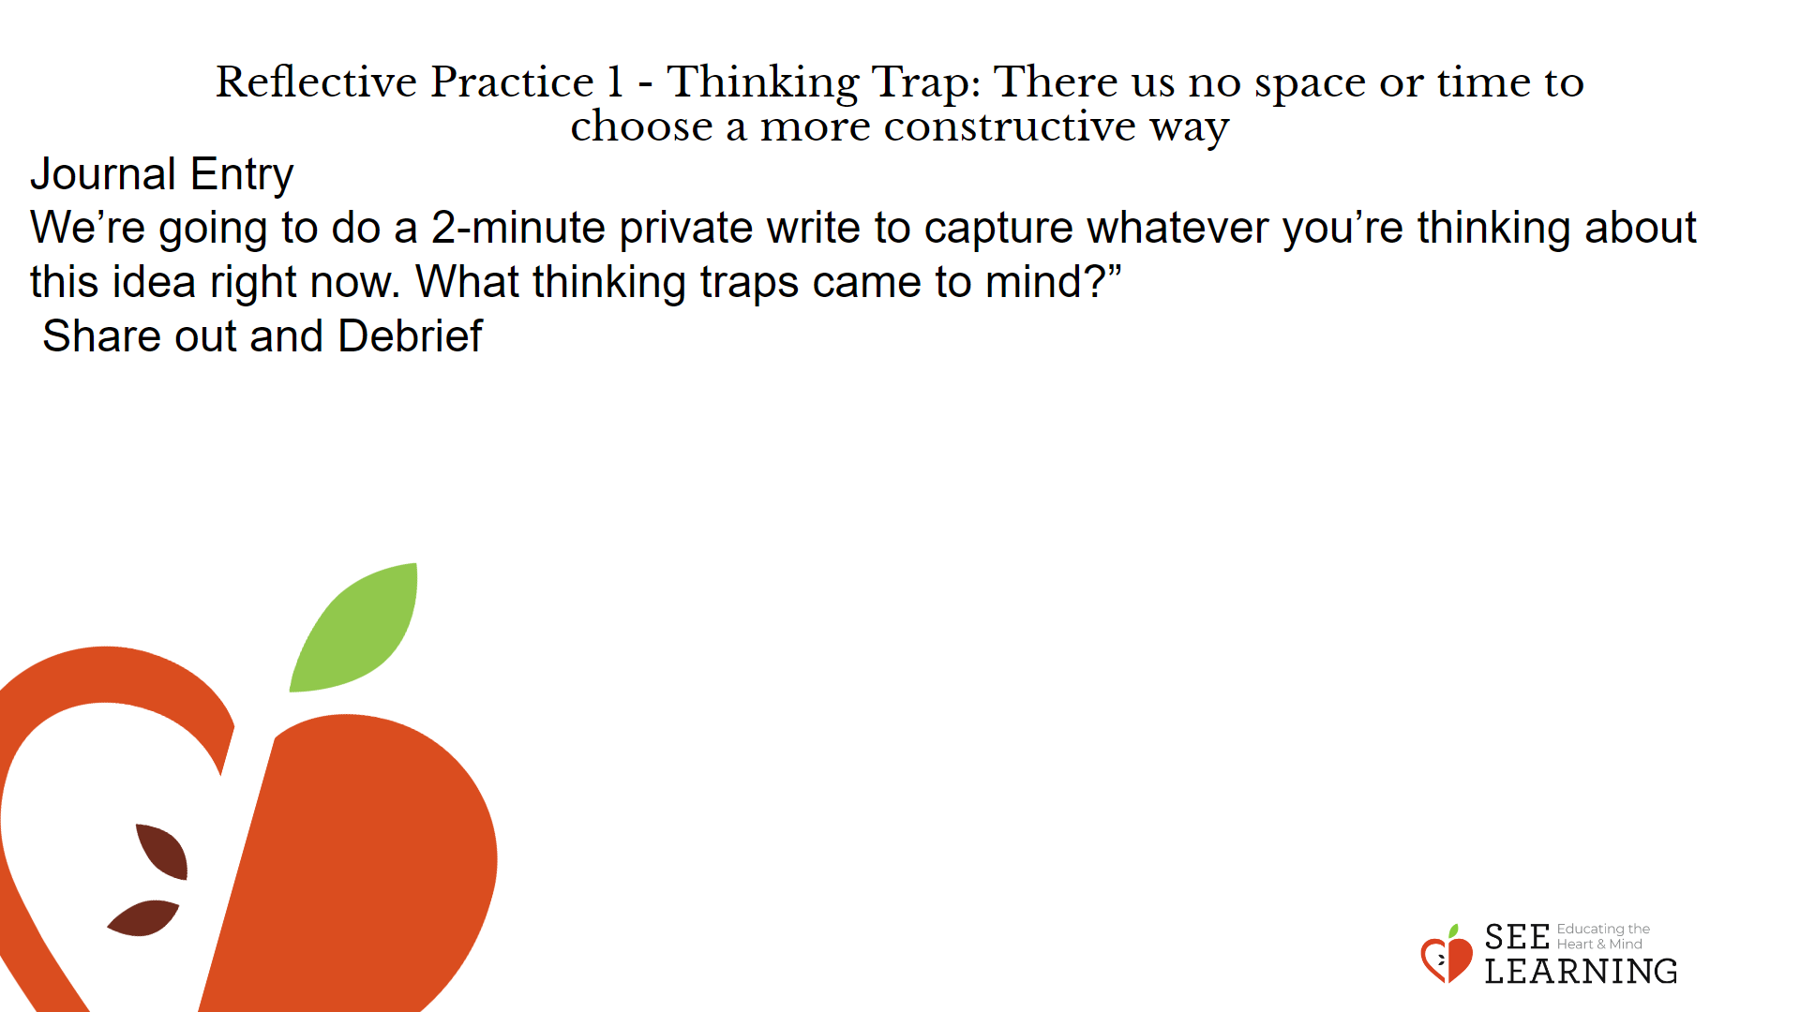 | Instructions and Guided Language  Thinking Trap: There is no space or time to choose a more constructive way.  Key Concepts  • “Does anyone remember what a thinking trap is? A Thinking Trap is a way of thinking that tends to distort reality, making it harder for us to think and act constructively.  • Developing an ability to watch thought processes in the mind is a great way to catch thinking traps. Sometimes when we are experiencing distressing thoughts or challenging feelings, we might feel that there is no space or time to choose a more constructive way to deal with the challenge. Our ideas or feelings could be so intense, paralyzing or compelling that it seems to us we have no choice to think, feel, or act differently.  • We do often have more choice than that, however. We can pause to remember: “I do not have to act on each emotional impulse or thought. I can navigate emotional experiences in healthy ways, to the benefit of myself and others”.”  Journal Entry “We’re going to do a 2-minute private write to capture whatever you’re thinking about this idea right now. What thinking traps came to mind?”  Share out and Debrief  • “Would anyone like to share an insight or idea they wrote down?  • We all have personal power over how we react to emotional impulses or challenging thoughts. We do not have to act on each emotional impulse. We can navigate emotional experiences in healthy ways to the benefit of ourselves and others. Observing the mind helps us notice potential thinking traps.”

Reflective Practice 2 (10 mins)
Observing the Mind/Meta-Awareness practice
Activity Overview
This is a reflective practice similar to the focused attention on the breath, except that instead of a single object of focus, students will be sitting quietly, noticing what arises in their mind, without getting involved with the contents of their thoughts and feelings. The aim of this practice is to watch and observe whatever thoughts and feelings come to mind with open curiosity and without getting too involved.

Teaching Tip
• You will notice that this practice combines resourcing and grounding, attention on the breath or single chosen object of focus, and then observing the mind. Each of these practices have been built up sequentially, so if your students are not yet able to do this full practice, provide additional experiences with the shorter practices before returning to this more complex practice. Scaffolding their experiences will build ease and confidence over time.
• Once they can do this combined practice, consider making this your main practice, and repeat it many times with your students, ideally twice or more each week. You can then gradually lengthen the pauses until they are 30 seconds to a minute in length. As your students build this skill, they will be engaging in very significant attention training and their progress will be an encouraging sign to them that they are strengthening their muscle of attention. These skills will serve as a foundation for practices in future chapters that deal with noticing and regulating emotions as they arise.

Slide 6: Reflective Practice 2  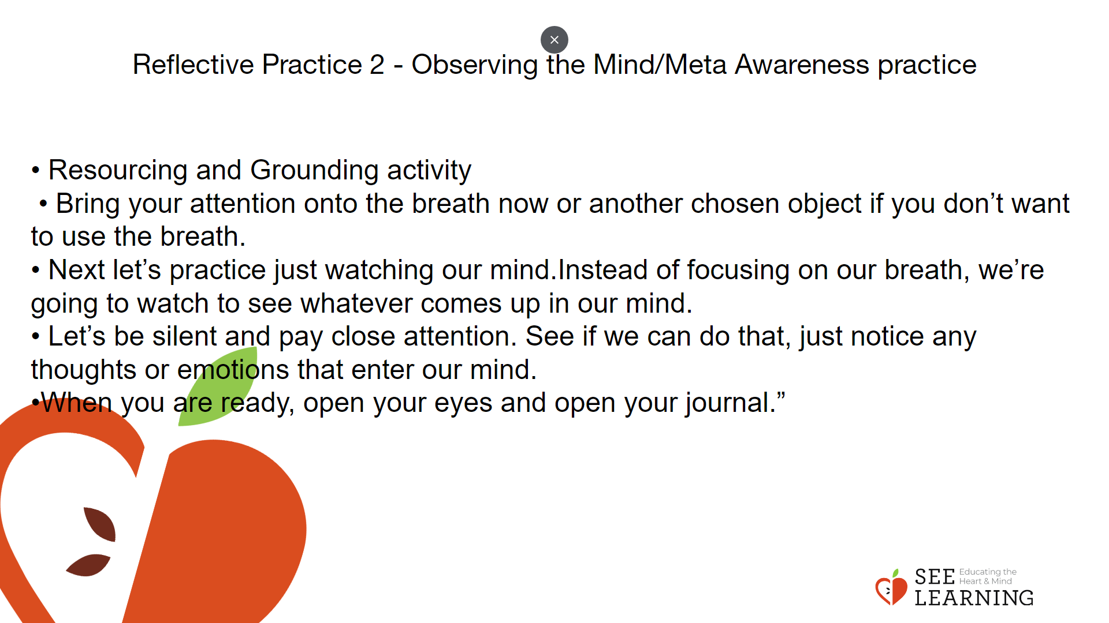 | Instructions and Guided Language  Introducing the activity  • “During this reflective practice we will try to watch our own thoughts.  • We are “just noticing” like we did with the object in the “I Notice, I Wonder.” activity.  • There aren’t any right or wrong thoughts here. A distraction of the mind is just something to notice. Not judge. Just notice and let it drift by, like a cloud.  • There are some practical strategies that can help strengthen this personal pause-power.  One is noticing and naming our mind’s activity. Sometimes people do that by naming thoughts, (“That’s a thought… that’s another thought” or “I’m thinking about x…” and “Now I’m thinking about y…”).  You can also name specific emotions or sensations (“I’m feeling anxious…” or “I’m feeling restless…”). Once you’ve labeled the thought or feeling, you can return your attention to the breath or other object of focus.”  Meta-Awareness Practice  • “Let’s take a comfortable, alert posture. You can choose to lower your eyes to the ground or close them.  • First we’ll do a resourcing and grounding activity to help us be in our resilient zone. Let’s think of one of our resources in silence. Or if you prefer, you can do some grounding where you are sitting. [PAUSE]  • Bring your attention onto the breath now or another chosen object if you don’t want to use the breath. Remember if you start to feel uncomfortable, you can go back to your resource or to grounding. [Pause for 30 seconds or longer if your students are comfortable doing so.]  • Next let’s practice just watching our mind. [PAUSE] Instead of focusing on our breath, we’re going to watch to see whatever comes up in our mind.  • Rather than getting caught up in our thoughts, we’re going to see if we can just watch them.  • Let’s be silent and pay close attention. See if we can do that, just notice any thoughts or emotions that enter our mind. [PAUSE for 15-30 seconds, or more if your students are comfortable doing so.]  • If we get distracted or caught up in our thoughts and emotions, remember that we’re just watching them, like clouds moving across the sky. We’re seeing them come, stay, and go. Let’s try to do that just a little bit more. [PAUSE for 15-30 seconds or more.] When you are ready, open your eyes and open your journal.”

Debrief (4 mins)
Slide 7: Debrief  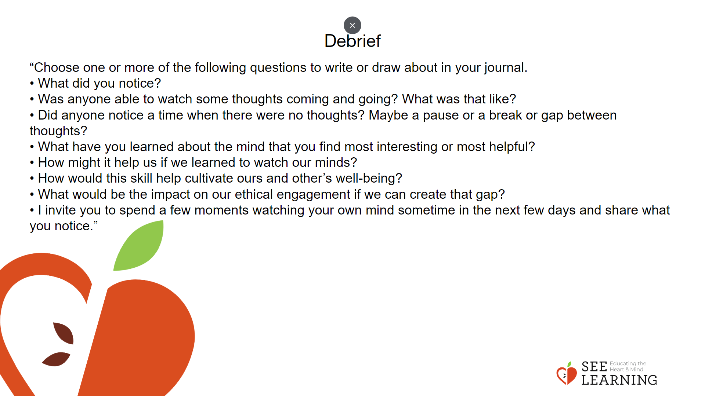 | Instructions and Guided Language  “Choose one or more of the following questions to write or draw about in your journal.  • What did you notice?  • Was anyone able to watch some thoughts coming and going? What was that like?  • Did anyone notice a time when there were no thoughts? Maybe a pause or a break or gap between thoughts?  • What have you learned about the mind that you find most interesting or most helpful?  • How might it help us if we learned to watch our minds?  • How would this skill help cultivate ours and other’s well-being? • What would be the impact on our ethical engagement if we can create that gap?  • I invite you to spend a few moments watching your own mind sometime in the next few days and share what you notice.”

