Cultivating Attention on an Object

Purpose:
The class will discuss a visual metaphor of training a puppy to attention training. This can be done as a whole group, in small groups or in pairs. The students will then practice an attention training exercise by placing their attention on the breath or other chosen object of focus.
Learning Objectives:  Students will be able to:  - Describe mindfulness and awareness through metaphors and direct experience.  - Engage in the practice of cultivating focused attention on a single object.  - Identify how mindfulness and awareness support healthy relationships with others | Primary Core Component  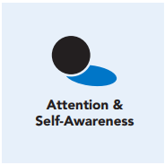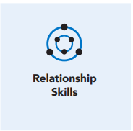
Length  45 Minutes | Materials Required  - Picture that contains all of the elements of the lesson story (one handout per student) Blank paper for drawing  - Colored pencils, crayons, skinny markers and/or pens  - Background music (optional)

Check-In (5 min)
Slide 2: Check-In  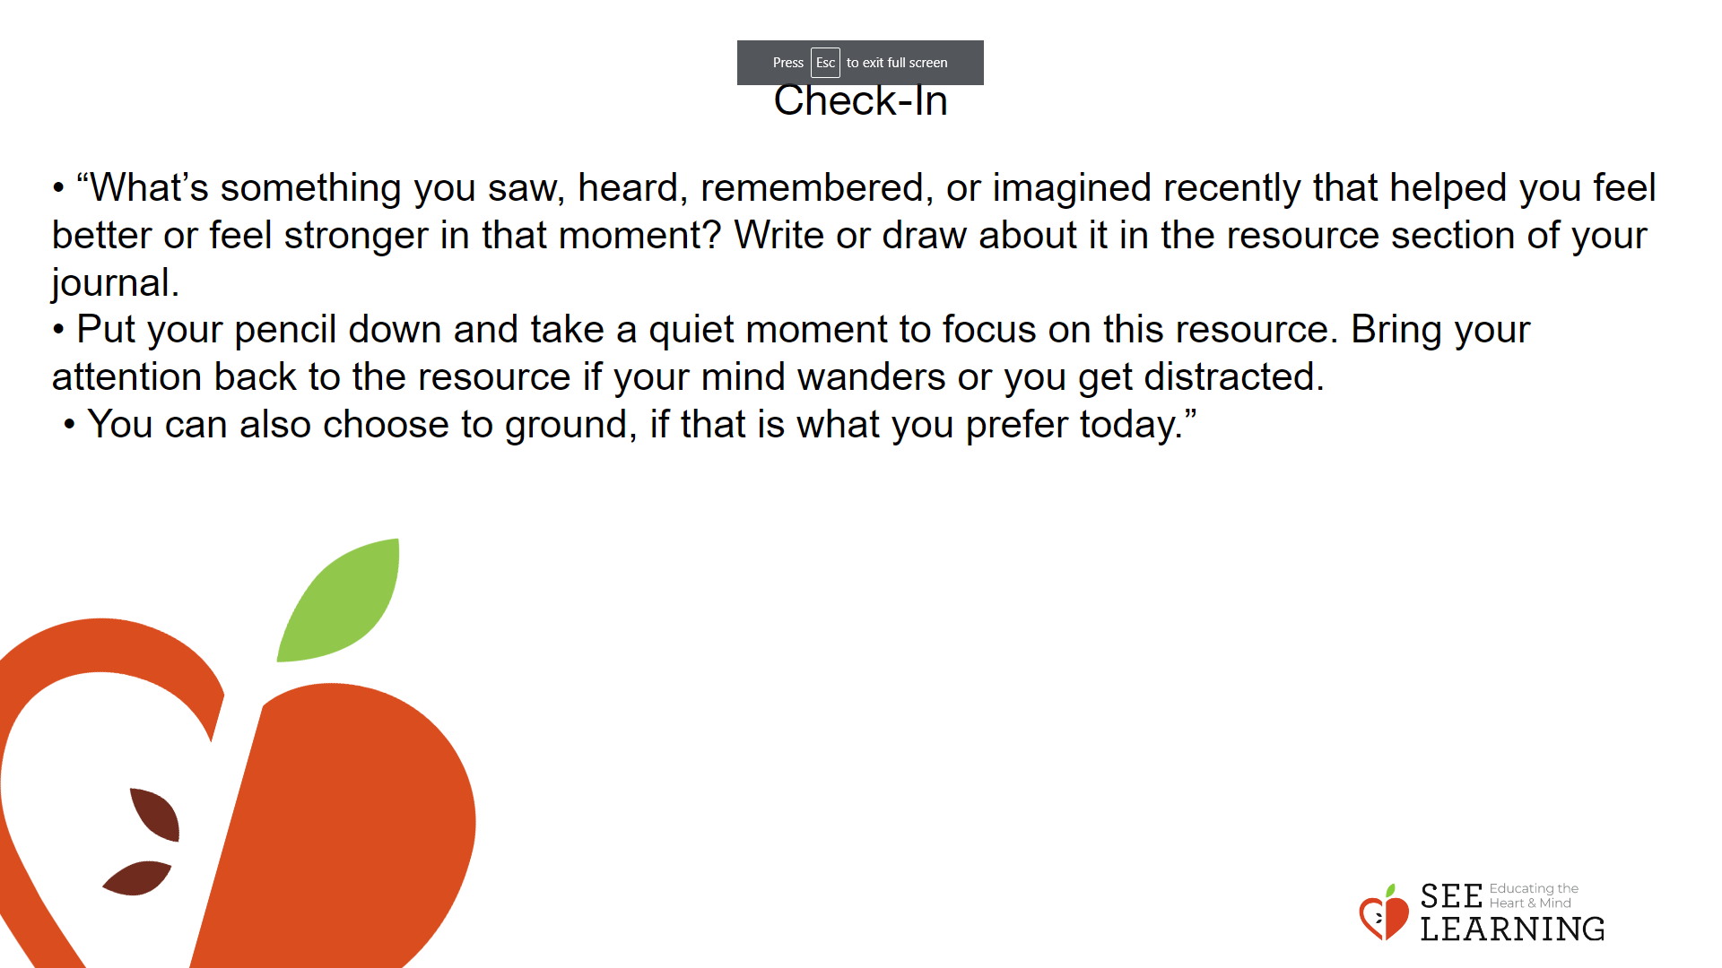 | Instructions and Guided Language  [PAUSE]s can be up to 10 seconds each  • “What’s something you saw, heard, remembered, or imagined recently that helped you feel better or feel stronger in that moment? Write or draw about it in the resource section of your journal.  • Put your pencil down and take a quiet moment to focus on this resource. Bring your attention back to the resource if your mind wanders or you get distracted.  • You can also choose to ground, if that is what you prefer today.”

Presentation (10 min)
Slide 3: Presentation  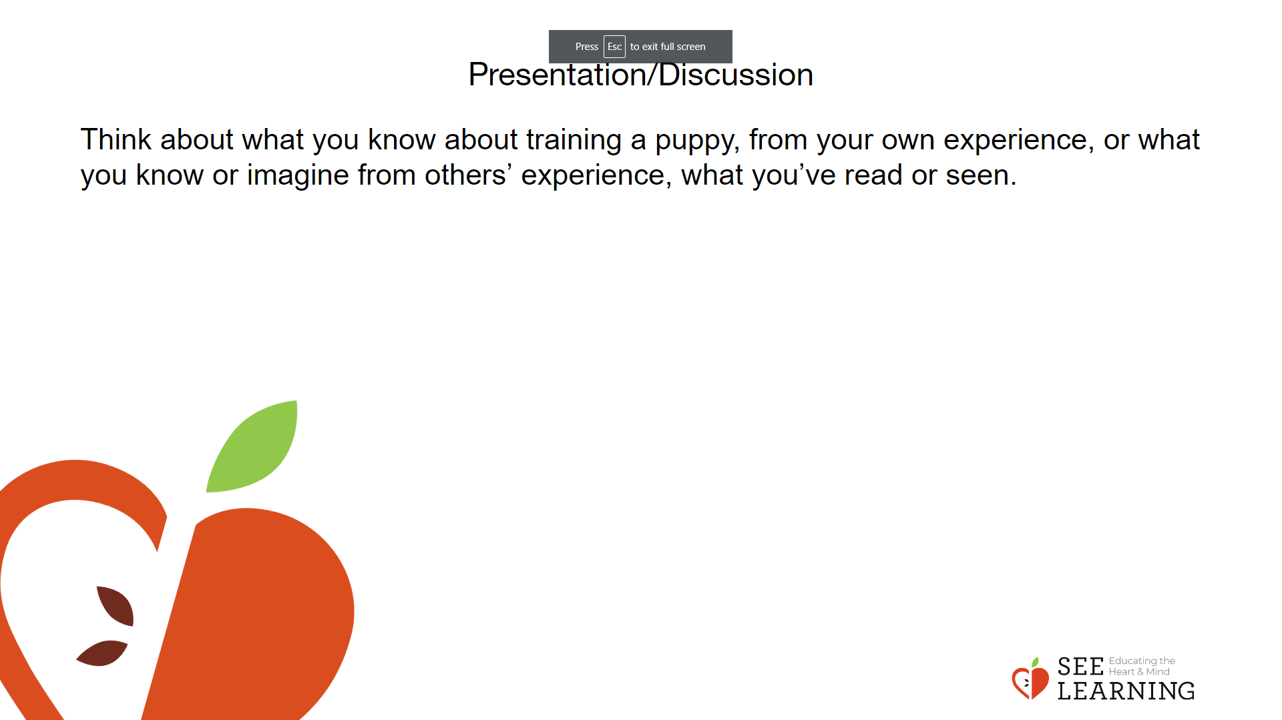 | Instructions and Guided Language  “As we become skillful in focused attention, it can help to bring about greater calm and well-being in our bodies and minds, and help strengthen our ability to pay attention the same way we can build muscle.  With increased attention we can learn better, focus better and pay attention better. We can redirect our attention more easily when necessary, and we can also use our attention as a tool for examining our own minds and mental processes, including our thoughts and emotions.  Today we’re exploring the practice of focusing on a single object and sustaining our attention there over time. To do this, we put our intentional focus on a neutral object of focus (like our breath) and then bring our mind back to it whenever we notice that our mind has wandered or has become sleepy (lethargic or dull).  It can be even more challenging to do this kind of focusing than the others we’ve done before, since the object of our attention is deliberately neutral, and could be perceived as less interesting.  Enhanced attention training involves learning how to pay attention even when something is not that stimulating, because we already naturally pay attention to things that we find interesting.  We’re going to use the metaphor of a compassionate owner training a puppy today, to think about cultivating focused awareness.  Let’s look together at this drawing and think about what you know about training a puppy, from your own experience, or what you know or imagine from others’ experience, what you’ve read or seen.  Pass out handout.  You’re welcome to label or make notes on your handout if you wish, and put it into your SEE Journal to reflect on at other times.

Insight Activity -Cultivating Focused Awareness (10 min)
Activity Overview
The class will discuss a visual metaphor of training a puppy to attention training. This can be done as a whole group, in small groups, or in pairs. Choose some or all of the questions below to facilitate a dialogue with/between students. Possible responses are provided but surfacing these particular responses is not the goal.

Slide 4: Reflective Practice  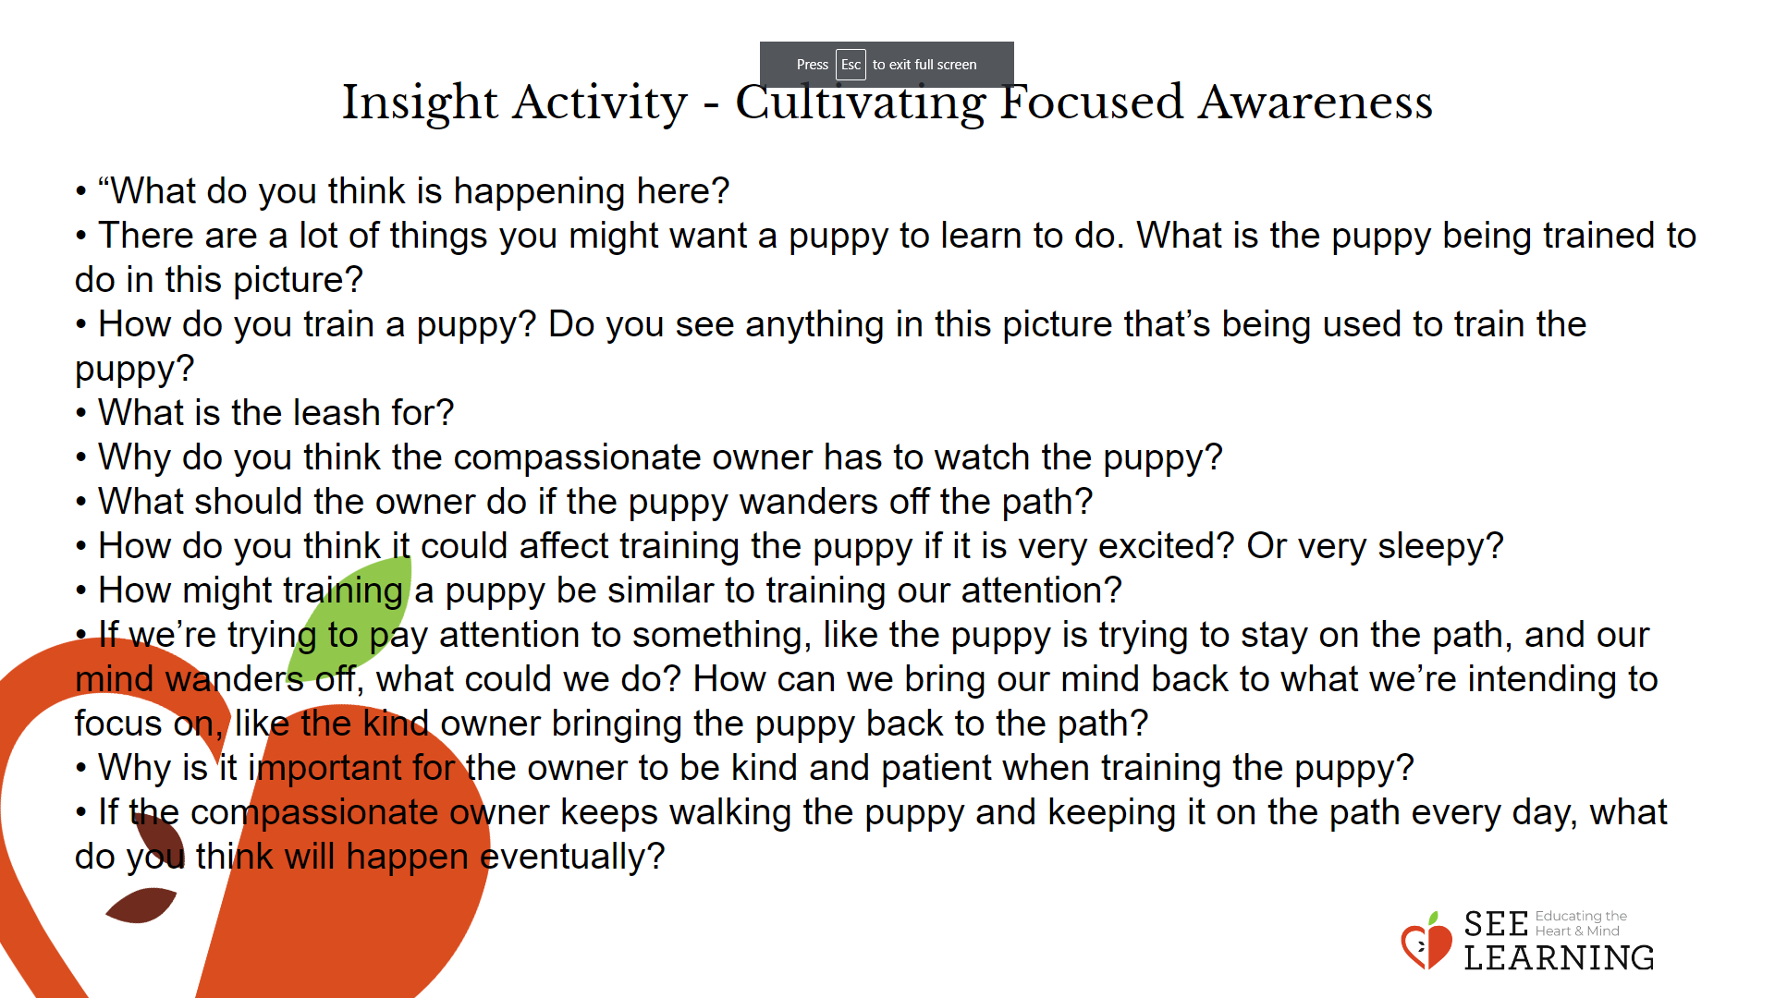 | Instructions and Guided Language  Discussion Prompts  • “What do you think is happening here?  • There are a lot of things you might want a puppy to learn to do. What is the puppy being trained to do in this picture? (Stay on the path. Walk along the path. Not run away.)  • How do you train a puppy? Do you see anything in this picture that’s being used to train the puppy?  • What is the leash for? (Keeping the puppy on the path. Not letting it run away. Keeping it safe.)  • Why do you think the compassionate owner has to watch the puppy? (It might stray off the path. It could get into danger.)  • What should the owner do if the puppy wanders off the path?  • How do you think it could affect training the puppy if it is very excited? Or very sleepy?  • How might training a puppy be similar to training our attention? (It takes time and practice. We keep our mind on one thing, like the trainer keeping the puppy on the path. We are training our mind.)  • If we’re trying to pay attention to something, like the puppy is trying to stay on the path, and our mind wanders off, what could we do? How can we bring our mind back to what we’re intending to focus on, like the kind owner bringing the puppy back to the path?  • Why is it important for the owner to be kind and patient when training the puppy? (Learning takes time. The puppy could get discouraged.)  • If the compassionate owner keeps walking the puppy and keeping it on the path every day, what do you think will happen eventually? (It will get used to it. It will get trained. It may be able to walk without a leash one day.)  We know from building our SEE vocabulary that mindfulness is being able to keep one’s mind on a chosen object without forgetting it, and awareness is noticing what is taking place in the mind (such as when it gets distracted or sleepy).  How might training a puppy to walk along a path be seen as a metaphor for training and strengthening our attention? (The mind is the puppy. The path is the object of focus or what we are paying attention to. The leash is mindfulness: our capacity to keep our focus and attention on a chosen object. The kind owner is awareness who sees if the puppy is staying on the path and if the puppy is alert, distracted, or sleepy.)

Reflective Practice 1 (10 mins)
Activity Overview
This reflective practice introduces the more formal practice of attention training on a single neutral object, such as our breath. The key strategy to sustain attention is to bring the mind back when it wanders or keep attention crisp if one becomes sleepy.

Teaching Tip
Since students who have experienced trauma, adversity, or illness may have trouble sitting still or focusing on the breath, and may even find the experience unpleasant, it is very important to remind students that they can always return to doing grounding or resourcing or can stop the practice entirely. This is especially true for those who experience dysregulation when trying to sit still or focus, and for whom it may take more time before they can do practices like this with ease. Be clear that there is no judgment attached to this comfort level or state of readiness, and avoid forcing students to do practices that bring them discomfort.

Slide 5: Reflective Practice 1  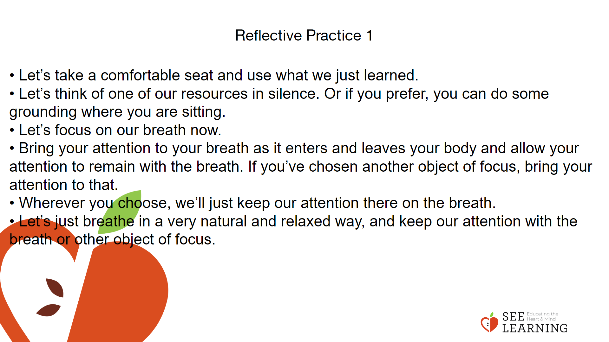 | Instructions and Guided Language  • “Now let’s try to train our attention in the way we’d train a puppy.  • Let’s take a comfortable seat and use what we just learned.  • Just like the puppy, if we’re too excited or too sleepy, or if we’re not in our resilient zone, it will be hard to train our attention.  • So first we’ll use resourcing and grounding activity to help us be in our resilient zone.  • Let’s think of one of our resources in silence. Or if you prefer, you can do some grounding where you are sitting. [PAUSE]  • As we think of our resources, let’s notice any pleasant or neutral sensations in the body. [PAUSE]  • If you find a pleasant or neutral sensation, just keep your focus on that. That can be your object of focus for now. [PAUSE]  • Maybe now our bodies are feeling more relaxed. Let’s focus on our breath now. We’ll use that as our object of focus. For some people, focusing on the breath can be uncomfortable. So if you don’t want to use your breath, you can choose a resource, a part of your body to ground with, or a neutral sensation.  • It can help to close your eyes. If you don’t want to close them, then lower your eyes to the floor. Let’s be careful not to distract anyone else, because we’re all trying to pay attention.  • Bring your attention to your breath as it enters and leaves your body and allow your attention to remain with the breath. If you’ve chosen another object of focus, bring your attention to that.  • You may notice the breath in your nose. If so, you can pay attention there.  • You may notice the breath in the rise and fall of your belly. If so, you can pay attention there.  • You may notice the breath somewhere else. Then you can pay attention there.  • Wherever you choose, we’ll just keep our attention there on the breath. [PAUSE]  • Let’s just breathe in a very natural and relaxed way, and keep our attention with the breath or other object of focus.  • We should be relaxed when doing this, but if instead you feel uncomfortable, you can stop paying attention to the breath and instead go back to doing resourcing or grounding. Or if you need to, just stop and relax on your own quietly.  • Otherwise let’s keep our attention on the breath. [PAUSE]  • If we get distracted or if the mind wanders, just bring your mind back to the breath or your chosen object, just like bringing the puppy back. And see if we can hold the breath in our mind a little longer. [LONGER PAUSE]  • Now we can open our eyes. Just like a compassionate owner knows that their puppy will need and deserve many chances to practice training before they can easily know what to do, we also need and deserve many opportunities to practice training our attention. So that down the road, we can return to being present and sustain our attention in the ways we want.”
Reflective Practice 2 (10 mins)

Slide 6:Reflective Practice 2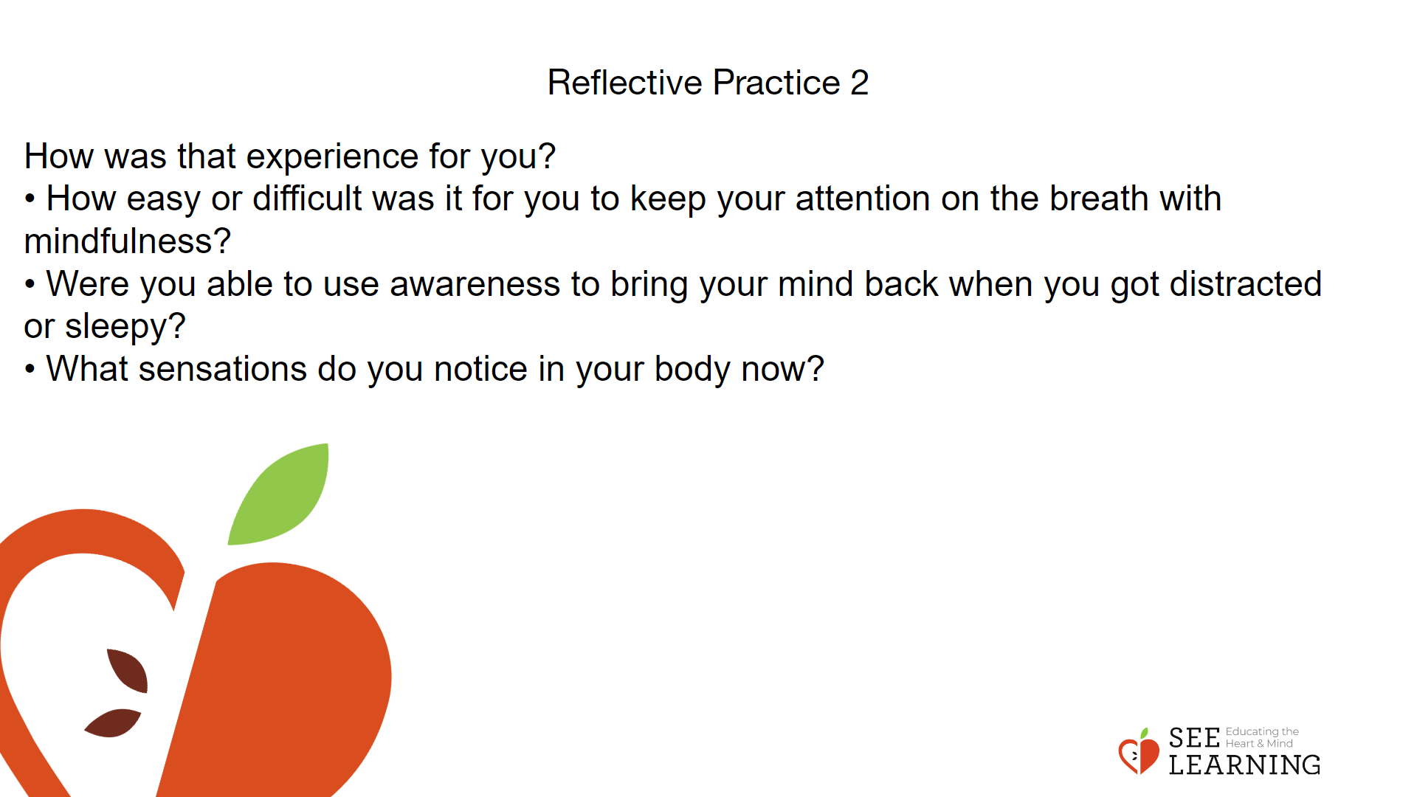 | Instructions and Guided Language  Drawing Attention Training  “Open up your journal and respond to one or more of the prompts below.  • How was that experience for you?  • How easy or difficult was it for you to keep your attention on the breath with mindfulness?  • Were you able to use awareness to bring your mind back when you got distracted or sleepy?  • What sensations do you notice in your body now?  As you reflect on these prompts, allow yourself to envision how the skill of mindfulness and awareness supports you in developing healthy relationships with others. Please use the following prompts to guide this reflection.

