Cultivating Attention in Activities: Part 2

Purpose:
Students will practice sustained attention in everyday activities including walking, eating, listening and writing to develop the skill of mindfulness and increase stamina to focus and pay attention. It is important to cultivate attention using neutral or “boring” things because it improves our ability to be present, pay attention for longer periods of time, and address tendencies toward negativity bias
Learning Objectives:  Students will be able to:  - Engage in the practice of sustained attention in everyday activities including walking, eating, listening, and writing to develop the skill of mindfulness and increase stamina to focus and pay attention  - Determine how being aware of negativity bias can be helpful in fostering self-compassion | Primary Core Component  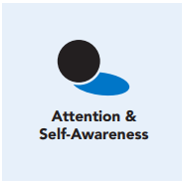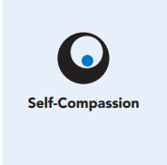
Length  45 Minutes | Materials Required  - A clear open space  - Healthy snack and a napkin for each student  - Writing utensils and paper

Check-In (10 min)
Slide 2: Check-In  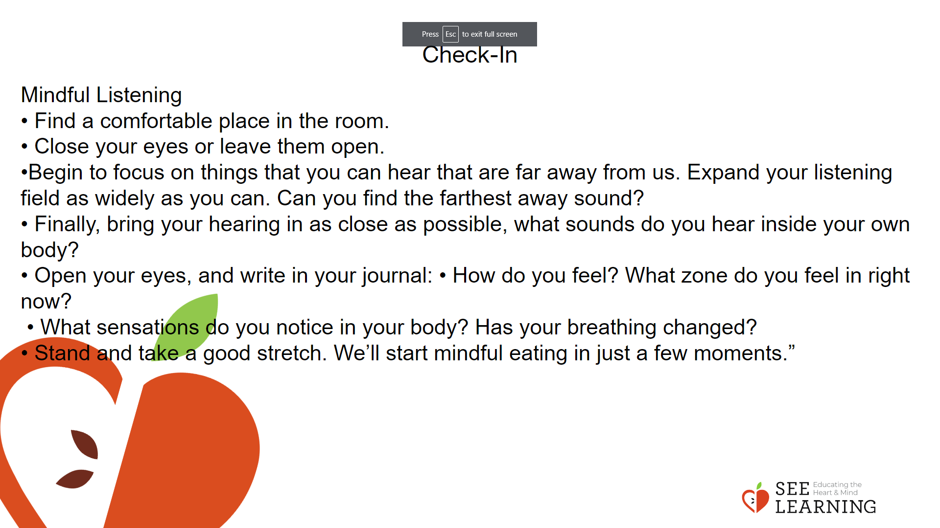 | Instructions and Guided Language  [PAUSE]s can be up to 10 seconds each Introduction  “Today we’re going to try three more mindful attention activities so that we have several options to choose from when we’re working to grow our attention skills. A few things that are important to remember about why we are practicing mindful listening, walking, and eating today are: • We can choose to pay attention while we do any activity. • We notice more when we slow down and pay close attention: things become more vivid and interesting.  • Paying close attention can balance and stabilize our body and mind.  • When we practice paying attention we can maintain focus for longer periods of time.”  Mindful Listening  “First, we will practice mindful listening by bringing our attention to the sounds we are hearing around us. Do your best to keep your attention on the sounds you hear.  If you become distracted, that is natural and okay. Simply invite yourself to bring your attention back to the sounds you hear.  • Find a comfortable place in the room.  • Close your eyes or leave them open. Take three breaths if that feels comfortable to you.  • Begin to focus on things that you can hear that are far away from us. Expand your listening field as widely as you can. Can you find the farthest away sound? It is not important to identify the sound, just notice it. [PAUSE]  • Now we are going to find the sounds happening inside the building. [PAUSE]  • And let’s bring it in even closer — notice the sounds happening inside the room. [PAUSE]  • Finally, bring your hearing in as close as possible, what sounds do you hear inside your own body? [PAUSE]  • Open your eyes, and write in your journal:  • How do you feel? What zone do you feel in right now? [PAUSE]  • What sensations do you notice in your body? Has your breathing changed? [PAUSE]  • Stand and take a good stretch. We’ll start mindful eating in just a few moments.”

Reflective Activity 1 (10 mins)
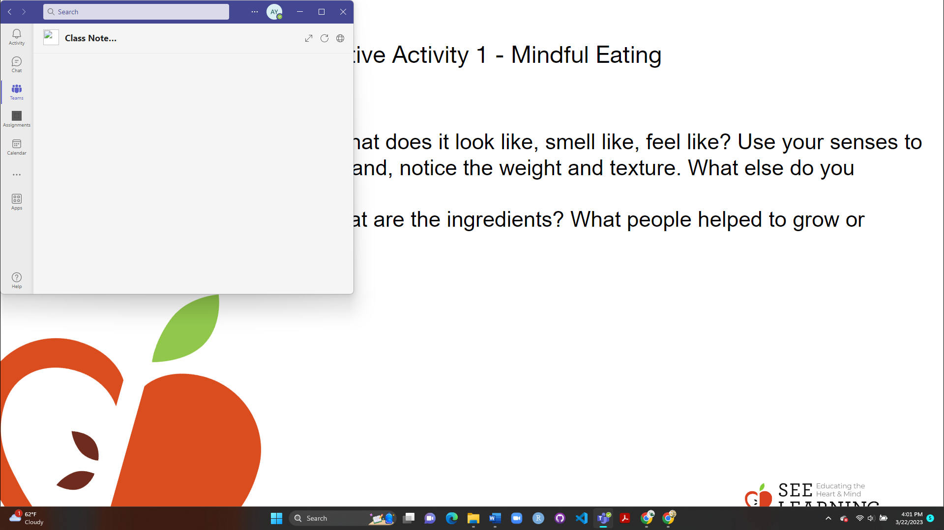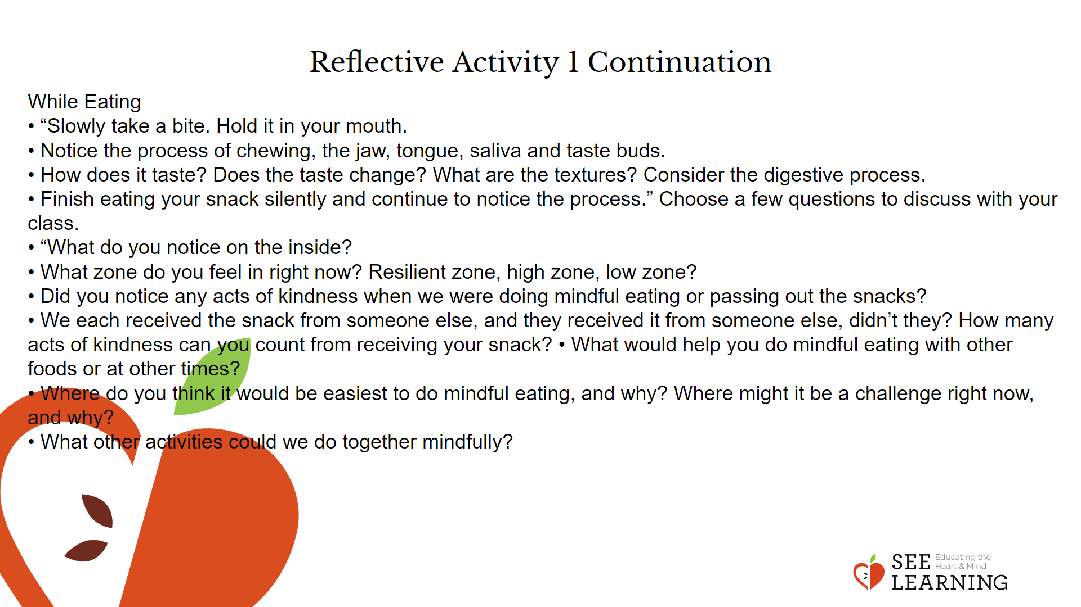 | Instructions and Guided Language  Mindful Eating “Now, we will practice mindful eating by bringing our attention to the food we are eating and the process of eating itself.  Do your best to keep your attention on the activity. As a reminder, if you become distracted, that is natural and ok, you can to bring your attention back to the mindful eating activity.  I will ask questions that you can ponder but we will not be sharing aloud at this time.”  Before Eating  • “Notice the food in front of you. What does it look like, smell like, feel like? Use your senses to describe the food. Place it in your hand, notice the weight and texture. What else do you notice?  • Review Interdependence. Consider what it took to get this food to us today. Where did the food originate? What are the ingredients? What people helped to grow or produce this food?  • When you think about eating it, what thoughts do you notice? Your mind might be telling you “Oh boy, I can’t wait!” or “Yuck, I don’t want to eat that!” You might feel a little curious or just neutral.”  While Eating  • “Slowly take a bite. Hold it in your mouth.  • Notice the process of chewing, the jaw, tongue, saliva and taste buds.  • How does it taste? Does the taste change? What are the textures? Consider the digestive process.  • Finish eating your snack silently and continue to notice the process.”  Choose a few questions to discuss with your class.  • “What do you notice on the inside? [Ask specifically about sensations and where they are in the body, reinforcing learning from Chapter 2].  • What zone do you feel in right now? Resilient zone, high zone, low zone?  • Did you notice any acts of kindness when we were doing mindful eating or passing out the snacks?  • We each received the snack from someone else, and they received it from someone else, didn’t they? How many acts of kindness can you count from receiving your snack?  • What would help you do mindful eating with other foods or at other times?  • Where do you think it would be easiest to do mindful eating, and why? Where might it be a challenge right now, and why?  • What other activities could we do together mindfully?

Reflective Activity 2 (10 min)
Slide 5: Reflective Activity 2  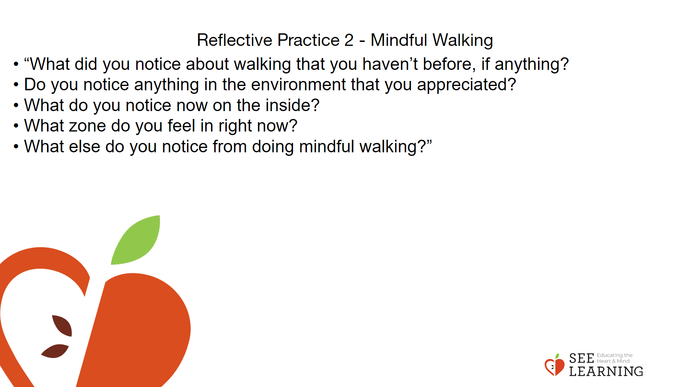 | Instructions and Guided Language  “Finally, we will practice mindful walking by bringing our attention to the process of walking itself.  Do your best to keep your attention on the activity.  As a reminder, if you become distracted, that is natural and okay.  You can bring your attention back to the mindful walking activity.”  Before Walking  “As you are walking, think about the movement of your body, your knees, hips, feet, arms, etc.  Notice your feet hitting the ground as you walk.  Take note of the environment around you. What do you see and hear?  We will do our best to walk in silence and keep a reasonably even pace with the rest of the class.  When you are ready, silently stand up and we will begin our mindful walking exercise.”  Choose a few questions to debrief.  • “What did you notice about walking that you haven’t before, if anything?  • Do you notice anything in the environment that you appreciated?  • What do you notice now on the inside? [Ask specifically about sensations and where they are in the body, reinforcing learning from Chapter 2].  • What zone do you feel in right now?  • What else do you notice from doing mindful walking?”  Mindful Walking Variations  It is recommended to do these activities more than once.  • Rise from your seat in silence as you join the line. Return to your seat in silence after the activity.  • A student can volunteer to be the “leader,” they can start and end the activity and set the pace.  • You could invite a few students to begin and then allow students to join the line or circle as they feel ready. In these cases, you would join last.

Reflective Practice 3 (10 mins)
Slide 6: Reflective Practice  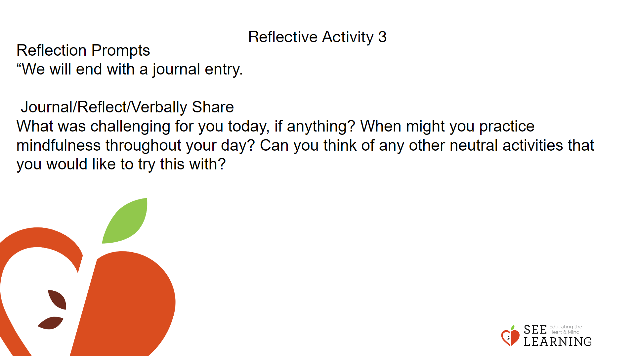 | Instructions and Guided Language  “We have been practicing paying attention to things that we do all the time.  We walk all the time, eat and listen everyday, so it’s hard to pay attention to these things.  It’s easier to pay attention when something is new, exciting, or fun. These activities can feel less stimulating and even boring.  It’s important to cultivate attention using neutral or “boring” things, because we naturally pay attention to fun and stimulating things. It is important to cultivate attention using neutral or “boring” things because it improves our ability to be present, and pay attention for longer periods of time.  One of the benefits of being present in the current moment is that it helps us to shift awareness from a negativity bias. When we are in the present, we do not ruminate about the past or a future we cannot control.  Present moment awareness provides us with a powerful self-compassion strategy as it enables us to turn off the doubting and worrying mind. It also promotes our ethical literacy by helping us recognize our emotional and physical well-being and take measures when needed.  If you were more present, how would it benefit your life, relationships, and personal wellbeing?”  Reflection Prompts  “We will end with a journal entry.  Do this as mindfully as you can, noticing the subtleties of writing.  You may notice the pen or pencil in your hand, the movement of the hand and wrist, the pressure of the pen or pencil on your paper, the quiet sound the writing utensil makes, etc.“  Journal/Reflect/Verbally Share  “What was challenging for you today, if anything?  When might you practice mindfulness throughout your day?  Can you think of any other neutral activities that you would like to try this with?”

