Cultivating Attention in Activities: Part 1

Purpose:
Students use scenarios to review the analogy of the spark and the forest fire as representations of feelings. They relate the scenarios to mindfulness, heedfulness, and awareness as tools and practices that can help us to catch a spark before it gets too big. Through reflection, they relate the learning to their own lives.
Learning Objectives:  Students will be able to:  • Notice that the training of attention can be involved in any activity we do  • Learn strategies for catching impulses before they cause us problems | Primary Core Component  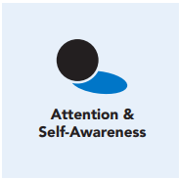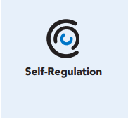
Length  45 Minutes | Materials Required  • Spark and forest fire images  • Writing utensils and paper

Check-In (5 min)
Slide 2: Check-In  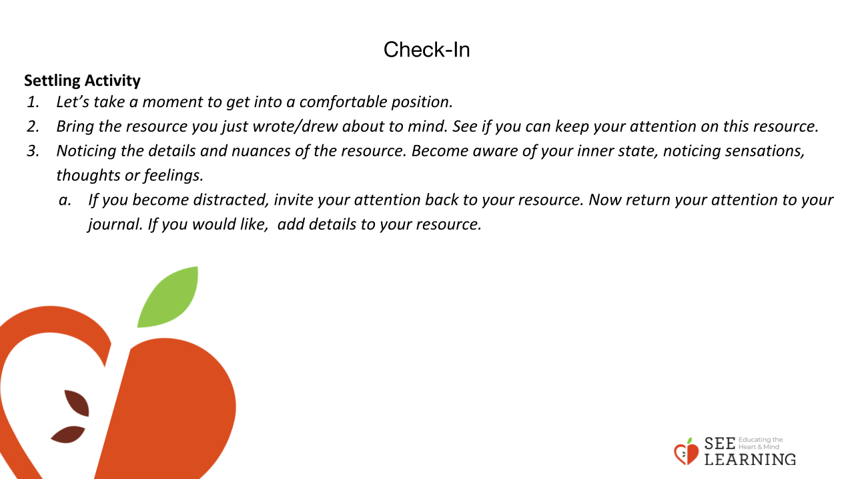 | Instructions and Guided Language  [PAUSE]s can be up to 10 seconds each  “In the resourcing section of your journal, answer the following question using words and illustrations.  What’s something, some place, or someone that helps you feel better, safer, happier or stronger?”  Settling Activity  • “Let’s take a moment to get into a comfortable position.  • Bring the resource you just wrote/drew about to mind. [PAUSE]  • See if you can keep your attention on this resource. Noticing the details and nuances of the resource. [PAUSE]  • Become aware of your inner state, noticing sensations, thoughts or feelings. If you become distracted, invite your attention back to your resource. [PAUSE]  • Now return your attention to your journal. If you would like, add details to your resource.”

Presentation (10 min)
Slide 3: Presentation  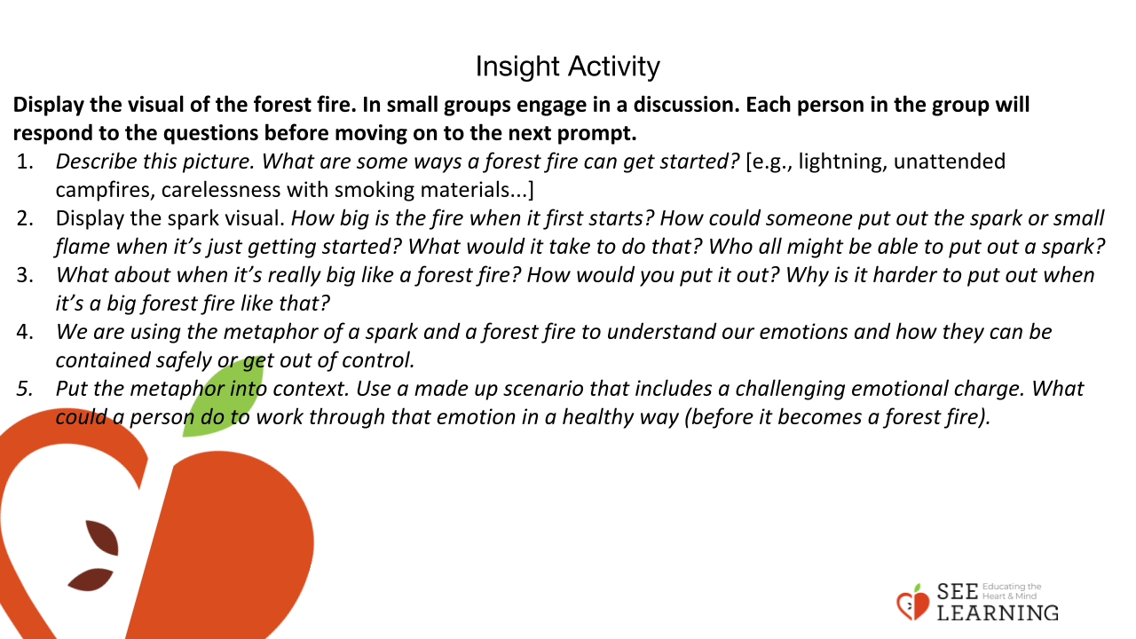 | Instructions and Guided Language  Display the visual of the forest fire.  • “Describe this picture. What are some ways a forest fire can get started? [e.g., lightning, unattended campfires, carelessness with smoking materials...] Display the spark visual.  • “How big is the fire when it first starts?  • How could someone put out the spark or small flame when it’s just getting started? What would it take to do that?  • Who all might be able to put out a spark?  • What about when it’s really big like a forest fire? How would you put it out?  • Why is it harder to put out when it’s a big forest fire like that?  • We are using the metaphor of a spark and a forest fire to understand our emotions and how they can be contained safely or get out of control.  • Once a forest fire reaches a certain size, it can’t be put out, even through collective efforts. So it just burns until it burns itself out.  • Similarly, emotions at an early stage are things we can become aware of and can then intentionally and bravely take action towards (like frustration or mild anger). However, once that emotion reaches a certain level, it takes over (all-consuming rage, hatred, or jealousy).  • At that level, we lose awareness, we lose reason, we are thrown out of our comfort zone, and we lose our capacity for bravely or compassionately taking action, because we are so consumed by the destructive emotion.  • At that moment, we may say or do something harmful to ourselves or others, that compromises our well-being and violates our basic human values, that we can never take back.  • Later, we wonder why we acted in that way, and say things like “I don’t know what I was thinking” or “I couldn’t control myself.”  • So the point is, if one can still be aware and can still take brave, intentional, productive action, then the emotion has not reached the forest fire level yet — and that’s precisely why we want to catch those emotions and mental states before they reach that level.”

Insight Activity - The Spark and The Forest Fire Scenarios (15 min)
Slide 4 and 5: Insight Activity  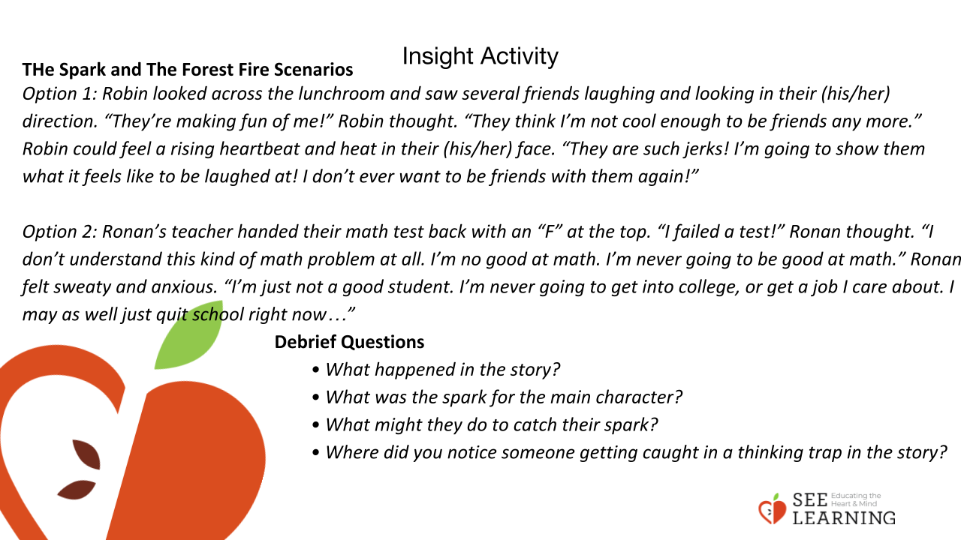 | Instructions and Guided Language  The Spark and The Forest Fire Scenarios  Independently, with partners or as a whole class, read the scenarios and respond to the questions.  Option 1  “Robin looked across the lunchroom and saw several friends laughing and looking in their direction. “They’re making fun of me!” Robin thought.  “They think I’m not cool enough to be friends any more.”  Robin could feel a rising heartbeat and heat in their face. “They are such jerks! I’m going to show them what it feels like to be laughed at! I don’t ever want to be friends with them again!””  Option 2  “Ronan’s teacher handed their math test back with an “F” at the top. “I failed a test!” Ronan thought.  “I don’t understand this kind of math problem at all. I’m no good at math. I’m never going to be good at math.”  Ronan felt sweaty and anxious. “I’m just not a good student. I’m never going to get into college, or get a job I care about. I may as well just quit school right now…””  Debrief Questions  • “What happened in the story?  • What was the spark for the main character?  • What might they do to catch their spark?  • Where did you notice someone getting caught in a thinking trap in the story?”

Reflective Practice (15 min)
Slide 6: Reflective Practice  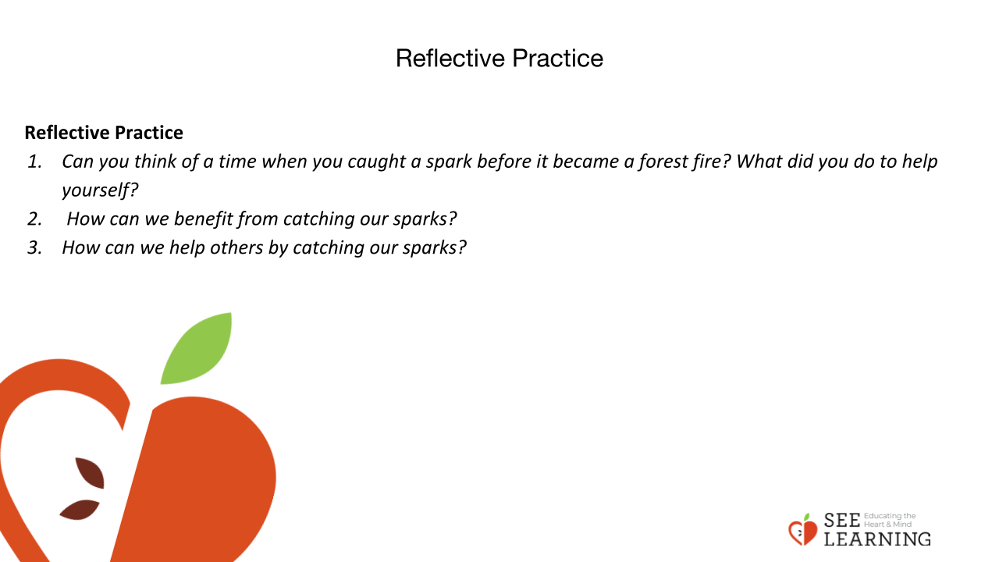 | Instructions and Guided Language  • “Can you think of a time when you caught a spark before it became a forest fire? What did you do to help yourself?  • How can we benefit from catching our sparks?  • How can we help others by catching our sparks?”  Share one or more of the points below, if they weren’t already surfaced in the student discussion.  “Emotions are things we feel, and they also involve physical systems in the body and brain.  Unlike unemotional thoughts, in emotion there is a sense of investment: we, or our bodies, care about something.  If we think about something we don’t care about at all, or have no investment in, we’re unlikely to get emotional about it. The more we care about something, the stronger our emotional response tends to be.  Feelings and impulses can be like sparks that quickly grow to a forest fire if we don’t catch them in time by paying close attention to how we are feeling and noticing what’s going on around us. It is important to notice our sparks and address them before they become fires, which we can do by strengthening our attention and awareness muscles.  When it’s still a spark, a fire is easy to put out and even a child can do it. Once it’s a forest fire, the consequences increase, and it lasts until it burns itself out.”

